ENHANCED ABATTOIR SURVEILLANCE PROGRAM

Pleurisy-Pneumonia
Pneumonia is the presence of an infection and inflammation in the lungs. If severe, the inflammation can extend to the outer layer of the lung, the pleura, and is then called pleurisy. This causes parts of the lungs to stick to the chest wall, resulting in trimming of the valuable rack at the processor. Onset of pneumonia can be either rapid or slow and is most commonly seen in lambs, weaners and hoggets.
Condition summary
Pneumonia is inflammation in the lungs and is caused by a variety of agents, most often bacteria and viruses. Pleurisy usually accompanies severe pneumonia when extensive inflammation causes the lungs to adhere to the chest wall.
Production losses are associated with reduced growth rates, ill-thrift and deaths.
If pneumonia is present at slaughter, lungs are condemned. If there is extensive pus or multiple abscesses, the carcase and all its parts are condemned. If pleurisy is present, the lungs adhere to the chest and cannot easily be removed. The adhesions must be trimmed but more often, the entire rib cage must be cut out and condemned.
Prevention is aimed at minimizing possible risk factors, including reducing stress, optimal nutrition, and good management and husbandry, including avoiding inhalation of dust, drenches and dips.
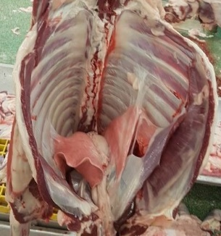

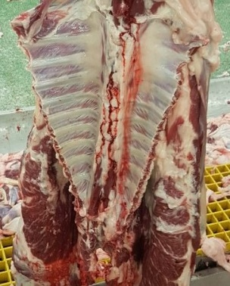

Top: Lungs adhering to the inside of the rib cage (pleurisy with arrows); Bottom: the same rack after trimming

What impact does this have?
The financial cost of pleurisy and pneumonia to the sheep industry, producers and processors is estimated to be $20 million per year and is one of the 3 most significant conditions monitored by the Enhanced Abattoir Surveillance program. Trimming of the ribs due to pleurisy which includes the valuable rack cut results in a less valuable product as well as significant reductions in carcase weight. Subclinical disease leading to poor growth is hard to detect and it is difficult to measure productivity losses. Therefore the full cost of pneumonia to the industry is unknown.

How do sheep get pneumonia and pleurisy?
Pneumonia and pleurisy are the result of a complex combination of multiple factors. Major risk factors include:
- An infectious agent – bacteria, viruses, parasites or fungi
- Weather and environmental conditions, especially hot, dry, dusty conditions, and sudden temperature and humidity fluctuations
- Poor sheep/lamb immune system, often a result of ‘stress’ due to things like mustering, yarding, transport, overcrowding, exhaustion, and mixing of lines of sheep from different origins
- Drench or dip fluid accidently passing into the windpipe and down into the lungs
A veterinary investigation will be required to differentiate the cause of pleurisy-pneumonia. Antibiotic treatment may be used if indicated.

What might be seen on farm?
Some sheep may cough, have respiratory distress or low exercise tolerance. Persistent coughing may cause rectal prolapse. Severely affected sheep are often found dead. Most affected sheep show no symptoms. A slow onset or rapid onset pattern of illness may be observed:
- ‘Summer’ pneumonia is a slow onset or chronic non-progressive pneumonia and it is most commonly seen in weaners during warmer months. In most cases it is sub-clinical with no obvious signs, but growth rate is affected (it is a ‘silent’ profit killer). Lamb growth can be slowed by as much as 50 percent. Coughing, nasal discharge, difficulty breathing and/or lagging behind the mob when moved may be noticed.
- Rapid onset pneumonia, also called acute fibrinous pneumonia. Sheep/lambs may stop eating, appear dull, separate from the flock and have nasal discharge and difficulty breathing. Deaths may occur and sheep that do survive usually do poorly, often as a result of pleurisy.

How do I prevent pneumonia and pleurisy?
Development of pleurisy-pneumonia is complex and not fully understood, therefore no single management practice alone can reduce or prevent disease. Producers should consider as many of the following practices as possible to reduce the incidence of pleurisy-pneumonia on their property.
- Yarding/Mustering/Transport:
  - Drive sheep slowly and ensure there is continual access to clean water.
  - Avoid prolonged yarding in overcrowded and extreme conditions such as in extreme temperatures (high or low) and dry and dusty conditions. If necessary, consider hosing down yards prior to yarding to reduce dust.
- Optimise stock health:
  - Ensure good worm control and appropriate vaccinations, minimise skin injuries and increase hygiene at shearing, dipping and marking.
  - No vaccines are registered for use in Australia against sheep respiratory disease. Seek veterinary advice for vaccines currently being trialled in sheep.
  - Avoid dusty feed and address any nutritional or mineral deficiencies.
- Minimise stress:
  - Avoid sudden diet changes, mixing of mobs and provide appropriate shelter for conditions.
- Drenching and dipping technique:
  - Do not dip tired or thirsty sheep. Avoid holding the sheep’s head above horizontal during drenching and do not drench in the cradle.
  - Minimise dip retention time and change dip fluid regularly, do not top up.

