HACCP PLAN
Cold Storage and Distribution of Meat and Meat Products for Human Consumption

Business Name
PIRSA Accreditation Number: XX/XXXX

This is a HACCP template, developed by the Department of Primary Industries and Regions (PIRSA) for Cold storage and Distribution of Meat and Meat Products.
An Accredited Meat Producer may identify additional steps or hazards upon undertaking their own hazard analysis and risk assessment of each hazard. If this occurs, the Accredited Meat Producer must discuss this with the PIRSA Food Standards team to ensure that this is reflected in this document and appropriately addressed.
It is the responsibility of the accredited producer to implement and maintain the HACCP plan as part of the approved Food Safety Arrangement.

Table of Contents
1 HACCP PROCESS 3
1.1 PRODUCT SPECIFICATION 4
1.2 FLOW CHART 5
1.3 CCP DECISION TREE 6
1.4 HAZARD ANALYSIS TABLE 7
1.5 HAZARD AUDIT TABLE 9
1.6 CCP WORK INSTRUCTIONS 11
1.7 CCP MONITORING FORMS 15
1.8 PROCESS VALIDATION 19

HACCP PROCESS

OUTCOME
To process food safely, producing safe food which complies with relevant legislation, regulations and standards.
HACCP
Process

This HACCP plan forms part of the Approved Food Safety Arrangement for the Accredited Meat Producer.
The HACCP team (as identified it the Food Safety Arrangement) is responsible for maintaining this HACCP plan through analysing and improving procedures along with implementing effective controls to manage food safety risks. Each process undertaken by the business needs to be covered by a HACCP plan. This HACCP plan covers:
Cold Storage and Distribution of Meat and Meat Products for human consumption

The producer acknowledges following have been taken into consideration in the development of this HACCP plan;
- Primary Produce (Food Safety Schemes) Act 2004
- Primary Produce (Food Safety Schemes) (Meat) Regulations 2017
- AS 4696:2023: Australian Standard for Hygienic Production and Transportation of Meat for Human Consumption
- AS 4465:2005 Australian Standard for construction of premises and hygienic production of poultry meat for human consumption.
- Meat and Livestock Australia - Guidelines for the Safe Manufacture of Smallgoods – 2nd edition 2015
- FSANZ Food Standards ode 4.2.2 and 4.2.3

Application for any alternative methods to those identified in the Australian Standard AS4696:2023 must be approved by the Accrediting body.
For the activity of Cold Storage and Distribution of Meat (including Poultry) and Meat products for human consumption the producer must hold accreditation to carry on the business of producing meat including these processes.

PRODUCT SPECIFICATION

, The following constitutes a Product Specification for the purpose of the Food Safety Arrangement and obligations under the Act. The Specification detail the product characteristics as listed below and are considered when reviewing the HACCP plan.
General Category Product Specification (Example)
Product Category | Meat (including poultry) both carcass and carton formats
General Composition | Meat
Method of Preservation | Refrigeration – chilled at or below 5°C  Shelf stable products may be transported and stored under dry ambient conditions.
Packaging | Primary | Nil (carcass) or plastic liner
 | Secondary | Nil (carcass) or Plastic containers or Cartons
Storage Conditions | As defined by supplier requirements:  Keep refrigerated at or below 5°C  Frozen: poultry to be stored at ≤-15°C  Suitable for freezing  Shelf stable – dry ambient conditions.
Distribution Method | Refrigerated vehicle at or below 5°C
Shelf Life | As defined by supplier requirements
Intended Use | Sensitive Customer | As defined by product label – applied by supplier
 | Customer Preparation | As defined by product label – applied by supplier

FLOW CHART
Objective | A step-by-step diagram of the flow of the operation/process with all stages, inputs and outputs identified. Key steps in the process that are critical to food safety are referred to as Critical Control Points, (CCP). These are highlighted on the Flow Chart.

CCP DECISION TREE

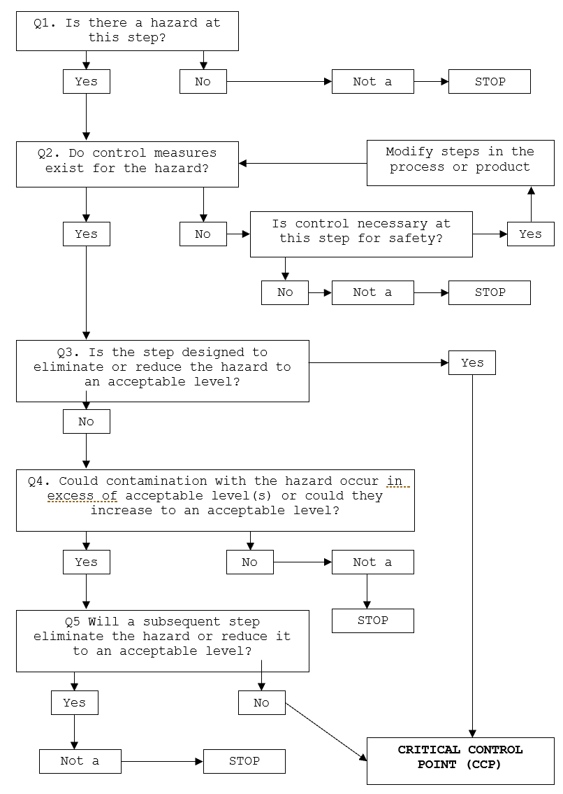

HAZARD ANALYSIS TABLE
Hazard Types: B – Biological; C – Chemical; P – Physical
Objective | A documented review of each step identified in the flow chart and with the importance of each step in the safety of the finished product rated to identify Critical Control Points (CCP).

Process Step |  | Hazard | Cause | Q1 | Q2 | Q3 | Q4 | Q5 | Preventative measures for hazard control | CCP | CP | GMP | Support Program
Applicable at each step and to all stages of process | Hygiene and sanitation | B - Microbiological cross contamination due to unclean surfaces/equipment | Poor cleaning and sanitation process | Y | Y | N | Y | Y | Hygiene and sanitation procedure  Pre-op monitoring
 |  | C – Chemical residue | Chemical residues at unsafe levels | Y | Y | N | Y | Y | Use of approved chemicals at correct dilutions  Training Program
 | Personnel Hygiene | B – Microbiological cross contamination due to unhygienic handling procedures | Poor personal hygiene | Y | Y | N | Y | Y | GMP procedures  Hygiene monitoring  Training program
 |  | P – foreign objects | Poor GMP procedures | Y | Y | N | Y | Y | Program of works  Pre-op monitoring

Process Step | Hazard | Cause | Q1 | Q2 | Q3 | Q4 | Q5 | Preventative measures for hazard control | CCP | CP | GMP | Support Program
- Receiving | B – Growth of microbiological pathogens above unsafe levels.  E.g., (Salmonella, Listeria, E. coli) | Elevated levels of pathogens which will not be inactivated by the further processes | Y | Y | Y | - | - | Product received less than or equal to 5°C (or 7°C for red meat carcasses).  Frozen – solid, no signs of thawing, Frozen poultry ≤-15°C. | CCP
 | P – contamination | Foreign matter - E.g., Bone splinters | Y | Y | N | Y | Y | Inspection by operator  Purchase from approved supplier
- Cold Storage | B – Growth of microbiological pathogens above unsafe levels.  E.g., (Salmonella, Listeria, E. coli) | Product not stored under appropriate temperature control. | Y | Y | Y | - | - | Product stored less than or equal to 5°C under active refrigeration without delay. | CCP
 | C – cross contamination | E.g., Operator error with cleaning chemicals | Y | Y | N | Y | Y | Suitable chemical storage and control and appropriate training for staff handling chemicals
 | P – contamination | Foreign objects e.g. rust. | Y | Y | N | Y | Y | Compliant chiller construction
- Despatch & Distribution | B – Growth of microbiological pathogens above unsafe levels.  E.g., (Salmonella, Listeria, E. coli) | Product not stored under appropriate temperature control. | Y | Y | Y | - | - | Product maintained less than or equal to 5°C under active refrigeration.  Frozen – remain solid, no signs of thawing, Frozen poultry ≤-15°C. | CCP

HAZARD AUDIT TABLE
Objective | Documented controls to be implemented and measured and recorded to demonstrate compliance to process to make safe food.

Step | Hazard | Critical Limit | Monitoring | Corrective Action | Records
Receiving  CCP 1 | B – Growth of microbiological pathogens above unsafe levels.  E.g., (Salmonella, Listeria, E. coli) | Carcass (excluding Poultry) temperature less than or equal to 7°C  All Poultry and Red Meat Portion temperature less than or equal to 5°C  Potentially Hazardous Foods (PHF) less than or equal to 5°C  Frozen – solid, no signs of thawing, Frozen poultry ≤-15°C. | What: Carcass surface temperature;  Poultry and portioned meat and other PHF’s core temperature; | Accept product out of temperature specification, place on hold and move into active refrigeration immediately to reduce the temperature to achieve required temperature. Investigate with supplier extent and duration of temperature abuse. Discard product if unable to confirm wholesomeness.  Or  Immediately reject product.  Note: If frozen product is thawed, product is not to be re-frozen. Suitable to be sold as chilled. | Receiving record  or  Invoice
How: Visual inspection with calibrated thermometer
Visual inspection for signs of thawing.
 |  |  | When: Each time meat or PHF are received.
 |  |  | Who: Operator
Cold Storage  CCP 2 | B – Growth of microbiological pathogens above unsafe levels. | Active refrigeration in place to maintain temperature of meat at less than or equal to 5°C. | What: Chiller temperature | Assess temperature of meat. If greater than 5°C, move product to alternate cold storage if available. If frozen product is thawed, product is not to be re-frozen. Suitable to be sold as chilled.  Adjust room temperature setting to achieve ≤ 5°C product temperature.  Repair or replace refrigeration unit. Discard product if unable to relocate to alternative cold storage. | Daily Cold Storage Temperature record  Or  Electronic monitoring  Calibration record
 |  |  | How: Chiller gauge
 |  |  | When: Monitored during use, recorded Daily
 |  |  | Who: Operator
Step | Hazard | Critical Limit | Monitoring | Corrective Action | Records
Despatch & Distribution  CCP 3 | B – Growth of microbiological pathogens above unsafe levels.  E.g., (Salmonella, Listeria, E. coli) | Active refrigeration in place to maintain temperature of meat at less than or equal to 5°C.  Frozen – solid, no signs of thawing, Frozen poultry ≤ -15°C. | What: Vehicle set temperature and actual air | Assess temperature of meat. If greater than 5°C, return product to chiller or move product to alternate refrigerated vehicle if available.  Product is not loaded out until product temperature is less than or equal to 5°C.  Adjust chiller or vehicle temperature setting to achieve less than or equal to 5°C product temperature.  If frozen product is thawed, product is not to be re-frozen. Suitable to be sold as chilled.  Advise the receiver of the meat or meat products to arrange refrigeration without delay.  Repair or replace refrigeration unit. | Load out record/invoice  Calibration record
 |  |  | How: Visual check of Calibrated refrigeration gauge or thermometer
 |  |  | When: At point of despatch for each delivery
 |  |  | Who: Operator

CCP WORK INSTRUCTIONS
Objective | At steps that are critical for the safety of the finished product, checks on the process are completed to confirm the process has met the critical limits and the results recorded. If the check finds the product has not met the critical limit of the process, actions need to be taken to make the product safe. These steps need to be documented in a work instruction.

- CCP 1 – Receiving
- CCP 2 – Cold Storage
- CCP 3 – Despatch & Distribution

WORK INSTRUCTION | Receiving
Objective | Products are received from approved suppliers in wholesome condition
Procedure | Meat and food products are purchased from an accredited business.  Meat arrives via accredited refrigerated transport.  Condition of transport vehicle and receival area are observed for cleanliness and general condition.  The temperature of the delivered meat in the vehicle is verified to confirm cold chain compliance and product is within critical limits:  - Carcass temperature less than or equal 7°C  - Portion and poultry carcass temperature less than or equal to 5°C  - Potentially Hazardous Foods (PHF) less than or equal to 5°C  - Frozen – solid, no signs of thawing, Frozen poultry ≤ -15°C.  The meat is immediately transferred from the vehicle to active refrigeration once accepted.  A product traceability system is in place from end to end of the supply chain (i.e., supplier to customer) to prevent inadvertent substitution of product.  Any product returned are segregated and evaluated for wholesomeness at time of return, with product deemed unwholesome defaced and discarded.
Frequency | Every delivery.
Records | Receival record; Invoice
Corrective Action | Accept product out of temperature specification and reduce the temperature immediately under active refrigeration to achieve required temperature.  Or  Reject product.
Responsibility | The operator is responsible for inspection, monitoring and documenting the receipt of goods.

WORK INSTRUCTION | Cold Storage
Objective | Suppress growth of microbiological pathogens in Meat and meat products; they are not contaminated nor their wholesomeness jeopardised.
Procedure | Active refrigeration in place to maintain temperature of meat at less than or equal to 5°C.  All product to be placed under refrigeration as soon as practically possible.  Product to be stored off the ground and spaced for adequate refrigerated air circulation, with all cooked and raw meats stored separately and that no cross contamination occurs.  Products to be frozen are to be hard frozen without delay. Frozen product intended to be stored frozen are to remain frozen during storage.  Shelf-stable meat products can be transported and stored under dry ambient conductions which will not adversely affect the microbiological safety of the product.  A product traceability system is in place from end to end of the supply chain (i.e., supplier to customer) to prevent inadvertent substitution of product.
Frequency | Daily or electronic monitoring system.
Records | Daily Storage Temperature monitoring form or electronic monitoring system.
Corrective Action | Assess temperature of meat. If greater than 5°C, move product to alternate cold storage if available.  Adjust room temperature setting to achieve less than 5°C product temperature.  Note: If frozen product is or becomes thawed, product is not to be re-frozen. Suitable to be sold as chilled.  Service and repair chiller.  Discard product if unable to relocate to alternate cold storage.
Responsibility | The operator is responsible for monitoring, documenting and maintaining temperature of cold storage areas.

WORK INSTRUCTION | Despatch & Distribution
Objective | Suppress growth of microbiological pathogens.
Procedure | Despatch  All meat products must be stored in a hygienic and safe manner to ensure the product integrity.  All loads are to be inspected for packaging integrity, contamination and other aspects, which could render the product unwholesome for human consumption.  Temperature of product to be monitored, with portioned meat at less than or equal to 5°C and carcass temperature less than or equal 7°C.  Frozen meat to remain frozen (chicken at -15 degrees)  Note: If frozen product is thawed, product is not to be re-frozen. Suitable to be sold as chilled.  Shelf-stable meat products can be transported and stored under dry ambient conductions.  Distribution  Cartons, portion and carcass meats are be transported in the meat carrying compartment of the vehicle.  The compartment operates at an air temperature to maintain meat temperatures in accordance with the Australian Standard:  - Temperature of carcase meat at less than or equal to 7°C.  - Temperature of poultry carcases, portioned or carton meats at less than or equal to 5°C.  - Shelf-stable meat products can be transported and stored under dry ambient conductions.  - Frozen products to remain frozen during transport. Frozen Poultry to remain ≤ -15°C.  Product to be stored off the ground and spaced for adequate refrigerated air circulation, with all cooked and raw meats stored separately and that no cross contamination occurs.  Record the set temperature of the vehicle when loading the vehicle.  Monitor the air temperature of the meat carrying compartment during transportation. Adjustment to the thermostat may be required to maintain required air temperature.  Monitor air temperature of meat compartment upon arrival at destination for compliance with Australian Standard.
Frequency | Each despatch/delivery.
Records | Load-out record/invoice.
Corrective Action | Product is not loaded out until portioned meat product temperature is ≤5°C.  Product is not loaded out until carcass temperature is ≤7°C.  Note: If frozen product is thawed, product is not to be re-frozen. Suitable to be sold as chilled.  If distributor becomes aware of conditions which may have compromised the wholesomeness during transport, they will advise the proprietor of the meat business that receives the meat or meat products without delay.
Responsibility | The operator is responsible for monitoring, documenting and maintaining temperature of cold storage areas.

CCP MONITORING FORMS

- Receiving record (CCP1)
- Daily Cold Storage Temperature Record (CCP 2)
- Load out record (CCP 3)

Date | Product | Supplier | Invoice no | Acceptable Condition | Temperature °C | Signature
1/9/22 | Pork | Meat supplier | 1234 | Yes | 4.5°C | SS

Corrective Action | Verification, Signed:

MONTH and YEAR

DATE

Chiller 1

Chiller 2
Freezer Temperature

DATE

Chiller 1

Chiller 2
Freezer Temperature

Corrective Action | Verification, Signed:

Date | Product | Customer | Invoice no | Temperature °C  (Despatch / Delivery) | Signature
1/9/22 | Pork Sausage | Local Pub | 1234 | 4.5°C | SS

Corrective Action | Verification, Signed:

PROCESS VALIDATION
Objective | Confirm the process followed will control the hazards identified, making the product safe for consumption.

Verification & Validation | Receiving
Objective | Theoretical validation – AS4696:2023 Section 15  Provide evidence sufficient active refrigeration is in place to maintain temperature of meat at less than or equal to 5°C.
Verification | Refer to work instruction for monitoring records and frequency to confirm validated process has been followed to achieve hazard control.  Calibration of thermometer probes required at this step:  - 3 monthly – internal calibration (as per Food Safety Arrangement); or  - annually – external calibration.

Verification & Validation | Cold Storage
Objective | Theoretical validation – AS4696:2023 Section 15  Provide evidence sufficient active refrigeration is in place to maintain temperature of meat at less than or equal to 5°C.
Verification | Refer to work instruction for monitoring records and frequency to confirm validated process has been followed to achieve hazard control.  Calibration of thermometer probes, chiller gauges required at this step:  - 3 monthly – internal calibration (as per Food Safety Arrangement); or  - annually – external calibration.

Verification & Validation | Despatch & Distribution
Objective | Theoretical validation – AS4696:2023 Section 15  Provide evidence sufficient active refrigeration is in place to maintain temperature of meat at less than or equal to 5°C.
Verification | Refer to work instruction for monitoring records and frequency to confirm validated process has been followed to achieve hazard control.  Calibration of thermometer probes required at this step:  - 3 monthly – internal calibration (as per Food Safety Arrangement); or  - annually – external calibration.

