Assessment of the proposed changes to the boardwalks and tours at Seal Bay, Kangaroo Island

Final report to the Department of Environment and Natural Resources

B. Page, S.D. Goldsworthy and P.D. Shaughnessy
  - SARDI Publication No. F2011/000047-1
  - SARDI Research Report Series No. 523
  - February 2011

This publication may be cited as:
Page, B. Goldsworthy, S.D and Shaughnessy, P.D (2011). Assessment of the proposed changes to the boardwalks and tours at Seal Bay, Kangaroo Island. Final report to the Department of Environment and Natural Resources. South Australian Research and Development Institute (Aquatic Sciences), Adelaide. SARDI Publication No. F2011/000047-1. SARDI Research Report Series No. 523. 94pp.
South Australian Research and Development Institute
SARDI Aquatic Sciences
2 Hamra Avenue
West Beach SA 5024
Telephone: (08) 8207 5400
Facsimile: (08) 8207 5406
Web: www.sardi.sa.gov.au
Disclaimer
The authors warrant that they have taken all reasonable care in producing this report. The report has been through the SARDI Aquatic Sciences internal review process, and has been formally approved for release by the Chief, Aquatic Sciences. Although all reasonable efforts have been made to ensure quality, SARDI Aquatic Sciences does not warrant that the information in this report is free from errors or omissions. SARDI Aquatic Sciences does not accept any liability for the contents of this report or for any consequences arising from its use or any reliance placed upon it.
© 2011 SARDI
This work is copyright. Apart from any use as permitted under the Copyright Act 1968 (Cth), no part may be reproduced by any process, electronic or otherwise, without the specific written permission of the copyright owner. Neither may information be stored electronically in any form whatsoever without such permission.
Printed in Adelaide: February 2011
SARDI Publication No. F2011/000047-1
SARDI Research Report Series No. 523
Author(s): B. Page, S.D. Goldsworthy and P.D. Shaughnessy
Reviewer(s): P. Rogers and C. Huveneers
Approved by: Dr. M. Deveney
Subprogram Leader - Marine Pests, Marine Environment & Ecology
Signed:
Date: 17 February 2011
Distribution: Department of Environment and Natural Resources, SAASC Library
Circulation: Public Domain

Table of contents

Table of contents 3

1. Executive summary 4

2. Background 4

3. Proposed actions at Seal Bay 7
Proposed construction activities 7
Replace a section of the asphalt path from the Visitor Centre to the Main Platform. The new path will be angled more to the West (Fig. 2, 3). 7
Proposed third-tier tours 7

4. Legislation relevant to the proposed actions at Seal Bay 8
Environment Protection and Biodiversity Conservation Act 1999 (EPBC Act) 8
Environmental assessment process administered by the Australian Government 8

5. Scope and approach of this assessment 10

6. Methods 11
Site visit 11
Literature reviews 11
Analyses of ASL data sets to develop performance indicators 11
Performance indicators 12
Age and sex groups of ASL 12

7. Results and discussion 12
Threatened species of mammal that are protected under the EPBC Act 12
Potential impacts from proposed construction work 14
Potential impacts from the proposed third-tier tours 15
Southern brown bandicoot Isoodon obesulus obesulus 25
Kangaroo Island dunnart Sminthopsis aitkeni 26
Threatened species of reptile, spiders and insects that are protected under the EPBC Act 26
Threatened species of bird that are protected under the EPBC Act 26
Threatened flora species that are protected under the EPBC Act 27
Other migratory species that are protected under the EPBC Act 30
Listed marine species that are protected under the EPBC Act 31
Hooded plover 32
Places that are included on the Register of the National Estate that are protected under the EPBC Act 33
Endangered Ecological Communities that are protected under the EPBC Act 33

8. Conclusions 33
Are there any matters of National Environmental Significance located in the area of the proposed actions? 33
Is there potential for impacts, including indirect impacts, on matters of National Environmental Significance? 34
Are there any proposed measures to avoid or reduce impacts on matters of National Environmental Significance? 34
Daily research tour - proposed measures to avoid or reduce impacts 34
WPA restricted area tour - proposed measures to avoid or reduce impacts 34
Are any impacts of the proposed actions on matters of National Environmental Significance likely to be significant? 35

9. Figures 36

10. Acknowledgements 56

11. References 56

1. Executive summary
As part of a proposed upgrade in tourism options available to visitors at Seal Bay, Kangaroo Island (South Australia), the Department of Environment and Natural Resources proposed modifications to the existing infrastructure, which will involve construction work on paths, boardwalks and viewing platforms; and the addition of high-end (third-tier) tours. Some of these third-tier tours will access areas of the Seal Bay Conservation Park that are currently closed to public. In line with the Seal Bay Management Plan, sustainable use of Australian sea lions and the natural habitat of the park are required to underpin the broader management objectives of the Seal Bay Conservation Park and to ensure that the site remains a sustainable tourism enterprise. This report provides an assessment of the potential impacts of the proposed actions against the Australian Government’s environmental assessment process.
Neither the proposed construction work nor two of the three third-tier tours (science specialist tour and the daily research tour) are likely to significantly impact any matters of National Environmental Significance.
This assessment also indicates that the other third-tier tour, which is termed the Western Prohibited Area (WPA) restricted area tour, may significantly impact one matter of National Environmental Significance at Seal Bay–the Australian sea lion (ASL). The increased human disturbance, which may result from the WPA restricted area tour, may result in ASL moving away from the WPA and broad spatial changes in the use of previously restricted areas by ASL for breeding, nursing and resting.
This report has two key recommendations:
- Department of Environment and Natural Resources take a precautionary approach to the management of risks to the ASL. A precautionary approach to the implementation of the WPA restricted area tour would involve Department of Environment and Natural Resources adopting further measures to mitigate the potential impacts of these tours.
- With regard to the addition of the WPA restricted area tour to the tourism options available to visitors at Seal Bay, this report recommends that Department of Environment and Natural Resources refer the decision to the Australian Government Minister for Department of Sustainability, Environment, Water, Population and Communities.

2. Background
Like many islands around Australia, Kangaroo Island plays an important role in the preservation of plant and animal species that have been heavily impacted by human activities on mainland Australia (Tyler et al. 1979). The geographic isolation of Kangaroo Island and the abundance of private and public lands that have been protected have resulted in the preservation of many of the island’s natural ecosystems, some of which contain endemic flora and fauna that are threatened with extinction (Tyler et al. 1979). Compared with the flora and fauna of mainland Australia, that of Kangaroo Island is typically less impacted by humans, in part because of the long duration (approximately 2,000 y) since the island was occupied by Aboriginal people (Lange 1979). In addition, Europeans did not introduce rabbits or foxes on the island, which together with extensive clearing for agriculture, have dramatically altered the flora and fauna of mainland Australia (Tyler et al. 1979). As a result, Kangaroo Island contains a suite of well-preserved, temperate ecosystems.
The Kangaroo Island tourism industry promotes the island as a world-class, nature-based tourist destination and it is regarded as a key attraction in the continued development of the State and National tourism industries (summarised in Davidson 2010). Kangaroo Island is an increasingly-popular destination for wildlife watching and other nature-related tourism activities, attracting more than 180,000 visitors per year, with a value of approximately $110M per year (based on $611 average expenditure per visitor, Davidson 2010). Such levels of visitation and income make Kangaroo Island the key nature-based and ecotourism destination in South Australia (SA).
Seals are one of the premier tourism attractions on Kangaroo Island and as such can be seen as underpinning the regional multi-million dollar tourism industry (Stirling 1973). The centrepiece of the Kangaroo Island tourism industry is the Australian sea lion (ASL or Neophoca cinerea) population at Seal Bay Conservation Park (Stirling 1973). Seal Bay was first recognised for its importance as a tourist attraction in the early 1950s, when the tourist industry and the SA Ornithological Association requested the protection of the ASL along the southern coast of Kangaroo Island (Department for the Environment 1977). In response, the Department of Fisheries and Game declared a sanctuary that encompassed Seal Bay in 1954, which prevented the taking of ASL for use as shark bait.
The first commercial tours at Seal Bay began in 1955 (Department for the Environment 1977). In 1967, two prohibited areas were declared to exclude tourists from the main breeding sites of ASL, which were at the eastern and western ends of Seal Bay. The remainder of the Seal Bay beach was dedicated as a Fauna Conservation Reserve under the Crown Lands Act. By 1969, six commercial tourist operators were using Seal Bay and additional tourists visited the Seal Bay beach without guides. From 1970–1972 the number of tourists visiting Seal Bay increased from approximately 20,000 per year to 30,000 per year (Department for the Environment 1977). The Park was proclaimed under the National Parks and Wildlife Act in 1972 to protect the ASL population and the natural habitat, and the two prohibited areas remained within the park (Department for the Environment 1977). The Seal Bay Management Plan was developed by the National Parks and Wildlife Division of the Department for the Environment in 1977 and the objectives of the Plan included: 1) the protection and maintenance of the ASL colony, and 2) the improvement of public access to the colony (Department for the Environment 1977). The Plan noted that tourist numbers had increased steadily, without apparent effect on the colony, and that tourist numbers would continue to increase with the expansion of tourism on the island.
Since 1987, entry to the ASL colony at Seal Bay has been limited to boardwalks and/or guided tours. These tours were implemented to reduce disturbance to the ASL colony, because tourist numbers had continued to increase, as had been forecast (DENR 1993). On the guided tours, people walk along the beach amongst ASL that are breeding and/or resting between foraging trips.
Tourist numbers at Seal Bay have remained relatively stable over the last 10 years, with between 100,000–111,000 visitors to the site each year (DENR unpublished data). It is not known what level of disturbance or visitation is sustainable at Seal Bay or if current management strategies for tourist interactions are impacting on the ASL population. Several strategies are in place to minimise the potential impact of the tourism industry on the Seal Bay ASL population, including the use of boardwalks and/or guides to direct tourists, limits on the number of tourists on each guided tour, limits on the total number of tourists on the main beach at Seal Bay (Fig. 1) at any given time and the two prohibited areas that are not used by tourists. Lovasz et al. (2008) investigated thresholds of ASL to tourism pressure. The study found that some ASL reacted to the presence of people that were 30 m away and that ASL in areas that were frequented by tour groups were less likely to react to the approach of people than ASL that were resting in areas not frequented by tourists (Lovasz et al. 2008). One recommendation that was adopted from this study included limiting the approach distance of tour groups (in areas that were used by tour groups) to ASL to 10 m, replacing the former limit of 6 m (Lovasz et al. 2008, J. Simpson pers. comm.). As part of the Seal Bay Management Plan, the potential impact of tourism on the ASL population at Seal Bay is monitored by ongoing population monitoring and research programs, including: 1) the long-term monitoring of pup production, pup mortality and vital demographic rates, and 2) targeted projects that address specific data gaps and management needs. The Seal Bay Management Plan indicates that further management actions may be necessary if the monitoring detects any decline in populations attributable to human interference. The Department of Environment and Natural Resources (DENR) in collaboration with the South Australian Research and Development Institute (SARDI) monitor the ASL population (e.g. Goldsworthy et al. 2010a).
DENR has considered additional tour products for the Seal Bay Conservation Park (DENR pers. comm.). Discussions between DENR and Commercial Tour Operators indicated that some visitors would be willing to pay a premium for a level of experience that was unique and special (DENR unpublished data). Some of the proposed third-tier (high-end) tours were to be conducted in the prohibited areas, which are currently off limits to tourists, but are occasionally visited by DENR staff and researchers (DENR unpublished data).
To assess the potential impact of the third-tier tours on the status of ASL at Seal Bay, DENR conducted a risk assessment (DENR unpublished data) in conjunction with La Trobe University, The South Australian Museum and SARDI. That risk assessment indicated that the third-tier tours may have negative impacts on ASL pups during breeding periods and concluded that third-tier tour products could not be offered year-round. The other two areas of concern–disturbance of non-breeding ASL and disturbance of habitat by humans–were rated at moderate levels of risk to ASL pups during breeding periods. The risk assessment concluded that third-tier tours should not be offered during the breeding season, but that it may be possible to allow limited and carefully managed third-tier tours without negatively impacting the ASL population. The report also concluded that there would be a need for a more thorough assessment, because the ASL is listed as threatened under the Environment Protection and Biodiversity Conservation Act 1999 (EPBC Act) (DENR unpublished data).
The colony of ASL at Seal Bay is one of the largest for the species (Goldsworthy and Page 2007, Shaughnessy et al. in press). The Seal Bay Management Plan requires sustainable use of ASL, including as a tourist amenity, and the natural habitat of the Seal Bay Conservation Park to underpin the broader management objectives of the Park. The current project stems from the recommendations of the risk assessment that was conducted by DENR.

3. Proposed actions at Seal Bay
As part of the proposed upgrade in tours available to visitors at Seal Bay, DENR proposed modifications to existing infrastructure that will involve some construction work on paths, boardwalks and viewing platforms; and the addition of third-tier tours, some of which include accessing areas of Seal Bay that are currently closed to public. Summaries of the proposed actions are given below.

Proposed construction activities

Construction activities on the path to the Main Platform and the platform itself (Fig. 1)

Replace a section of the asphalt path from the Visitor Centre to the Main Platform. The new path will be angled more to the West (Fig. 2, 3).
- Replace the rest area on the path from the Visitor Centre to the Main Platform. The new rest area is to be located in a similar area (Fig. 4, 5, 6)
- Replace a section of asphalt path immediately before the start of the bridge that leads to the Main Platform. The new path will be angled more to the southwest (Fig. 6, 7, 8, 9).
- Replace the bridge that leads to the Main Platform. The new bridge would be wider and approximately 700 mm higher. The new bridge would require additional footings (approximately 1.5 m deep concrete footings) (Fig. 8, 9, 10, 11, 12). The new bridge would be angled more to the southwest so it meets the north-western corner of the main platform (Fig. 9, 10, 11, 13).
- Replace the decking on the Main Platform and bridge (Fig. 14, 15, 16).

Construction work on Don Dixon boardwalk (Fig. 1, 17)
- Widen sections of boardwalk referred to as “turn 2” and “turn 4”, so that interpretation facilities can be incorporated at these locations (Fig. 18, 19, 20).
- Widen the platform at the end of the Don Dixon boardwalk (Fig. 21, 22, 23, 24). The platform would be widened into the dunes (i.e. to the North) rather than to the beach (i.e. to the South).

Proposed third-tier tours

Daily research tour
The daily research tour would begin at the visitor centre and proceed down the Don Dixon boardwalk to the Main Beach, possibly accessing the Dunes East or Dunes Central sectors (Fig. 1). The tours would then proceed along the Main Beach to the main access path that is used for the current guided tours (Fig. 1). The daily research tour would include aspects of the current guided tours (Fig. 25), but the daily research tour interpretation would be focused on the ASL research and monitoring activities at Seal Bay. The tours would be offered year-round, 1-2 times per day, with up to 8 tourists per tour. As part of a demographic monitoring program, individually-numbered microchips are implanted into most ASL pups, so that these ASL can be identified using microchip readers. This tour may include accessing the fore-dunes (e.g. Dunes E. or DC, Fig. 1) to scan an ASL to determine whether it has an implanted microchip (Fig. 25).

WPA restricted area tour
The WPA restricted area tour would access areas of the colony that are currently not used for tours. Each tour would have up to 6 tourists and tours would be offered for a maximum of 12 months out of every 18 months, because 3 month closures would be implemented either side of the middle of the ASL breeding season. The tours would be offered once per day.
The guided tours would start from the Visitor Centre and head southwest along a path that runs to an old road, which is no longer used by vehicles (Fig. 1, 26). The path from the Visitor Centre meanders through heath and meets the old road about 40 m to the southwest of the carpark (Fig. 1, 26). This route was chosen so that the tour would start off heading back to the carpark (Fig. 1, 26). Once near the end of the old road, the tour would take a meandering route through the vegetated dune swales to Danger Point. Along the way the tour would deviate to approach and/or avoid ASL resting nearby (Fig. 27, 28, 29). At Danger Point, the tour would view ASL on the beaches below the cliffs as well as to the South, West and East of Danger Point (Fig. 30, 31, 32, 33, 34, 35, 36). The typical vegetation in the areas that would be accessed during the tours of the WPA is shown in figures 36, 37, 38. The tour may then head along the Main Beach to the Main Platform (Fig. 39) and would conclude by taking the asphalt path back to the Visitor Centre (Fig. 1).
Science specialist tour
The science specialist tour would see up to 10 tourists accompanying a DENR guide and scientists that are capturing an ASL to deploy or recover a satellite transmitter. The tours would be run on an ad-hoc basis, because they would be dependent on the timing of research at Seal Bay. The location of the tours would be dependent on the location of the target ASL, so the tour may access any part of the colony. The tourists would not help (hands-on) with the research, but rather they would view the capture and processing of the ASL from a relatively close distance. After release of the ASL by the researchers, the tourists would be taken on a tour of a similar format to daily research tour (described above).

4. Legislation relevant to the proposed actions at Seal Bay

Environment Protection and Biodiversity Conservation Act 1999 (EPBC Act)
The EPBC Act 1999 provides protection to threatened species, by making it an offence to kill, injure, take, trade, keep, or move any member of a listed threatened and/or marine species without a permit or exemption.

Environmental assessment process administered by the Australian Government
The Australian Government administers an environmental assessment process to assess proposals for actions that are likely to have a significant impact on any listed threatened or endangered species, endangered ecological communities and/or migratory species that are protected under international agreements (refer: www.environment.gov.au/epbc/publications/pubs/nes-guidelines.pdf). Actions likely to have a significant impact require the approval of the Minister for the Department of Sustainability, Environment, Water, Population and Communities (DSEWPC) (refer: www.environment.gov.au/epbc/publications/pubs/assessment-process.pdf).
Actions are defined broadly in the EPBC Act and include projects, developments, undertakings, an action or a series of actions, or an alteration of any of these things (refer: www.environment.gov.au/epbc/publications/pubs/nes-guidelines.pdf). Actions include, but are not limited to: construction, expansion, alteration or demolition of buildings, structures, infrastructure or facilities; industrial processes; mineral and petroleum resource exploration and extraction; storage or transport of hazardous materials; waste disposal; earthworks; impoundment, extraction and diversion of water; agricultural activities; aquaculture; research activities; vegetation clearance; culling of animals; and dealings with land. Actions encompass site preparation and construction, operation and maintenance, and closure and completion stages of a project, as well as alterations or modifications to existing infrastructure. To be ‘likely’, it is not necessary for a significant impact to have a greater than 50% chance of happening; it is sufficient if a significant impact on the environment is a real or not remote chance or possibility. If there is scientific uncertainty about the impacts of an action and potential impacts are serious or irreversible, the precautionary principle is applicable. Accordingly, a lack of scientific certainty about the potential impacts of an action will not itself justify a decision that the action is not likely to have a significant impact on the environment.
Under the Australian Government’s environmental assessment process, an action is likely to have a significant impact on a vulnerable species if there is a real chance or possibility that it will either:
- lead to a long-term decrease in the size of an important population of a species;
- reduce the area of occupancy of an important population;
- fragment an existing important population into two or more populations;
- adversely affect habitat critical to the survival of a species;
- disrupt the breeding cycle of an important population;
- modify, destroy, remove or isolate or decrease the availability or quality of habitat to the extent that the species is likely to decline
- result in invasive species that are harmful to a vulnerable species becoming established in the vulnerable species’ habitat
- introduce disease that may cause the species to decline; or
- interfere substantially with the recovery of the species.
Under the Australian Government’s environmental assessment process, ‘habitat critical to the survival of a species or ecological community’ refers to areas that are necessary:
- for activities such as foraging, breeding, roosting, or dispersal
- for the long-term maintenance of the species or ecological community (including the
- maintenance of species essential to the survival of the species or ecological community, such as pollinators)
- to maintain genetic diversity and long term evolutionary development, or
- for the reintroduction of populations or recovery of the species or ecological community.
Under the Australian Government’s environmental assessment process, an ‘important population’ is a population that is necessary for a species’ long-term survival and recovery. This may include populations identified as such in recovery plans, and/or that are:
- key source populations either for breeding or dispersal;
- populations that are necessary for maintaining genetic diversity; or
- populations that are near the limit of the species range.
Under the Australian Government’s environmental assessment process, ‘referral’ of an action involves advising the Minister (DSEWPC). Whether an action requires referral is contingent on an assessment of the following (www.environment.gov.au/epbc/publications/pubs/nes-guidelines.pdf):
- Are there any matters of National Environmental Significance located in the area of the proposed action (noting that ‘the area of the proposed action’ is broader than the immediate location where the action is undertaken; consider also whether there are any matters of National Environmental Significance adjacent to or downstream from the immediate location that may potentially be impacted)? Matters of National Environmental Significance are listed threatened or endangered species, endangered ecological communities, migratory or marine species or sites that are on the Register of the National Estate that are protected under the EPBC Act and international agreements.
- Considering the proposed action at its broadest scope (that is, considering all stages and components of the action, and all related activities and infrastructure), is there potential for impacts, including indirect impacts, on matters of National Environmental Significance?
- Are there any proposed measures to avoid or reduce impacts on matters of National Environmental Significance (and if so, is the effectiveness of these measures certain enough to reduce the level of impact below the ‘significant impact’ threshold)?
- Are any impacts of the proposed action on matters of National Environmental Significance likely to be significant impacts (important, notable, or of consequence, having regard to their context or intensity)?

5. Scope and approach of this assessment
The scope and approach of this report is to examine and assess the potential impacts that the proposed actions (construction and third-tier tours) may have on matters of National Environmental Significance within the Seal Bay Conservation Park. No assessment is made of the appropriateness of the locations/designs for the proposed construction work.
In consideration of the Australian Government’s environmental assessment process, where the proposed actions are identified as potentially impacting on matters of National Environmental Significance, options for mitigation and monitoring potential impacts are provided.
Assessment of the potential impacts of the proposed actions, and where appropriate options for mitigation and monitoring, are addressed in the results/discussion section. Overall assessments of the potential impacts of the proposed actions against the Australian Government’s environmental assessment process are presented in the conclusions section.

6. Methods

Site visit
Seal Bay was visited twice in October 2010–the first by Assoc. Prof. S Goldsworthy and Dr B Page and the second by Dr B Page. The sites of the proposed construction work and the third-tier tours were inspected. The logbooks maintained at Seal Bay to record the bird, reptile and mammal species identified at Seal Bay were also reviewed.
The proposed sites of construction at Seal Bay were inspected with the project architects and DENR staff from the project team. Ms J Simpson (DENR) and Mr C Kennedy (DENR) led the project team, architects and Dr B Page to these sites. During the tours of the respective sites, the project architects and staff from the DENR project team detailed the proposed construction work.
Inspections of the proposed sites of the third-tier tours were made with DENR staff from the project team. Ms J Simpson and Mr C Kennedy led the project team and Dr Brad Page on these tours. During the tours of the respective sites, the staff from the DENR project team detailed the proposed locations of the third-tier tours. Flora surveys were conducted on the second visit by Dr Brad Page, in the areas of the proposed actions.

Literature reviews
Literature was reviewed to find data on the distribution and abundance of threatened fauna and flora species and other matters of National Environmental Significance on Kangaroo Island and/or within the Seal Bay Conservation Park. The Australian Government maintains records on matters of National Environmental Significance in an on-line database which was searched and reviewed. The Australian Government also maintains a database of recently-nominated threatened species and endangered ecological communities and this database was searched and reviewed. Recovery Plans that were available for some of the threatened and endangered species were reviewed to aid in the assessment of the potential impacts of the proposed actions. Records maintained by DENR on the distribution and abundance of flora and fauna on Kangaroo Island and/or within the Seal Bay Conservation Park, were searched and reviewed. The Seal Bay Management Plan (Department for the Environment 1977) and amendments (DENR 1993) were reviewed. Published and unpublished databases and reports were searched for data on the ecology of threatened and endangered species on Kangaroo Island and/or within the Seal Bay Conservation Park.

Analyses of ASL data sets to develop performance indicators
As part of the Seal Bay Management Plan, the distribution of ASL at Seal Bay is monitored by DENR and SARDI. Since 2006, counts of newborn ASL have been conducted up to twice per week during the breeding season. We determined the start/end of each breeding season by the presence/absence of new pups and the peak month of each breeding season was determined as the month when the most new pups were recorded. For newborn pups, we used data from counts that had been conducted in the following sectors: Road Reserve West, Central and East (RRW, RRC, RRE), Pebble Beach and Walk Up (Peb. Bch, Peb. Bch WU), Danger Point, Cove and WU (DP, DP Cove, DP Cove WU), Western Cove and Walk Up (W Cove, W Cove WU), West End (WE), Main Beach West (MBW) and Dunes West. These sectors are the ones that may be impacted by the WPA restricted area tour. The data from these counts of newborn ASL were available for the period 2006-10, which included 4 ASL breeding seasons. The data from the last half of 2010 were not available.
DENR have conducted monthly counts of ASL older than pups during both the breeding and non-breeding seasons and some of these data are summarised in Goldsworthy et al. (2008). For older ASL the monthly count data have been recorded for the following sectors: Pup Cove, Western Prohibited Area (WPA), Beach (Main Beach) and the Eastern Prohibited Area (EPA). The data from these monthly counts were available for the period 2002-10, which included 6 ASL breeding seasons. We classified each count by the number of months before/after the respective peak month of the nearest breeding season. The data from all 6 breeding seasons were then summed or averaged or the maximums and minimums were calculated, to provide summaries of the progression of the ASL breeding seasons.

Performance indicators
To mitigate potential impacts on matters of National Environmental Significance, this report suggests options for a range of performance indicators that could be used by DENR to assess the short and long-term impacts of the proposed activities. The performance indicators were selected based on: 1) analyses of the data collected by DENR, and 2) the authors’ expectation that the performance indicators may reflect the potential impacts of the proposed activities at Seal Bay. The performance indicators could be monitored and used to reduce the level of potential impacts below the ‘significant impact’ threshold. These indicators would be used to detect whether the proposed activities were having impacts on matters of National Environmental Significance at Seal Bay. This report provides options for some of this monitoring to be undertaken by tourists on third-tier tours, for example, collecting data on the number of ASL seen and their reactions.

Age and sex groups of ASL
Throughout this report, we refer to different age/sex groups of ASL. The age sex groups are adopted from those described in Lovasz et al. (2008) and are summarised here. Adult males are dark brown with a blonde mane; adult females have a two-toned pelage, which is darker dorsally and lighter ventrally; subadult males are larger than adult females but they have a uniformly-dark pelage and lack the blonde mane of adult males; juveniles have a two toned pelage but are smaller than adult females; moulted pups have a grey-tan pelage; brown pups have their natal (brown to black) pelage, which they retain for approximately 4-6 weeks.

7. Results and discussion

Threatened species of mammal that are protected under the EPBC Act

Australian sea lion (ASL)
The ASL is one of six extant sea lion species in the world. ASL are part of the Otariidae, which includes all of the fur seals and sea lions. Globally, sea lion populations are facing substantial conservation and management challenges. Most sea lion species are either in low abundance or facing declines throughout parts or all of their range. The ASL is Australia’s only endemic seal species and its least numerous. It is unique among pinnipeds in being the only species that has a non-annual breeding cycle of 17 to 18 month intervals (Gales et al. 1994). Furthermore, breeding is temporally asynchronous across its range (Gales et al. 1994, Gales & Costa 1997). It has the longest gestation period of any pinniped, and a protracted breeding and lactation period (Higgins & Gass 1993, Gales & Costa 1997). The evolutionary pressures that select for this atypical life-history remain poorly understood. Recent population genetics studies have indicated little or no interchange of females among breeding colonies, even those separated by short distances (Campbell 2003, Campbell et al. 2008, Lowther unpublished data cited in Goldsworthy and Lowther 2010). The important management implication of extreme levels of female natal site-fidelity is that each colony effectively represents a closed population.
There are 76 locations where ASL pups have been recorded, 48 of them are in South Australia (SA), where the species is most numerous (86% of pups counted), with the remainder (28 sites) in Western Australia (WA) (Goldsworthy et al. 2009b, Shaughnessy et al. in press). The species was subject to sealing in the late 18th, the 19th and early 20th centuries, resulting in a reduction in overall population size and extirpation of populations in Bass Strait and other localities within its current geographic range (Warneke 1982, Shaughnessy et al. 2005, Robinson et al. 2008). Despite the large number of breeding sites, only eight sites produce over 100 pups per season: North and South Page Islands, Seal Bay Conservation Park on Kangaroo Island, Dangerous Reef, Lewis Island, West Waldegrave Island, Olive Island and Purdie Island, all of which are in SA (Goldsworthy et al. 2009b, Shaughnessy et al. in press). Total pup production for the species during each breeding cycle is estimated to be 3,622, with an estimated overall population size of approximately 14,780 (Shaughnessy et al. in press). Although the pre-harvested population size of the ASL is unknown, the overall population is still likely to be in recovery. Unlike populations of the Australian fur seal, Arctocephalus pusillus doriferus and New Zealand fur seal, A. forsteri, which have been recovering rapidly throughout southern Australia, there is a general view that population recovery of the ASL is limited, and it remains unclear why (Goldsworthy et al. 2009b).
Despite the high level of protection on land, the ASL population at Seal Bay on Kangaroo Island has been declining for at least the past 20 years (Shaughnessy et al. 2006), which is thought to be a result of ASL bycatch in the Australian Government-managed demersal gillnet shark fishery (Goldsworthy et al. 2010b, Goldsworthy and Lowther 2010). The estimated decline is based on analyses of maximum live pup counts for 17 breeding seasons between 1985 and 2008-09, which suggests an annual decrease of 0.65% per year, or -0.95% per breeding cycle equating to a decrease of 14.2% over the 17 year period (Goldsworthy et al. 2010a). Maximum live pup counts are known to under-estimate total pup production, which has been estimated for the last 5 breeding season using improved survey methods (McIntosh et al. 2006; Goldsworthy et al. 2010a). Pup production for the 2008-09 breeding season at Seal Bay was estimated to be 268 (Goldsworthy et al. 2010a). Analyses of pup production estimates for five breeding seasons between 2002-03 and 2008-09 show no significant trend in pup production, but inter-season variation in pup production is high (~18%) (Goldsworthy et al. 2010a).
The leading concern with respect to anthropogenic threats to ASL populations is fishery bycatch and entanglement in marine debris (Robinson & Dennis 1988, Shaughnessy & Dennis 1999, Gibbs 2002, Shaughnessy & Dennis 2003, Page et al. 2004, Goldsworthy et al. 2007a, b, Campbell et al. 2008a). Of these, bycatch in gillnet fisheries has been identified as the most pressing management issue for the species because the fishery overlaps substantially with the foraging distribution of ASL, effort in the fishery has been and currently is high, fishing occurs year round in close proximity to ASL colonies, and it potentially impacts all age and sex classes (Goldsworthy et al. 2007b, Goldsworthy and Page 2007, Goldsworthy et al. 2010b, Goldsworthy and Lowther 2010).
The ASL is listed under the EPBC Act as threatened (vulnerable category, February 2005), as vulnerable under the South Australian National Parks and Wildlife Act 1972 (February 2008), and endangered under the International Union for the Conservation of Nature (IUCN) Redlist (October 2008). The ASL is also protected under the South Australian Fisheries Management Act 2007.

Potential impacts from proposed construction work
All of the phases of the proposed construction at Seal Bay, including the upgrade of the current asphalt path from the Visitor Centre to the Main Platform; replacement of the rest area on the main path; replacement of the bridge to the Main Platform, and upgrade of the Main Platform have the potential to have negative impacts on ASL. As there is always a constant cycle of ASL coming ashore to rest and then returning to sea to feed, the numbers of ASL exposed to the potential impacts over the construction period could represent a significant part of the overall ASL population at Seal Bay. Impacts from noise, injury and disturbance are possible.
- Noise
Increased noise levels from earth moving machinery; power, pneumatic and hand tools are likely to disturb ASL. ASL at Seal Bay are not used to noises generated through construction, much of which will be at levels and frequencies that ASL do not usually experience.
Immediate and short-term risk: Likely. ASL are likely to avoid areas around construction; the radius of impact is likely to vary on a day to day basis, depending on construction activity and the noise levels/frequencies being generated. Densities of ASL in other parts of the colony may increase as a consequence of ASL moving away from the construction areas.
Medium to long-term risks: Possible. ASL may avoid areas where construction works occurred for weeks, months or years following construction, resulting in a change in the spatial distribution of ASL throughout the Seal Bay colony.
- Injury
During the construction period, interactions with machinery, earthworks and construction materials have the potential to injure ASL. ASL use habitual resting places and they are curious. Conditions and stages of construction will vary from day to day as new ASL return from foraging trips and others depart. As such, the types and likelihood of risk is likely to vary from day to day.
Immediate and short-term risk: Possible. Injury to ASL that walk into construction areas and interact with construction materials, equipment and earthworks is possible.
Medium to long-term risks: Unlikely.
- Disturbance
ASL are habituated to human traffic along the paths, boardwalks, viewing platforms and the Main Beach area, but the construction period will require increased human traffic and presence in the swale and dune areas under and adjacent to bridge, boardwalk and platform areas which are excluded from public access. This increased human activity has the potential to disturb ASL.
Immediate and short-term risk: Likely. ASL avoid areas around construction sites. Densities of ASL in other parts of the colony may increase as a consequence of ASL moving away from disturbed areas.
Medium to long-term risks: Possible. ASL avoid areas with increased disturbance for weeks, months or years following the construction period, resulting in a change in the spatial distribution of ASL throughout the Seal Bay colony.

Mitigation and monitoring options
- DENR to develop Standard Operating Procedures for construction workers to follow at Seal Bay and DENR to brief each new construction worker before they commence working at Seal Bay.
- DENR guides to regularly inspect construction activities.
- DENR guides to move ASL from the construction site, if required and if possible. DENR guides to follow DENR standard operating procedures to move ASL.
- Undertake construction work outside breeding season (approximately November 2011 till June 2012) and/or at times when use of swale and dune areas by ASL is lowest (i.e. Summer-Autumn or during Winter on days when the wind speed < 20 km/h and temperature > 15 degrees, because ASL move onto the beach during these conditions, authors’ unpublished data).
- Use of temporary fencing to stop ASL from accessing hazardous areas and workers during construction.
- Ensure that building materials, tools and other equipment are secured and/or removed from construction areas at the end of each day so they do not present a hazard to ASL outside the work period.
- Ensure that the period of construction and potential disturbance is as short as practical.
- Minimise the use of noisy machinery.
- Surveys of the density of ASL in proximity to construction areas before during and after construction period, and until such time as densities return to pre-construction (baseline densities).

Potential impacts from the proposed third-tier tours
All of the proposed third-tier tours will enable tourism access and increased human traffic into areas of the ASL colony at Seal Bay that are presently closed to tours. On the daily research tour, ASL may be scanned by the guide for the presence of a microchip, as a demonstration of research and monitoring activities being undertaken in the Seal Bay Conservation Park. On the science specialist tour, tourists may be to able accompany researchers undertaking specialised procedures on ASL, such as deploying/recovery satellite telemetry and other bio-logging devices. Any increase in the frequency and number of tourists accessing areas that are currently prohibited (e.g. WPA restricted area tour), with close proximity approaches (<10 m for scanning purposes) has the potential to increase the level of human disturbance that ASL are exposed to.
Given the likely frequency of the science specialist tour (annual) and the maximum number of tourists (10 people plus DENR guide), the risk of additional erosion or significant impacts on ASL or other fauna is low. Tourists would typically be observers of research activities and would be in addition to the research team, which typically comprises 4-6 people. Before each tour, permission from the DENR Research Permit Section would be required to ensure that tourists can be regarded as “volunteers” on research permits, which would be required if tourists are to be <10 m from ASL at Seal Bay. DENR would ensure insurance cover for tourists that are involved in research activities, or tourists would indemnify researchers, their employers and DENR before the tour. Because the science specialist tour is not likely to significantly impact any matters of National Environmental Significance at Seal Bay, only the potential impacts of the daily research tour and the WPA restricted area tour are considered in the following section.
The proposed WPA restricted area tour are planned to operate outside the ASL the breeding season, which would reduce the potential impacts on ASL mothers and pups, the latter of which are young and naïve. Such an approach would see third-tier tours offered for a maximum of 12 months in every 18 month ASL breeding cycle. One of the Commercial Tour Operators from Kangaroo Island indicated that the third-tier tours would only be commercially-viable if closed seasons were forecast 12 months in advance (C. Wickham pers. comm.). We analysed the data from the last three ASL breeding seasons at Seal Bay, to determine the proportion of ASL that were born during and outside the proposed periods when tours would not be offered (i.e. 3 months either side of the middle of the ASL breeding season). Only data from the WPA were used in these analyses (Table 1). Over three breeding seasons, in the WPA, an average of 96% of pups were born during the proposed closed period, 2% of pups were born before the closed period and 2% were born after it.
We analysed data on the location of other age and sex groups of ASL at Seal Bay, from counts that were conducted over 6 ASL breeding and non-breeding seasons (2002-2010). We summarised the ages and sexes of ASL that were present before, during and after each ASL breeding season (Table 2). To focus on the distribution of ASL in the areas that might be impacted by the proposed WPA restricted area tour, we did not include data for Pup Cove in the WPA totals (i.e. Pup Cove data were summed with data from the remainder of the colony). The summaries indicate that ASL of all age/sex groups were found in all sectors of the colony, at all stages of the breeding and non-breeding seasons (Table 2). The numbers of ASL that were counted in the WPA as a percentage of the total were: brown pups 33.5% ± 11.9%, moulted pups 14.7% ± 5.4%, juveniles 11.7% ± 2.9%, adult females 12.8% ± 4.7%, subadult males 17.1% ± 10.7% and adult males 15.0% ± 8.1% (Table 2). The higher proportion of brown pups in the WPA (compared with the proportions of all other age classes) highlights the importance of this sector for young and naïve ASL pups. We could not locate any published data on the behaviour of young (brown) ASL pups in the presence of tourists, so we could not assess the potential impact on WPA restricted area tour on these young ASL with the same level of certainty as we could for older age classes.

Table 1. The distribution of newborn ASL pups at Seal Bay by stage of the breeding season and by location: Road Reserve West, Central and East (RRW, RRC, RRE), Pebble Beach and Walk Up (Peb. Bch, Peb. Bch WU), Danger Point, Cove and WU (DP, DP Cove, DP Cove WU), Western Cove and Walk Up (W Cove, W Cove WU), West End (WE), Main Beach West (MBW). The blue bar highlights the season when the proposed WPA restricted area tour would not be offered. The grey bar highlights the months in which the tour would not be offered for an additional 2 weeks.
New pups
Count data | RRE | RRC | RRW | Peb. Bch | WU | DP | DP Cove | WU | W Cove | W Cove WU | WE | Dunes W | MBW
Total sighted over 3 seasons
Three months before peak | 0 | 0 | 0 | 1 | 0 | 0 | 1 | 0 | 1 | 1 | 6 | 4 | 0
Two months before peak | 0 | 1 | 0 | 14 | 5 | 1 | 1 | 0 | 2 | 4 | 15 | 8 | 0
One month before peak | 0 | 3 | 6 | 9 | 7 | 2 | 5 | 0 | 11 | 8 | 35 | 31 | 0
Peak of breeding | 0 | 0 | 6 | 12 | 6 | 2 | 2 | 0 | 9 | 6 | 42 | 30 | 1
One month after peak | 0 | 0 | 1 | 11 | 1 | 2 | 0 | 0 | 2 | 4 | 27 | 3 | 2
Two months after peak | 0 | 0 | 0 | 3 | 0 | 0 | 0 | 0 | 2 | 0 | 8 | 0 | 0
Three months after peak | 0 | 0 | 0 | 1 | 0 | 0 | 0 | 0 | 0 | 0 | 0 | 0 | 0
Four months after peak | 0 | 0 | 0 | 0 | 0 | 0 | 0 | 0 | 0 | 0 | 1 | 1 | 0
Five months after peak | 0 | 0 | 0 | 1 | 1 | 0 | 0 | 0 | 0 | 1 | 2 | 0 | 0
Six months after peak | 0 | 0 | 0 | 0 | 0 | 0 | 0 | 0 | 1 | 0 | 0 | 0 | 0
Average count per day
Three months before peak | 0 | 0 | 0 | 1 | 0 | 0 | 1 | 0 | 1 | 1 | 1 | 1 | 0
Two months before peak | 0 | 1 | 0 | 1 | 2 | 1 | 1 | 0 | 1 | 1 | 1 | 1 | 0
One month before peak | 0 | 1 | 1 | 1 | 1 | 1 | 1 | 0 | 1 | 1 | 2 | 2 | 0
Peak of breeding | 0 | 0 | 1 | 1 | 1 | 1 | 2 | 0 | 1 | 1 | 2 | 2 | 1
One month after peak | 0 | 0 | 1 | 2 | 1 | 1 | 0 | 0 | 2 | 1 | 2 | 1 | 1
Two months after peak | 0 | 0 | 0 | 1 | 0 | 0 | 0 | 0 | 1 | 0 | 2 | 0 | 0
Three months after peak | 0 | 0 | 0 | 1 | 0 | 0 | 0 | 0 | 0 | 0 | 0 | 0 | 0
Four months after peak | 0 | 0 | 0 | 0 | 0 | 0 | 0 | 0 | 0 | 0 | 1 | 1 | 0
Five months after peak | 0 | 0 | 0 | 1 | 1 | 0 | 0 | 0 | 0 | 1 | 1 | 0 | 0
Six months after peak | 0 | 0 | 0 | 0 | 0 | 0 | 0 | 0 | 1 | 0 | 0 | 0 | 0
Table 1. (cont.)
New pups
Count data | RRE | RRC | RRW | Peb. Bch | WU | DP | DP Cove | WU | W Cove | W Cove WU | WE | Dunes W | MBW
Standard deviation
Three months before peak | 0 | 0 | 0 | 0 | 0 | 0 | 0 | 0 | 0 | 0 | 0 | 0 | 0
Two months before peak | 0 | 0 | 0 | 1 | 1 | 0 | 0 | 0 | 0 | 1 | 1 | 0 | 0
One month before peak | 0 | 0 | 0 | 0 | 0 | 0 | 0 | 0 | 0 | 0 | 1 | 1 | 0
Peak of breeding | 0 | 0 | 0 | 0 | 0 | 0 | 0 | 0 | 0 | 0 | 1 | 1 | 0
One month after peak | 0 | 0 | 0 | 1 | 0 | 0 | 0 | 0 | 0 | 0 | 1 | 0 | 0
Two months after peak | 0 | 0 | 0 | 0 | 0 | 0 | 0 | 0 | 0 | 0 | 1 | 0 | 0
Three months after peak | 0 | 0 | 0 | 0 | 0 | 0 | 0 | 0 | 0 | 0 | 0 | 0 | 0
Four months after peak | 0 | 0 | 0 | 0 | 0 | 0 | 0 | 0 | 0 | 0 | 0 | 0 | 0
Five months after peak | 0 | 0 | 0 | 0 | 0 | 0 | 0 | 0 | 0 | 0 | 0 | 0 | 0
Six months after peak | 0 | 0 | 0 | 0 | 0 | 0 | 0 | 0 | 0 | 0 | 0 | 0 | 0
Maximum count per day
Three months before peak | 0 | 0 | 0 | 1 | 0 | 0 | 1 | 0 | 1 | 1 | 2 | 1 | 0
Two months before peak | 0 | 1 | 0 | 3 | 2 | 1 | 1 | 0 | 1 | 2 | 2 | 2 | 0
One month before peak | 0 | 1 | 1 | 2 | 1 | 1 | 1 | 0 | 2 | 1 | 3 | 5 | 0
Peak of breeding | 0 | 0 | 1 | 2 | 2 | 1 | 2 | 0 | 1 | 1 | 4 | 4 | 1
One month after peak | 0 | 0 | 1 | 4 | 1 | 1 | 0 | 0 | 2 | 1 | 4 | 1 | 1
Two months after peak | 0 | 0 | 0 | 1 | 0 | 0 | 0 | 0 | 1 | 0 | 4 | 0 | 0
Three months after peak | 0 | 0 | 0 | 1 | 0 | 0 | 0 | 0 | 0 | 0 | 0 | 0 | 0
Four months after peak | 0 | 0 | 0 | 0 | 0 | 0 | 0 | 0 | 0 | 0 | 1 | 1 | 0
Five months after peak | 0 | 0 | 0 | 1 | 1 | 0 | 0 | 0 | 0 | 1 | 1 | 0 | 0
Six months after peak | 0 | 0 | 0 | 0 | 0 | 0 | 0 | 0 | 1 | 0 | 0 | 0 | 0
Minimum count per day
Three months before peak | 0 | 0 | 0 | 0 | 0 | 0 | 1 | 0 | 1 | 1 | 1 | 1 | 0
Two months before peak | 0 | 1 | 0 | 1 | 1 | 1 | 1 | 0 | 1 | 1 | 1 | 1 | 0
One month before peak | 0 | 1 | 1 | 1 | 1 | 1 | 1 | 0 | 1 | 1 | 1 | 1 | 0
Peak of breeding | 0 | 0 | 1 | 1 | 1 | 1 | 2 | 0 | 1 | 1 | 1 | 1 | 1
One month after peak | 0 | 0 | 1 | 1 | 1 | 1 | 0 | 0 | 2 | 1 | 1 | 1 | 1
Two months after peak | 0 | 0 | 0 | 0 | 0 | 0 | 0 | 0 | 1 | 0 | 1 | 0 | 0
Three months after peak | 0 | 0 | 0 | 0 | 0 | 0 | 0 | 0 | 0 | 0 | 0 | 0 | 0
Four months after peak | 0 | 0 | 0 | 0 | 0 | 0 | 0 | 0 | 0 | 0 | 1 | 1 | 0
Five months after peak | 0 | 0 | 0 | 1 | 0 | 0 | 0 | 0 | 0 | 1 | 1 | 0 | 0
Six months after peak | 0 | 0 | 0 | 0 | 0 | 0 | 0 | 0 | 1 | 0 | 0 | 0 | 0

Table 2. The distribution of ASL at Seal Bay by stage of the breeding season and by location: Pup Cove (PC), Eastern and Western Prohibited Areas (EPA and WPA), Main Beach (Beach). Age/sex groups of ASL are separated. Data are from counts that are done once each month and are presented as the average, standard deviation, maximum, minimum counts from the last 6 breeding seasons. The blue bar highlights the season when the proposed WPA restricted area tour would not be offered. The grey bar highlights the months in which the tour would not be offered for an additional 2 weeks.
 | Brown pups |  |  |  | Moulted pups |  |  |  | Juveniles
Season | PC | WPA | Beach | EPA | PC | WPA | Beach | EPA | PC | WPA | Beach | EPA
Average count
Six months before peak | 0 | 1 | 2 | 1 |  |  |  |  | 0 | 18 | 75 | 9
Five months before peak | 1 | 3 | 5 | 1 |  |  |  |  | 1 | 8 | 68 | 7
Four months before peak | 6 | 14 | 13 | 9 |  |  |  |  | 1 | 6 | 62 | 6
Three months before peak | 12 | 34 | 19 | 14 |  |  |  |  | 2 | 9 | 44 | 5
Two months before peak | 13 | 35 | 36 | 19 |  |  |  |  | 1 | 6 | 60 | 10
One month before peak | 12 | 39 | 38 | 28 | 0 | 0 | 1 | 0 | 1 | 11 | 58 | 11
Peak of breeding season | 12 | 34 | 45 | 28 | 0 | 1 | 2 | 1 | 1 | 10 | 59 | 9
First month after peak | 6 | 25 | 50 | 22 | 0 | 3 | 6 | 2 | 1 | 9 | 55 | 10
Second month after peak | 3 | 17 | 33 | 13 | 0 | 3 | 21 | 7 | 1 | 9 | 52 | 10
Third month after peak | 1 | 10 | 19 | 14 | 0 | 11 | 40 | 13 | 0 | 6 | 54 | 11
Fourth month after peak | 0 | 7 | 10 | 4 | 0 | 10 | 63 | 14 | 0 | 10 | 59 | 12
Fifth month after peak | 0 | 2 | 3 | 1 | 0 | 16 | 56 | 14 | 0 | 10 | 51 | 9
Sixth month after peak | 0 | 1 | 1 | 1 | 0 | 17 | 50 | 11 | 0 | 9 | 48 | 7
Seventh month after peak | 0 | 1 | 0 | 1 | 0 | 7 | 50 | 12 | 0 | 9 | 62 | 5
Eighth month after peak | 0 | 1 | 0 | 1 | 0 | 11 | 43 | 7 | 1 | 5 | 43 | 5
First month after breeding |  |  |  |  | 0 | 13 | 61 | 8 | 1 | 7 | 52 | 4
Second month after breeding |  |  |  |  | 0 | 8 | 49 | 8 | 0 | 7 | 48 | 8
Third month after breeding |  |  |  |  | 0 | 5 | 47 | 5 | 0 | 4 | 52 | 6
Fourth month after breeding |  |  |  |  | 0 | 5 | 45 | 5 | 0 | 7 | 39 | 6
Fifth month after breeding |  |  |  |  | 0 | 0 | 10 | 1 | 1 | 13 | 53 | 9
Sixth month after breeding |  |  |  |  |  |  |  |  | 0 | 10 | 75 | 10
Standard deviation
Six months before peak | 0 | 1 | 1 | 1 |  |  |  |  | 0 | 15 | 5 | 1
Five months before peak | 1 | 3 | 3 | 2 |  |  |  |  | 1 | 2 | 13 | 2
Four months before peak | 6 | 11 | 10 | 5 |  |  |  |  | 2 | 4 | 16 | 4
Three months before peak | 7 | 10 | 7 | 6 |  |  |  |  | 2 | 5 | 18 | 4
Two months before peak | 4 | 9 | 10 | 8 |  |  |  |  | 1 | 4 | 15 | 5
One month before peak | 6 | 13 | 20 | 13 | 0 | 1 | 2 | 1 | 1 | 8 | 11 | 4
Peak of breeding season | 11 | 15 | 15 | 15 | 0 | 1 | 1 | 2 | 1 | 5 | 18 | 3
First month after peak | 2 | 19 | 22 | 2 | 1 | 3 | 3 | 2 | 1 | 6 | 19 | 3
Second month after peak | 1 | 6 | 15 | 4 | 1 | 2 | 10 | 4 | 1 | 3 | 16 | 4
Third month after peak | 0 | 6 | 8 | 11 | 0 | 6 | 16 | 6 | 0 | 2 | 20 | 3
Fourth month after peak | 0 | 4 | 8 | 5 | 0 | 2 | 19 | 4 | 0 | 2 | 9 | 5
Fifth month after peak | 0 | 2 | 2 | 2 | 0 | 6 | 10 | 6 | 1 | 5 | 11 | 6
Sixth month after peak | 0 | 1 | 1 | 1 | 0 | 3 | 10 | 3 | 1 | 4 | 14 | 3
Seventh month after peak | 0 | 1 | 0 | 1 | 0 | 3 | 8 | 1 | 0 | 6 | 18 | 0
Eighth month after peak | 0 | 0 | 0 | 0 | 0 | 0 | 0 | 0 | 0 | 0 | 0 | 0
First month after breeding |  |  |  |  | 0 | 8 | 5 | 2 | 1 | 4 | 8 | 1
Second month after breeding |  |  |  |  | 0 | 6 | 4 | 5 | 0 | 3 | 10 | 2
Third month after breeding |  |  |  |  | 0 | 5 | 11 | 2 | 0 | 2 | 9 | 3
Fourth month after breeding |  |  |  |  | 0 | 4 | 3 | 2 | 1 | 5 | 7 | 4
Fifth month after breeding |  |  |  |  | 0 | 0 | 20 | 1 | 2 | 11 | 18 | 6
Sixth month after breeding |  |  |  |  |  |  |  |  | 0 | 0 | 0 | 0
Table 2 (cont.)
 | Brown pups |  |  |  | Moulted pups |  |  |  | Juveniles
Season | PC | WPA | Beach | EPA | PC | WPA | Beach | EPA | PC | WPA | Beach | EPA
Maximum count
Six months before peak | 0 | 1 | 2 | 1 |  |  |  |  | 0 | 28 | 78 | 9
Five months before peak | 3 | 8 | 10 | 4 |  |  |  |  | 3 | 11 | 90 | 9
Four months before peak | 15 | 27 | 25 | 15 |  |  |  |  | 3 | 12 | 82 | 10
Three months before peak | 21 | 44 | 26 | 19 |  |  |  |  | 6 | 15 | 60 | 8
Two months before peak | 20 | 44 | 45 | 31 |  |  |  |  | 2 | 11 | 76 | 17
One month before peak | 19 | 59 | 60 | 47 | 0 | 2 | 4 | 1 | 1 | 22 | 69 | 16
Peak of breeding season | 32 | 53 | 67 | 52 | 1 | 3 | 4 | 3 | 2 | 15 | 84 | 13
First month after peak | 16 | 48 | 81 | 24 | 2 | 7 | 12 | 4 | 3 | 18 | 81 | 15
Second month after peak | 6 | 25 | 55 | 18 | 1 | 6 | 34 | 11 | 2 | 13 | 78 | 17
Third month after peak | 2 | 19 | 29 | 34 | 1 | 17 | 63 | 20 | 1 | 7 | 74 | 14
Fourth month after peak | 1 | 13 | 23 | 12 | 0 | 17 | 80 | 22 | 1 | 13 | 74 | 18
Fifth month after peak | 0 | 4 | 6 | 3 | 1 | 23 | 68 | 24 | 1 | 16 | 57 | 17
Sixth month after peak | 0 | 2 | 1 | 3 | 1 | 20 | 61 | 15 | 1 | 13 | 67 | 11
Seventh month after peak | 0 | 2 | 0 | 1 | 0 | 9 | 55 | 13 | 0 | 13 | 75 | 5
Eighth month after peak | 0 | 1 | 0 | 1 | 0 | 11 | 43 | 7 | 1 | 5 | 43 | 5
First month after breeding |  |  |  |  | 0 | 24 | 68 | 11 | 3 | 13 | 63 | 5
Second month after breeding |  |  |  |  | 0 | 16 | 57 | 18 | 0 | 11 | 64 | 10
Third month after breeding |  |  |  |  | 0 | 14 | 60 | 7 | 0 | 7 | 68 | 9
Fourth month after breeding |  |  |  |  | 0 | 11 | 48 | 8 | 1 | 13 | 47 | 10
Fifth month after breeding |  |  |  |  | 0 | 0 | 39 | 2 | 4 | 30 | 68 | 18
Sixth month after breeding |  |  |  |  |  |  |  |  | 0 | 10 | 75 | 10
Minimum count
Six months before peak | 0 | 0 | 1 | 0 |  |  |  |  | 0 | 7 | 71 | 8
Five months before peak | 0 | 0 | 1 | 0 |  |  |  |  | 0 | 6 | 57 | 4
Four months before peak | 0 | 1 | 0 | 1 |  |  |  |  | 0 | 1 | 43 | 2
Three months before peak | 3 | 19 | 8 | 5 |  |  |  |  | 0 | 4 | 22 | 0
Two months before peak | 10 | 25 | 20 | 10 |  |  |  |  | 0 | 2 | 36 | 5
One month before peak | 5 | 26 | 21 | 14 | 0 | 0 | 0 | 0 | 0 | 3 | 46 | 6
Peak of breeding season | 3 | 20 | 30 | 15 | 0 | 0 | 1 | 0 | 0 | 2 | 36 | 5
First month after peak | 2 | 4 | 31 | 19 | 0 | 0 | 3 | 0 | 0 | 3 | 38 | 7
Second month after peak | 0 | 12 | 20 | 8 | 0 | 1 | 7 | 0 | 0 | 5 | 37 | 6
Third month after peak | 0 | 4 | 7 | 7 | 0 | 3 | 23 | 5 | 0 | 3 | 31 | 6
Fourth month after peak | 0 | 4 | 4 | 1 | 0 | 5 | 38 | 11 | 0 | 7 | 50 | 7
Fifth month after peak | 0 | 0 | 0 | 0 | 0 | 6 | 43 | 10 | 0 | 4 | 32 | 4
Sixth month after peak | 0 | 0 | 0 | 0 | 0 | 12 | 40 | 7 | 1 | 2 | 31 | 3
Seventh month after peak | 0 | 0 | 0 | 0 | 0 | 5 | 44 | 11 | 0 | 4 | 49 | 5
Eighth month after peak | 0 | 1 | 0 | 1 | 0 | 11 | 43 | 7 | 0 | 5 | 43 | 5
First month after breeding |  |  |  |  | 0 | 5 | 57 | 6 | 0 | 3 | 38 | 3
Second month after breeding |  |  |  |  | 0 | 2 | 45 | 5 | 0 | 4 | 37 | 5
Third month after breeding |  |  |  |  | 0 | 0 | 33 | 2 | 0 | 2 | 44 | 2
Fourth month after breeding |  |  |  |  | 0 | 2 | 42 | 3 | 0 | 2 | 30 | 1
Fifth month after breeding |  |  |  |  | 0 | 0 | 0 | 0 | 0 | 5 | 28 | 4
Sixth month after breeding |  |  |  |  |  |  |  |  | 0 | 10 | 75 | 10

Table 2 (cont.)
 | Adult females |  |  |  | Subadult males |  |  |  | Adult males
Season | PC | WPA | Beach | EPA | PC | WPA | Beach | EPA | PC | WPA | Beach | EPA
Average count
Six months before peak | 0 | 8 | 54 | 5 | 1 | 7 | 6 | 1 | 3 | 8 | 16 | 6
Five months before peak | 3 | 5 | 61 | 6 | 1 | 3 | 6 | 2 | 4 | 6 | 19 | 5
Four months before peak | 9 | 16 | 57 | 12 | 1 | 2 | 9 | 3 | 7 | 12 | 20 | 7
Three months before peak | 18 | 36 | 58 | 16 | 1 | 3 | 6 | 2 | 9 | 17 | 18 | 10
Two months before peak | 15 | 24 | 85 | 18 | 1 | 3 | 14 | 5 | 10 | 12 | 21 | 8
One month before peak | 12 | 23 | 78 | 18 | 2 | 3 | 11 | 3 | 6 | 9 | 17 | 6
Peak of breeding season | 6 | 24 | 90 | 16 | 1 | 3 | 13 | 3 | 5 | 5 | 18 | 5
First month after peak | 5 | 17 | 101 | 20 | 0 | 3 | 15 | 2 | 2 | 3 | 19 | 5
Second month after peak | 4 | 19 | 92 | 21 | 1 | 3 | 16 | 3 | 1 | 3 | 23 | 4
Third month after peak | 2 | 17 | 95 | 21 | 0 | 2 | 15 | 4 | 1 | 2 | 23 | 7
Fourth month after peak | 0 | 18 | 108 | 16 | 0 | 2 | 12 | 3 | 0 | 3 | 26 | 5
Fifth month after peak | 1 | 16 | 84 | 12 | 0 | 2 | 13 | 3 | 0 | 2 | 25 | 4
Sixth month after peak | 1 | 19 | 86 | 11 | 1 | 2 | 10 | 3 | 1 | 2 | 21 | 6
Seventh month after peak | 0 | 14 | 90 | 11 | 0 | 2 | 8 | 1 | 1 | 2 | 19 | 2
Eighth month after peak | 2 | 15 | 88 | 15 | 1 | 1 | 13 | 1 | 0 | 3 | 13 | 2
First month after breeding | 1 | 13 | 87 | 8 | 0 | 1 | 13 | 1 | 1 | 1 | 21 | 4
Second month after breeding | 1 | 11 | 86 | 10 | 0 | 1 | 8 | 1 | 0 | 3 | 19 | 4
Third month after breeding | 0 | 8 | 82 | 8 | 0 | 2 | 10 | 3 | 1 | 3 | 22 | 3
Fourth month after breeding | 0 | 6 | 81 | 7 | 0 | 1 | 10 | 1 | 1 | 2 | 24 | 6
Fifth month after breeding | 0 | 6 | 69 | 6 | 0 | 2 | 9 | 1 | 2 | 5 | 20 | 5
Sixth month after breeding | 1 | 4 | 83 | 12 | 0 | 4 | 6 | 0 | 0 | 6 | 10 | 3
Standard deviation
Six months before peak | 0 | 9 | 8 | 4 | 1 | 6 | 5 | 0 | 1 | 5 | 2 | 1
Five months before peak | 2 | 3 | 11 | 2 | 1 | 1 | 4 | 2 | 1 | 3 | 8 | 2
Four months before peak | 7 | 10 | 5 | 5 | 1 | 1 | 2 | 2 | 3 | 6 | 4 | 3
Three months before peak | 11 | 8 | 21 | 5 | 1 | 1 | 4 | 2 | 2 | 4 | 9 | 5
Two months before peak | 9 | 6 | 23 | 7 | 1 | 3 | 10 | 3 | 2 | 2 | 5 | 1
One month before peak | 3 | 10 | 21 | 6 | 2 | 3 | 11 | 2 | 4 | 5 | 6 | 4
Peak of breeding season | 3 | 10 | 9 | 7 | 1 | 2 | 3 | 1 | 4 | 4 | 6 | 3
First month after peak | 3 | 14 | 33 | 4 | 0 | 2 | 6 | 2 | 2 | 3 | 7 | 3
Second month after peak | 4 | 6 | 13 | 7 | 1 | 2 | 6 | 4 | 1 | 3 | 7 | 2
Third month after peak | 3 | 8 | 17 | 6 | 0 | 2 | 5 | 3 | 1 | 2 | 7 | 1
Fourth month after peak | 0 | 8 | 22 | 7 | 0 | 4 | 4 | 2 | 1 | 3 | 7 | 4
Fifth month after peak | 1 | 4 | 6 | 5 | 0 | 1 | 3 | 2 | 1 | 1 | 10 | 2
Sixth month after peak | 1 | 7 | 16 | 2 | 1 | 1 | 3 | 3 | 1 | 1 | 2 | 2
Seventh month after peak | 0 | 4 | 27 | 6 | 0 | 3 | 1 | 1 | 1 | 0 | 4 | 1
Eighth month after peak | 0 | 0 | 0 | 0 | 0 | 0 | 0 | 0 | 0 | 0 | 0 | 0
First month after breeding | 1 | 7 | 25 | 3 | 0 | 1 | 4 | 1 | 1 | 1 | 4 | 1
Second month after breeding | 1 | 7 | 38 | 4 | 0 | 1 | 4 | 1 | 0 | 2 | 5 | 2
Third month after breeding | 0 | 5 | 21 | 3 | 0 | 2 | 4 | 1 | 1 | 2 | 9 | 2
Fourth month after breeding | 0 | 3 | 18 | 6 | 0 | 1 | 3 | 1 | 1 | 1 | 7 | 2
Fifth month after breeding | 0 | 9 | 6 | 4 | 1 | 2 | 6 | 1 | 1 | 3 | 5 | 4
Sixth month after breeding | 0 | 0 | 0 | 0 | 0 | 0 | 0 | 0 | 0 | 0 | 0 | 0

Table 2 (cont.)
 | Adult females |  |  |  | Subadult males |  |  |  | Adult males
Season | PC | WPA | Beach | EPA | PC | WPA | Beach | EPA | PC | WPA | Beach | EPA
Maximum count
Six months before peak | 0 | 14 | 59 | 7 | 1 | 11 | 9 | 1 | 3 | 11 | 17 | 7
Five months before peak | 5 | 9 | 81 | 8 | 2 | 5 | 12 | 5 | 6 | 11 | 31 | 7
Four months before peak | 17 | 27 | 64 | 18 | 2 | 4 | 11 | 5 | 9 | 18 | 25 | 10
Three months before peak | 33 | 49 | 76 | 21 | 2 | 4 | 13 | 5 | 13 | 22 | 29 | 16
Two months before peak | 30 | 31 | 107 | 26 | 1 | 6 | 30 | 9 | 14 | 14 | 28 | 9
One month before peak | 16 | 32 | 96 | 26 | 5 | 7 | 31 | 6 | 13 | 16 | 24 | 10
Peak of breeding season | 10 | 38 | 102 | 25 | 2 | 5 | 17 | 4 | 11 | 8 | 26 | 9
First month after peak | 9 | 37 | 153 | 23 | 1 | 5 | 24 | 5 | 4 | 7 | 29 | 8
Second month after peak | 8 | 26 | 111 | 28 | 2 | 6 | 25 | 8 | 1 | 8 | 31 | 6
Third month after peak | 7 | 29 | 118 | 28 | 0 | 6 | 23 | 9 | 3 | 4 | 34 | 8
Fourth month after peak | 1 | 26 | 130 | 27 | 0 | 9 | 18 | 6 | 1 | 9 | 32 | 12
Fifth month after peak | 1 | 22 | 93 | 19 | 1 | 3 | 16 | 5 | 1 | 4 | 40 | 6
Sixth month after peak | 3 | 24 | 109 | 13 | 2 | 3 | 12 | 7 | 2 | 3 | 23 | 10
Seventh month after peak | 0 | 16 | 109 | 15 | 0 | 4 | 8 | 2 | 1 | 2 | 20 | 3
Eighth month after peak | 2 | 15 | 88 | 15 | 1 | 1 | 13 | 1 | 0 | 3 | 13 | 2
First month after breeding | 3 | 23 | 134 | 12 | 0 | 3 | 21 | 3 | 2 | 3 | 29 | 6
Second month after breeding | 2 | 24 | 161 | 15 | 1 | 3 | 14 | 2 | 1 | 5 | 30 | 8
Third month after breeding | 1 | 14 | 115 | 13 | 0 | 5 | 16 | 3 | 2 | 6 | 38 | 5
Fourth month after breeding | 0 | 10 | 105 | 15 | 0 | 2 | 14 | 2 | 2 | 3 | 33 | 8
Fifth month after breeding | 0 | 19 | 78 | 11 | 1 | 5 | 14 | 2 | 2 | 9 | 23 | 11
Sixth month after breeding | 1 | 4 | 83 | 12 | 0 | 4 | 6 | 0 | 0 | 6 | 10 | 3
Minimum count
Six months before peak | 0 | 1 | 48 | 2 | 0 | 3 | 2 | 1 | 2 | 4 | 14 | 5
Five months before peak | 0 | 2 | 53 | 3 | 0 | 2 | 2 | 0 | 2 | 3 | 11 | 2
Four months before peak | 0 | 2 | 51 | 4 | 0 | 0 | 6 | 1 | 1 | 5 | 15 | 4
Three months before peak | 5 | 29 | 25 | 8 | 0 | 1 | 2 | 0 | 7 | 12 | 4 | 2
Two months before peak | 6 | 17 | 49 | 7 | 0 | 0 | 3 | 2 | 8 | 10 | 17 | 6
One month before peak | 8 | 12 | 54 | 14 | 0 | 0 | 4 | 0 | 2 | 4 | 11 | 1
Peak of breeding season | 3 | 10 | 78 | 9 | 0 | 0 | 10 | 2 | 1 | 0 | 11 | 1
First month after peak | 2 | 6 | 74 | 14 | 0 | 0 | 11 | 0 | 0 | 1 | 11 | 2
Second month after peak | 1 | 11 | 79 | 12 | 0 | 0 | 9 | 0 | 0 | 1 | 13 | 1
Third month after peak | 0 | 9 | 69 | 14 | 0 | 0 | 10 | 1 | 0 | 0 | 16 | 6
Fourth month after peak | 0 | 9 | 74 | 10 | 0 | 0 | 7 | 0 | 0 | 1 | 15 | 2
Fifth month after peak | 0 | 11 | 79 | 4 | 0 | 0 | 8 | 0 | 0 | 1 | 14 | 1
Sixth month after peak | 0 | 8 | 69 | 8 | 0 | 1 | 5 | 1 | 0 | 1 | 20 | 4
Seventh month after peak | 0 | 11 | 71 | 6 | 0 | 0 | 7 | 0 | 0 | 2 | 14 | 1
Eighth month after peak | 20 | 15 | 88 | 15 | 1 | 1 | 13 | 1 | 0 | 3 | 13 | 2
First month after breeding | 0 | 2 | 66 | 3 | 0 | 0 | 9 | 0 | 0 | 0 | 18 | 2
Second month after breeding | 0 | 5 | 62 | 4 | 0 | 0 | 4 | 0 | 0 | 1 | 15 | 2
Third month after breeding | 0 | 1 | 60 | 3 | 0 | 1 | 6 | 0 | 0 | 0 | 12 | 1
Fourth month after breeding | 0 | 2 | 61 | 2 | 0 | 0 | 8 | 0 | 0 | 0 | 19 | 4
Fifth month after breeding | 0 | 1 | 63 | 2 | 0 | 0 | 1 | 0 | 1 | 3 | 13 | 2
Sixth month after breeding | 1 | 4 | 83 | 12 | 0 | 4 | 6 | 0 | 0 | 6 | 10 | 3

Lovasz et al. (2008) identified that location (areas used by tourists versus areas not used by tourists) was the most important factor in determining the distance at which ASL responded to the approach of humans. Across all age classes of ASL, Lovasz et al. (2008) found that in the WPA and Road Reserve sectors (where WPA restricted area tour are proposed to take place) ASL reacted to human presence at a greater distance than those on the main beach. These findings suggest that the expansion of tours into areas currently closed to public access will result in an increased level of disturbance to ASL in those areas, indicating that DENR may need to increase the approach distance for the proposed WPA restricted area tour. The findings of Lovasz et al. (2008) indicate that at approach distances of 15 m, approximately 10-15% of ASL in the WPA reacted to the presence of humans, whereas at 20m approximately 0-10% reacted. A precautionary approach would see the approach distance set at 15-20m. Ongoing assessments of approach distances (based on methods outlined below) may indicate that they should be increased (e.g. if the distribution of ASL at Seal Bay changes) or decreased (e.g. if the distribution of ASL at Seal Bay does not change, because ASL appear to become habituated).
Lovasz et al. (2008) also determined a higher level of ‘aggressive’, ‘avoid’ and ‘interact’ responses from ASL approached to <5 m, compared to greater distances. The proposal to include scanning of ASL into the daily research tour, which would require <5 m approaches by guides, is therefore likely to result in increased levels of these responses from ASL during tours.
Immediate and short-term risk: Likely.
Disturbance by humans is known to have a short-term impact on ASL behaviour. This typically manifests as increased vigilance and display of aggressive behaviour towards humans or temporary displacement from haul-out and breeding sites (Martinez 2003, Orsini 2004, Lovasz et al. 2008). The few studies that have been conducted on ASL have been limited in duration and based at sites where ASL are likely to be habituated to human visitation to some extent. ASL appear more wary of humans at sites that are less-frequented by humans (Stirling 1972). The increased human disturbance, which may result from the WPA restricted area tour may result in ASL moving away from the WPA, resulting in an increase in the density of ASL in other parts of the colony. The impacts of potential changes in the distribution and density of ASL at Seal Bay are not known.
Medium to long-term risks: Possible.
No research has been undertaken to investigate the medium to long-term impacts of human disturbance on ASL colonies. Research on the impact of human disturbance on other seal species has indicated that increased vigilance by females may contribute to shorter lactation times and subsequently to lowered growth rates of pups (Lidgard 1996, in Constantine 1999). Studies on California sea lions have indicated that disturbance by humans once per week can result in relocation of females with pups (Richardson et al. 1995). Research on harbor seals has also indicated that pup production was lower and pup mortality higher at highly-disturbed sites compared to non-disturbed sites (Allen and King 1992). At Seal Bay, the medium to long term impacts of the proposed WPA restricted area tour may include broad spatial changes in the use of previously restricted areas by ASL for breeding, nursing and resting. Over time, habituation to the presence of tour groups may also occur (Lovasz et al. 2008).

Mitigation and monitoring options
- Avoidance of close-encounters and/or disturbance of ASL during scanning (for the daily research tour). If ASL are to be scanned on tours, then an individual should be selected on the basis of minimising disturbance. ASL should only be scanned if they are on their own, asleep, can be approached without disturbing other ASL and can be approached from down-wind. If this is not possible a model of an ASL could be scanned to demonstrate what happens when live ASL are scanned. Such an approach would negate close encounters entirely.
- WPA restricted area tour would only be undertaken outside the peak of the breeding season. DENR have indicated that tours would not occur 3 months either side of the middle of the ASL breeding season (i.e. a total of approximately 6 months). Knowing when the middle of the breeding season occurs is contingent on the maintenance of ongoing pup production monitoring throughout the breeding season. Baseline data on the timing of breeding in the areas that may be impacted by the proposed WPA restricted area tour (Fig. 1) are provided in Table 1.
- DENR to consider increasing the minimum approach distance (currently 10m) between tour groups and ASL in the WPA (e.g. to 15 or 20m).
- DENR to consider changing the methods used for monthly counts of the ASL colony. Counts of ASL age and sex groups within the WPA (e.g. Table 2) should be split into smaller sectors, so that changes in the distribution of ASL within the WPA can be assessed (if the WPA restricted area tour is approved). The sectors used for counts of new pups (Table 1) would be adequate for these analyses.
- The scale of significant, long-term impacts of the proposed tours on ASL can only assessed and measured through long-term monitoring. Broadly, these would assess whether there is any longer term impact on total pup production, the distribution of pup production and density of ASL in areas open to third-tier tours relative to other areas in the Seal Bay Conservation Park. These would become performance indicators and reference points for long-term assessments of the impacts of tourism on the ASL population.
- Performance indicators may include:
- Total number ASL born at Seal Bay per breeding season. Monitoring of this indicator is a requirement under the Seal Bay Management Plan.
- Number/proportion of pups born in each of the sectors that the third-tier tours may impact (based on data in Table 1).
- Number/proportion of pups using the WPA compared with the rest of Seal Bay–i.e. have the tours caused broad scale shifts in breeding habitat use at Seal Bay (based on data in Table 1).
- Number/proportion of ASL resting (by age class: brown pups, moulted pups, juveniles, adult females, subadult males and adult males) in the WPA, PC, Beach and EPA at different stages of the breeding and non-breeding season–i.e. have the tours caused broad scale shifts in habitat use by ASL at Seal Bay (based on data in Table 2).
- Data collected on WPA restricted area tour and daily research tour. For certain sectors of the Seal Bay colony, e.g. RRC, West End and Dunes West, the DENR guides and tourists record the following: total number of ASL sighted in each sector, total number of ASL that reacted (broken into two or three different classes of reaction, which reflect the severity of the reaction). Performance indicators would describe: 1) total number of ASL seen, 2) proportion of ASL that negatively reacted.
The data on the distribution of ASL at Seal Bay (Table 1 and 2) would facilitate the development and implementation of performance indicators. Based on these baseline data, performance indicators could be implemented to compare the distribution of ASL before, during and after the construction activities and before and during (monitoring temporal changes) third-tier tours. Based on what DENR requires, future data on the distribution of ASL could be compared against the total, average, minimum and/or maximum counts of ASL in a given sector/s (Table 1 and 2). If this approach were implemented, it would enable real time assessment of the impacts of the proposed actions at Seal Bay. In the event that a performance indicator was triggered, it would then be investigated to determine whether it was caused by the proposed actions at Seal Bay. If subsequent investigations indicate that the proposed actions at Seal Bay were not responsible, the performance indicators would be adjusted. This would be an important aspect of the ongoing monitoring program because it would enable DENR to quantify the potential impacts (or lack of impacts) on ASL at Seal Bay. Such an approach would both reduce the risk of long term impacts on the ASL population at Seal Bay and fulfil the requirements of the Seal Bay Management Plan (Department for the Environment 1977).

Southern brown bandicoot Isoodon obesulus obesulus
In South Australia, the southern brown bandicoot is found in the Mount Lofty Ranges, the South East and on Kangaroo Island and was once found on Eyre Peninsula but has not been recorded there recently (Haby and Long 2005). The species is listed as threatened under the EPBC Act. A number of threatening processes affect the survival of the southern brown bandicoot. These include habitat loss and fragmentation, habitat alteration through grazing by stock, weed invasion, the spread of plant diseases and understorey clearance, predation by foxes, cats and dogs, altered frequencies, scales and timing of wildfires, mortality through road kills and diseases (Haby and Long 2005).
Southern brown bandicoots primarily live in stringybark eucalypt woodlands and forests that have a dense shrubby understorey (Haby and Long 2005). The dense understorey is important for the survival of bandicoots because it provides them with protection from predators. Southern brown bandicoots search for their food under leaf litter and in the soil. Bandicoots consume a wide range of invertebrates, fungi, fruits and other plant material.
Because the southern brown bandicoot does not occur near the sites of the proposed actions (Paull 1993, 1995, 2004, Haby and Long 2005), they are unlikely to significantly impact this species.

Mitigation and monitoring options
Despite the low risk of a significant impact, DENR may adopt further mitigation strategies, to further reduce the potential impacts of construction and third-tier tours. Options to further reduce the risk of impact include:
- DENR to develop Standard Operating Procedures for construction workers to follow at Seal Bay and DENR to brief each new construction worker before they commence working at Seal Bay.
- DENR guides to regularly inspect construction activities.
- Temporary fencing around potential hazards (e.g. large holes).
- DENR guides to conduct checks of potential hazards (e.g. large holes) before construction work commences and at the end of each day.
- Ensure that materials and equipment are secured and/or removed from construction areas at the end of each working day so they do not present a hazard outside work period.
- Ensure period of construction and potential disturbance is as short as practical.

Kangaroo Island dunnart Sminthopsis aitkeni
The Kangaroo Island dunnart is endemic and is listed as endangered under the EPBC Act (Gates 2009). This is the only species of dunnart that occurs on Kangaroo Island (Strahan 1995, Gates 2001a,b). The dunnart’s extent of occurrence is thought to be less than 100 km² and all individuals are at a single site, where there is continuing decline in: the extent of occurrence, area of occupancy, the extent and quality of its habitat, number of locations, and number of mature individuals (Gates 2009).
Earlier records of the species included the eastern end of the island, including a site near Seal Bay, but the species is unlikely to be present there due to habitat modification (Gates 2001a, b, 2009). Capture sites show high habitat variability owing to structural, floristic and fire history differences (Gates 2009).
Wildfires are the greatest threat to the survival of the Kangaroo Island dunnart because a single large wildfire could eliminate the species (Gates 2009). Another threat to Kangaroo Island dunnarts is Phytophthorra cinnamomi, a water-borne mould that is destroying many heath species in the area, resulting in general changes in habitat structure that may affect the species. Kangaroo Island dunnarts may also be affected by introduced cats, although their impact is not well understood (Gates 2001b, 2009). On the eastern end of Kangaroo Island, the preferred habitat of the dunnart has been degraded by stock grazing, weeds, and other processes associated with fragmentation, such as land clearance for agriculture (Gates 2001b).
Because the known range of the species (Gates 2009) does not fall within the Seal Bay Conservation Park, the proposed actions are not likely to significantly impact the Kangaroo Island dunnart.

Mitigation and monitoring options
Despite the low risk of a significant impact, DENR may adopt further mitigation strategies, to further reduce the potential impacts of construction and third-tier tours, as outlined in the section on southern brown bandicoots.

Threatened species of reptile, spiders and insects protected under the EPBC Act
No threatened species of reptile, spider or insect are known to occur near the sites of the proposed construction or tour actions in the Seal Bay Conservation Park.

Mitigation and monitoring options
Despite the low risk of a significant impact, DENR may adopt further mitigation strategies, to further reduce the potential impacts of construction and third-tier tours. Options to further reduce the risk of impact are outlined in the section on southern brown bandicoots.

Threatened species of bird protected under the EPBC Act
The glossy black cockatoo Calyptorhynchus lathami halmaturinus and the Australian painted snipe Rostratula australis are the only threatened species of terrestrial birds that occur on Kangaroo Island. The remnant population of glossy black cockatoos on Kangaroo Island occurs mainly along the north coast and hinterland (Mooney and Pedler 2005).
The Australian painted snipe is endemic to Australia, and its distribution is patchy and its abundance in all areas is low (New South Wales National Parks and Wildlife Service 1999, Lane and Rogers 2000, Rogers 2001). It frequents shallow, freshwater wetlands with a thick cover of low vegetation (Lane and Rogers 2000).
There are no records of either glossy black cockatoos or Australian painted snipes near the sites of the proposed construction or tour actions in the Seal Bay Conservation Park (DENR List of birds in the Seal Bay Conservation Park, www.environment.sa.gov.au/parks/pdfs/seal_pdfs_birdlist.pdf). Because the known ranges of these species do not include the Seal Bay Conservation Park, the proposed actions are not likely to significantly impact the glossy black cockatoo or the Australian painted snipe.

Mitigation and monitoring options
Despite the low risk of a significant impact, DENR may adopt further mitigation strategies, to further reduce the potential impacts of construction and third-tier tours, as outlined in the section on southern brown bandicoots.

Threatened flora species protected under the EPBC Act
Seal Bay Conservation Park consists of a rugged limestone cliff coastline and a sandy beach backed by scrubland. The coastal vegetation community is typically in excellent condition, despite the abundance of sandy tracks, which are frequently used by ASL and/or other fauna.
The Australian Government has records of 17 species of threatened or endangered flora that occur on Kangaroo Island (Table 3). A recent report on the threatened and endangered flora of Kangaroo Island lists an additional species as being in the process of being listed (Taylor 2003). This report considers the potential impact of the proposed actions on all 18 of these species of flora.
Table 3. The names and status of the species of native flora that are listed as threatened or endangered under the EPBC Act.
Species | Common name | EPBC status
Asterolasia phebalioides | Downy star-bush | Vulnerable
Beyeria subtecta | Kangaroo Island turpentine bush | Vulnerable
Caladenia ovata | Kangaroo Island spider-orchid | Vulnerable
Caladenia tensa | Greencomb spider-orchid | Endangered
Cheiranthera volubilis | Twining finger flower | Vulnerable
Correa calycina | Hindmarsh correa | Vulnerable
Eucalyptus paludicola | Mount Compass swamp gum | Endangered
Euphrasia colina osbomii | Osborn’s eyebright | Endangered
Leionema equestre | Kangaroo Island phebalium | Endangered
Logania insularis | Kangaroo Island logania | Vulnerable
Olearia microdisca | Small-flowered daisy bush | Endangered
Pomaderris halmaturina halmatruina | Kangaroo Island pomaderris | Vulnerable
Ptilotus beckerianus | Ironstone mulla mulla | Vulnerable
Pultenaea villifera glabrescens | Yello bush-pea | Vulnerable
Spyridium eriocephalum var. glabrisepalum | MacGilivray spyridium | Vulnerable
Thelymitra matthewsii | Spiral sun-orchid | Vulnerable
Veronica derwentiana subsp. Homalodonta | Mount Lofty speedwell | Critically endangered
Pultenaea insularis | Beyeria bush pea | Endangered*
*in the process of being listed
A review of the most recent report on the threatened or endangered flora of Kangaroo Island (Taylor 2003) indicates that the known distributions of these species do not overlap with the proposed construction site or the proposed sites of the third-tier tours.
Data from the DENR Biological Survey database indicates that of the 18 threatened species of flora, two species (Euphrasia collina osbornii and Ptilotus beckerianus) have been recorded in the Seal Bay Conservation Park since 1983 (DENR Biological Survey, SA Interim Flora Species List: www.environment.sa.gov.au/biodiversity/pdfs/species_lists/flora/). Euphrasia collina osbornii is presently thought to occur in one sub population, near Cape Willoughby (>70 km from Seal Bay Conservation Park, Taylor 2003). Ptilotus beckerianus occurs in 12 subpopulations, which are scattered throughout the western half of Kangaroo Island. The known populations of Ptilotus beckerianus that are within or close to the Seal Bay Conservation Park are located near the northern boundary of the Park. As a result, the closest known subpopulations of Ptilotus beckerianus to the proposed construction and tour sites are approximately 5-10 km to the north and northwest.
Flora surveys conducted for this report (October 2010) of the proposed construction site and the proposed site of the third-tier tours did not identify any of the threatened species listed in Table 3. The plant species that were identified during the surveys conducted for this report are listed in Table 4. None of these are listed as threatened or endangered species under the EPBC Act.
Table 4. Species of flora that were identified during surveys of the proposed construction site and the proposed site of the third-tier tours in October 2010.
Species | Common name
Apium annuum | Annual celery
Atriplex cinerea | Coast saltbush
Austrostipa stipoides | Coast spear-grass
Calytrix tetragona | Common fringe-myrtle
Carpobrotus rossii | Native pigface
Correa reflexa | Common correa
Enchylaena tomentosa | Ruby saltbush
Eucalyptus diversifolia | Coastal white mallee
Frankenia pauciflora | Southern sea-heath
Isolepis nodosa | Knobby club-rush
Ixiolaena supina | Coast plover-daisy
Ixodia achillaeoides | Coast ixodia
Lasiopetalum discolor | Coast velvet-bush
Leucopogon parviflorus | Coast beard-health
Melaleuca sp. | Tea trea
Myoporum insulare | Common boobialla
Olearia axillaris | Coast daisy-bush
Pelargonium austral | Australian pelargonium
Rhagodia candolleana | Sea-berry saltbush
Senecio odoratus | Sceneted grounsel
Spinifex sericeu | Rolling spinifex
Spyridium phylicoides | Narrow-leaf spyridium
Swainsona lessertifolia | Ciast swainson-pea
Tegragonia implexicoma | Bower spinach
The proposed actions are not likely to impact the threatened flora species because they do not occur near the sites of the proposed actions.

Mitigation and monitoring options
It is likely that the majority of the damage to the coastal habitat at Seal Bay is, and always will be, caused by ASL and natural processes such as storms. Despite the low risk that the third-tier tours will have a significant impact on flora species of national significance, DENR may adopt further mitigation strategies, to further reduce the potential impacts of construction and third-tier tours. The coastal habitats that may be impacted by the proposed actions include the sand dunes (by construction and third-tier tour) and the rocky outcrops that may be accessed during the WPA restricted area tour. Degradation of these habitats may be caused by the construction activities or by the increased foot-traffic in areas that are not currently frequented by people. Both of these processes may damage the coastal vegetation and cause additional erosion of the sand dunes and surrounding cliffs.
The sand dunes at Seal Bay comprise shore-parallel fore-dunes that sit 5-20 m from the high tide mark. The dominant fore-dune vegetation is coast saltbush Atriplex cinerea, which plays a vital role in stabilising the sand dune system by accumulating windblown sand. At Seal Bay, coast saltbush plants are used by ASL for shelter from the wind and by pups that are evading adults (B. Page pers. obs.). Coast saltbush is long-lived and can withstand highly saline conditions, inundation from the sea, undermining, sand burial and blasting, very low nutrient levels, periods of drought and high surface sand temperatures. Most importantly, coast saltbush is a large, dense bush to 2 m and once established it is too large to be trampled by ASL. The fore-dune vegetation also includes sea-berry saltbush Rhagodia candolleana and bower spinach Tetragonia implexicoma, which are typical colonising species on Kangaroo Island. In the fore-dunes at Seal Bay, both sea-berry saltbush and bower spinach typically occur in close association with coast saltbush, most likely because they cannot survive being trampled by ASL in this environment.
Minimising the potential impact of proposed construction activities on the fore-dune habitat will be best achieved by not damaging the vegetation. If some vegetation is damaged or removed during the construction activities, the vegetation should be replaced using the indigenous species/seed sources. Local plants that are large/mature should be used as the seed source for revegetation and revegetated areas should be fenced to exclude ASL. Before the commencement of the proposed construction activities the distribution and abundance of flora should be recorded in the areas that are likely to be impacted, so that the revegetation can mimic the original state.
Sand drift fencing may be required if the dunes are extensively damaged by the construction activities. Sand drift fences reduce wind speed, which in turn causes drifting sand to accumulate near the fence. Drift fencing will be particularly important if revegetation is required.
Behind the fore-dunes the vegetation is more diverse (Table 4), but it is typically patchy, because of the extensive tracks that are maintained by the movement of ASL. Tracks caused by ASL appear to have triggered sand drift and dune blowouts, which are evident in several places at Seal Bay. Because the vegetation in the dune swales is highly disturbed, the impacts of neither the construction activities nor third-tier tours are likely to significantly affect the vegetation in this area. Nonetheless, revegetation of impacted sites will provide shelter for ASL and maintain the aesthetic appeal of the site.
The rocky outcrops around Seal Bay are made of aeolionite–a rock composed of wind-blown quartz grains and shell fragments cemented together by lime (Daily et al. 1979). This forms a very soft fragmented rock that is easily eroded. The WPA restricted area tour may impact these rocky habitats if the tour accesses the areas of Danger Point or the cliffs either side of Danger Point (Fig 1, 33, 34, 35, 38). In this area, the rock crevices are covered by a thin layer of sand, which is held together by vegetation that is dominated by southern sea-heath Frankenia pauciflora, native pigface Carpobrotus rossii and bower spinach Tetragonia implexicoma. The vegetation in this coastal habitat appears to be slow-growing and stunted by wind and salt spray. It is possible that even low levels of human traffic will lead to the development of tracks, which may result in irreversible erosion and long-term degradation of these habitats.
If these areas are to be accessed on WPA restricted area tour, photo points should be established before the tours commence, to monitor change in the condition of the vegetation. If paths develop, DENR should immediately adopt means to reduce the extent of subsequent erosion. Because boardwalks would reduce the aesthetic appeal of these areas, avoidance of these habitats may be required to facilitate the recovery of vegetation.
DENR may consider the adoption of beach and dune related performance indicators, which have been suggested for State of the Environment reporting for Coasts and Oceans (Beeton et al. 2006). These indicators include:
- Monitoring changes in beach and dune areas;
- Monitoring changes in the area of fore-dunes and dune swales covered by vegetation and the main plant assemblages; and
- Monitoring the nature and cost of beach rehabilitation and stabilisation works.
The areas of beach, vegetated and unvegetated dunes could be estimated from aerial photography and/or satellite imagery. Photo points could be used to monitor the nature of changes in dune systems at finer scales.

Other migratory species protected under the EPBC Act
The Australian Government database of matters of National Environmental Significance indicates that the Kangaroo Island region is used by 28 migratory and resident species for breeding, feeding and/or sheltering. Eight of these 28 species are whales (6 species) or marine turtles (2 species)–none which are likely to be significantly impacted by the proposed actions at the Seal Bay Conservation Park. Twenty of the 28 species are seabirds or wetland birds. If individuals of any of these species are resting or feeding along the shoreline or in nearby waters, they may be disturbed by the construction work or third-tier tours, but such impacts are not likely to be significant. Accordingly, none of these species are likely to be significantly impacted by the proposed actions.
Three migratory species are listed as terrestrial–the white-bellied sea-eagle Haliaeetus leucogaster, white-throated needletail Hirundapus caudacutus and the rainbow bee-eater Merops ornatus. We could not find any records of the white-throated needletail or the rainbow bee-eater in the Seal Bay Conservation Park. Accordingly, neither of these species are likely to be significantly impacted by the proposed actions.
The white-bellied sea-eagle feeds and breeds in close proximity to the Seal Bay Conservation Park, but it is unlikely to feed, breed or roost in any of the areas where the proposed actions may take place (del Hoyo et al. 1994, Ferguson-Lees and Christie 2001, Marchant and Higgins 1993, Rose 2001). White-bellied sea-eagles that fly nearby Seal Bay may be disturbed by construction activities, but such impacts are not likely to be significant. Accordingly, the white-bellied sea-eagle is not likely to be significantly impacted by the proposed actions.

Mitigation and monitoring options
Despite the low risk of a significant impact, DENR may adopt further mitigation strategies, to further reduce the potential impacts of construction and third-tier tours, as outlined in the section on southern brown bandicoots.

Listed marine species protected under the EPBC Act
The Australian Government database of matters of National Environmental Significance indicates that the Kangaroo Island region is used by 53 listed marine species for breeding, feeding and/or sheltering. Thirty of these 53 species are fish–none which are likely to be impacted by the proposed actions at the Seal Bay Conservation Park. The other 23 listed marine species are marine mammals (3 species) and birds (20 species).
Three marine mammal species are listed under this section of the EPBC Act and have been recorded in the Seal Bay Conservation Park–New Zealand fur seal Australian fur seal and the ASL. The review of the Seal Bay logbooks, discussions with DENR guides at Seal Bay and the authors’ personal observations indicate that neither the New Zealand fur seal nor the Australian fur seal are frequently recorded at Seal Bay and so neither are likely to be significantly impacted by the proposed actions. The importance of the assessment of the potential impacts of the proposed actions on the ASL population at Seal Bay is reinforced through the listing as a marine species, as well as under the Register of the National Estate (refer below) and the threatened status of ASL under the EPBC (refer above).
Of the twenty species of listed marine birds that have been recorded on Kangaroo Island, 13 species have not been recorded in the Seal Bay Conservation Park and so none of these species are likely to be significantly impacted by the proposed actions. The seven species that have been recorded in the Seal Bay Conservation Park are: fork-tailed swift Apus pacificus, ruddy turnstone Arenaria interpres, red-necked stint Calidris ruficollis, white-bellied sea-eagle, silver gull Chroicocephalus novaehollandiae, osprey Pandion haliaetus and the hooded plover Thinornis rubricollis rubricollis.
The hooded plover feeds and breeds on beaches and in sand dunes, and as a result, there is a greater risk that the proposed actions will impact this species. The potential impacts on the hooded plover are discussed below.
The fork-tailed swift, ruddy turnstone, red-necked stint, white-bellied sea-eagle, silver gull, and osprey all feed and/or breed in the Seal Bay Conservation Park, but they are unlikely to extensively use the areas where the proposed actions may take place. Based on the locations of the proposed activities, they will not disturb the nesting habitat of any of these species (B. Page, pers. obs.). If individuals of any of these species are resting or feeding along the shoreline or in nearby waters, they may be disturbed by the construction work or the third-tier tours, but such impacts are not likely to be significant. Accordingly, none of these species are likely to be significantly impacted by the proposed actions.

Mitigation and monitoring options
Despite the low risk of a significant impact, DENR may adopt further mitigation strategies, to further reduce the potential impacts of construction and third-tier tours, as outlined in the section on southern brown bandicoots.

Hooded plover
The hooded plover is endemic to southern Australia, where they inhabit ocean beaches, reef platforms, coastal inlets and lakes (Schulz et al. 1984, Buick 1985, Schulz 1986). They are opportunistic feeders, utilising a variety of invertebrates, such as crustaceans, molluscs, insects and polychaete worms (Schulz et al. 1984, Buick 1985). Hooded plovers forage in the sand at all levels of the zone of wave-wash during low and mid-tide or among seaweed at high-tide, and occasionally in sand dunes (Schulz et al. 1984, Buick 1985, Schulz 1986). When on rocks they forage in crevices in the wave-wash or spray zone, avoiding elevated rocky areas and boulder fields (Schulz 1986). In coastal lagoons they forage in damp or dry substrates and in shallow water, depending on the season and water levels. At night they favour the upper zones of beaches for roosting (Buick 1985).
In South Australia, hooded plovers breed during Spring and Summer (Buick 1985). Hooded plovers build a nest in a depression in the sand, typically next to vegetation or half-buried seaweed on the uppermost sections of beaches or in sand dunes, at times on low rocky headlands. Both parents incubate 2-3 eggs for a period of 28 days and share the care of the young. Hooded plovers display high nest site fidelity between breeding seasons and they do not nest in colonies.
Most hooded plover populations are in decline and the primary causes are thought to be human disturbance, introduced predators, habitat modification or dogs (Weston 1993). During the breeding season hooded plovers are particularly prone to human disturbance, which can disrupt breeding behaviour and/or cause damage to nests. As a result, most hooded plovers have very low breeding success (Weston 1993, 1997).
The estimated population of hooded plovers in Australia is approximately 5000 birds (Murlis 1989). Approximately 50 pairs of hooded plovers breed on Kangaroo Island, which represents approximately one third of South Australia’s hooded plover population (DENR unpublished data). One pair of hooded plovers breeds on the Seal Bay beach each year (J Simpson, DENR, personal communication).
When a hooded plover nest is located at Seal Bay, the DENR guides are informed of its location and no subsequent tours are taken near the nest (J Simpson, DENR, personal communication). This strategy appears to effectively reduce the impact of disturbance on nesting hooded plovers, because hooded plover chicks are recorded at least every second year (J Simpson, DENR, personal communication).
At Seal Bay, hooded plovers typically breed on the beach in the WPA (J Simpson, DENR, personal communication). When hooded plovers are resting or feeding along the shoreline they may be disturbed by the construction work, but such impacts are not likely to be significant because the hooded plovers appear to be habituated to people at Seal Bay.
The third-tier tours are likely to increase the level of human disturbance experienced by the single pair of hooded plovers that breed on the Seal Bay beach, but provided the tours avoid the nest, it is unlikely that the hooded plovers will be significantly impacted. As a result, there is no need to consider the conservation requirements of the hooded plover in the plans for the proposed construction and third-tier tours at Seal Bay. Despite the low risk of a significant impact, DENR may adopt further mitigation strategies, to further reduce the potential impacts of construction and third-tier tours, as outlined in the section on southern brown bandicoots.

Places included on the Register of the National Estate protected under the EPBC Act
The Seal Bay Conservation Park itself is protected under the EPBC Act because it is included on the Register of the National Estate. The Park is listed as significant because it is “one of Australia's largest and most viable colonies of the ASL”. In the case of the Seal Bay Conservation Park, the importance of the assessment of the potential impacts of the proposed actions on the ASL population at Seal Bay is reinforced by both this listing under the Register of the National Estate, as well the status of the ASL as both marine and threatened under the EPBC Act.

Endangered Ecological Communities that are protected under the EPBC Act
Kangaroo Island does not contain any Endangered Ecological Communities, so the potential impacts of the proposed actions do not require assessment in this category.

8. Conclusions
This section provides an assessment of the potential impacts of the actions that have been proposed by DENR to improve the visitor experience at the Seal Bay Conservation Park. The assessment is based on the information presented above and follows the guidelines of the Australian Government’s environmental assessment process, as summarised below.

Are there any matters of National Environmental Significance located in the area of proposed actions?
This report reviewed the following matters of National Environmental Significance, which are located in the area of the proposed actions:
- Twenty-three threatened or endangered species: three species of mammal, two species of birds and 18 flora species.
- Twenty-eight listed migratory species: 6 species of whale, 2 species of marine turtle, 20 species of birds.
- Fifty-three listed marine species: 30 fish species, 3 species of seal, 20 species of birds.
- The Seal Bay Conservation Park, which is listed on the Register of National Estate.

Is there potential for impacts, including indirect impacts, on matters of National Environmental Significance?
This assessment indicates that neither the proposed construction work nor the science specialist tour is likely to significantly impact any matters of National Environmental Significance.
This assessment indicates that the daily research tour and the WPA restricted area tour may significantly impact one matter of National Environmental Significance at Seal Bay–the ASL.
The manner in which these potential impact might be addressed follows.

Are there any proposed measures to avoid or reduce impacts on matters of National Environmental Significance?
The proposed measures are considered separately for the daily research tour and the WPA restricted area tour.

Daily research tour - proposed measures to avoid or reduce impacts
- Avoidance of close encounters and/or disturbance of ASL during scanning (for the daily research tour). If ASL are to be scanned on tours, then individuals should be selected on the basis of minimising disturbance. ASL should only be scanned if they are on their own, asleep, can be approached without disturbing other ASL and can be approached from down-wind. If this is not possible, a dummy ASL could be scanned (i.e. avoid close encounters).
Assessment: It is likely that the above measures would reduce the level of impact below the ‘significant impact’ threshold for the daily research tour.

WPA restricted area tour - proposed measures to avoid or reduce impacts
- WPA restricted area tour would only be undertaken outside peak of breeding season. DENR have indicated that tours would not occur during the 3 months that are either side of the middle of the ASL breeding season. Knowing when this peak period occurs is contingent on the maintenance of ongoing pup production monitoring throughout the breeding season. Baseline data on the timing of breeding in the areas that may be impacted by the proposed WPA restricted area tour (Fig. 1) are provided in Table 1.
- DENR to consider increasing the minimum approach distance between tour groups and ASL in the WPA from 10 m to 15 or 20 m.
- DENR to consider changing methods for monthly counts of the ASL colony. Counts of ASL age and sex groups within the WPA (e.g. Table 2) should be split into smaller sectors, so that changes in the distribution of ASL within the WPA can be assessed if the proposed tours are approved. The sectors used for counts of new pups (Table 1) would be adequate for these analyses.
- The scale of significant, long-term impacts of proposed tours on ASL can only be assessed and measured through long-term monitoring. Such monitoring would assess whether there has been any long-term impact on overall pup production, the distribution of pup production and density of ASL in areas open to third-tier tours relative to other areas in the Seal Bay Conservation Park. These could become performance indicators and reference points against longer term assessments of the sustainability on impacts of tourism on the ASL population.
Assessment: It is unlikely that the measures currently proposed by DENR will reduce the level of impact below the “significant impact” threshold for the WPA restricted area tour. This assessment is influenced by three key points:
- The ASL population at Seal Bay has been in decline for at least 20 years.
- Research based on other seal species (outlined above) indicates that several critical demographic parameters of ASL may be negatively affected by increased human disturbance. If any of these parameters were negatively affected, the rate of decline of the ASL population would be likely to increase.
- Recent genetic data indicates that the Seal Bay colony is a genetically-isolated subpopulation, which represents a discrete management unit (Lowther unpublished data, cited in Goldsworthy and Lowther 2010).
Given the status of the ASL population at Seal Bay and uncertainty in the outcomes of the proposed mitigation measures, this report recommends a precautionary approach be taken to the management of risks to the ASL. A precautionary approach to the implementation of the WPA restricted area tour would involve DENR adopting further measures (outlined above) to mitigate the potential impacts of the WPA restricted area tour. The implementation of these additional measures would likely reduce the level of impact below the “significant impact” threshold for the WPA restricted area tour.

Are any impacts of the proposed actions on matters of National Environmental Significance likely to be significant?
This assessment indicates that the WPA restricted area tour may significantly impact the ASL. The proposed mitigation strategies are unlikely to avoid significant impacts on the ASL.
This report provides options to further reduce potential impacts and to monitor and quantify the potential impacts of the WPA restricted area tour. It is likely that these additional mitigation strategies would reduce the level of impacts on the ASL, because impacts would be detected in real time. In the event that an impact was detected, it would be possible to determine whether or not the cause was the WPA restricted area tour. Such an approach would allow adaptive management of the potential impacts (or lack of impacts) of the WPA restricted area tour.
Because of the uncertainty about whether the WPA restricted area tour may have a significant impact on a matter of National Environmental Significance, this report also recommends that DENR refer the decision to the Australian Government Minister responsible for Department of Sustainability, Environment, Water, Population and Communities.

9. Figures
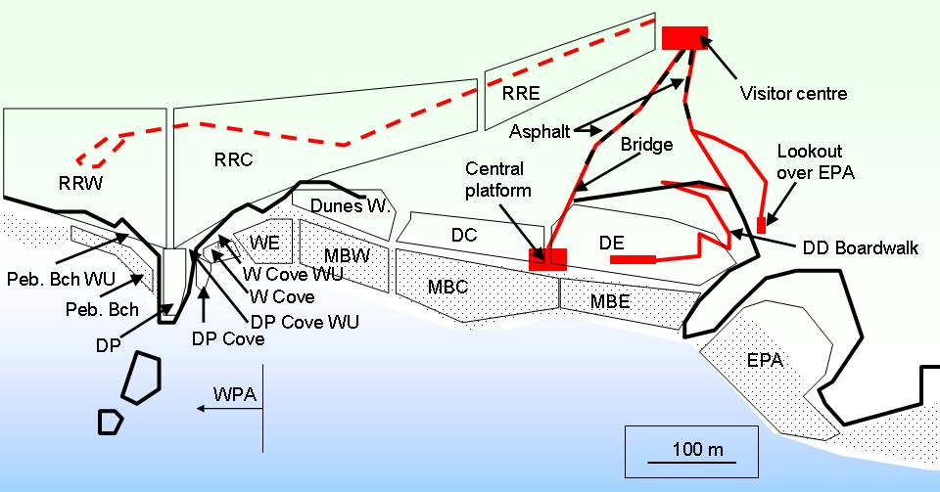
Fig. 1. Schematic view of the Seal Bay site. Locations mentioned in the report are indicated on the map (except for Pup Cove, which is 1.5km to the West of the Visitor Centre). The dashed red line is the old road, which is now used as a walkway to gain access to the WPA (WPA includes all coastal areas to the West of Danger Point). The thick black lines represent sections of cliff and rocky outcrops. Asphalt sections are indicated by dashed red/black lines and the wooden bridge, boardwalk and platforms are solid red lines. The sectors that are used to separate counts of ASL are indicated by thin black lines: Road Reserve West, Central and East (RRW, RRC, RRE), Pebble Beach and Walk Up (Peb. Bch, Peb. Bch WU), Danger Point, Cove and WU (DP, DP Cove, DP Cove WU), Western Cove and Walk Up (W Cove, W Cove WU), West End (WE), Main Beach West, Central and East (MBW, MBC, MBE), Dunes West, Central and East (Dunes W., DC, DE), Eastern Prohibited Area (EPA). Scale bar and platform sizes are approximate.
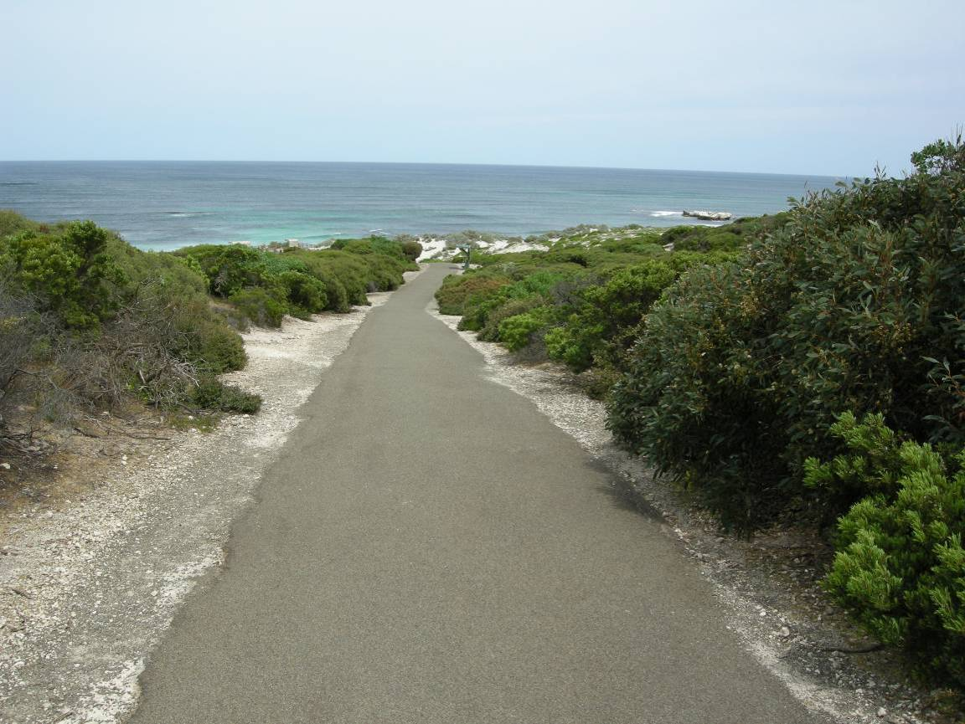
Fig. 2. View to South near the start of the asphalt section of the path from the Visitor Centre to the Main Platform. A section of this path will be replaced and angled more to the right of the picture as indicated by the red line.
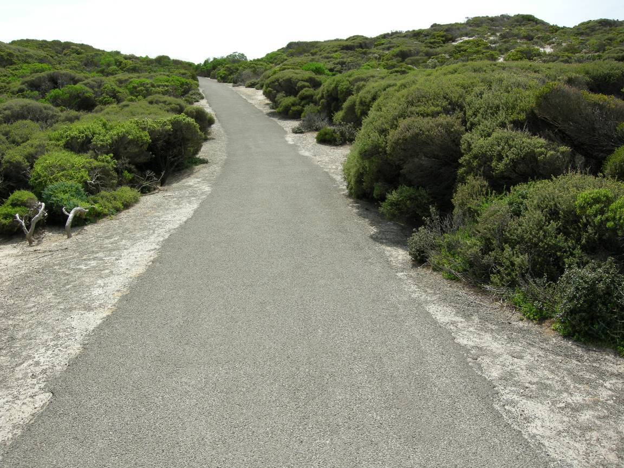
Fig. 3. View to North on the asphalt section of the path from the Visitor Centre to the Main Platform. A section of this path will be replaced and angled more to the left of the picture.

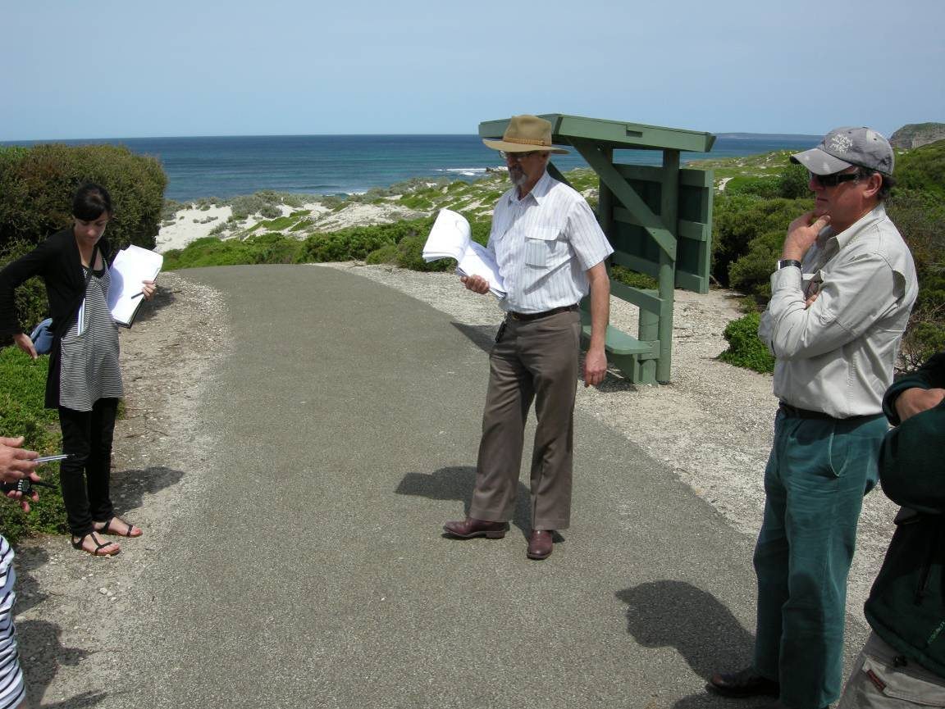
Fig. 4. View to South on the asphalt section of the path from the Visitor Centre to the Main Platform. Rest area pictured is to be replaced with a new rest area, which will be located to the left (East) of its current location.
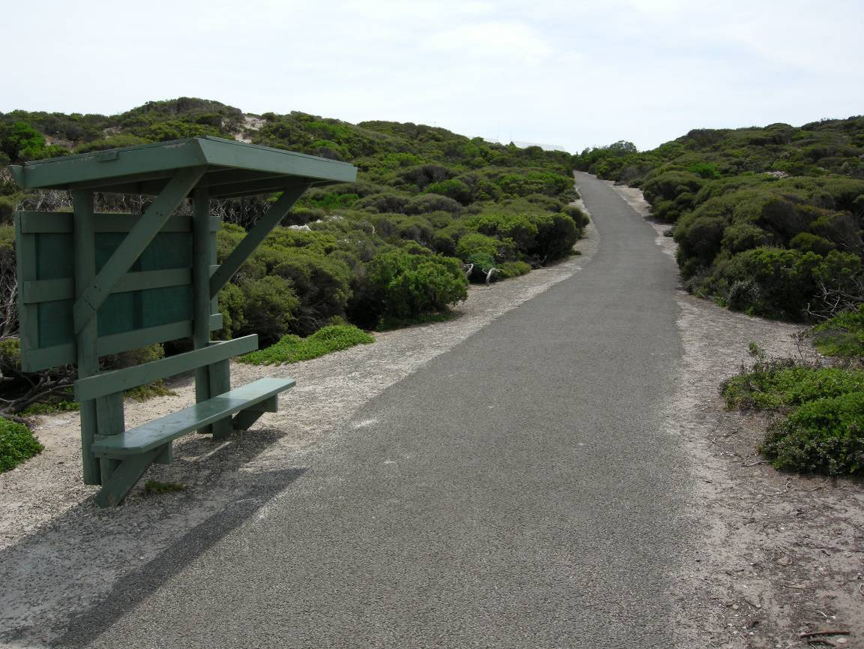
Fig. 5. View to North on the asphalt section of the path from the Visitor Centre to the Main Platform. Rest area pictured is to be replaced with a new rest area, which will be located to the right (East) of the picture, with the path to run along the West of the new rest area.

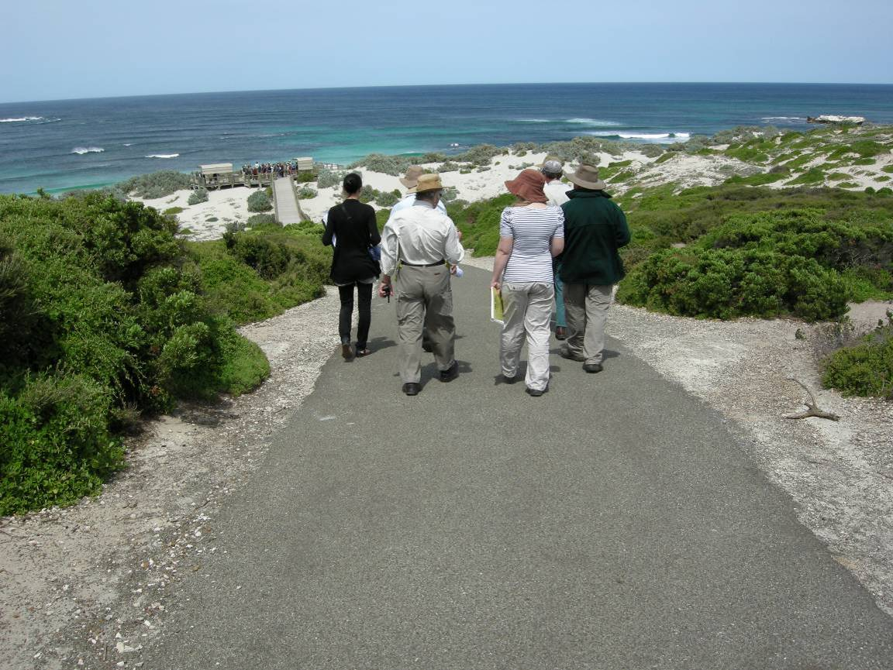
Fig. 6. View to South on the asphalt section of the path from the Visitor Centre to the Main Platform. Picture taken to the South of the location of the new rest area.
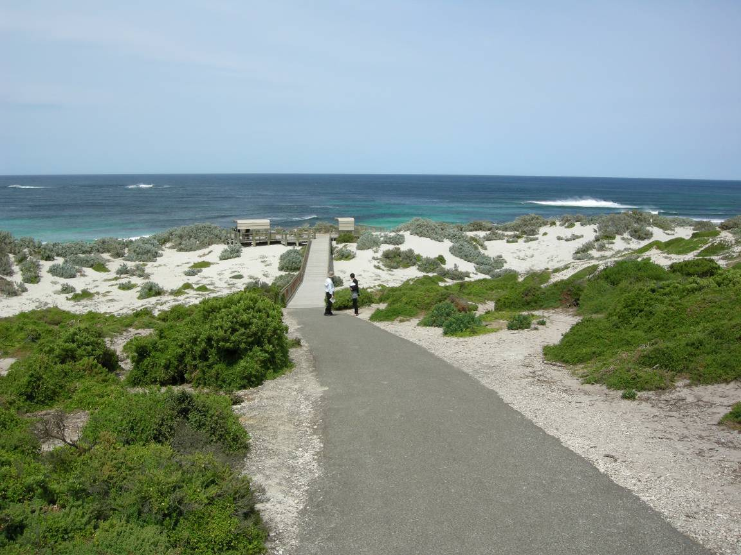
Fig. 7. View to South on the asphalt section of the path from the Visitor Centre to the Main Platform. This section of path will be replaced and angled to the right of the picture, so that it is centred on the person who is circled in the picture, where the new bridge will commence.
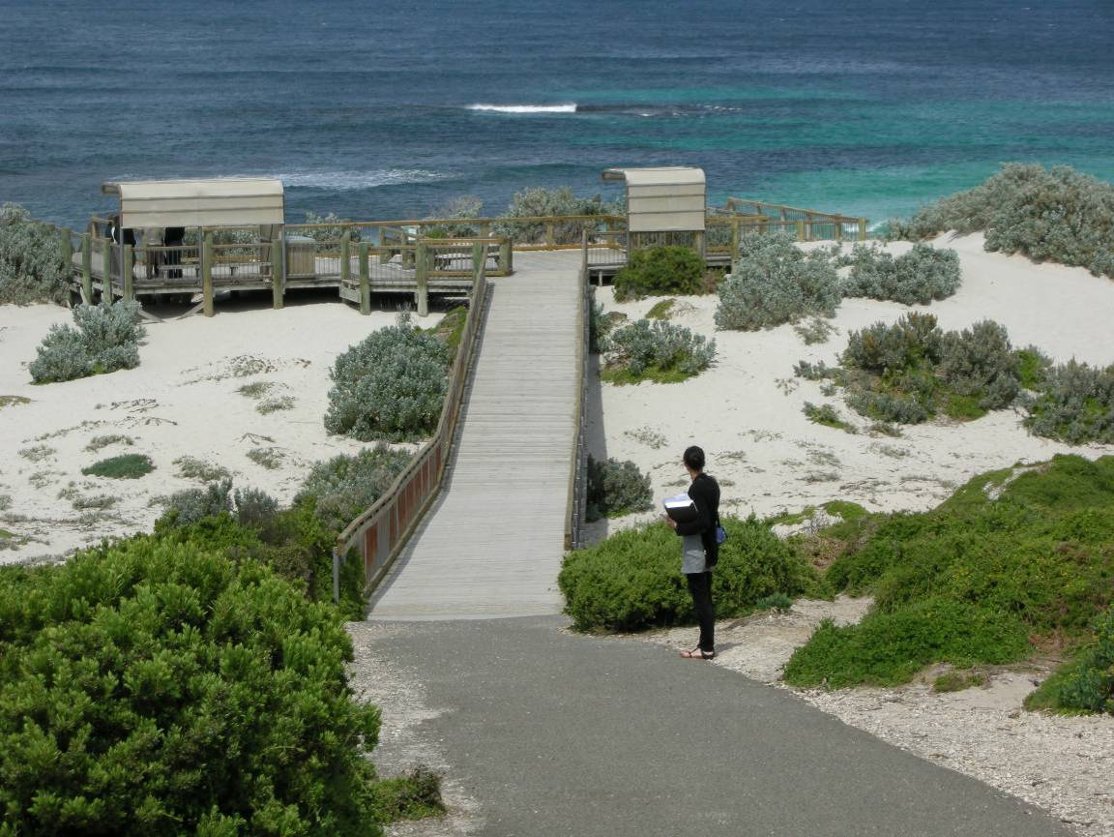
Fig. 8. View to South on the asphalt section of the path from the Visitor Centre to the Main Platform. Close up view of the section of where the path will be angled to the right of the picture, so that it is centred on the person who is circled in the picture, where the new bridge will commence. The new bridge would be wider and approximately 700mm higher than the current bridge.
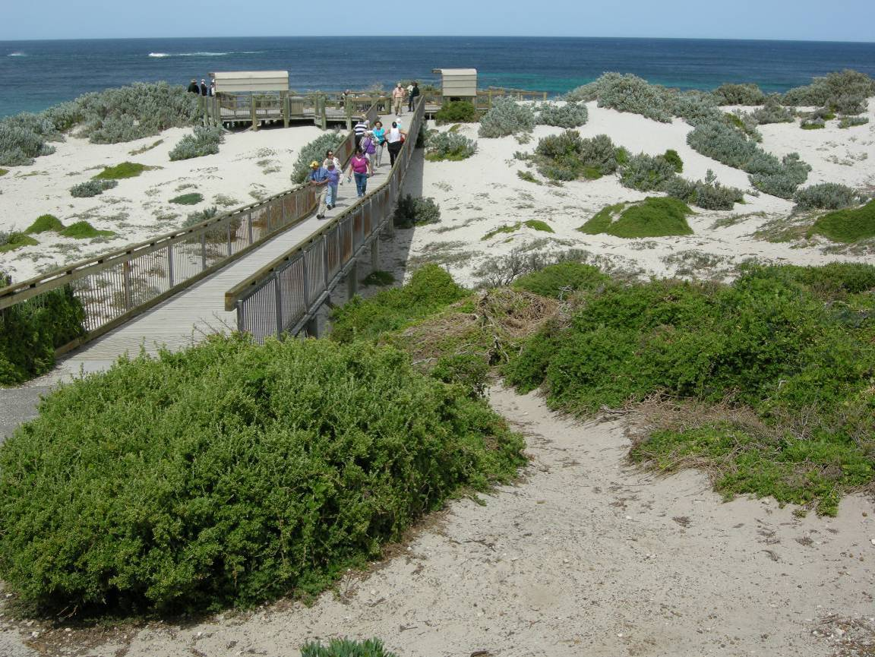
Fig. 9. View to South just off the asphalt section of the path from the Visitor Centre to the Main Platform. The new bridge will commence from where the photographer is located and will extend to the north-western corner of the Main Platform (circled). The new bridge would be wider and approximately 700mm higher than the current bridge. The pier footings supporting the bridge can also be seen in the picture–these footings would be replaced and the number would be increased, particularly where the bridge is to be widened.
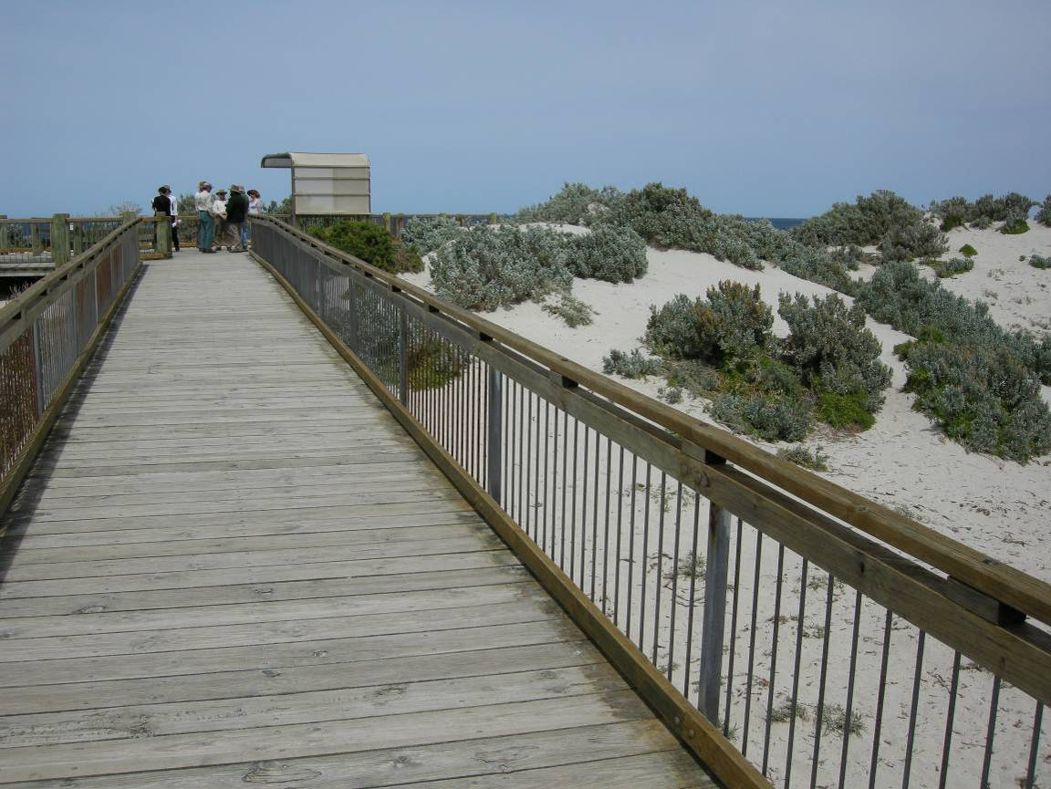
Fig. 10. View to South on the bridge between the path from the Visitor Centre and the Main Platform. The new bridge would be to the right of the picture and will extend to the north-western corner of the Main Platform. The new bridge would be wider and approximately 700mm higher than the current bridge.
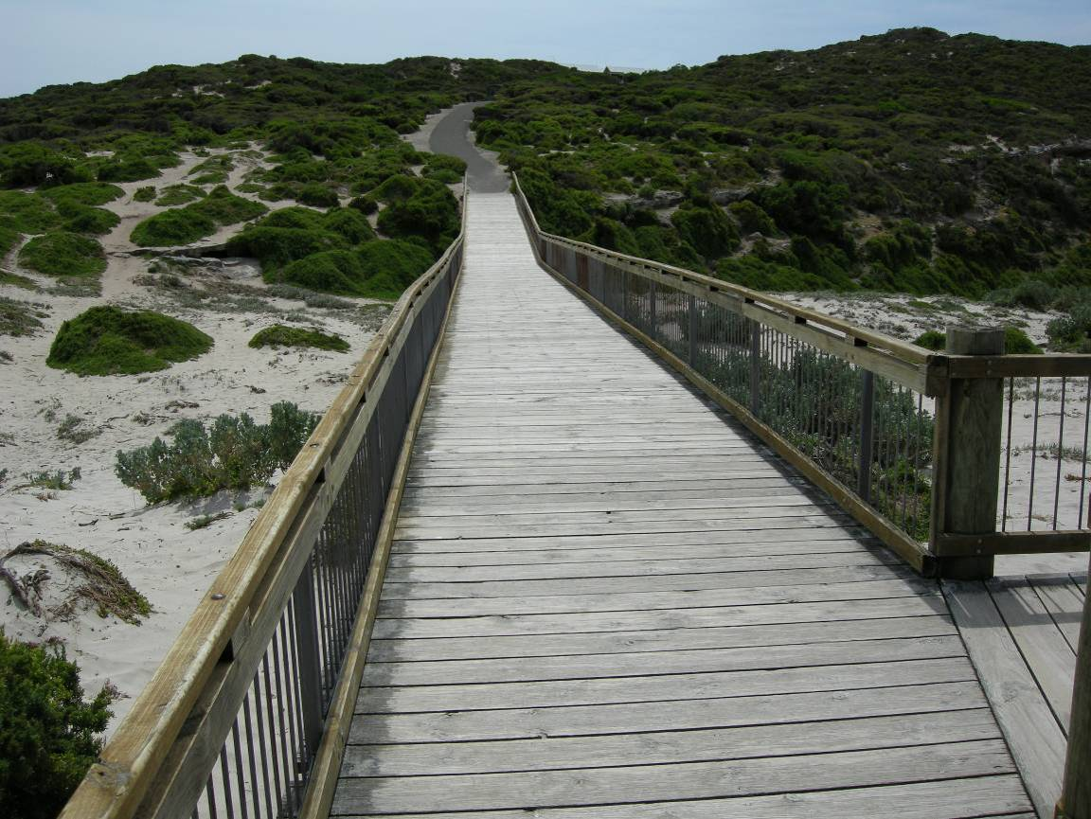
Fig. 11. View to North on the bridge between the path from the Visitor Centre and the Main Platform. The new bridge would be to the left of the picture and will extend from where the new path would end (red dot). The new bridge would be wider and approximately 700mm higher than the current bridge.
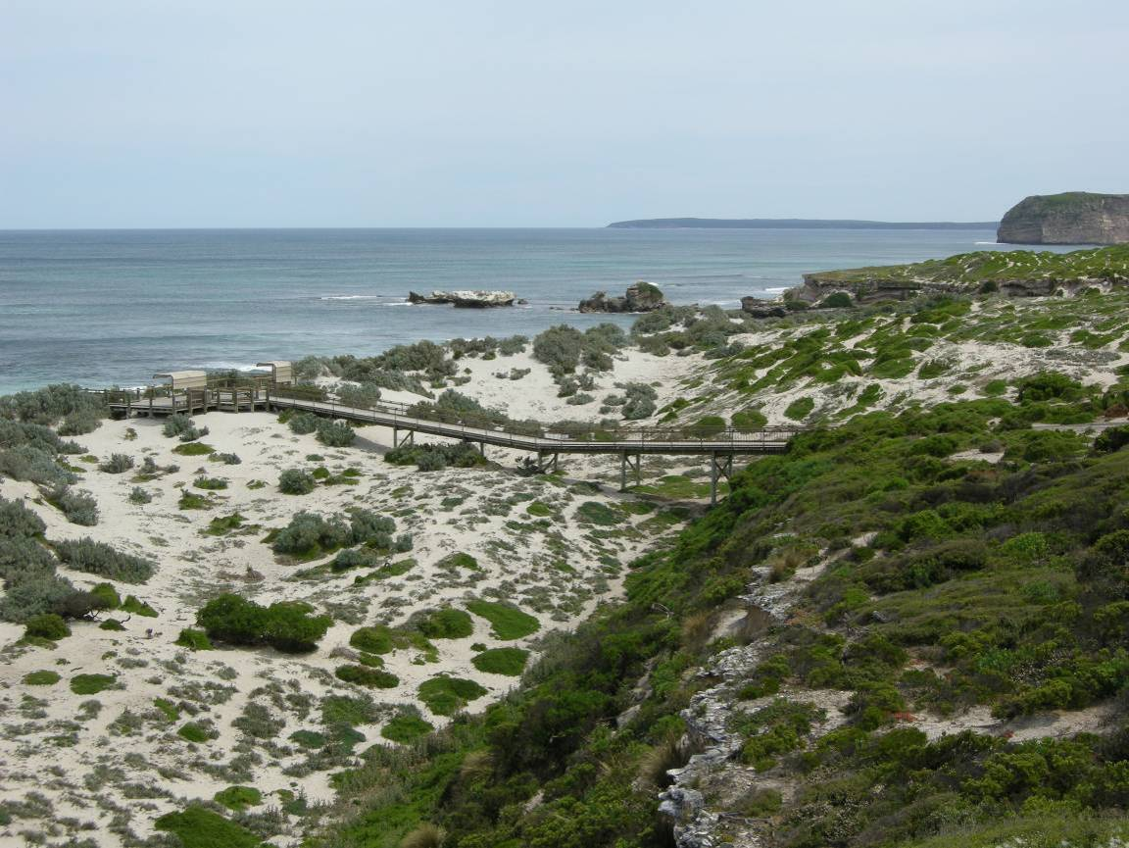
Fig. 12. View to the West including the bridge between the path from the Visitor Centre and the Main Platform taken from the start of the Don Dixon boardwalk. The new bridge would be flat and approximately 700mm higher than the current bridge.
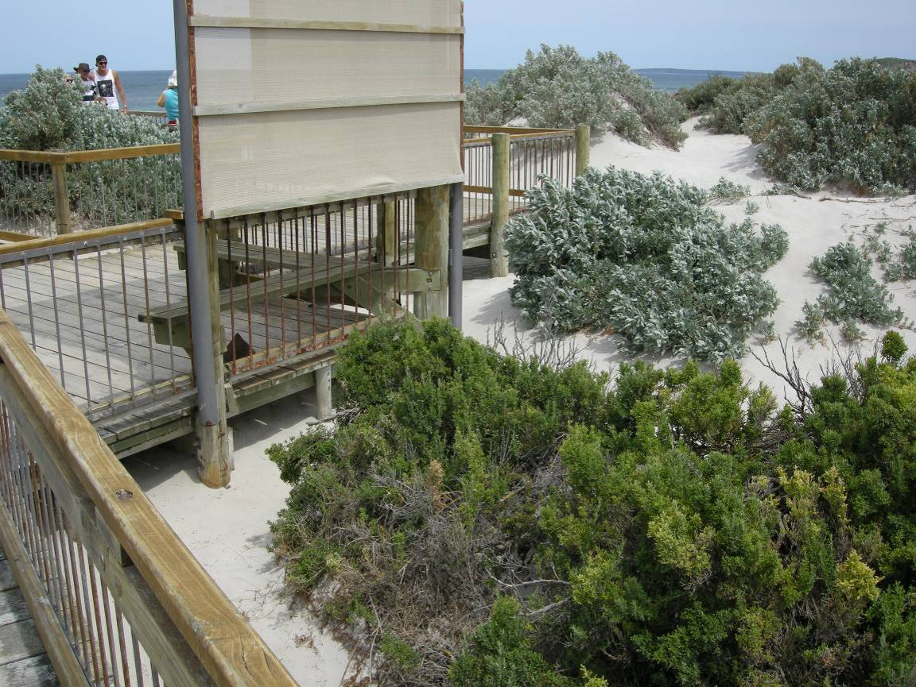
Fig. 13. View to southwest on the bridge between the path from the Visitor Centre and the Main Platform. The new bridge would be to the right of the picture and will extend to the north-western corner of the Main Platform (circled).
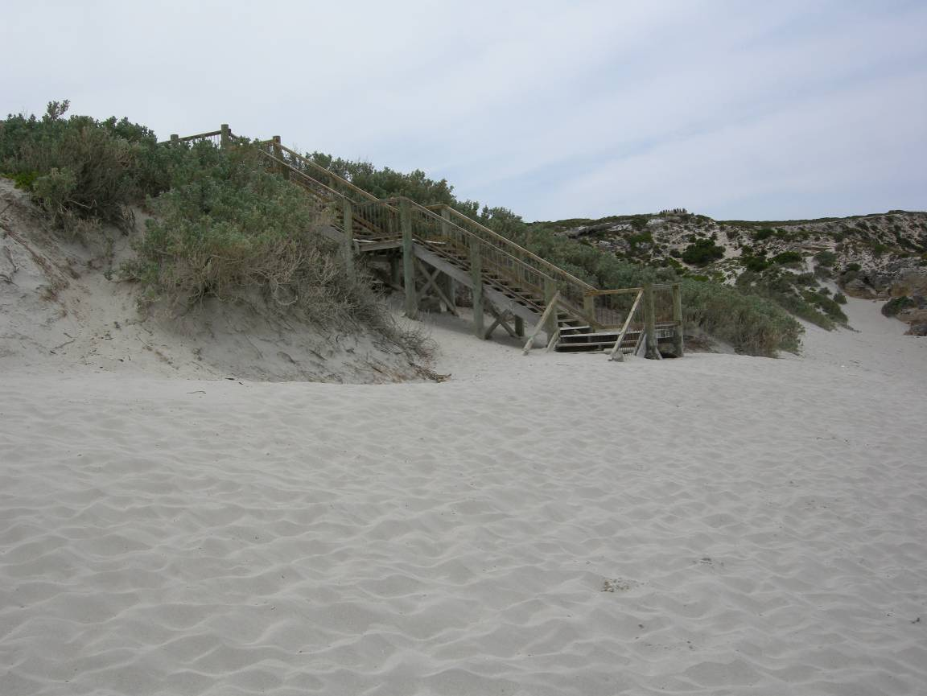
Fig. 14. View to northeast on the Main Beach to the South of the Main Platform. The picture shows the steps leading from the Main Platform.
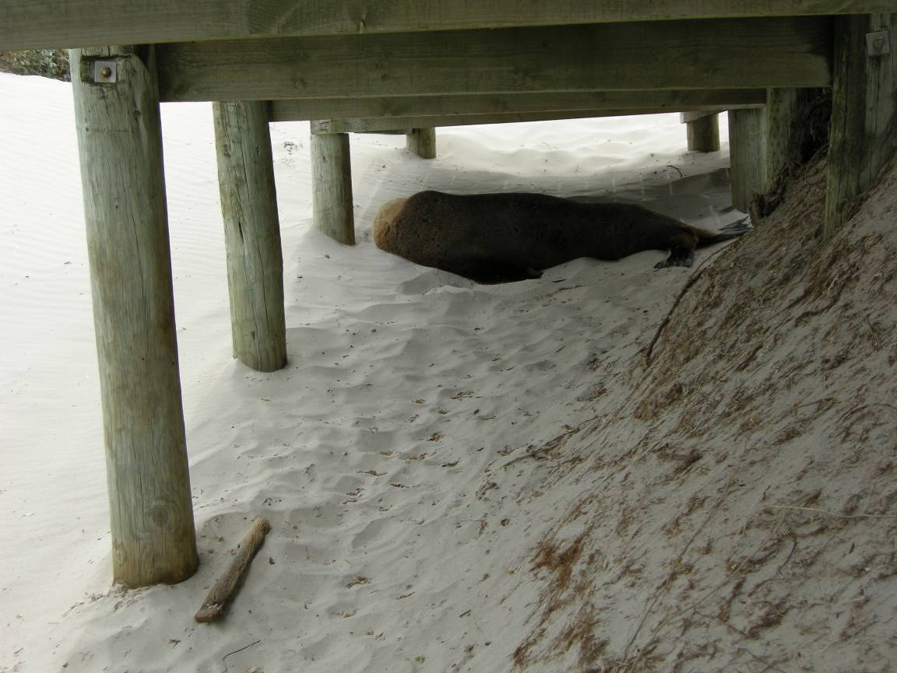
Fig. 15. View to the West, looking underneath the Main Platform. The picture shows an adult male ASL resting in the shade of the Main Platform.
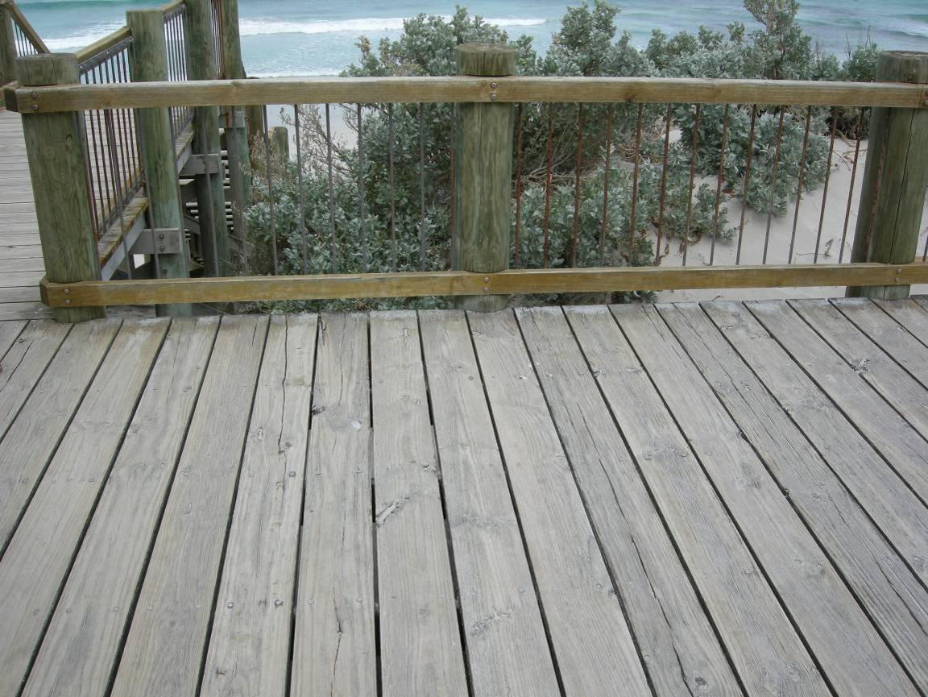
Fig. 16. View of the decking on the current Main Platform. This decking will be replaced as part of the construction.
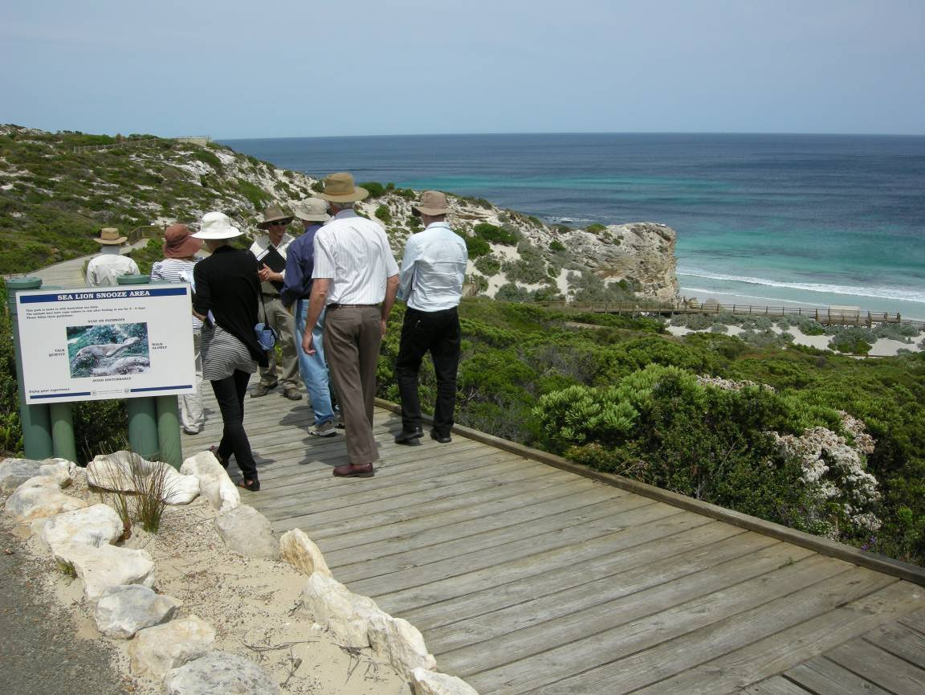
Fig. 17. View to the southeast taken from the start of the Don Dixon Boardwalk, showing the endpoint of the boardwalk in the background.

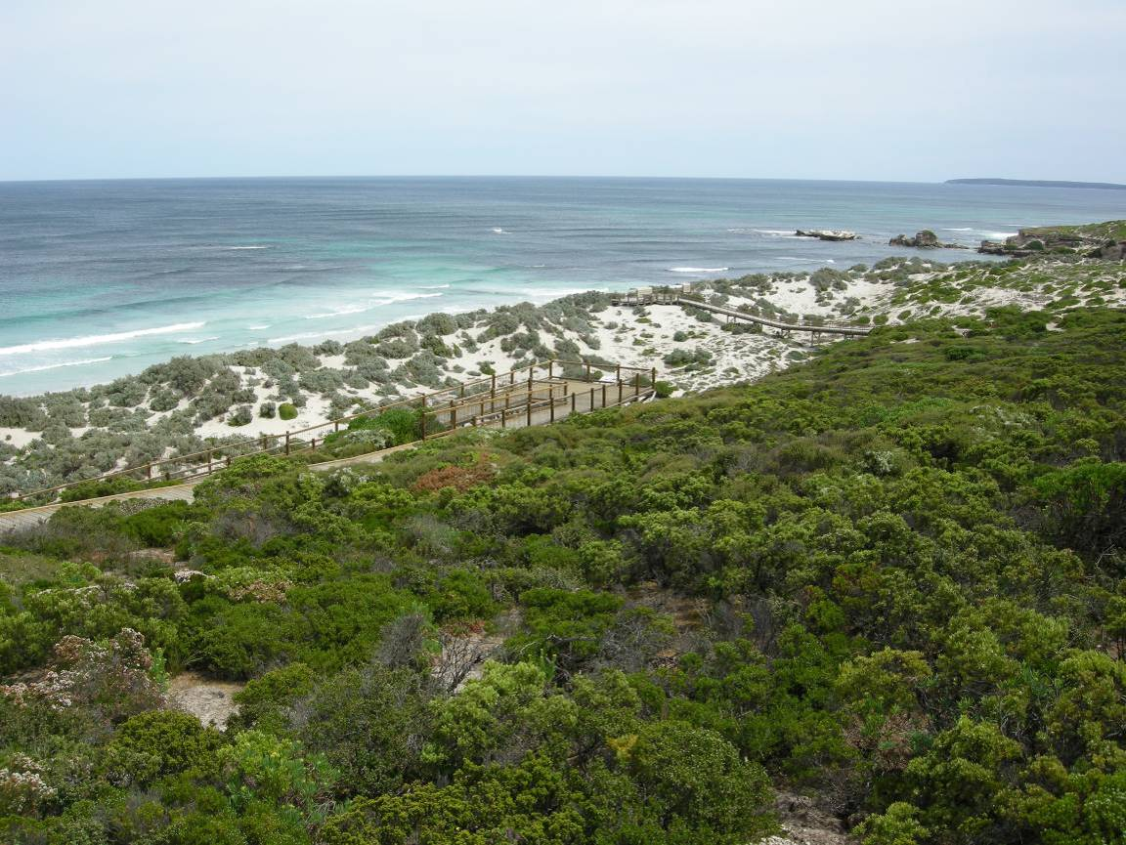
Fig. 18. View to the southwest taken from near the start of the Don Dixon Boardwalk. Near the centre of the picture is turn two, which may be widened to accommodate more tourist interpretation facilities.
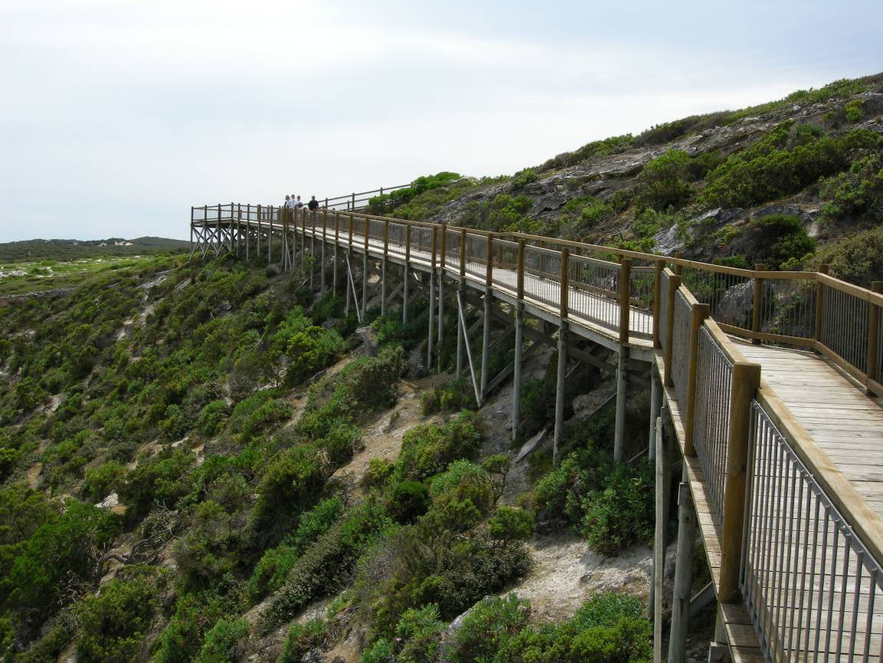
Fig. 19. View to the northwest taken from between turn two and turn three on the Don Dixon Boardwalk. Near the centre of the picture is turn two, which may be widened to accommodate more tourist interpretation facilities.
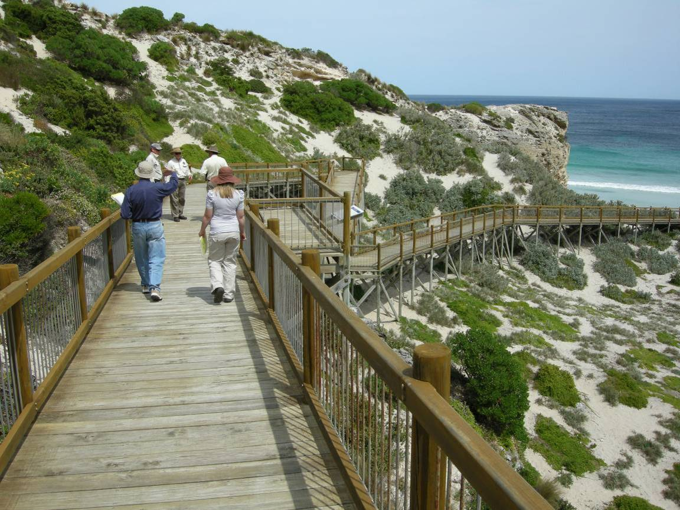
Fig. 20. View to the South taken from between turn two and turn three on the Don Dixon Boardwalk. Near the centre of the picture is a red dot, which indicates the location of turn four, which may be widened to accommodate more tourist interpretation facilities.
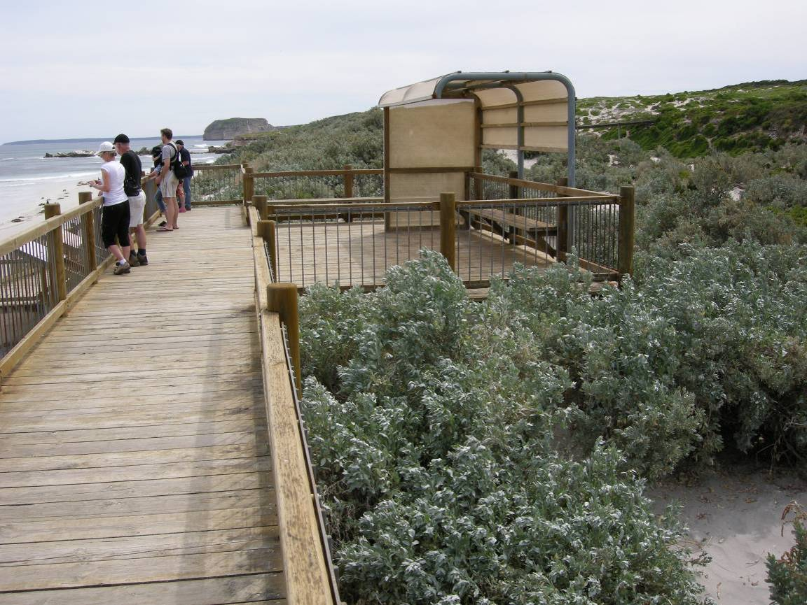
Fig. 21. View to the West taken on the platform at the end of the Don Dixon Boardwalk. This platform may be widened (into the dunes, not the beach).
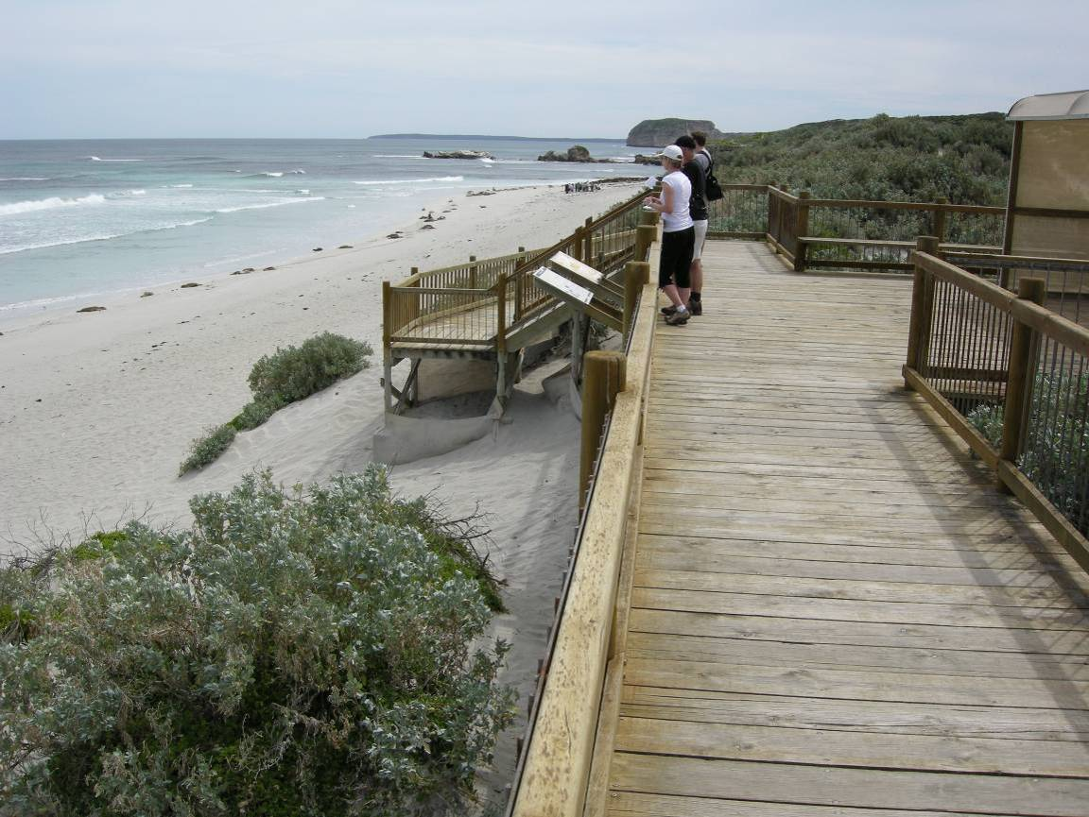
Fig. 22. View to the West taken on the platform at the end of the Don Dixon Boardwalk. This platform may be widened (into the dunes, not the beach).
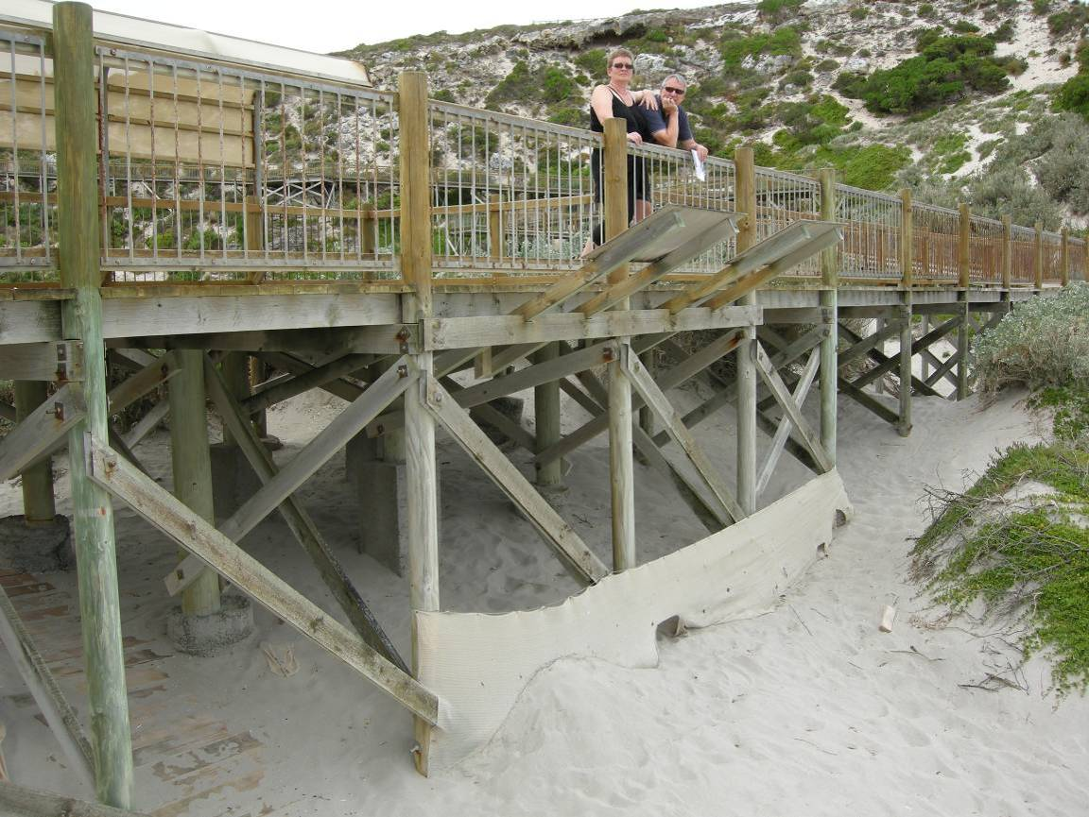
Fig. 23. View to the Northeast taken from the beach below the platform at the end of the Don Dixon Boardwalk. This platform may be widened (into the dunes, not the beach). The picture shows the exposed concrete footings and the shade cloth and duckboards that have been put in place to minimise erosion caused by wind and ASL.
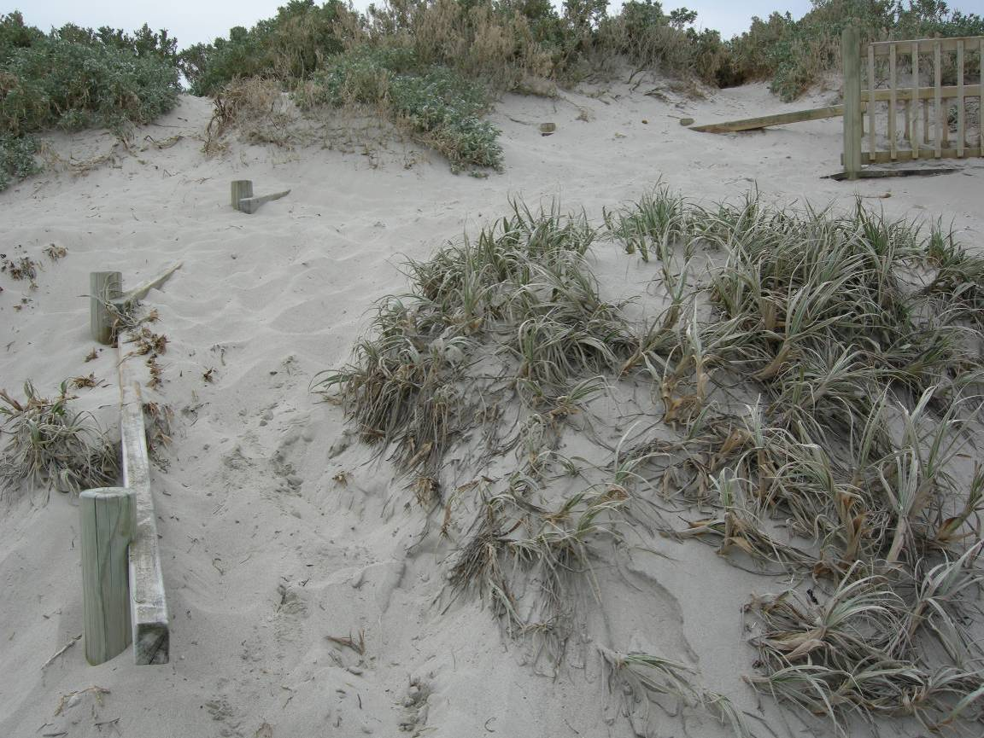
Fig. 24. View to the North taken from the beach below the platform at the end of the Don Dixon Boardwalk. The picture shows the buildup of sand at the end of this platform.
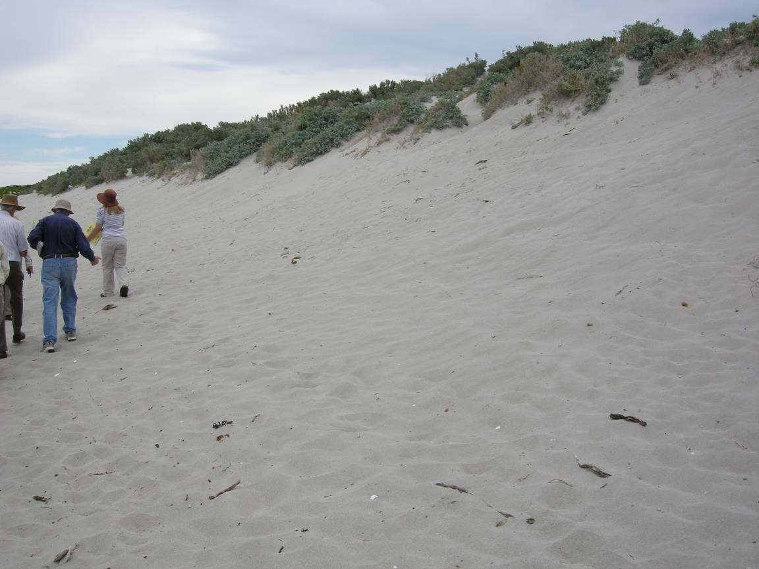
Fig. 25. View to the West taken from the beach below the platform at the end of the Don Dixon Boardwalk. The picture shows the steep dunes that are typical of the Main Beach.
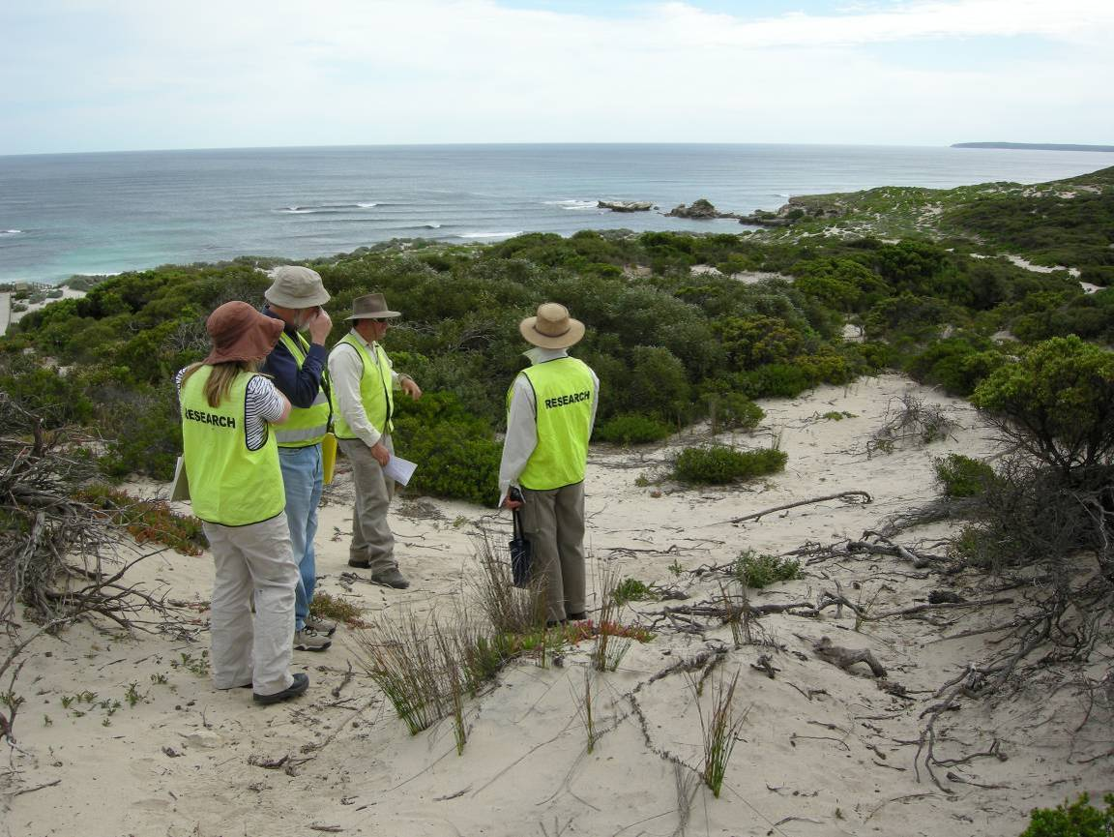
Fig. 26. View to the southwest from the western side of the visitor centre. Danger Point and the old road are circled.
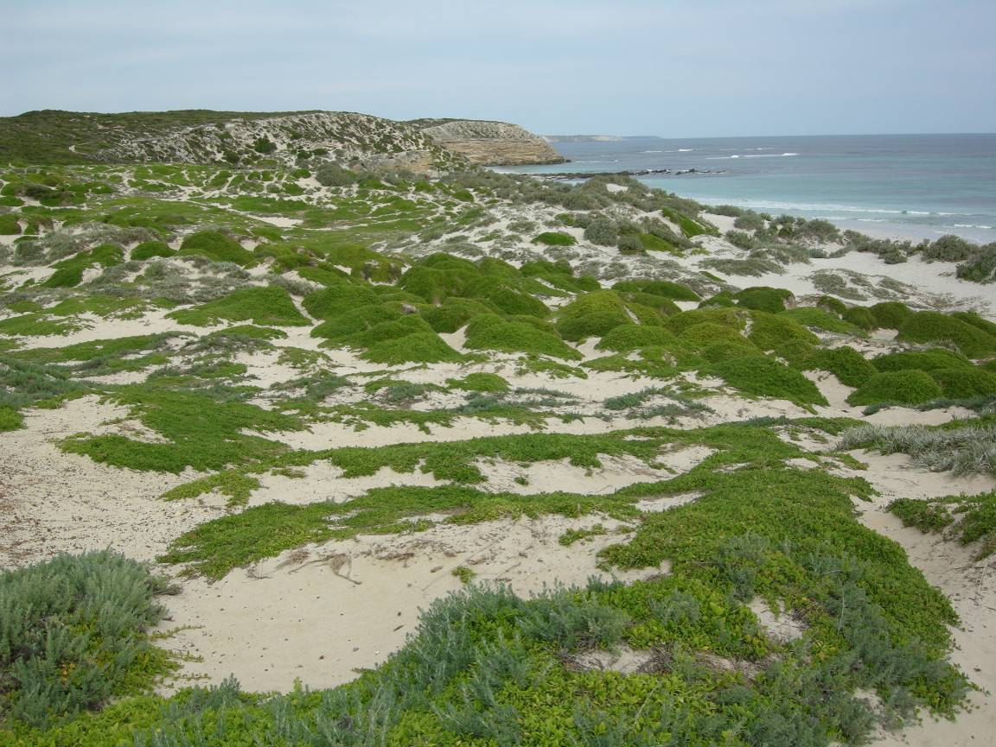
Fig. 27. View to the East from the south-western end of the old road. The foreground shows the area that would be accessed during the WPA tours.

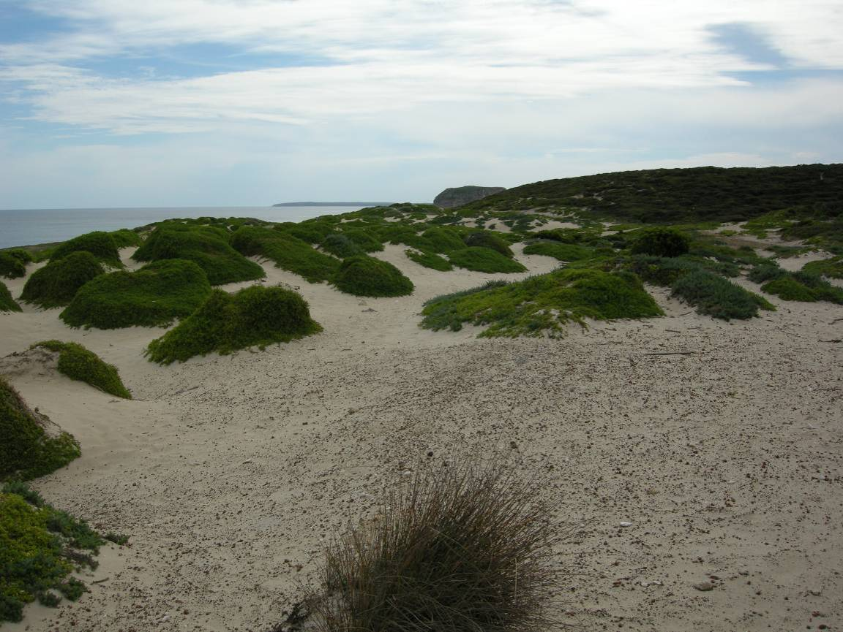
Fig. 28. View to the West from the end of the old road. The foreground shows the area that would be accessed during the WPA tours.
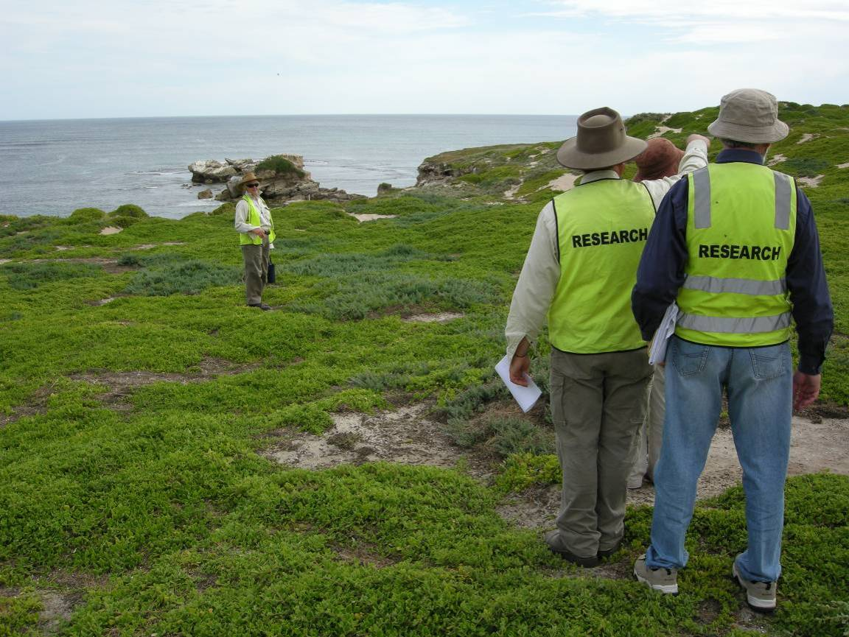
Fig. 29. View to the southwest, from the dunes to the South of the old road. In the background of the picture is Danger Point. The foreground shows the area that would be accessed during the WPA tours.

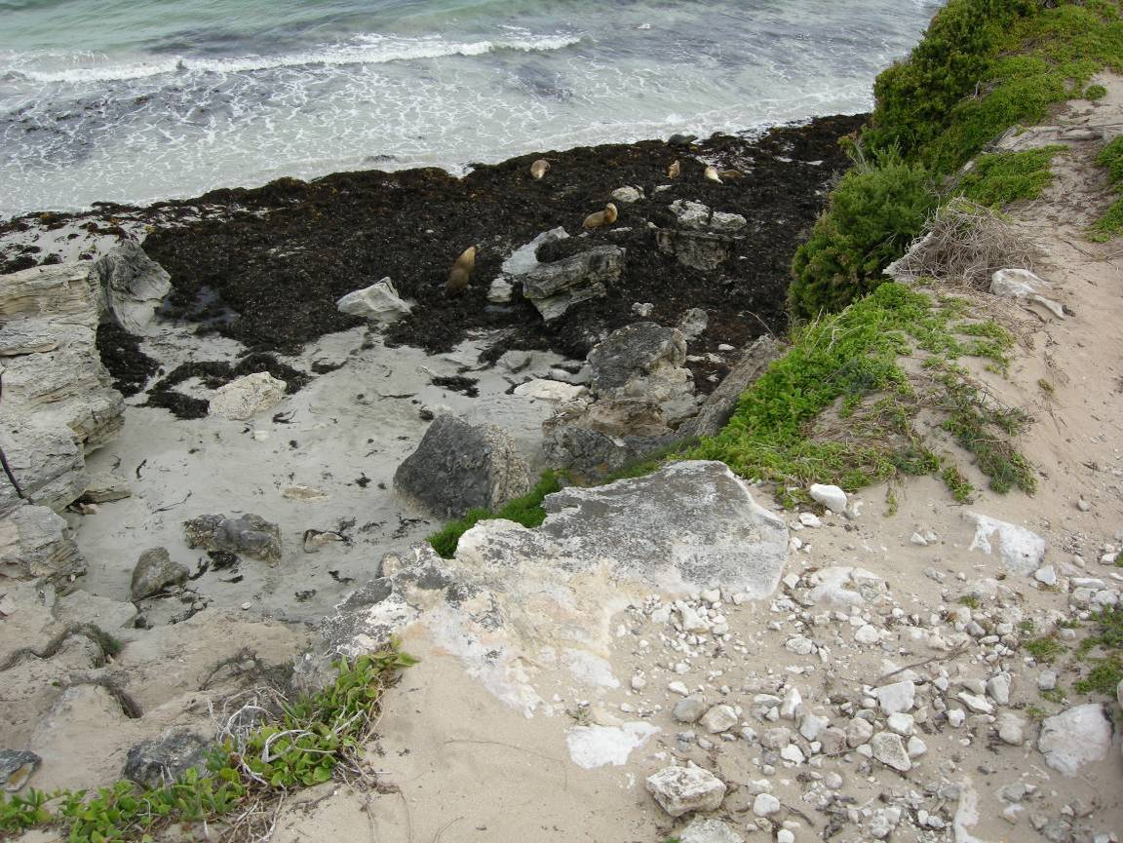
Fig. 30. View to the South from the cliff above West End. This section of cliff would be accessed during the WPA tours.
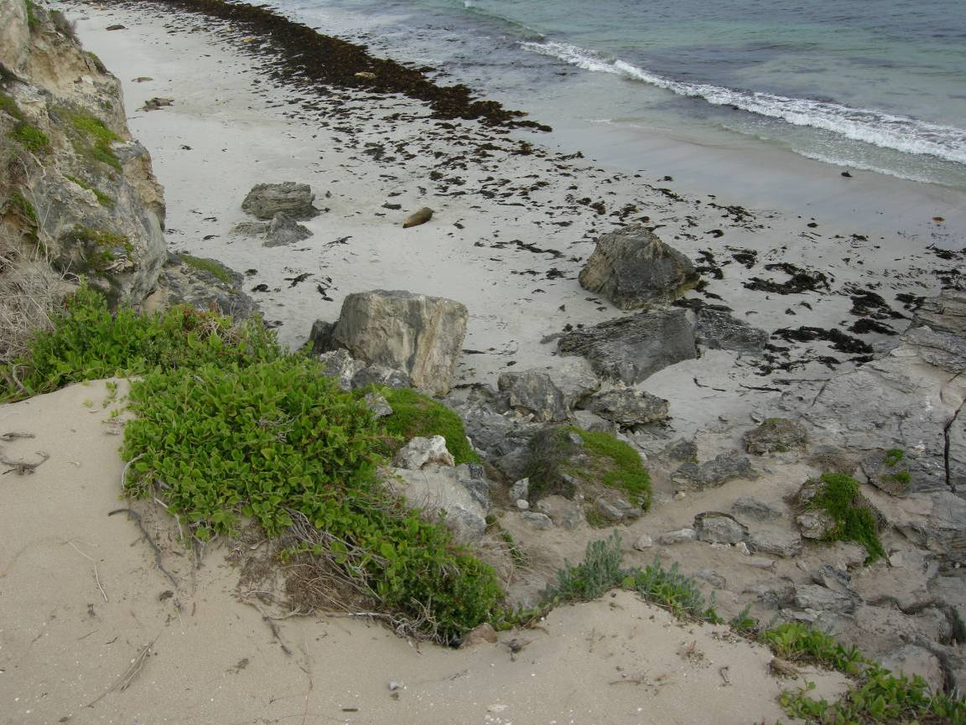
Fig. 31. View to the southeast from the cliff above West End. This section of cliff would be accessed during the WPA tours.

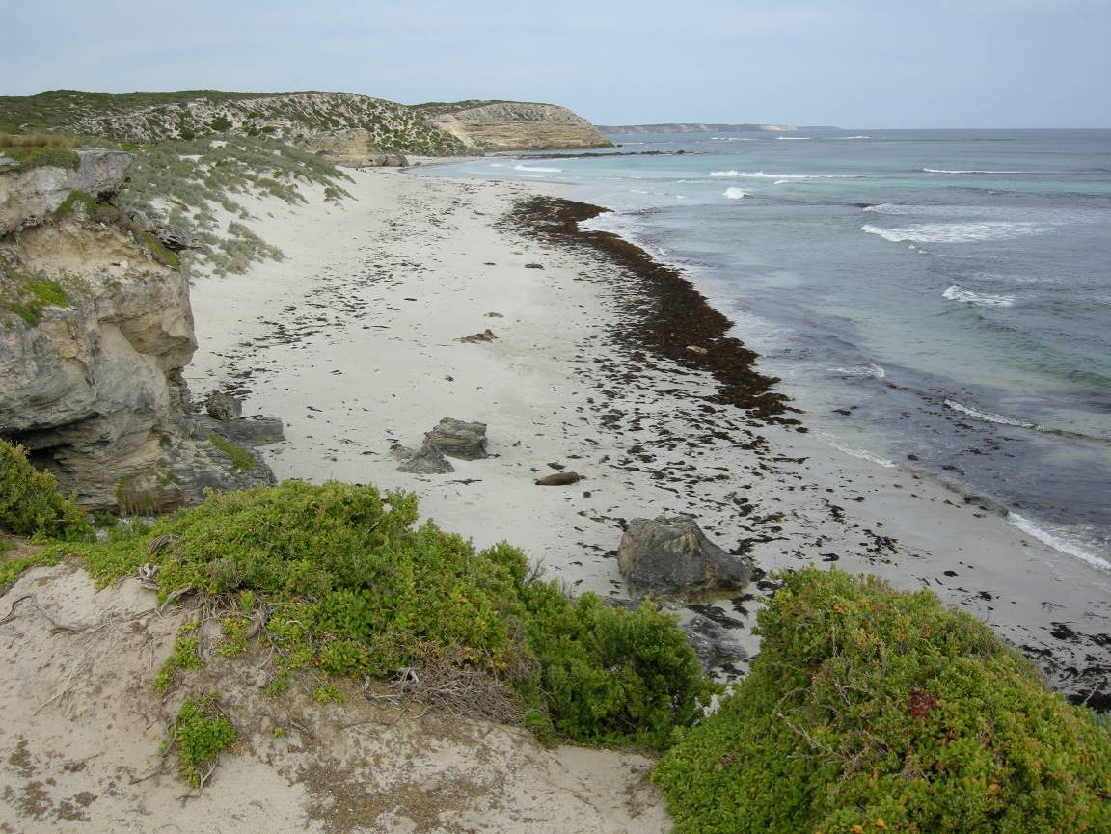
Fig. 32. View to the East from the cliff above West End. This section of cliff would be accessed during the WPA tours.
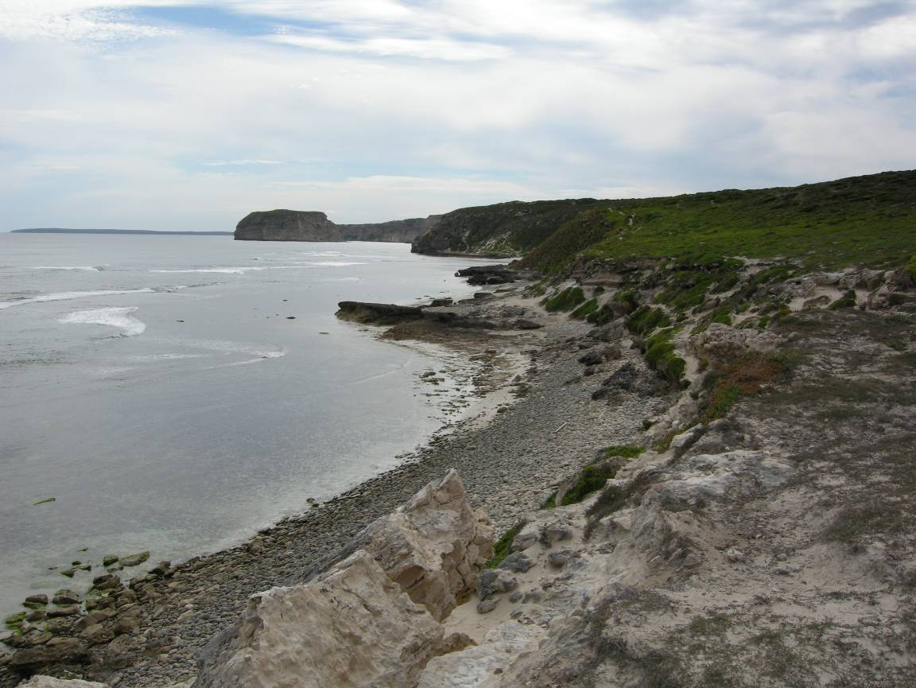
Fig. 33. View to the West from the cliff above Pebble Beach. This section of cliff would be accessed during the WPA tours.

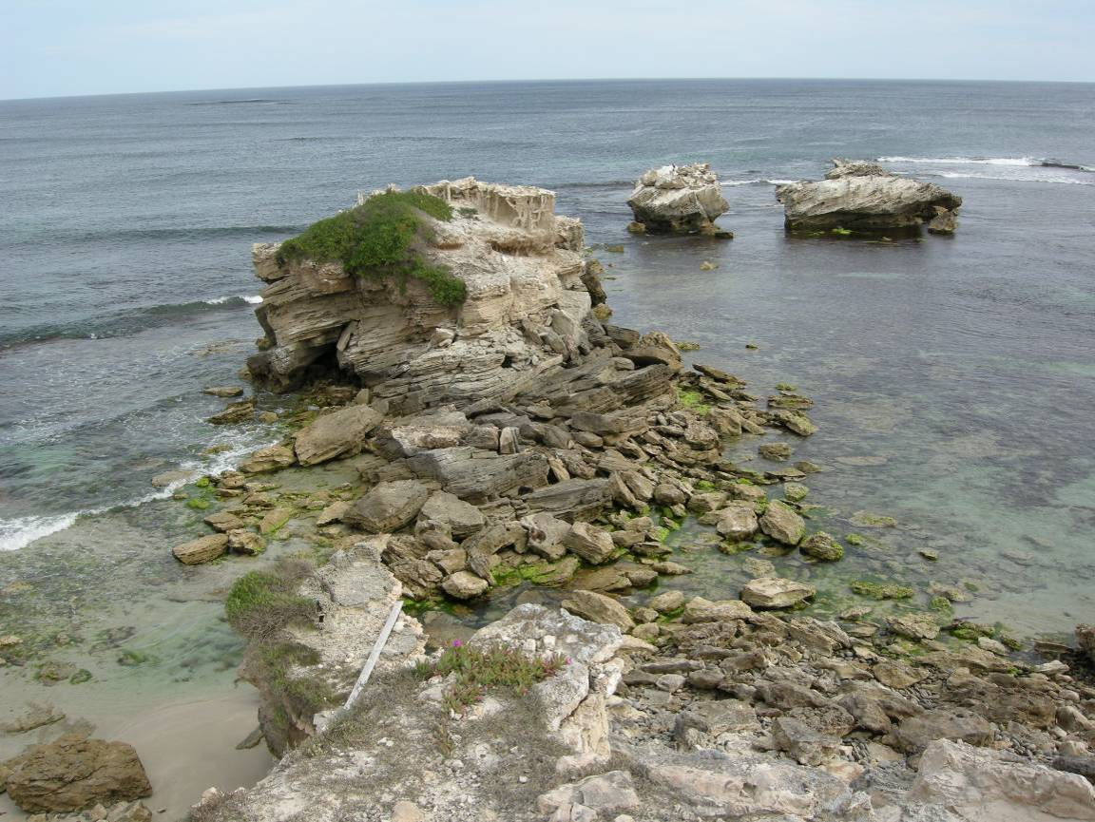
Fig. 34. View to the South from the cliff above Danger Point. This section of cliff would be accessed during the WPA tours.
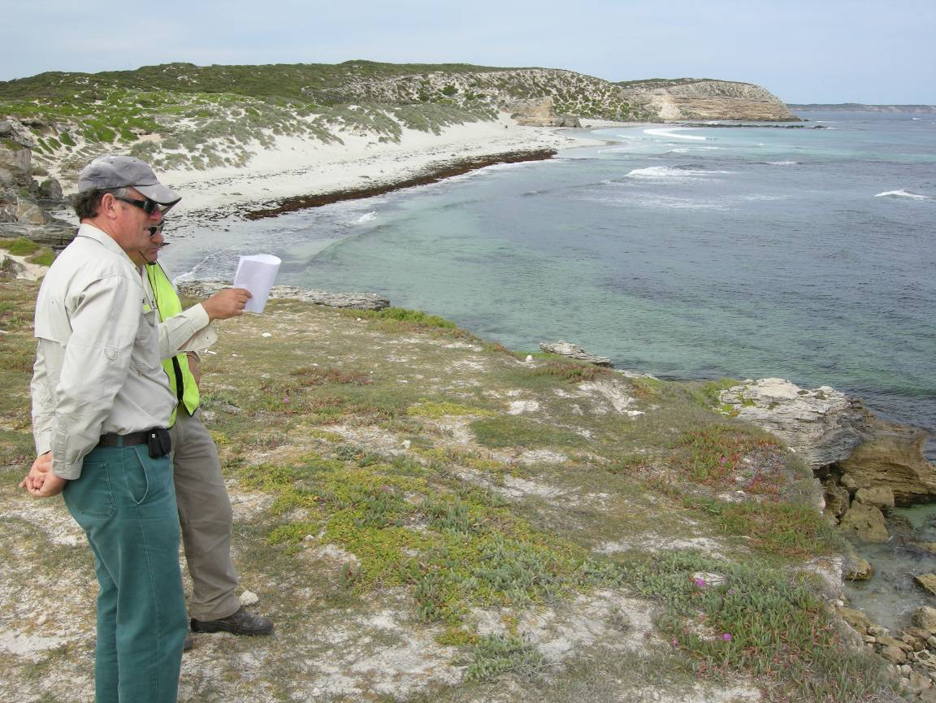
Fig. 35. View to the East from the cliff above Danger Point. This section of cliff would be accessed during the WPA tours.
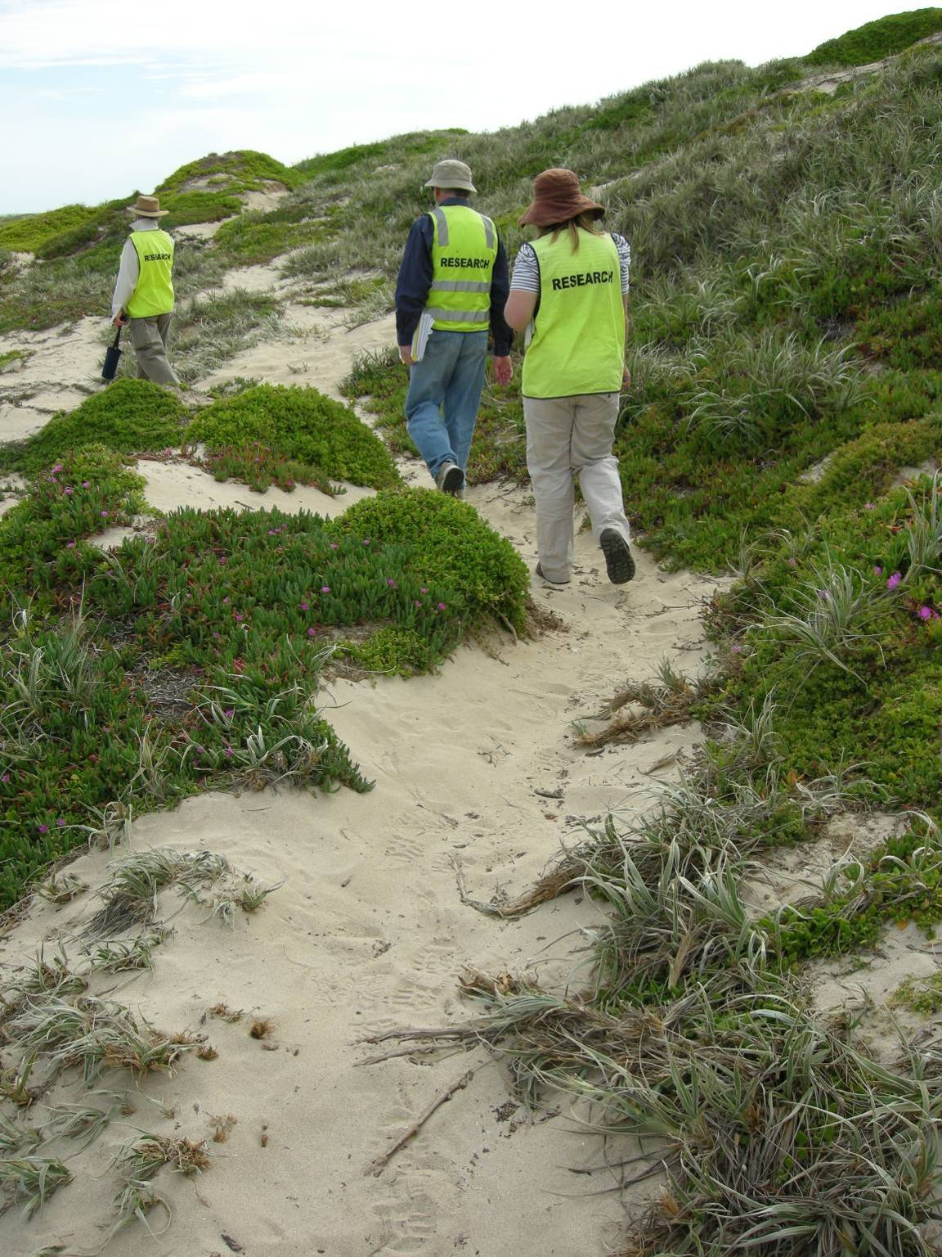
Fig. 36. View to in the West the sector called Road Reserve West. This is a typical path that would be used during the WPA tours. The sand dune vegetation is typical of that found in the dunes of the following sectors: Road Reserve West, Road Reserve Central, Dunes West and Dunes Central.

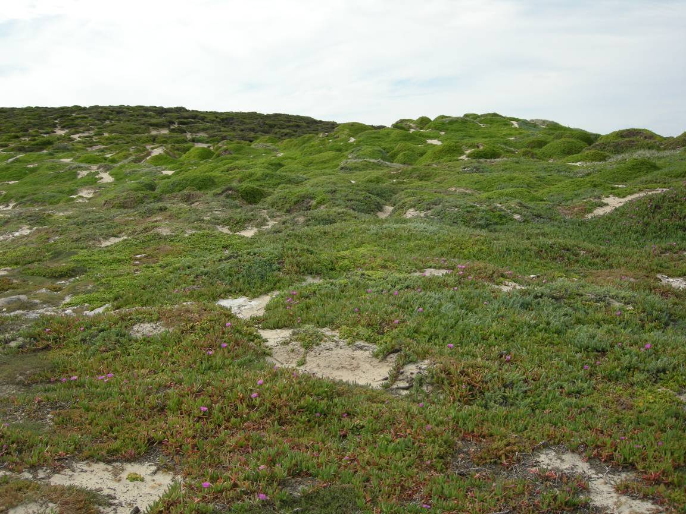
Fig. 37. View to the North from the cliff above Danger Point. This vegetation is typical of the areas that would be accessed during the WPA tours. Note the sandy paths that have been created by ASL.
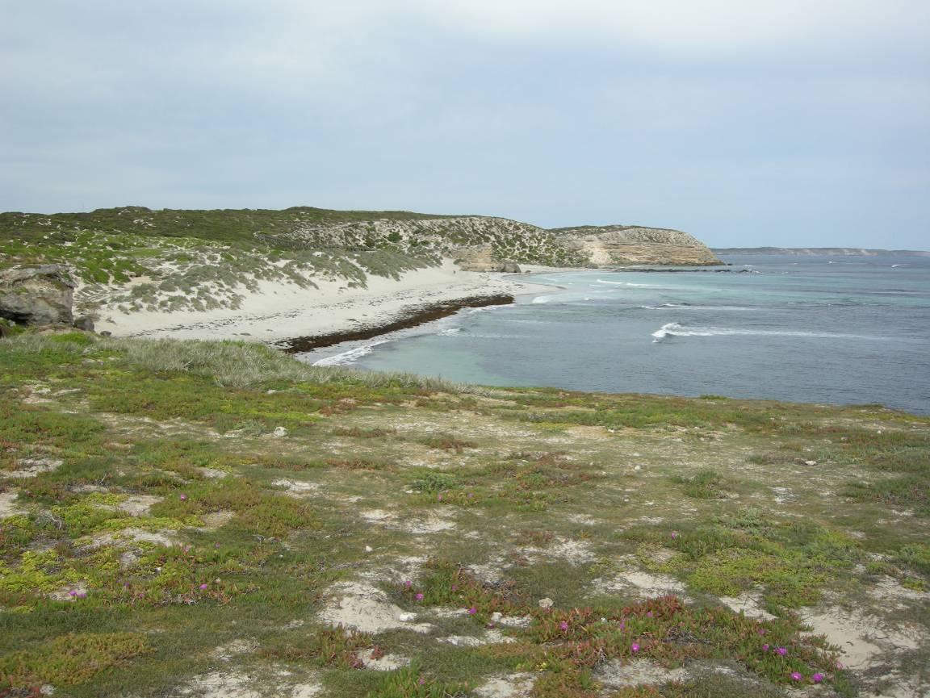
Fig. 38. View to the East from the cliff above Danger Point. This section of cliff would be accessed during the WPA tours. The picture shows the typical foreground vegetation that is found on the cliff-top areas in the WPA.

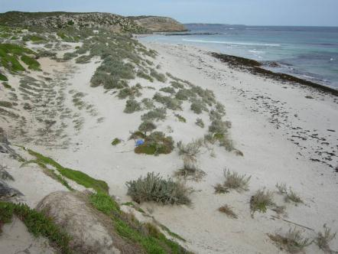
Fig. 39. View to the East from the cliffs above the sector called West End. The picture shows the areas called Dunes West and Main Beach West and Central, which may be accessed after the tour departs Danger Point. The tour may then head to the Main Platform, which is approximately in line with the red dot in the figure.

10. Acknowledgements
We thank the DENR staff on the project team for their assistance this project, including Kerri Villiers, Janet Simpson, Graham Hearne, Roger Collins, Bill Haddrill and Graeme McGregor. We thank Janet Simpson, Clary Kennedy and Kate Venable for their help in compiling the ASL data and answering many questions about the sea lions at Seal Bay. We thank Bec McIntosh for her tremendous efforts in streamlining the data that are collected on the ASL at Seal Bay and also for helping to develop the methods that are used for the counts of ASL. We thank Marty Deveney, Paul Rogers, Charlie Huveneers and the DENR staff on the project team and the steering committee for reviewing drafts of this report.

11. References
Allen, S.G. and King, M.E. (1992). Tomales Bay harbor seals: a colony at risk. In Proceedings of The Third Biennial State of the Bay Tomales Bay Conference, Inverness Foundation, Inverness, California, USA, pp. 35-39.
Beeton, R.J.S., Buckley, K.I., Jones, G.J., Morgan D., Reichelt R.E., Trewin D. (2006). Australia State of the Environment. Independent report to the Australian Government Minister for the Environment and Heritage. Department for the Environment and Heritage, Canberra 132 pp.
Buick, A.. (1985). The behavioural ecology of the Hooded Plover Charadrius rubricollis in the Coorong region of South Australia. Honours Thesis. University of Adelaide.
Campbell, R. (2003). Demographic and population genetic structure of the Australian sea lion, Neophoca cinerea. PhD Thesis. University of Western Australia, Perth.
Campbell, R. (2008). Interaction between Australian sea lions and the demersal gillnet fisheries in Western Australia. Report produced by the Department of Fisheries Research Division to the Australian Centre for Applied Marine Mammal Science.
Campbell, R.A., Gales, N.J., Lento, G.M. and Baker, C.S. (2008). Islands in the sea: extreme female natal site fidelity in the Australian sea lion, Neophoca cinerea. Biology Letters, 4: 139-142.
Constantine, R. (1999). Effects of tourism on marine mammals in New Zealand. Department of Conservation, New Zealand. Science for Conservation: 106.
Daily, B., Milnes, A.R., Twidale, C.R. and Bourne, J. (1979). Geology and geomorphology. In: Tyler MJ, Twidale CR, Ling JK. (eds). Natural history of Kangaroo Island. Royal Society of South Australia. pp 1-38.
Davidson, J. (2010). TOMM Kangaroo Island Committee. Visitor exit survey 2009/2010. Colmar Burton, Adelaide. 105 pp.
Department for the Environment. (1977). Management Plan. Seal Bay and Cape Gantheaume Conservation Parks. Kangaroo Island. South Australia. Department for the Environment, Adelaide. 35 pp.
Department of Environment and Natural Resources. (1993). Seal Bay Conservation Park Management Plan. Amendment to Plan of Management. Department of Environment and Natural Resources, Adelaide. 5 pp.
Ferguson-Lees, J. and Christie, D.A. (2001). Raptors of the World. Christopher Helm, London.
Gales, N.J. and Costa, D.P. (1997). The Australian sea-lion: a review of an unusual life-history. In Hindell, M. and Kemper, C. (eds), Marine Mammal research in the Southern Hemisphere. Surrey Beatty and Sons, Chipping Norton, Sydney, pp. 78-87.
Gales, N.J., Shaughnessy, P.D. and Dennis, T.E. (1994). Distribution, abundance and breeding cycle of the Australian sea lion, Neophoca cinerea (Mammalia: Pinnipedia). Journal of Zoology, London, 234: 353-370.
Gates, J. A. (2001). Recovery plan for the Kangaroo Island dunnart Sminthopsis aitkeni: 2002-2006. Report to the Threatened Species and Communities Section, Environment Australia. National Parks and Wildlife South Australia, Kingscote, South Australia, Australia.
Gates, J. A. (2001). The Distribution and Ecology of the Kangaroo Island Dunnart Sminthopsis aitkeni. Department for Environment and Heritage, Adelaide, South Australia, Australia.
Gates, J.A. (2009). Recovery Plan for the Kangaroo Island Dunnart Sminthopsis aitkeni. Department for Environment and Heritage, South Australia
Gibbs, S.E. (2002). Perceptions in the South Australian commercial fishing industry with regard to seals. Master of Environmental Studies Thesis, University of Adelaide, Adelaide, 114 pp.
Goldsworthy, S.D., and Page, B. (2007). A risk-assessment approach to evaluating the significance of seal bycatch in two Australian fisheries. Biological Conservation 139:269-285
Goldsworthy, S.D. and Lowther, A.D (2010). Genetic population structure and bycatch: assessment of management measures for reducing the bycatch of Australian sea lions in the demersal gillnet fishery off South Australia. Report to the Department of Sustainability, Environment, Water, Population and Communities. South Australian Research and Development Institute (Aquatic Sciences), Adelaide. SARDI Publication No. F2010/000979-1. SARDI Research Report Series No. 515. 32pp.
Goldsworthy, S.D., Shaughnessy, P.D., Page, B., Dennis, T.E., McIntosh, R.R., Hamer, D., Peters, K.J., Baylis, A.M.M., Lowther, A., and Bradshaw, C.J.A. (2007a). Developing population monitoring protocols for Australian sea lions. Final report to the Department of the Environment and Water Resources. SARDI Aquatic Sciences Publication Number F2007/000554. SARDI Research Report Series No: 219. 75 pp.
Goldsworthy, S.D., Lowther, A., Shaughnessy, P.D., McIntosh, R.R. and Page, B. (2007b). Assessment of pup production and the maternal investment strategies of the Australian sea lion Neophoca cinerea at Dangerous Reef in the 2006-07 breeding season. Report to the Department for Environment and Heritage, Wildlife Conservation Fund South Australia. SARDI Aquatic Sciences Publication Number F2007/000929-1. SARDI Research Report Series No 249. 58 pp.
Goldsworthy, S.D., Shaughnessy, P.D., McIntosh, R.R., Kennedy, C., Simpson, J., and Page, B. (2008). Australian sea lion populations at Seal Bay and Seal Slide (Kangaroo Island): Continuation of the monitoring program. Report to the DEH Wildlife Conservation Fund. SARDI Aquatic Sciences Publication number F2008/000645-1, SARDI Research Report Series No. 293.
Goldsworthy, S.D., McKenzie, J., Shaughnessy, P.D., Mcintosh, R.R., Page, B., and Campbell, R. (2009a). An update of the report: Understanding the impediments to the growth of Australian sea lion populations. Report to the Department of the Environment, Water, Heritage and the Arts. SARDI Publication Number F2008/00847-1. SARDI Research Report series No. 356. 175pp.
Goldsworthy, S.D., Page, B. Lowther, A., Shaughnessy, P.D., Peters, K.P., Rogers, P., McKenzie, J., and Bradshaw, C.J.A. (2009b). Developing population protocols to determine the abundance of Australian sea lions at key subpopulations in South Australia. Final Report to the Australian Marine mammal Centre, Department of the Environment, Water, Heritage, and the Arts. SARDI Aquatic Sciences Publication Number F2009/000161-1, SARDI Research Report Series No. 348. 58pp.
Goldsworthy, S.D., McIntosh, R.R. Shaughnessy, P.D., Page, B., and Haddrill, B. (2010a). Population demography of the threatened Australian sea lion: understanding the causes of decline in the Seal Bay population. South Australian Research and Development Institute (Aquatic Sciences), Adelaide. SARDI Publication No. F2010/000382-1. SARDI Research Report Series No. 470.
Goldsworthy, S.D., Page B, Shaughnessy, P.D and Linnane A (2010b). Mitigating Seal Interactions in the SRLF and the Gillnet Sector SESSF in South Australia. Report to the Fisheries Research and Development Corporation. South Australian Research and Development Institute (Aquatic Sciences), Adelaide. SARDI Publication No. F2009/000613-1. SARDI Research Report Series No. 405.
Haby, N., and Long, K. (2005). Recovery plan for the southern brown bandicoot in the Mount Lofty Ranges, South Australia, 2004 to 2009. Department for Environment and Heritage, Adelaide. 34 pp.
Higgins, L.V. and Gass, L. (1993). Birth to weaning: parturition, duration of lactation, and attendance cycles of Australian sea lions (Neophoca cinerea). Canadian Journal of Zoology, 71: 2047-2055.
del Hoyo, J., Elliott. A., and Sargatal, J. (eds). (1994). Handbook of Birds of the World. In: Volume 2: New World Vultures to Guineafowl. Barcelona: Lynx Editions.
Lane, B. A. and Rogers, D. I. (2000). The taxonomic and conservation status of the Australian Painted Snipe Rostratula (benghalensis) australis. Stilt 36:26-34.
Lange, R.J. (1979). Native vegetation. In: Tyler MJ, Twidale CR, Ling JK. (eds). Natural history of Kangaroo Island. Royal Society of South Australia. Pp 65-80.
Lidgard, D.C. (1996). The effects of human disturbance on the maternal behaviour and performance of grey seals (Halichoerus grypus) at Donna Nook, Lincolnshire, UK. Preliminary Report to the British Ecological Society, U.K.
Lovasz, T., Croft, D.B. and Banks, P. (2008). Establishing tourism guidelines for viewing Australian sea lions Neophoca cinerea at Seal Bay Conservation Park, South Australia. In Lunney, D., Munn, A. and Meikle, W. (eds), Too close for comfort: contentious issues in human-wildlife encounters. Royal Zoological Society of New South Wales, Mosman, NSW. pp. 225-232.
Marchant, S. and Higgins, P.J. (eds) (1993). Handbook of Australian, New Zealand and Antarctic Birds. Volume 2: Raptors to Lapwings. Oxford University Press, Melbourne.
Martinez, A. (2003). Swimming with sea lions: friend or foe? Impacts of tourism on Australian sea lions, Neophoca cinerea, at Baird Bay, S.A. BSc Honours Thesis. Flinders University of South Australia, Adelaide, South Australia.
McIntosh, R.R., Shaughnessy, P.D. and Goldsworthy, S.D. (2006a). Mark-recapture estimates of pup production for the Australian sea lion (Neophoca cinerea) at Seal Bay Conservation Park, South Australia In Trites, A. W., Atkinson, S. K., DeMaster, D. P., Fritz, L. W., Gelatt, T. S., Rea, L. D. and Wynne, K. M. (eds), Sea Lions of the World. Alaska Sea Grant College Program, University of Alaska: Fairbanks, Alaska, pp 353-367.
Mooney, P.A. and L.P. Pedler (2005). Recovery Plan for the South Australian Subspecies of the Glossy Black-Cockatoo (Calyptorhynchus lathami halmaturinus): 2005-2010. South Australian Department for Environment and Heritage, Adelaide.
Murlis M. (1989). National Survey of Hooded Plovers, October 1988 Report. Stilt 14: 32-37
New South Wales National Parks and Wildlife Service. (1999). Threatened Species Information Sheet - Painted Snipe. NPWS, Hurstville, NSW.
Orsini, J.-P. (2004). Human impact on Australian sea lions, Neophoca cinerea, hauled out on Carnac Island (Perth, Western Australia): implications for wildlife and tourism management. Masters thesis. School of Environmental Science, Murdoch University, Perth, Western Australia.
Page, B., McKenzie, J., McIntosh, R., Baylis, A., Morrissey, A., Calvert, N., Haase, T., Berris, M., Dowie, D., Shaughnessy, P.D. and Goldsworthy, S.D. (2004). Entanglement of Australian sea lions and New Zealand fur seals in lost fishing gear and other marine debris before and after Government and industry attempts to reduce the problem. Marine Pollution Bulletin, 49: 33-42.
Paull, D.J. (1993). The distribution, ecology and conservation status of the Southern Brown Bandicoot (Isoodon obesulus obesulus) in South Australia. MA Thesis, University of Adelaide, 251 pp.
Paull, D.J. (1995). The distribution of the southern brown bandicoot Isoodon obesulus obesulus in South Australia. Wildlife Research 22 , 585-600.
Paull, D.J. (2004). Habitat fragmentation and the southern brown bandicoot Isoodon obesulus at multiple spatial scales. PhD Thesis, University of New South Wales, 226 pp.
Richardson, W.J., Greene, C.R., Malme, C.I. and Thomson, D.H. (1995). Marine mammals and noise. Academic Press, San Diego, California.
Robinson, A.C. and Dennis, T.E. (1988). The status and management of seal populations in South Australia. In Augee, M.L. (ed.), Marine Mammals of Australasia: field biology and captive management. Royal Zoological Society of NSW, Sydney, pp. 87-104.
Robinson, A.C., Armstrong, D.M., Canty, P.D., Hopton, D., Medlin, G.C., and Shaughnessy, P.D. (2008). Investigator Group expedition 2006: vertebrate fauna. Transactions of the Royal Society of South Australia. 132, 221-242.
Rogers, D. (2001). Conservation Directions - Painted Snipe. Wingspan 11(4): 6-7.
Rose, A.B. (2001). Supplementary records of the food of some terrestrial non-passerines in New South Wales. Australian Bird Watcher. 19:60-68.
Schulz, M. (1986). The Hooded Plover (Charadrius rubricollis) as a reef-forager. Stilt 9: 50-55.
Schulz, M., Grant, A. and Lumsden, L. (1984). Some aspects of the feeding behaviour and diet in the Hooded Plover, Charadrius rubricollis (Charadriidae), during the non-breeding season. Stilt 5: 2-8.
Shaughnessy, P. and Dennis, T. (1999). Seal research in South Australia, 1998/99: Abundance of New Zealand fur seal pups on Kangaroo Island and Australian sea lion pups at Dangerous Reef. Report to South Australian National Parks and Wildlife Service. CSIRO Sustainable Systems, Canberra.
Shaughnessy, P. and Dennis, T. (2003). Population assessment of New Zealand fur seals and Australian sea lions in some South Australian colonies, 2002-2003. Report to National Parks and Wildlife South Australia, Department for Environment and Heritage. CSIRO Sustainable Systems, Canberra.
Shaughnessy, P.D., Dennis, T.E. and Seager, P.G. (2005). Status of Australian sea lions, Neophoca cinerea, and New Zealand fur seals, Arctocephalus forsteri, on Eyre Peninsula and the Far West Coast of South Australia. Wildlife Research, 32: 85-101.
Shaughnessy, P.D., McIntosh, R.R., Goldsworthy, S.D., Dennis, T.E., and Berris, M. (2006). Trends in abundance of Australian sea lions, Neophoca cinerea, at Seal Bay, Kangaroo Island, South Australia. In Trites, A.W., Atkinson, S.K., DeMaster, D.P., Fritz, L.W., Gelatt, T.S., Rea, L.D. and Wynne, K.M. (eds), Sea Lions of the World. Alaska Sea Grant College Program, University of Alaska: Fairbanks, Alaska, pp. 325-351.
Shaughnessy PD, Goldsworthy SD, Hamer DJ, Page B, McIntosh RR (in press) Australian sea lions Neophoca cinerea at colonies in South Australia: distribution and abundance, 2004 to 2008. Endangered Species Research DOI 10.3354/esr00317
Stirling, I. (1972). Observations on the Australian sea lion, Neophoca cinerea (Péron). Australian Journal of Zoology, 20(3): 271-279.
Stirling, I. (1973). The economic value and management of seals in South Australia. Department of Fisheries, Adelaide. Publication No. 2. 11 pp.
Strahan, R. (Ed.) (1995). The mammals of Australia. Reed Books, Chatswood, NSW.
Taylor, D.A. (2003). Recovery plan for 15 nationally threatened plant species on Kangaroo Island, South Australia. Report to the Threatened Species and Communities Section, Department for the Environment and Heritage, Department for the Environment and Heritage, Adelaide. 217 pp.
Tyler, M.J., Twidale, C.R., Ling, J.K. (1979). Natural history of Kangaroo Island. Royal Society of South Australia, Adelaide. 184 pp.
Warneke, R.M. (1982). The distribution and abundance of seals in the Australasian region, with summaries of biology and current research. In Mammals in the Seas, FAO Fisheries Series, No 5, Vol. 4: 431-475.
Weston, M.A. (1993). Twelve years of counting the Hooded Plover in Victoria, Australia. Stilt 23: 15-19.
Weston, M.A. (1997). Keeping people on the beach: Fencing as a technique for managing the Hooded Plover. Bird Observer 759: 5-7.

