Agricultural Marketing and the Industry Today

Prepared for the SA History of Agriculture Group

Venton Cook and Geoff Thomas

Contents

Introduction 2

Overview 3
The grains industry and the effect of deregulation 4
The value of rural production 7
The limits to grain production 8

The wool industry 9
Other trends following deregulation 11
What of the future? 13

Introduction

This paper complements ‘Rural Market Regulation and Legislation in South Australia’, an earlier paper (see Link to ‘Rural Market Regulation and Legislation in South Australia’) which describes and evaluates South Australian rural marketing legislation throughout the 20th century.

It traces the rise and fall of marketing regulation in agriculture, in response to conditions of the time and identifies major events which were the drivers market intervention and the establishment of organised marketing.
This overview of today’s rural industries shows that they have adjusted to a more open economic environment.
Overview
In the past agriculture was generally a supply-driven industry – that is, one in which farmers focused on producing the crops they were good at producing and hoped the market would find a home for their produce. Commodities were traded in markets where relatively small shifts in supply or demand lead to large swings in prices. This was the scenario facing farmers early in the 20th century. Then the need for organised marketing was recognised and Australian agriculture saw the rise of ‘non-partisan’ farmer pressure groups whose sole aim was the realisation of their primary objective – a marketing and price stabilisation and price support plan for Australian wheat.
Now agriculture is increasingly referred to as a demand or market-driven industry, one in which farmers focus more on producing what customers demand. A feature of this scenario is an open and deregulated market. Marketing strategies to manage price risk are ubiquitous.
Following deregulation in the latter part of the century and now, in the midst of Covid 19, deglobalisation has emerged and with it greater state intervention, controls and barriers to free movement of goods and services. These trends are being driven by political populism, demographic shifts and climate change.
Markets are now driven more by the actions of consumers and retailers rather than producers. That not only means improved quality control and timing of supply but addressing such things as animal welfare and increasingly, climate impacts and energy efficiency. Some saw market advantage in what was (and still is) seen as Australia’s “clean/green image”. Others have pursued the “organic” route in production and sales. Of major significance has been organisational change to marketing arrangements, for example in the grains industry, from monopoly handling of crops by Statutory Marketing Authorities (SMA’s) to trade in a free market characterised by the presence of large companies, commodity traders and advisors, and buyers operating in open markets. A range of management tools have emerge including forward contracts, alliances and the use of futures trading known as hedging. Marketing practices have changed because of deregulation, dismantling of statutory marketing authorities, and the information flow and trading opportunities provided by the internet.
The other major change has been the progressive trend towards identification and production of value-added products, as evidenced by the range of such products on supermarket shelves.
Technology has also played an important part. At the farm level, farmers have not only increased production but adopted a greater range of risk management strategies including diversification and other practices aimed at balancing profit and risk, many of which have been made possible through agricultural research and extension.
Despite these advances, in 2003 university academic Frank Vanclay wrote , ‘Australian governments, strongly influenced by economic rationalist ideology, have given insufficient consideration to the rural social landscape … little critical reflection was given to whether Australia, and its farmers, would actually benefit from deregulation, or what the social impacts of this trend might be. Deregulation inevitably invoked structural adjustment, forced farmers out of agriculture, depopulated rural areas, and created social hardship … at the same time the exit of farmers from agriculture has not been as fast as was expected ….’
The years 1989 to 2003 were fraught with difficulty for farmers. There was continuation of the long term ‘cost price squeeze’ (annual inflation was around 8 per cent), high interest rates (15-20% for much of the 70s, 80s, and 90s), drought and the effect of collapse of the wool reserve price scheme all added to the need for farm structural adjustment. All the while there was anxiety at impeding deregulation of the grains industry. Up to the present time farm size has continued to increase as some farmers exit the industry.

The grains industry and the effect of deregulation

The extent of deregulation in the latter part of the 20th century was spelled out in ‘Rural Market Legislation and Regulation in South Australia’. In contrast to market deregulation, during the first two decades of the 21st century there was increased regulation of crop choice on farms as States individually imposed legislated moratoriums or restrictions on cultivating genetically modified crops, particularly GM canola. This restriction was imposed until there was confidence in supply chain segregation to meet market standards. This restriction was removed in mainland SA in 2020.

The dismantling of the single desk wheat exporting arrangements in 2008 did not occur without opposition from many growers and at a political level by the National Party. Farmer rallies were held at the Parliament House Canberra to protest against the changes.

Deregulation presented growers with a new set of circumstances including more selling options. Some growers saw no immediate benefits for reasons of location, lack of information and financial inexperience.

Although deregulation generally created acceptance by growers of more options and a competitive market, a study of wheat growers in the Wimmera indicated that they felt competition at local receival sites was minimal. Instances occurred where growers lost money from selling to grain traders who became insolvent. (One of the important features of SMA’s was security of payment). Participants in this study also reported that they lacked power in the open market compared with buyer power. Generally however, farmers are savvier about marketing and handling price risks, and they are taking advantage of a freer market and more options. Information technology enables this and with the internet growers are also better able to do deals on the input side.

With deregulation and the abolition of SMA’s, grain handling and storage was privatised. Buyers of storage facilities included two large private companies, GrainCorp and Viterra, along with the emergence of sundry traders and a range of grain marketing advisers.
The NSW Government controlled the elevators (silos) and terminals until 1989, when the NSW Grain Handling Authority was corporatised, paving the way for privatisation. In 1992, a group of grain farmers banded together to buy the company from the NSW Government. Since then, GrainCorp, as it became known, has transformed from a NSW-based grain handling company into an international agribusiness with a diversified revenue stream.
Viterra acquired ABB Grain which had incorporated SACBH.
Much more grain is now stored by farmers, on farm and by Viterra and GrainCorp, to take advantage of seasonal market fluctuations. Direct contract sales of specialty grains such as Durum wheat, pearling barley and feed grain sold direct manufacturers and feedlots comprise a larger part of the market.

The SA Stock Journal reported, ‘despite last year’s bumper harvest (2020 -21) wheat and barley have increasingly been difficult to access, forcing buyers to draw interstate supplies from Victoria and NSW to keep mills running’. Though anecdotal, the report indicates that high grain industry production and exports are being achieved since deregulation of the domestic and export markets.
The healthy state of the industry is also indicted by a current report of the latest harvest (2020-21), ‘SA’s major bulk handler Viterra is on track to export 1.8 million tonnes of new-crop grain in the opening quarter of its new-crop shipping year … the shipping program for Viterra continues at pace at least until June, as the Glencore-owned company plays its role in a national export program out of all mainland Australian states … Viterra has strong demand from 25 different buyers that have already purchased new-season grain, many of who are purchasing directly from growers … this includes 11 exporters sending barley, wheat, canola and pulses to multiple international destinations’.
With the advent of deregulation and in the decade since, total grain production including wheat has increased. Whilst there are several reasons for this deregulation has certainly not hindered production.
Many factors influence the final return to growers such as world production, price and exchange rates. In 2010, two seasons after deregulation, the Productivity Commission reported that, ‘It is still too early to be able to make comparisons about returns to growers under the current arrangements with those under the single desk … ‘.
Another study (Curwen, Mugara and White) immediately following deregulation is also inconclusive on price effects.
A further report (CME, Mecardo, 2019) states, ‘It’s not easy to determine whether deregulation is for better or worse, as we cannot run the two situations side by side. We do not know whether AWB would make better or worse decisions … for the most part, it’s down to farmers to judge whether the additional buyers and availability of new tools for managing risk have been beneficial. The post-deregulation period has seen record crops in Australia, whereas the preceding ten years were some of our worst. In recent years, however, we have received what is considered reasonably strong basis levels at a time of high production’.

The overall effect on prices of grain market deregulation remains unclear but the grain industry in S A and nationally not only is viable it is flourishing - total production and exports are increasing. But it stands to reason that there are limits to increased grain production.

The value of rural production
The rural sector has prospered over the past 20 years following deregulation with most industries growing in value and volume of production.
The gross value of Australia’s agricultural production is forecast to reach a record $73.0 billion in 2021–22. If realised, this would be the first time that agricultural gross value has surpassed $70 billion.
This is up from $66.3 billion in 2020-21 and $59.6 billion in the drought affected season in 2017-18.
The gross value of agricultural production, 2000–01 to 2021–22
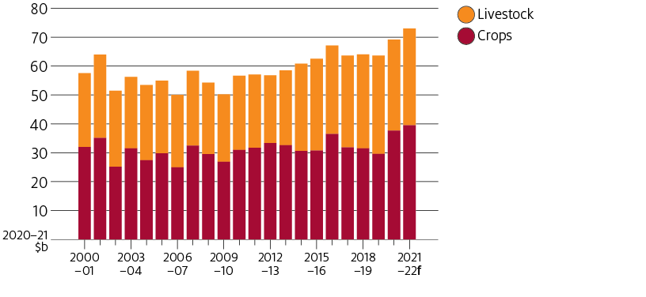
The gross value of agricultural production, 2000–01 to 2021–22
The driver of crop value growth over the past 20 years was increased volumes as producers improved productivity by adopting new technologies and management practices. This growth was offset however by the ‘millennium’ drought and a fall in real prices.
Higher meat and livestock prices have driven value growth reflecting growing demand for protein in emerging countries and also factors such as drought in the United States and disease outbreaks in meat importing countries.
Crop exports are forecast to make the largest contribution to growth. The value of crop exports is forecast to increase by 17% to $30.0 billion, the highest since 2016–17. This is being driven by higher forecast prices for most crops, combined with continued high export volumes.
The value of livestock exports is forecast to increase by 7% to $24.7 billion, driven by higher wool, beef, lamb and dairy exports.
Wool exports are expected to record strong growth in 2021–22, as the global economic recovery increases demand for natural fibres, pushing up prices. Beef export volumes are forecast to grow 8% in 2021–22 after falling by 24% the previous year, driving the value of beef exports above $9 billion.

The limits to grain production

The limits to national grain production were addressed by Head of ANZ Agribusiness Michael Whitehead who said, ‘the area under grain has plateaued at 20 to 23 million hectares. Peak grain acreage is probably about 25 million hectares.

Grain area fluctuates with numbers of sheep and cattle for which there is currently strong demand. How much more grain can be produced from the available grain area is largely depends on seed and varietal improvement, and agricultural technology generally. These developments will in turn be in response to climate change.

The ANZ report predicts even with 'peak acreage', on the current trajectory, the sector could still increase production by 20 per cent over the next decade.

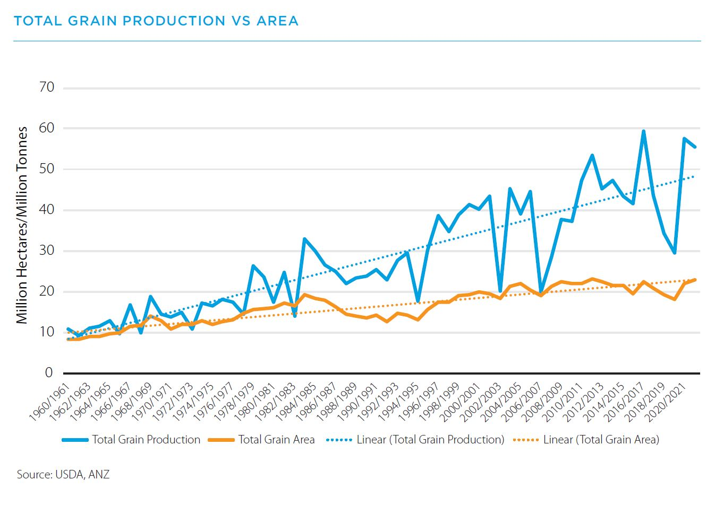
Grain production and area 1961/62

Wheat is still the dominant crop in Australia but its share of the sector has declined over time as barley and canola has increased.

The wool industry
The value of Australian wool exports is estimated to be around $3.6 billion annually. This reflects the continuing strong global demand for Australia’s wool. The industry’s value is at this level despite a dramatic decline in sheep numbers from 165 million in the year 2000 to 70 million currently.
The collapse of the reserve price scheme (RPS), the legislated marketing arrangement put in place for wool has had a massive effect on growers.
Whilst it was operating, the traditional means of selling wool by open auction, continued although there was always another buyer in the market, the Australian Wool Corporation. The ultimate cost to the industry of the RPS, whose ostensible aim was to ‘smooth out price fluctuations’, was very high.

Today wool is still sold through a limited number of agents, mainly by auction but much of it is sale by description and online rather than in the auction houses of old.

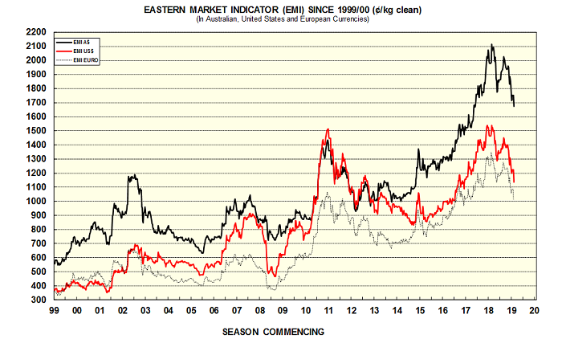www.agriculture.gov.au/ag-farm-food/meat-wool-dairy/wool

The graph shows that following the scheme’s collapse, apart from one year, 2002 – 03, wool prices failed to exceed 1990 levels until 2011.
The low prices for wool and the fall in sheep numbers at the time are attributed largely to the wool stockpile weighing on the market following collapse of the RPS.
The recovery in sheep numbers and wool production since has been slow and influenced by a number of factors such as drought, shortage of specialist labour such as shearers and wool classers, the high prices and demand for sheep meats, an increase in cropping and improved crop technologies, and the deterioration of on farm infrastructure such as fencing and water and its high cost of replacement.
Wool prices have improved in recent years to bring new stability and profitability to the industry.
Some other trends following deregulation
In the meat industry, there is more is over the hooks selling of livestock and online sales through computer description. More meat is sold by direct to supermarkets. Sales by auction in sale yards has diminished and are used increasingly for feedlot buyers and restockers.
Animal identification and tracing is becoming the norm, both for export and domestic trading. There are fewer abattoirs, market forces have closed northern abattoirs and hence there are longer distances to markets, including for the live animal trade. This has raised animal welfare concerns and the need for stricter management practices.
There is now increased demand for free range eggs with consumers prepared to pay extra. Free range producers are certified and monitored leading to regulation by other, non-legislative means.
In response to public opinion and preference, supermarkets supply ‘clean and green products’ i.e. no hormone use in the production system and ‘RSPCA certified’ products.
Animal welfare and ‘net zero emission’ requirements are becoming issues affecting farm practice. Some farm practices are being regulated in the interests of the soil and water resource. There is pressure on farmers to meet in energy efficiency requirements and greenhouse gas reductions/balance.
Driven by public opinion, or perception, urban populations are having greater influence on consumer behaviour.
In fruit and vegetable industries there has been a transition to larger, specialist producers and to large corporate marketing entities. Direct selling by large growers to supermarkets has been a feature of the past twenty years.

Most food processing (canning and drying) has ceased. There are now only two large fruit canneries, SPC in Victoria and Golden Circle in Queensland, both privately owned. Some coop packing houses still exist, at Lenswood, Mildura and Irymple, but more have become private companies.

In part this is due to reduced production since deregulation. For example, dried vine fruit production which peaked at around 100,000t in 1992, is now about 16,000t. Similar changes have occurred in other horticultural crops with the resources now being used for wine and table grapes, almonds, and other nut crops.

Use of maturity measurement technology, computer driven automated packing lines, with quality assurance systems geared to retailer and consumer demand has largely eliminated the immature and low quality fruit from the market and has obviated the need for grading and marketing legislation.

Wine grapes are sold almost entirely by contract, with stricter quality demands. The demise of the fortified wine and spirits markets has meant there are fewer outlets for poor quality. Unlike the days of the coops, wineries will simply not take poor quality fruit.

Irrigation is an example of how market forces have revolutionised water markets.

In the past irrigation was governed by water boards (except for private irrigators) who decided who got how much water, and when it was supplied to growers. This often had more to do with the capacity of the supply system than the needs of the crop. Now growers or large irrigation trusts own the water and manage its application according to crop demand, thereby improving production, efficiency and the range of crops that can be grown.

Farmers are more savvy about marketing and price risks, and they take advantage of the more open systems. The information technology age allows them to do this not only for outputs but inputs as farmers do better deals by shopping around.
In this new production and marketing environment there is de facto regulation. As stated earlier, ‘Increasingly, agricultural industries are being seen as a complete food and value chain from ‘paddock to plate’ with product opportunities, integrity and traceability along the entire chain … in 2010 the Australian Government committed to develop a national food plan to better integrate food policy along the food supply chain to help protect and improve Australia’s food security status, support population health outcomes and maximise food production opportunities. The food industry is adopting integrity and product description measures common to other industries.
Government policies in non-agricultural areas can still have very disruptive effects on the farm. Take for example the restrictions imposed as part of COVID management which have resulted in shortages of seasonal labour and disrupted the across border and across national flow of goods and services and added to costs.

What of the future?

It is difficult to see a return of substantial government intervention in marketing as in the past.
We are likely to see the current trends in marketing continue with consumer demand driving production and sales.
Government actions are likely to be different but still important and driven by voter perceptions and political imperatives.

In this environment, policy setting around energy use/carbon emissions/carbon farming; animal welfare; use of chemicals, product safety/integrity/traceability, as well as things like the availability of farm labour and transport infrastructure will impact both production and marketing systems.

The adoption of a sustainability framework will be important in terms of the environment (emissions, soil, water, biodiversity, resource use); socio-economic (animal welfare, health and safety, livelihoods, communities, markets and resources); and governance (legal and regulatory compliance, ethics, competitive behaviour and risk management).

Investment by producers, government and the wider industry in research and innovation, and the adoption of new practices on and off farm will be important drivers of change and adjustment to changing circumstances. This in itself will require clear directions on the place of agriculture and policies to encourage its growth, something which is difficult as the understanding of the importance of farming and rural communities diminishes in what has become a largely urban society.

In the wider economy, fiscal and monetary policies, exchange rates, and the establishment of trade agreements with a wider range of partners and more direct seller/buyer arrangements will be important as Australia continues largely as an agricultural exporting nation. But this has always been the case.

Robert Ingram Smith, ‘Organise or be damned', Australian Wheatgrowers' Organisations and Wheat Marketing, 1927-1948, PhD Thesis, Australian National University, 1969.
John Spriggs, https://cdn.csu.edu.au/__data/assets/pdf_file/0008/2805569/Chapter12_Spriggs.pdf
Frank Vanclay, The impacts of deregulation and agricultural restructuring for rural Australia, , The Australian journal of social issues, February 2003, https://www.researchgate.net/publication/285539658
ABC News, Wheat growers rally against marketing changes, June 2008.
Patrick O’Keeffe and Melissa Neave, Experiences of wheat growers in Australia’s western Wimmera following deregulation of the export wheat market, Rural Society, Volume 26, 2017.
The Wheat Marketing Act 1989 (Cwlth) removed the Board’s compulsory acquisition powers for wheat and deregulated the domestic market, replaced the regime of guaranteed prices with a government guarantee on the Boards’ borrowings and permitted the Board to trade in grains other than wheat. The Wheat Export Marketing Act 2008 came into effect on 1 July 2008. The Act established a new regulator, Wheat Exports Australia (WEA), to formulate and administer an accreditation scheme for bulk wheat exports. The Wheat Export Accreditation Scheme 2008 also came into effect on 1 July 2008.
GrainCorp website
Lloyd George, Stock Journal, Grain, Thursday August 12, 2021, p. 44.
Grain Central, https://www.graincentral.com/markets/viterra-exporting-1-8mt-sa-grain-over-oct-jan/
Productivity Commission, Wheat Export Marketing Arrangements, Inquiry Report No. 51, 1 July 2010, p. 133
Curwen, Mugara and White, Deregulation of the Australian Wheat Export Market: What Happened to Wheat Prices, Journal of International Food & Agribusiness Marketing , 2011.
Basis is the premium or discount for Nov/Jan during each season for local price (ASW*) against spot Chicago futures.
CME, Mecardo, ‘A look back at deregulation’, in https://www.crt.com.au/a-look-back-at-deregulation/ , 2020.
https://www.agriculture.gov.au/abares/research-topics/agricultural-outlook/agriculture-overview
Ibid
Ibid
The Country Hour, ABC Radio, 8th September, 2021.
https://www.abc.net.au/news/rural/2021-09-09/australia-reaches-peak-acreage-but-production-keeps-rising/100443338
John Radcliffe, Extract from Influence of Australian Agricultural Council and successors on Australian Agriculture, 1980-2014 Operation, marketing and Responses to the Risks of farming, 2020, Agric Sci 31, http://hdl.handle.net/102.100.100/365169?index=1 p.7

