ENHANCED ABATTOIR SURVEILLANCE
2018 ANNUAL REPORT

2018 PROGRAM REPORT
The South Australian (SA) Enhanced Abattoir Surveillance (EAS) Program is unique.
SA producers are the only producers in the country to receive twice weekly feedback on diseases and conditions detected in their sheep at Thomas Foods International (TFI) Lobethal. Feedback provided is in addition to routine processor condemnation information and includes information on over 20 conditions (if detected in >5% or more of a line).
This timely and comprehensive feedback enables management change to maximise production efficiency on farm and minimise trimming/condemnations at the abattoir. In turn animal welfare is improved as is the health of the SA flock – both of paramount importance to secure trade access to present and future market opportunities.
This report covers the period January to December 2018.

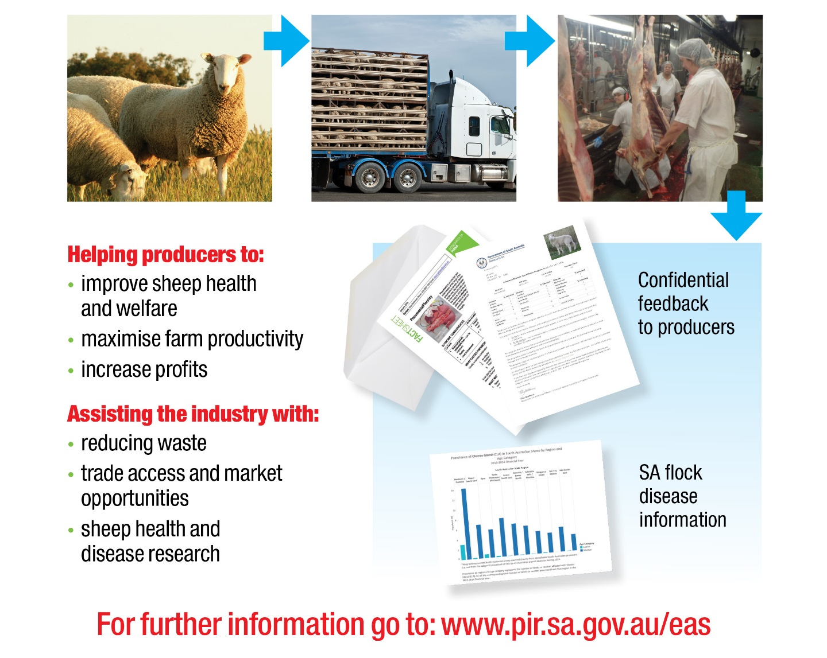

SNAPSHOT OF 2018
2018 Enhanced Abattoir Surveillance at Thomas Foods International (TFI) Lobethal included:

>1.9 million Australian sheep

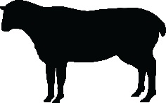
of which 83% were South Australian

From >2,600 South Australian properties

across all regions of the State

This included 56% of commercial* South Australian producers

resulting in >4,200 feedback letters

and >6,300 feedback emails

*Commercial producers were defined (for this report) as those who transferred >100 sheep on the NLIS database in 2018 (movements recorded as at February 10 2019)
HOW BEST TO INTERPRET THE FEEDBACK I RECEIVE
Consider all available information when interpreting your EAS results.
The following procedure may help to guide you:
- Weigh sheep prior to loading. Keep a record of weights and use this as a guide only to calculate expected carcase weights (keep in mind curfew and transport further reduces these weights).
- When you receive your invoice and summary feedback sheet from the processor ask yourself the following questions:
  - Are the carcase weight ranges what you expected from the line of sheep consigned?
  - Did you incur grid penalties for underweight carcases?
  - How many animals were lighter than expected?
  - Were there any carcasses condemned for monitored conditions?
- Identify any conditions present in your consignment by referring to the EAS feedback letter received. Consider the degree of trim that may be associated with each condition (refer to Table 1 below and the information within this report).
- Compare your EAS feedback results to others in your region and the state – this information can be found in regional benchmarking reports via the link : http://www.pir.sa.gov.au/eas and within this report. How does your farm compare to others in your region?
Photo: Example of a high value carcase
Consider all of the above information when interpreting the meaning of your results and contact Dr Allison Crawley if you require further clarification, assistance or information (see page 17 for contact details).
Involve your private vet, livestock agent, local PIRSA animal health officer or livestock consultant to further assist on-farm decision making.
Conditions that reduce carcase weights during processing due to trim | Arthritis, grass seeds, pleurisy and dog bites – trim can be significant, depending on severity.
 | Bruising, cheesy gland (CLA), rib fractures and vaccination lesions – trim generally less significant than for conditions listed above.
Conditions that may result in condemned carcases | Severe sheep measles (ovis), polyarthritis, bruising and jaundice.
Conditions only affecting offal (no impact on carcase weight at the time of processing) | Bladder worm, sheep measles (ovis), pneumonia, sarcocystis, nephritis, cirrhosis, knotty/pimply gut and liver fluke.
Table 1: EAS monitored conditions and relative potential impacts on carcase weights (if any).

2018 RESULTS FOR CONDITIONS MONITORED
The ultimate aim for producers and processors alike is maximum carcase yield with minimal waste. Production of a carcase free of disease or other conditions ensures producers maximise production efficiency on farm as well as carcase weight and grid price at slaughter. A high value chilled product, free from trim, downgrading or offal condemnation is also the ultimate desired outcome of a carcase for processors.
With all supply chain sectors aiming for the same premium product, EAS feedback is highly valuable for producers and should be used strategically to improve sheep health/production efficiency, animal welfare and carcase value.
For the purposes of this report prevalence refers to the percentage of sheep affected out of all sheep processed for that area and age category.
The following key has been developed to display the significant information for each condition.
= condition description and/or cause
= proportion of producers consigning affected stock
= effect of the condition on farm
= lamb and mutton specific information
= effect of the condition at the abattoir
= specific trends, regional or other information

Seeds in the carcase due to spear, brome, barley, silver and Chilean needle grasses or geranium.

= ↓weaner growth rates → lighter weaners, ↓ wool production, associated pain/discomfort and ↓ carrying capacity.
= ↑ trimming (lighter carcases) which can be significant, c/kg penalty and damaged skins.
2018 Grass Seeds – Lambs

Grass Seeds
Cause and consequences

 | ~1 in 12 producers consigned affected stock.
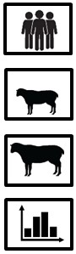 | 3% lamb prevalence (range 0% to 12.2% across the State).
 | 1% mutton prevalence (range 0% to 6.0% across the State).
 | Grass seed prevalence continues to occur at the highest prevalence in the Murray Mallee and Upper South East.
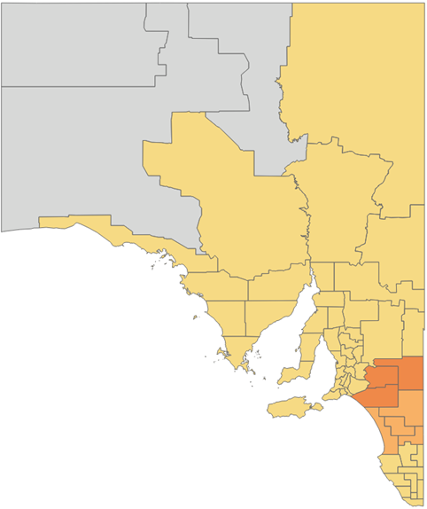
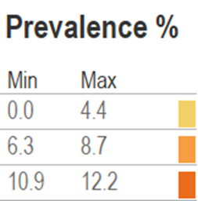
2018 Results
Swollen and damaged joints caused by a bacteria entering wounds at marking/mulesing or via the umbilical cord at birth.
= deaths (+ culling cripples not fit for transport off farm),
↓ production. Arthritis is a condition of welfare concern.

= trimming of affected joints, carcase condemnation if >4 joints affected.

Arthritis
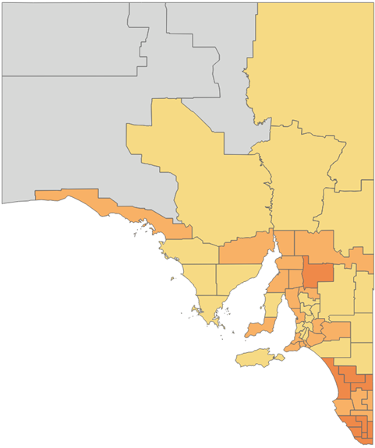
Cause and consequences
2018 Arthritis – Lambs
2018 Results
~1 in 3 producers consigned affected stock
0.6% lamb prevalence (range 0% to 1.4% across the State).
3% mutton prevalence (range 1.4% to 6.0% across the State).
Arthritis is a State wide issue. On average 1 in 14 carcases are trimmed for the condition within affected lines.
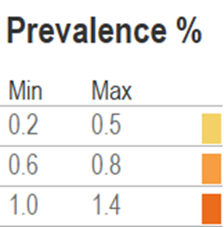

Sheep Measles (Cysticercus ovis)
Cause and consequences
Cysts detected in sheep muscle – carcase and/or offal. Cysts are the larval stage of a tapeworm parasite found in dogs.

= no effect on sheep health on-farm. Monthly de-worming of ALL dogs on farm with Praziquantel (also controls bladder worm).
= trimming or carcase condemnation if >5 cysts detected.
2018 Sheep Measles – Mutton
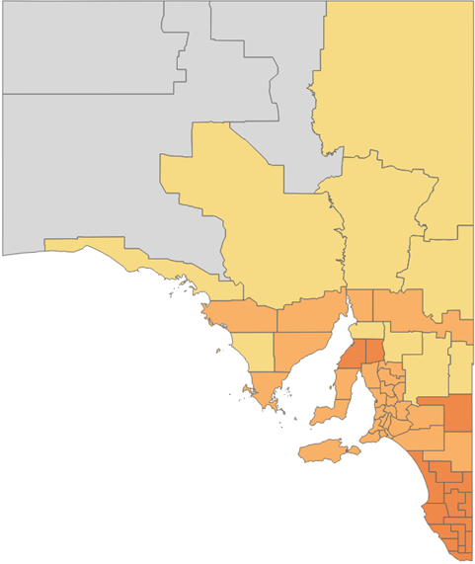
~6 in 10 producers consigned affected mutton.
0.5% lamb prevalence (range 0% to 2.6% across the State).
4% mutton prevalence (range 2.1% to 6.1% across the State).
Sheep Measles is found in similar levels on fox free Kangaroo Island as mainland SA. Therefore dogs should be still be considered the main carriers and should be de-wormed monthly.
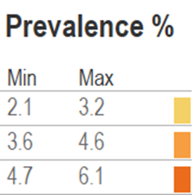
2018 Results

Pleurisy
Cause and consequences
Extension of pneumonia (lung infection/inflammation) causing parts of the lungs to stick to the chest wall (valuable rack of ribs).
= ↓ production and deaths in some instances.

= trimming of the ribs to remove adhesions (↓ carcase weight).
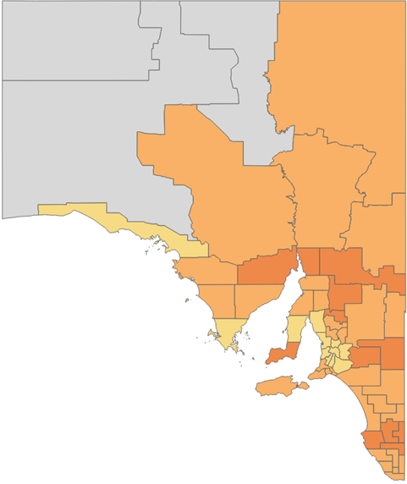
2018 Pleurisy – Mutton
>7 in 10 producers consigned affected mutton.
1% lamb prevalence (range 0% to 2.2% across the State).
9% mutton prevalence (range 5.6% to 12.0% across the State).
Pleurisy is a significant condition in mutton lines across all State regions. On average, in 1 in 8 carcases are trimmed for the condition in affected lines.
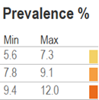
2018 Results

Pneumonia
Cause and consequences
Infection/inflammation of the lungs caused by the combination of an infectious agent, poor sheep immunity/stress and environmental conditions (hot, dry and dusty).
= ↓ production and deaths in some instances.

= condemnation of lungs.
2018 Pneumonia – Lambs
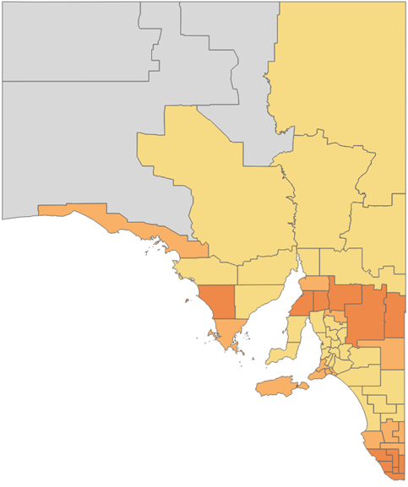
2018 Results
1 in 5 producers consigned affected stock.
1.5% lamb prevalence (range 0.5% to 3.4% across the State).
1% mutton prevalence (range 0% to 2.6% across the State).
Pneumonia is of particular concern when it progresses to cause pleurisy. Cases of pleurisy are found in almost all lines of mutton and require carcase trimming.
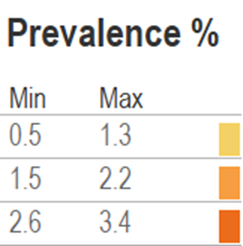
Contagious bacterial disease causing lymph node abscesses. It is most commonly transmitted at shearing. Vaccination is effective.

= ↓ wool production (up to 7% in the year of infection), wool contamination, occasionally chronic infection causes illthrift, emaciation and poor reproductive performance.

= trimming (↓ carcase weight).

Cheesy Gland (CLA)
Cause and consequences
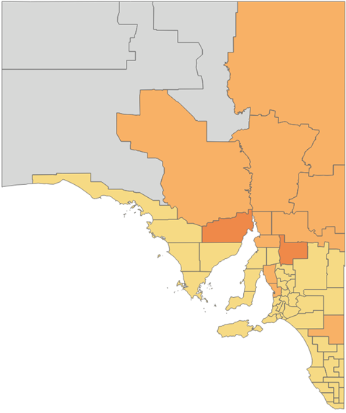
2018 Cheesy Gland – Mutton
1 in 3 producers consigned affected mutton.
<0.1% lamb prevalence (range 0% to 1.7% across the State).
5.5% mutton prevalence (range 1.5% to 15.7% across the State).
CLA remains a problem in mutton sourced from the Northern Pastoral region with more than double the mutton prevalence when compared to the remainder of the State.
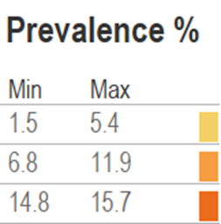
2018 Results

Vaccine Lesions
Cause and consequences
Abscesses from incorrect needle length, vaccinating wet sheep and/or using blunt or dirty needles. All vaccines should be given under the skin high on the neck and not into muscle.
= if vaccine is given on the face reactions can interfere with feed intake.

= trimming (↓ carcase weight), less impact if lesion is high up on the neck rather than in the legs or along the back.
2018 Vaccine Lesions – Lamb
1 in 12 producers consigned affected stock.
1.5% lamb prevalence (range 0% to 8.5% across the State).
2% mutton prevalence (range 0% to 8.8% across the State).
By far the highest level of vaccine lesions are seen in sheep from properties surrounding Adelaide in the hills and northern Fleurieu.
Note – This program records all vaccine reactions; some would be caused by Gudair for which reactions can occur regardless of vaccination technique or hygiene.
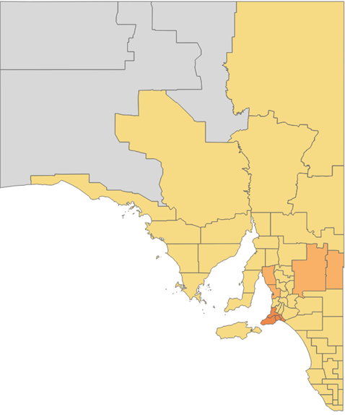
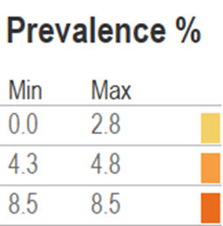
2018 Results
Weak bones result from mineral deficiencies or imbalances (especially calcium and copper). Weak bones may break without excessive force or as a result of inappropriate handling/facilities.
= ↓ production and is of welfare importance.
= affected ribs trimmed (↓ carcase weight).
2018 Rib Fractures – Lamb

Rib Fractures
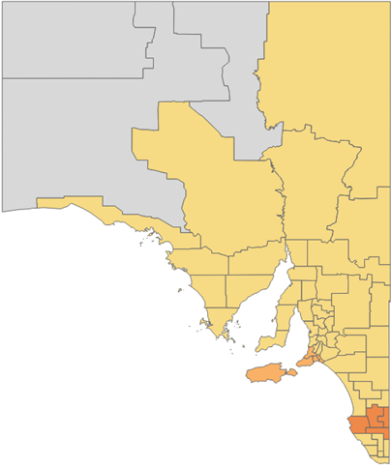
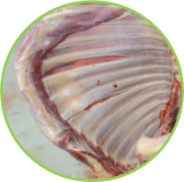
Cause and consequences

1 in 15 producers consigned affected stock.
0.6% lamb prevalence (range 0% to 2.9% across the State). .
0.2% mutton prevalence (range 0% to 1% across the State).
Research estimates rib fractures cost the SA industry $3M annually, $25/carcase to the processor and $1.30/carcase to the producer.
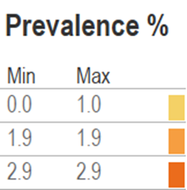
2018 Results
A result of external trauma, usually caused during yarding, transport or if processed within 2 weeks off shears.
= a condition of welfare importance.

= trimming of discolored muscle (↓ carcase weight).

Bruising
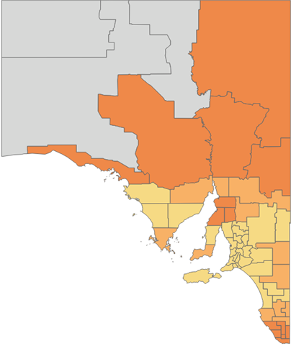
Cause and consequences
2018 Bruising – Lamb

~1 in 3 producers consigned affected stock.
2% lamb prevalence (range 0.3% to 4.1% across the State).
2.5% mutton prevalence (range 0.4% to 5.5% across the State).
If bruising is extensive or deep, entire legs may be trimmed.

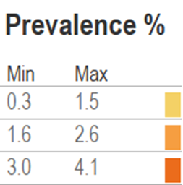
2018 Results
Larval cysts (‘bladders’) found in the liver. Cysts are the larval stage of a tapeworm parasite found in dogs (and foxes).
= usually no effect on sheep health, will occasionally trigger Black Disease (a clostridial disease) in unvaccinated stock.

= livers are trimmed or condemned.
2018 Bladder Worm – Mutton

Bladder Worm
Cause and consequences
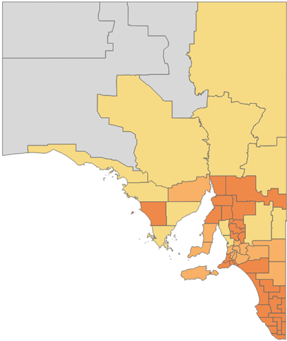
~8 in 10 producers consigned affected mutton.
2.5% lamb prevalence (range 0.3% to 4.9% across the State).
22.5% mutton prevalence (range 12.3% to 36.6% across the State).
The advantage producers gain by controlling bladder worm is that these control measures are also controlling/preventing Sheep Measles (a condition that can result in condemnation).
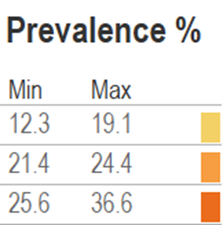
2018 Results
Damaged/scarred liver due to ingestion of toxic plants e.g. Potato weed (heliotropes), Salvation Jane, Lesser loosestrife, Caltrop and Panic grasses.
= ↓ production.

= liver condemnation.
2018 Cirrhosis – Mutton

Cirrhosis
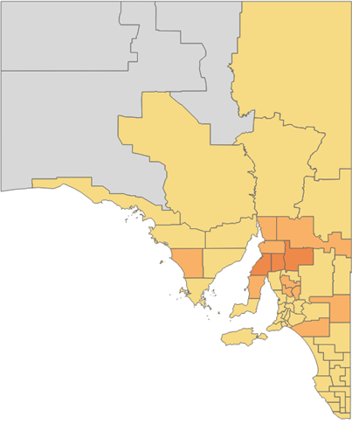
Cause and consequences

Very few producers (6.7% 2018) consigned affected mutton in 2018, a significant reduction from previous years of ~1 in 5.
0.1% lamb prevalence (range 0% to 1.0% across the State).
0.5% mutton prevalence (range 0% to 2.2% across the State).
Cirrhosis is usually only of concern in mutton due to prolonged and repeated exposure to toxic plants/weeds.
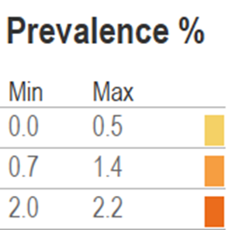
2018 Results
Due to bacterial spread from contaminated marking/mulesing wounds and inflammation of the rumen (due to grain feeding), toxic plant ingestion and some other toxins.
= obvious clinical signs of disease are only observed if >75% of kidney function is affected.

= kidney condemnation.

Nephritis
Cause and consequences
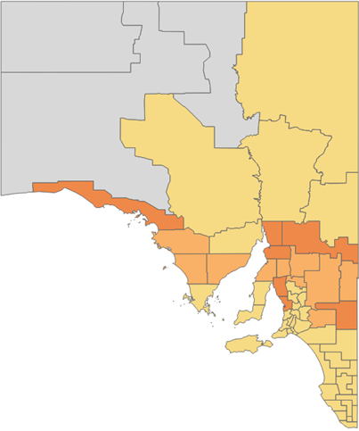
2018 Nephritis – Lambs
1 in 3 producers consigned affected lambs.
4% lamb prevalence (range 0.7% to 9.3% across the State).
0.1% mutton prevalence (range 0% to 0.4% across the State).
Nephritis appears to be a lamb specific condition. It’s significance in terms of effect on productivity is poorly understood.
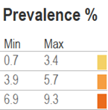
2018 Results
LOW PREVALENCE/OTHER CONDITIONS
Jaundice was detected at >5% in only 1 SA mutton line in 2018. |  | Liver Fluke was detected on only 5 SA properties in 2018.
Knotty gut/pimply gut, caused by the intestinal parasite Nodule worm (Oesophagostomum columbianum), was detected on 113 SA properties in 2018. The parasite prefers a summer rainfall climate. |  | Sarcocystis is only a concern for producers on Kangaroo Island (42% mutton prevalence).  82% of Kangaroo Island producers consigned affected mutton.

ON-SITE PLANT TOURS

SA producers and livestock agents from all regions of the State were fortunate to participate in tours of the TFI Lobethal and JBS Bordertown plants during 2018. These tours, facilitated by Tiffany Bennett from Rural Solutions, and Gary Glasson and Mary Chirgwin from Zoetis Animal Health, are conducted in collaboration with Biosecurity SA.
These tours continue to be very popular, providing producers and their associated agents/rural re-sellers with key insights into the operation and market drivers of processors. Tours at the Lobethal plant also demonstrate how the EAS program operates and how to best interpret feedback. Producers gain a greater appreciation and understanding of the financial losses that occur during processing, necessary to maintain a high standard of food safety and meat quality, that are as a direct result of conditions found at slaughter.
These tours also aim to provide key animal health information to producers. During 2018 tours were carried out at TFI Lobethal and JBS Bordertown using the SA sheep industry funded tour guide headsets, with ~140 producers, rural resellers, students and stock agents participating. These audio units have significantly improved the value and safety of these tours and are also used for training purposes.
Producers interested in taking part in a tour should contact their local rural re-seller, Gary Glasson (Zoetis, 0418 812 457) or Mary Chirgwin (Zoetis, 0418 898 505).

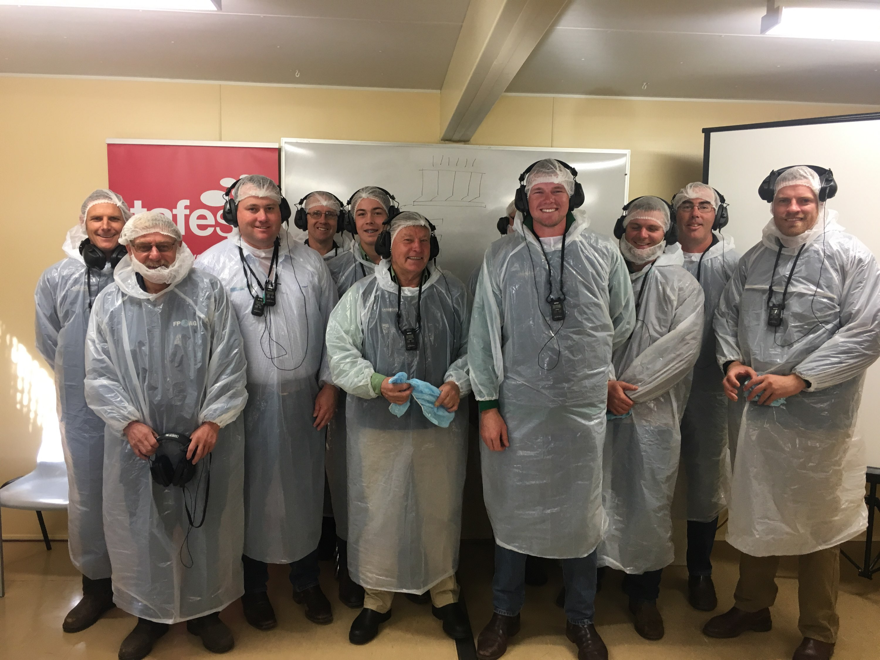
Photo: Livestock Agents tour at the TFI Lobethal Plant, as part of the 2018 Agent Tours and Workshops facilitated by Rural Solutions.
REDUCING THE FINANCIAL IMPACT OF ENDEMIC CONDITIONS IN SHEEP – A VALUE CHAIN APPROACH
In January 2018 a three-year collaborative project began between Primary Industries and Regions SA (PIRSA) Biosecurity SA, Thomas Foods International (TFI), JBS Australia (JBS), Meat & Livestock Australia (MLA), Animal Health Australia (AHA) and the University of Adelaide.
The objective of this project is to monitor, analyse and act to reduce the rate of endemic conditions in sheep processed in South Australia through a value chain approach. The project goal is to enhance the flow of animal health information to drive improvement both on-farm and supply chain performance. This project seeks to address all the factors above by focussing on eight conditions and diseases that were identified as having either a high occurrence or cost and the potential for prevention or effective on-farm management or treatment. These conditions are: arthritis/polyarthritis, sheep measles, pleurisy, pneumonia, grass seeds, lungworm, cheesy gland (or caseous lymphadenitis (CLA)) and rib fractures. Additionally the cost of these major health conditions to the sheepmeat value chains operating in SA will be quantified to provide the basis for ongoing investment in monitoring and reducing health condition incidence for the benefit of the overall sheepmeat industry.
The project will be undertaken in SA but provide a model that could be implemented on a national basis and will include exploring the options for and trialing of individual animal recording mechanisms (rather than the current 5% increment approach).
Funding for this project has been provided provided by the South Australian Sheep Industry Fund, Animal Health Australia (AHA) and the MLA Donor Company (MDC) a fully-owned subsidiary of Meat & Livestock Australia (MLA).
The University of Adelaide Researchers involved in delivering on the research outputs of this collaborative project are Eleonora Dal Grande and Jackson Adams.
Eleonora Dal Grande

Eleonora Dal Grande joined the project in July 2018 as a postdoctoral researcher (Epidemiologist) in the School of Animal and Veterinary Science, The University of Adelaide. Before joining this project, Eleonora has worked in the public health field and with population health data since 1995. As part of this project, she has been using deidentified EAS data to conduct epidemiological analyses on eight diseases and conditions by describing the prevalence rates and distribution, to identify the trends in condition occurrence and the on-farm predisposing factors, and looking into the cost of key conditions in sheep.

To date, this project has completed a desktop study using deidentified EAS data on diseases and condition prevalence, and the associated economic impact of the selected eight conditions across the meat value chain from production (on-farm / producer level) through to the processor (abattoir / processor level). The contribution of this desktop study is to answer the project objectives, and to identify gaps and to provide supporting information to assist in implementing other components in this project. It revealed that very little recent information is available, especially for the abattoir sector.

Jackson Adams

Jackson has a Bachelor of Agricultural Science with first class honours in Animal Science and is the current Livestock Consulting Intern at the University of Adelaide. He commenced a PhD at University of Adelaide in March 2019, and will be working with deidentified Enhanced Abattoir Surveillance data to quantify costs of selected disease conditions and to further improve outcomes for producers.

EAS DATA USE FOR RESEARCH AND OTHER PROJECTS
In addition to individual feedback, de-identified EAS data continues to contribute to research and other projects of industry benefit and progression.

Jenny Hanks - PhD on the production effects, diagnosis and control of small lungworms in sheep

Jenny started her PhD a year ago at the University of Melbourne, although her research involves working with producers from South Australia. Jenny aims to quantify a potentially important health problem for the sheep industry in South Australia by developing a better understanding of the impact that small lungworm (Muellerius capillaris and Protostrongylus rufescens) has on sheep production. This will include investigating the distribution of infected sheep using EAS data, and the amount and nature of any associated production losses. In addition, a more rapid and sensitive molecular diagnostic test will be developed to improve the detection and diagnosis of small lungworm. Control strategies will be formulated and evaluated to assist producers better manage this disease in those areas where it is identified to be a problem.

Infections of sheep are often detected at post-mortem examinations and at abattoirs but thought unimportant because few obvious clinical signs or production losses can be directly attributed to them on farms. However, heavy lungworm infections may cause production loss, either directly or by potentiating other respiratory diseases, such as pneumonia.

Farms with a high risk of lungworm infections from the southeast of South Australia are now being monitored. Live weight, growth rate and carcase weights is compared to the presence and severity of lungworm infection based on visual assessment of lungworm nodules. Lungs are scored on a scale of 0-3, with 0 indicating no nodules and 3 being the most severely affected, with extensive nodules throughout the lungs. Preliminary results suggest that sheep can be highly infected; 100% of lambs were infected on one farm, and this relates to the snail burden (intermediate host) on pasture. They also suggest that production was not affected by the presence of small lungworm lesions. However, further comparison between other farms and other age classes is needed.

Patrick Taggart – PhD on Toxoplasmosis and Sarcocystosis in South Australia
Patrick is nearing completion of his PhD project at the University of Adelaide and will have results available during 2019. He is investigating the ecology of two cat-borne diseases on Kangaroo Island: Toxoplasmosis and Sarcocystis. In particular, he is interested in why these two diseases have a significantly higher prevalence on Kangaroo Island when compared to the remainder of the South Australian mainland. Both diseases are caused by parasites shed by cats and can have significant impacts on sheep production.
He is looking for alternative methods for monitoring the prevalence of toxoplasmosis (caused by Toxoplasma gondii) in sheep flocks across South Australia. There is currently no feasible way of conducting widespread monitoring of T. gondii in South Australian sheep flocks. However, since T. gondii and the parasites responsible for sarcocystis are both cat-borne parasites and both have similar biology, it is possible that they may be associated. If this is the case, we may be able to use sarcocystis as an indicator for T. gondii prevalence. This would offer another use for the EAS data at no additional cost to the sheep industry. Patrick’s studies will also use the EAS data to map sarcocystosis in sheep flocks across South Australia to identify hotspots of and risk factors associated with the disease.

Dr Colin Trengove – Investigation and PhD on Lamb rib fractures
Dr Colin Trengove is in the final stages of his research into the cause, prevalence and prevention of rib fractures primarily in lambs across South Australia. He was granted permission to use de-identified Enhanced Abattoir Surveillance data toward a PhD initially to estimate the prevalence, distribution and seasonal variation in rib fractures identified in lambs at slaughter. This was assisted by funding from MLA which enabled a targeted abattoir study with on-farm follow up in the south east of South Australia and western Victoria to explore the factors associated with the detection of rib fractures. Further funding from the Limestone Coast Red Meat Cluster and PIRSA facilitated the extension of the interim findings and proposed remedies via a webinar https://youtu.be/mEyUEIkU81Y
Ten years of EAS data has highlighted that the condition has a widespread distribution across South Australia and is most prevalent in new season lambs in above average rainfall years. This evidence combined with mapping the number and distribution of rib fractures on affected carcases indicates conclusively that focal physical impact during handling is a major contributing factor.
Mapping soil type against rib fracture traceback data, as well as on-farm sampling has identified a higher prevalence associated with acidic soils presenting as calcium and copper deficiency. These factors coincide with higher rainfall environments such as the Adelaide Hills, Fleurieu Peninsula, central western Kangaroo Island and the Mid and Lower South East.
Rib fractures are evident in about 10% of lamb consignments with up to 40% of lambs within these consignments affected. Microscopic and radiographic studies have revealed that rib lesions at slaughter are only indicative of bones broken in the preceding 2 months and so represent less than a third of all rib fractures that occur. This finding underlines the welfare impact of this condition and reported delay in finishing affected lambs.
The estimated $3 million annual cost to the red meat industry in SA is conservative and does not attempt to quantify the lost production and welfare impact on farm. Unfortunately, resolution of the problem is even more difficult to quantify at the industry level as measures to lower the prevalence of rib fractures in lambs will require some or all of the following strategies to be implemented:

- Soil testing and liming to identify and treat calcium deficiency;
- Pasture / lamb / ewe testing to diagnose and treat / prevent copper deficiency;
- Improved lamb husbandry through better facilities and stockmanship to reduce injuries; and
- Greater education and awareness of the importance of animal welfare to advance standards in the red meat industry.

Prevention Advice:
- Ensure adequate nutrition in the pregnant and lactating ewe to promote good calcium and copper uptake and transfer to the foetus/lamb:
- High soil calcium, sulphur, molybdenum, cadmium and iron can all reduce copper uptake in the ewe/lamb and so check these before deciding on how to supplement copper if needed.
- Give copper via a capsule or injectable form. Injectable is preferred as it avoids rumen interference.
- Provide ad lib calcium supplement (stock lime) to ewes from mid-pregnancy when grain is a major dietary component.

- How to determine if your sheep have adequate calcium and copper uptake:
- Test the pasture during pregnancy for available dry matter (FOO or “feed on offer”) and mineral content (calcium, sulphur, molybdenum, copper and iron).
- Blood sample ewes at joining (spring) and lambs at marking to check copper status.
- Perform a soil test to identify calcium deficiency (applying lime, dolomite or gypsum may adequately rectify the deficiency for long-term benefit).

- Adopt management strategies to reduce lamb trauma
- Be gentle when yarding/handling lambs and review the use of dogs in yards (not all dogs are bad).
- Minimise the number of times lambs are yarded by drafting into light/medium/heavy at the first draft.
- Identify and remove hazards in the yards.

CONTACTS
For further information regarding Enhanced Abattoir Surveillance, contact Dr Allison Crawley, EAS program Manager on 08 8429 0866 or email allison.crawley@sa.gov.au
FOR MORE INFORMATION ABOUT EAS
For links to all disease and conditions fact sheets and the 2018 annual benchmarking reports (by region) please visit the PIRSA website: www.pir.sa.gov.au/eas
ACKNOWLEDGEMENTS
- All participating SA sheep producers and their livestock agents.
- The SA Sheep Advisory Group (SASAG) and the SA Sheep Industry Fund, Animal Health Australia and the MLA Donor Company (MDC) a fully-owned subsidiary of Meat & Livestock Australia (MLA) for their continued funding of the program.
- Thomas Foods International, Lobethal for their continued collaboration
  - Kellie O’Brien and the data entry team.
  - Meagan Abbott, Justin Tomalin and the Quality Assurance team, and Tania Linke.
- Reserve Group meat inspectors for their continued cooperation and participation in the program.
- Elroy Klenke (Reserve Group) for supplying photographs.
- Tiffany Bennett (Rural Solutions) – Agent Workshops
- Gary Glasson (Zoetis), Mary Chirgwin (Zoetis) - Plant Tours.
- Peter Zviedrans, Biosecurity SA.

