HACCP PLAN
Manufacturing of Dry Cured meats for human consumption

Business Name
PIRSA Accreditation Number: XX/XXXX

This is a HACCP template, developed by the Department of Primary Industries and Regions (PIRSA) for Manufacture of Dry Cured Meats for human consumption.
An Accredited Producer may identify additional steps or hazards upon undertaking their own hazard analysis and risk assessment of each hazard. If this occurs, the Accredited Meat Producer must discuss this with the PIRSA Food Standards team to ensure that this is reflected in this document and appropriately addressed.
It is the responsibility of the accredited producer to implement and maintain the HACCP plan as part of the approved Food Safety Arrangement.

Table of Contents
1 HACCP PROCESS 4
1.1 PRODUCT SPECIFICATION 5
1.2 PRODUCT RECIPE Example 6
1.3 FLOW CHART 7
1.4 CCP DECISION TREE 8
1.5 HAZARD ANALYSIS TABLE 9
1.6 HAZARD AUDIT TABLE 12
1.7 CCP WORK INSTRUCTIONS 14
1.8 CCP MONITORING FORMS 19
1.9 PROCESS VALIDATION 21

HACCP PROCESS

OUTCOME
To process food safely, producing safe food which complies with relevant legislation, regulations, and standards.
HACCP
Process

This HACCP plan forms part of the Approved Food Safety Arrangement for the Accredited Meat Producer.
The HACCP team (as identified it the Food Safety Arrangement) is responsible for maintaining this HACCP plan through analysing and improving procedures along with implementing effective controls to manage food safety risks. Each process undertaken by the business needs to be covered by a HACCP plan. This HACCP plan covers:
Manufacture of Dry cured meats for human consumption

The following have been taken into consideration in the development of this HACCP plan;
- Primary Produce (Food Safety Schemes) Act 2004
- Primary Produce (Food Safety Schemes) (Meat) Regulations 2017
- AS 4696:2023: Australian Standard for Hygienic Production and Transportation of Meat for Human Consumption
- Meat and Livestock Australia - Guidelines for the Safe Manufacture of Smallgoods – 2nd edition 2015

Application for any alternative methods to those identified in the Australian Standard AS4696:2023, must be approved by the Accrediting body.
To produce and sell Dry Cured Smallgoods for human consumption the producer must hold accreditation and approval for these activities. Additional conditions may be required by PIRSA Food Standards Program as part of the approval of this process.

PRODUCT SPECIFICATION
The following constitutes a Product Specification for the purpose of the Food Safety Arrangement and obligations under the Act. The Specification detail the product characteristics as listed below and are considered when reviewing the HACCP plan. General Category Product Specification (Example)
Product Category | Dry cured meat
General Composition | Meat
Method of Preservation | Salting/Curing, Drying
Packaging | Primary | Plastic covering
 | Secondary | Clean Cartons
Storage Conditions | Shelf stable
Distribution Method | Direct to Customer – Butcher shop display  Refrigerated vehicle at or below 5°C
Shelf Life | TO BE VALIDATED BY OPERATOR
Labelling | If packaged:  As per FSA; Labels to include:  - Product name  - Accredited business  - Business address and contact details  - Directions for use and storage conditions  - Packaging Date  - Use By Date (may include batch identification)  - Advisory statement/warning (e.g., allergens)  - Ingredient information (as per recipe)  - Nutrition information  - Country of Origin
Intended Use | Sensitive Customer | Suitable for General population
 | Customer Preparation | Ready to eat (RTE), further processing not required prior to consumption.

PRODUCT RECIPE
Example
Product Description |  | Prosciutto (Pork Legs Whole Muscle or Boneless)
Product Category |  | Dry cured meats
Ingredients |  | Quantity (kg/ pieces) | Country of Origin
Pork
Salt
Preservative Addition (optional)
Preservative (Nitrite)
Processing
Step 1 – Weigh out meat and ingredients
Step 2 – Trim and Prepare legs (Remove Femur Bone for boneless)
Step 3 – Addition of Salt (and preservatives if applicable) covering all surfaces of the meat and return to chiller ≤5°C
Step 4 – Cure under refrigeration for approximately (XX) 12-24 days depending on the mass of the meat.
Step 5 – Wash / Remove salt crystals.
Step 6 – Drain and place under a Temperature and Humidity controlled environment for Drying for approximately (XX) 6 – 12 months.
Application of a lubricant may be applied to cut surfaces throughout the Drying process.
Step 7 – Mould Removal (washing and drying).
Step 8 – Debone or Portion and vacuum pack (label applied).
Step 9 – Store for sale.
Issue Date | DATE

FLOW CHART
Objective | A step-by-step diagram of the flow of the operation/process with all inputs and outputs identified. Key steps in the process that are critical to food safety are referred to as Critical Control Points, CCP. These are highlighted on the Flow Chart.

CCP DECISION TREE

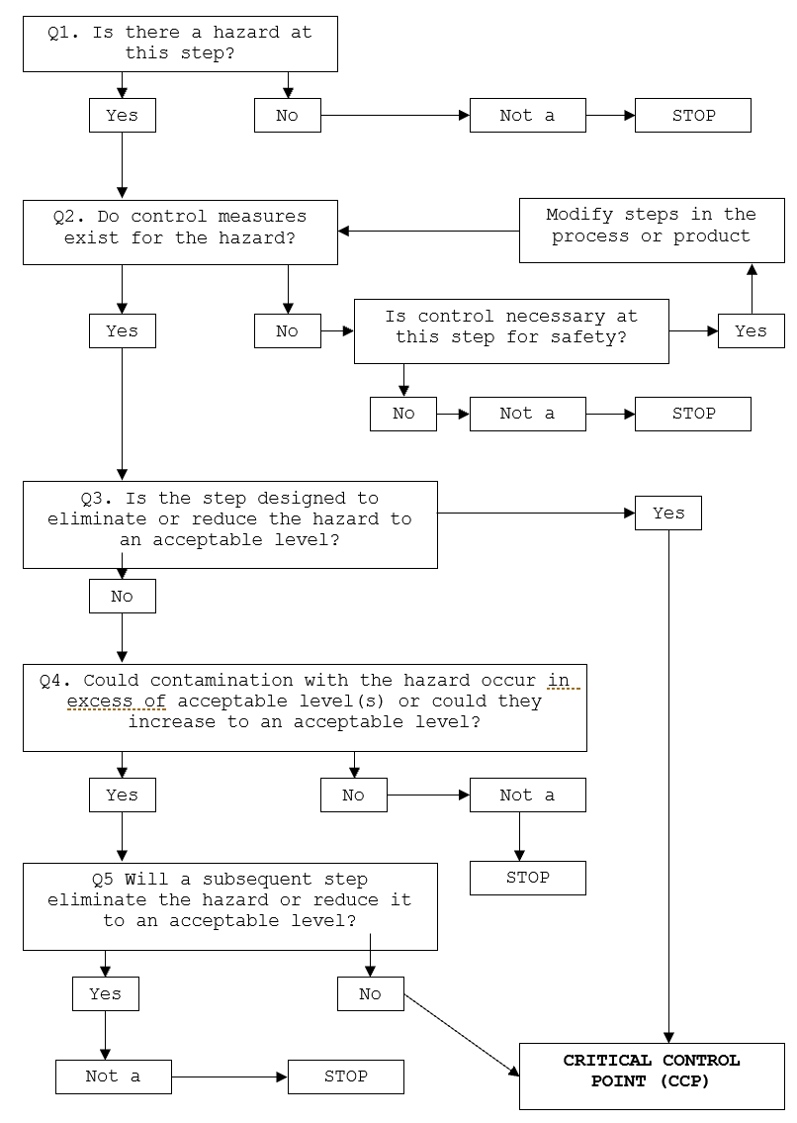

HAZARD ANALYSIS TABLE
Hazard Types: B – Biological; C – Chemical; P – Physical
Objective | A documented review of each step identified in the flow chart and with the importance of each step in the safety of the finished product rated to identify Critical Control Points (CCP).

Process Step | Hazard | Cause | Q1 | Q2 | Q3 | Q4 | Q5 | Hazard control measure | CCP | CP | GMP | Support Program
2. Curing | B – Pathogens (Salt Tolerant S. areus) at point of microbiological concern (surface) | Bacterial growth if salt is not evenly distributed or at too low a level | Y | Y | Y | - | - | Apply correct amounts of salt and ensure it is evenly distributed over all meat surfaces while curing.  Product maintained less than or equal to 5°C under active refrigeration. | CCP
- Washing | B – microbiological contamination | Contaminated water used for washing  Cross contamination from unhygienic handling of product. | Y | Y | N | Y | Y | Potable water source used for washing.  Use of PPE and or good hand sanitation when handling products. Keep Raw and RTE products and equipment separate.
 | P – Foreign matter | Foreign objects | Y | Y | N | Y | Y | Construction of wash area
- Drain | B – Growth of microorganisms | Bacterial growth if temperature and time allow  Cross contamination from unhygienic handling of product | Y | Y | N | Y | Y | Monitor temperature of meat during processing and time in process does not allow multiplication of microorganisms  Use of PPE and or good hand sanitation when handling products. Keep Raw and RTE products and equipment separate.
 | P – Foreign matter | Foreign objects | Y | Y | N | Y | Y | Construction of draining area
Process Step | Hazard | Cause | Q1 | Q2 | Q3 | Q4 | Q5 | Hazard control measure | CCP | CP | GMP | Support Program
- Drying | B – Pathogens (Salt Tolerant Staph Aureus) | Staph aureus potentially able to grow if moisture content remains high | Y | Y | N | Y | Y | Ensure the environment is controlled for Temperature and Relative Humidity.
- Mould removal | B – Growth of microorganisms | Bacterial growth if temperature and time allow | Y | Y | N | Y | Y | Monitor temperature of meat during processing and time in process does not allow multiplication of microorganisms
- Apply lubricant to cut surface | B – microbiological contamination | Bacterial growth if temperature and time allow  Cross contamination from unhygienic handling of product. | Y | Y | N | Y | Y | Monitor temperature of meat during processing and time in process does not allow multiplication of pathogens  Use of PPE and or good hand sanitation when handling products. Keep Raw and RTE products and equipment separate.
 | C – cross contamination | Operator error with cleaning chemicals | Y | Y | N | Y | Y | Suitable chemical storage and control and appropriate training for staff handling chemicals
 | P – contamination | Foreign objects | Y | Y | N | Y | Y | Compliant chiller construction
- Drying | B – Pathogens (Salt Tolerant Staph Aureus) | Staph aureus potentially able to grow if moisture content remains high | Y | Y | Y | - | - | Ensure the environment is controlled for Temperature and Relative Humidity.  Reduce the water activity to which will eliminate some pathogens and inhibit others. | CCP
Process Step | Hazard | Cause | Q1 | Q2 | Q3 | Q4 | Q5 | Hazard control measure | CCP | CP | GMP | Support Program
- Vacuum Packaging | B – Growth of microbiological pathogen (L. mono) under vacuum packaging | Pathogen L. mono growth if product vacuum packed water activity remains >0.92 | Y | Y | Y | - | - | Reduce the water activity to a level (<0.92) which will inhibit growth of L. monocytogenes  Continue the drying process to achieve a water activity level of the finished product <0.92 | CCP
 | B – Growth of microorganisms | Bacterial growth if temperature and time allow  Cross contamination from unhygienic handling of product  Insufficient seal or vacuum | Y | Y | N | Y | Y | Monitor temperature of meat during processing and time in process does not allow multiplication of microorganisms  Use of PPE and or good hand sanitation when handling products. Keep Raw and RTE products and equipment separate.  Check of seal and vacuum for sufficient application.
- .Pack and Labelling | C – All ingredients, date marking or warning statements not listed on packaging. | Inadequate traceability and labelling of finished product. | Y | Y | Y | - | - | Mandatory information included on labels as per FSANZ Food Standards Code Section 1.2 Labelling and other information requirements. | CCP
- Store | B – cross contamination | Cross contamination from unhygienic handling and storage of product. | Y | Y | N | N | - | Designated storage in segregated area protected from cross contamination

HAZARD AUDIT TABLE
Objective | A documented review of each step identified in the flow chart and with the importance of each step in the safety of the finished product rated.

Step | Hazard | Critical Limit |  | Monitoring | Corrective Action | Records
Curing CCP 1 | B – Pathogens (Salt Tolerant S. areus) | -Every surface coated in salt throughout curing  -Curing to occur under controlled environment at <5°C |  | What: Surface salt coverage and room temperature | Salt replaced at intervals during curing to ensure even coverage and distribution.  Assess temperature of meat. If greater than 5°C, move product to alternate cold storage if available.  Adjust room temperature setting for product to achieve ≤5°C. Discard product if unable to maintain product temperature ≤5°C.  Repair or replace refrigeration unit. . | Dry Cured meat processing record
 |  |  |  | How: Visual & refrigeration unit gauge
 |  |  |  | When: Every batch
 |  |  |  | Who: Trained operator
Drying  CCP 2 | B- Growth of pathogenic bacteria | Controlled Environment (Example: 10 – 15 ̊ C and relative humidity of RH 75%) as per Guidelines for the safe manufacture of smallgoods |  | What: Product | Failure in temperature or relative humidity, product placed on hold and assessed as per Work Instruction.  Assessment may include verification via product analysis for water activity.  Where the safety of the product is jeopardised or unable to be confirmed, the product is disposed of. | Dry Cured meat processing record
 |  |  |  | How: temperature and RH monitoring
 |  |  |  | When: Every batch
 |  |  |  | Who: Trained operator
Step | Hazard | Critical Limit |  | Monitoring | Corrective Action | Records
Vacuum Packaging  CCP 3 | B – Growth of pathogen (L. mono) under vacuum packaging | Product is vacuum packed when water activity of <0.92 is achieved – monitored by weight loss % from original weight (e.g. > 40%) to achieve required water activity limit of <0.92.  Weight loss requirement is determined via validated relationship between weight loss and water activity. |  | What: Product weight loss % calculation | Do not vacuum pack product.  Continuing drying product until weight loss % requirements are met to achieve water activity limit of <0.92. | Dry Cured meat processing record
 |  |  |  | How: Test piece weight using calibrated scales
 |  |  |  | When: Every batch
 |  |  |  | Who: Trained operator
Labelling  CCP 4 | C – All ingredients, date marking or warning statements not listed on packaging | Correct mandatory labelling including date marking applied to finished products. | What: Label applied to product |  | Isolate and hold product with incorrect labels. Where labelling details are incorrect or inaccurate, the labels shall be removed.  Discard incorrect labels, apply correct details to product.  All previous products from the batch shall be re-inspected for compliance and corrective action taken if found to be incorrect/inaccurate.  All non-complying and used packaging shall be disposed of and not reused.  Release product for despatch once correct labels have been applied and verified. | Dry Cured meat processing record
 |  |  | How: Visually
 |  |  | When: Every batch
 |  |  | Who: Trained operator

CCP WORK INSTRUCTIONS
Table of Work Instructions
Objective | At steps that are critical for the safety of the finished product, checks on the process are completed to confirm the process has met the critical limits and the results recorded. If the check finds the product has not met the critical limit of the process, actions need to be taken to make the product safe. These steps need to be documented in a work instruction.

- CCP 1 – Curing
- CCP 2 – Drying
- CCP 3 – Vacuum Packaging
- CCP 4 – Labelling

WORK INSTRUCTION | Curing
Objective | Product is Salted and Cured under conditions that do not support the growth of pathogenic bacteria
Procedure | Pre-operational hygiene check is completed. Any discrepancies are amended prior to beginning.  Record raw weight of ingoing meat prior to salting.  Dry salting  Whole muscle product (bone in or out) is evenly covered with salt.  Curing  Product is placed covered in the chiller less than or equal to 5°C for designated period of time as per recipe.  Additional salt is added where required to maintain coverage of meat.
Frequency | Every Batch
Records | - Pre-operational hygiene form  - Dry curing record
Corrective Action | Salt replaced at intervals during curing.  Assess temperature of meat. If greater than 5°C, move product to alternate cold storage if available.  Adjust room temperature setting for product to achieve ≤5°C. Discard product unable to maintain product temperature ≤5°C.  Repair or replace refrigeration unit. .
Responsibility | The Accredited producer and suitably qualified person may delegate the monitoring to a suitably trained staff member.  The trained operator is responsible for curing and monitoring of the product and process.

WORK INSTRUCTION | Drying
Objective | Product is dried in conditions that do not support the growth of bacteria
Procedure | - Pre-operational checks for cleanliness and maintenance are completed with any issues corrected before product is stored  - Prepared product is hung and stored in the drying cabinet.  - Product is protected from external contamination.  - Temperature and Relative Humidity (RH) are monitored and recorded for each batch.  Critical Limits:  - RH 75%  - Temperature maintained between 10 – 15 ̊ C  Product is cured for a time that is validated to achieve required weight loss in order to reduce the water activity of the product to <0.92 at point of microbiological concern. The time will vairy dependent on the product size (approximately 12 to 24 days). Refer to product recipe for details.
Frequency | Each Batch
Records | - Pre-operational hygiene form  - Dry curing record
Corrective Action | Product that has not achieved an acceptable water activity result can be returned to the chiller for further curing to achieve Water Activity (Aw) <0.92.  Where temperature or relative humidity fails, the product will be placed on hold and assessed by suitably qualified operator (holding certificate in production of smallgoods from RTO) to determine the time out of controlled environment and the wholesomeness of the product.  Where the product is believed to still be within acceptable condition, the safety of the product should be verified before sale or consumption. This can be achieved via product analysis by a NATA lab, testing against microbial limits in foods FSANZ code 1.6.1, schedule 27 (section -Packaged cooked cured/salted meat and Ready-to-eat food in which growth of Listeria monocytogenes can occur) and product parameters of Aw.  Where the safety of the product is jeopardised or unable to be confirmed, the product is disposed of.
Responsibility | The Accredited producer and suitably qualified person may delegate the monitoring to a suitably trained staff member.  The trained operator is responsible for drying and monitoring of the product and process.

WORK INSTRUCTION | Vacuum Packaging
Objective | During packaging the wholesomeness of Ready to Eat meat that does not support the growth of Listeria monocytogenes, is not jeopardised and all packaging and labelling comply with the requirements of the Food Standards Code.
Procedure | Meat products are packaged in accordance with the time and temperature controls as outlined in AS4696:2023, Section 12 Thawing, tempering, boning and other processing of raw meat.  Where meat and meat product packaging is not undertaken in a temperature controlled environment maintained <10°, the times and temperature of packaging of meat and meat products is monitored on raw meat production form with product returned to Chiller upon completion of packaging to maintain surface temperature ≤5°C, unless additional processing is undertaken without delay.  Product is vacuum packed when >40% weight loss from original weight is achieved (meeting required water activity limit of <0.92)  Place product into appropriate bag and place in vacuum packing machine to apply vacuum.  Confirm sufficient vacuum and seal have been applied.  Clean and sanitise all food contact surfaces and equipment as appropriate prior to, during and post vacuum packing.
Frequency | Every Batch.
Records | Dry curing record
Corrective Action | Packaged meat is returned to chiller and surface temperature monitored to confirm temperature achieves ≤5°C.  Do not vacuum pack product if product has not achieved required weight loss.  Continuing drying product until weight loss %requirements are met. (Achieving water activity limit of 0.92)  Where insufficient vacuum or seal is identified, carefully re-pack product during the production of that batch.
Responsibility | The trained operator is responsible for the completing necessary checks and corrective actions associated with this Work Instruction.  The accredited producer is responsible for verifying the satisfactory documentation of these activities for each batch.

WORK INSTRUCTION | Labelling
Objective | All labelling must comply with the requirements of the Food Standards Code.
Procedure | All food must be accurately labelled for items not sold through assisted display.  - Meats are to be packaged with approved material, suitable for food contact. All packaging shall be new and not used or contaminated.  - An accurate description of the meat product including its ingredients shall be displayed in a prominent position.  - A label shall include mandatory information where applicable as per FSANZ Food Standards Code (section 1.2).
Frequency | Every Batch
Records | Dry Cured Meat Production Record
Corrective Action | Isolate and hold product with incorrect labels.  - Where labelling details are incorrect or inaccurate, the labels shall be removed  - Discard incorrect labels, apply correct details to product.  - All previous products from the batch shall be re-inspected for compliance and corrective action taken if found to be incorrect/inaccurate.  All non-complying and used packaging shall be disposed of and not reused.  - Release product for despatch once correct labels have been applied and verified.
Responsibility | - The operator is responsible for monitoring and documenting the label application for each batch.

CCP MONITORING FORMS

-Dry curing record

Date | Product made | Batch weight (kg) | Preservative addition as per recipe  ( / ) | Product covered by Salt  ( / ) | Curing |  | Drying |  |  | Start weight (kg) | Final weight (kg) | Weight loss (%) | Packaging and labelling details correct | Best Before Date or Batch code | Signature / Initials
 |  |  |  |  | Refrigeration  @ ≤ 5°C  ( / ) | Time (days) | Temperature  (°C) | Humidity  (% RH) | Time (days)

Corrective Action | Verification, Signed:

PROCESS VALIDATION AND VERIFICATION
Objective | Confirm the process followed will control the hazards identified, making the product safe for consumption.

CCP | Processes | Validation/Justification
Drying | Refer to work instruction for monitoring records and frequency to confirm validated process has been followed to achieve hazard control.  Theoretical validation –, slow cured meat products will not support the growth of Listeria monocytogenes providing the water activity is <0.92 (MLA Guidelines for the safe manufacture of smallgoods).  Data logger – demonstrate drying cycle can achieve temperature for required time as per critical limits.  Water activity < 0.92; relationship between weight loss and water activity.
 | Frequency | First Batch (initial validation of process)  Annual Validation Required, measure weight loss of data-logged batch; send product for analysis of water activity to confirm limit set for weight loss achieves required water activity.  Or as directed by an authorised officer from the PIRSA Food Standards Program
Labelling | Refer to work instruction for monitoring records and frequency to confirm validated process has been followed to achieve hazard control.  Theoretical validation – FSANZ Food Standards Code section 1.2  Provide evidence product is labelled with mandatory information to comply with FSANZ Food Standards Code. (Section 1.2).  Annual label review for accuracy (recipe against label content and mandatory requirements – capture via annual internal audit.
 | Frequency | Annual Label review at change in product or ingredient composition.

