Enhanced Abattoir Surveillance

2020 Annual Program Report

Enhanced Abattoir Surveillance 2020
Annual Program Report
Information current as of 27 April 2021.
© Government of South Australia 2021
Disclaimer
PIRSA and its employees do not warrant or make any representation regarding the use, or results of the use, of the information contained herein as regards to its correctness, accuracy, reliability and currency or otherwise. PIRSA and its employees expressly disclaim all liability or responsibility to any person using the information or advice.
Contact
Primary Industries and Regions SA (PIRSA)
Enhanced Abattoir Surveillance
Dr Allison Crawley, EAS Program Manager
T 08 8429 0866
E allison.crawley@sa.gov.au

Fact sheets and the 2020 annual benchmarking reports by region can be found at pir.sa.gov.au/eas
Acknowledgements
- All participating South Australian sheep producers and livestock agents
- The SA Sheep Advisory Group (SASAG) and the SA Sheep Industry Fund, Animal Health Australia and the MLA Donor Company (MDC) a fully-owned subsidiary of Meat & Livestock Australia (MLA) for their continued funding of the program
- Thomas Foods International for their continued collaboration
  - Kellie O’Brien and the data entry team
  - Meagan Abbott, Tania Linke, Brad Boerth and the Quality Assurance team
  - Reserve Group meat inspectors for their continued participation in the program and for providing photographs

Contents
Enhanced Abattoir Surveillance program 4
Snapshot of 2020 5
2020 Program summary and updates 6
How to interpret feedback and EAS results 6
EAS monitored conditions and relative potential impacts on carcase weights 7
2020 results for conditions monitored 7
Symbol Key 7
Grass Seeds 8
Arthritis 8
Sheep Measles (Cysticercus ovis) 9
Pleurisy 9
Pneumonia 10
Cheesy Gland (CLA) 10
Vaccine Lesions 11
Rib Fractures 11
Bruising 12
Bladder Worm 12
Cirrhosis 13
Nephritis 13
Low prevalence and other conditions 14
On-site plant tours 14
EAS data use for research and other projects 15
Reducing the financial impact of endemic conditions in sheep – a value chain approach: University of Adelaide 15
The production effects, diagnosis and control of small lungworms in sheep: Jenny Hanks 17
Accessing EAS data online 18
Producers registered with One Biosecurity 18
Producers registered with Livestock Data Link (LDL) 19

Enhanced Abattoir Surveillance program

The South Australian Enhanced Abattoir Surveillance (EAS) program is unique.

South Australian producers are the only producers in the country to receive twice weekly feedback reports on diseases and conditions detected in their sheep at Thomas Foods International (TFI) in Lobethal. Feedback provided is sent to producers and is in addition to routine processor condemnation information and includes information on over 20 conditions (if detected in >5% or more of a line).

This timely and comprehensive feedback enables management change to maximise production efficiency on farm and minimise trimming/condemnations at the abattoir. In turn, animal welfare and the health of the flock is improved, both of paramount importance to secure trade access in current and future market opportunities.

This report covers the period January to December 2020.

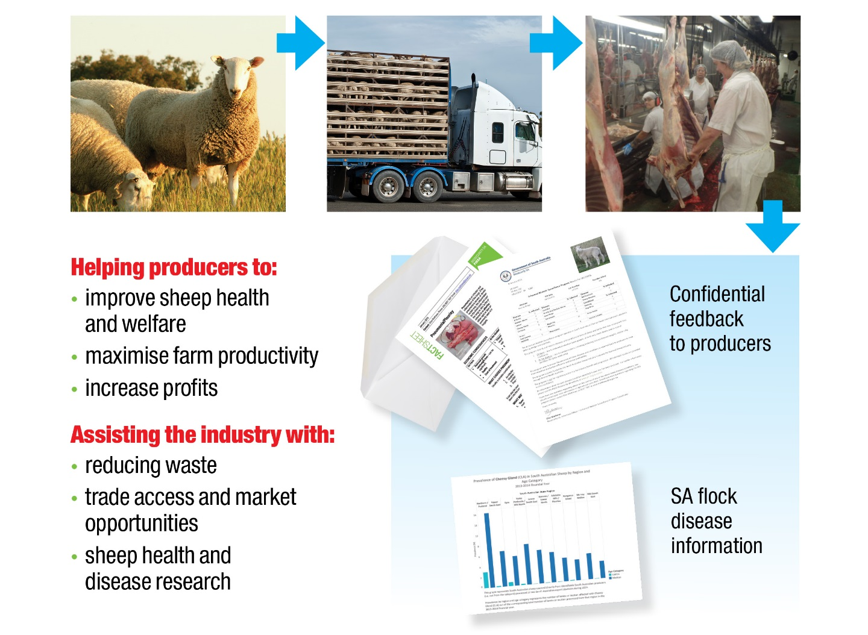

Snapshot of 2020

2020 Enhanced Abattoir Surveillance at Thomas Foods International (TFI) Lobethal included:

~1.4 million Australian sheep

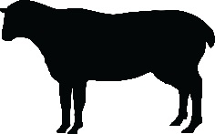
of which 81% were South Australian

From ~2,100 South Australian properties

across all regions of the State

This included 43% of commercial** South Australian producers

resulting in >2,200 feedback letters

and >5,100 feedback emails

*For the purpose of this report, as at 16 February 2021 commercial producers were defined as those who transferred >100 sheep on the NLIS database in 2020.

2020 Program summary and updates
The Enhanced Abattoir Surveillance program has continued to deliver uninterrupted, comprehensive abattoir monitoring at TFI Lobethal throughout 2020, despite disruptions to many programs and industries across Australia due to the COVID-19 pandemic response.
Feedback has been provided to SA producers by email and letter about condition occurrence and potential on-farm intervention by fact sheets.
Since early 2021, South Australian sheep producers may request ongoing Johne’s Disease (JD) inspection of their direct mutton consignments at South Australian TFI abattoirs (currently only Lobethal). The sheep are inspected for lesions in the intestinal tract. Any lesions detected will be further tested to confirm JD by the laboratory (tissue examination – histopathology). Register at https://pir.sa.gov.au/biosecurity/animal_health/sheep/health/ojd/voluntary_abattoir_surveillance
A suite of factsheets about the diseases and conditions assessed are available on the PIRSA website and also by request (at pir.sa.gov.au/eas).
Further email or phone call support is provided to all producers with any queries.
Research using historical de-identified data is ongoing to drive improvement both on-farm and in supply chain performance, to benefit the livestock industry.

Since November 2019, South Australian data is visible to producers registered on One Biosecurity, with all future results (from the date they register and set up an account with One Biosecurity) being visible online (https://www.onebiosecurity.pir.sa.gov.au/Home).
Since late 2018, results are also available on Livestock Data Link, which is updated monthly with new South Australian data (https://www.mla.com.au/research-and-development/livestock-data-link/).

How to interpret feedback and EAS results
Consider all available information when interpreting EAS results.
The following procedure may assist:
- Weigh sheep prior to loading. Keep a record of weights and use this as a guide only to calculate expected carcase weights (keep in mind curfew and transport further reduces these weights).
- When you receive your invoice and summary feedback sheet from the processor ask yourself the following questions:
  - Are the carcase weight ranges what you expected from the line of sheep consigned?
  - Did you incur grid penalties for underweight carcases?
  - How many animals were lighter than expected?
  - Were there any carcasses condemned for monitored conditions?
- Identify any conditions present in your consignment by referring to the EAS feedback letter received. Consider the degree of trim that may be associated with each condition (refer to Table 1 below and the information within this report).
Example of a high value carcase.
- Compare your EAS feedback results to others in your region and the state. This information can be found in regional benchmarking reports at pir.sa.gov.au/eas and within this report.
- Involve your private vet, livestock agent, local PIRSA animal health officer or livestock consultant to further assist on-farm decision making.

EAS monitored conditions and relative potential impacts on carcase weights
Conditions that reduce carcase weights during processing due to trim | Arthritis, grass seeds, pleurisy and dog bites – trim can be significant, depending on severity.
 | Bruising, cheesy gland (CLA), rib fractures and vaccination lesions – trim generally less significant than for conditions listed above.
Conditions that may result in condemned carcases | Severe sheep measles (C.ovis), polyarthritis, bruising and jaundice.
Conditions only affecting offal (no impact on carcase weight at the time of processing) | Bladder worm, sheep measles (C.ovis), pneumonia, sarcocystis, nephritis, cirrhosis, knotty/pimply gut and liver fluke.

2020 results for conditions monitored
The ultimate aim for producers and processors alike is maximum carcase yield with minimal waste. Production of a carcase free of disease or other conditions ensures producers maximise production efficiency on farm as well as carcase weight and grid price at slaughter. A high value chilled product, free from trim, downgrading or offal condemnation is also the ultimate desired outcome of a carcase for processors.
With all supply chain sectors aiming for the same premium product, EAS feedback is highly valuable for producers and should be used strategically to improve sheep health/production efficiency, animal welfare and carcase value.
For the purposes of this report, prevalence refers to the percentage of sheep affected out of all sheep processed for that area and age category.

Symbol Key
The following key has been developed to display the significant information for each condition on the following pages.
= specific trends, regional or other information
= lamb and mutton specific information
= effect of the condition on farm
= condition description and/or cause
= proportion of producers consigning affected stock
= effect of the condition at the abattoir

Seeds in the carcase due to spear, brome, barley, silver and Chilean needle grasses, geranium and others.

= ↓weaner growth rates → lighter weaners, ↓ wool production, associated pain/discomfort and ↓ carrying capacity.
= ↑ trimming (lighter carcases) which can be significant, c/kg penalty and damaged skins.
2020 Grass Seeds – Lamb

Grass Seeds
Cause and consequences

~1 in 15 producers consigned affected stock.
1.7% lamb prevalence (range 0% to 10.9% across the State).
1.5% mutton prevalence (range 0% to11.2% across the State).

Grass seed prevalence in lambs continues to occur at the highest prevalence in the Upper South East/Murray Mallee, however, has reduced overall in SA in 2020 compared with 2018 and 2017 (2-fold reductions).
2020 Results
Swollen and damaged joints caused by bacteria entering wounds at marking/mulesing or via the umbilical cord at birth.
= deaths (+ culling cripples not fit for transport off farm),
↓ production. Arthritis is a condition of welfare concern.

= trimming of affected joints, carcase condemnation if >4 joints affected.

Arthritis
Cause and consequences
2020 Arthritis – Lamb
2020 Results
~1 in 5 producers consigned affected stock
0.3% lamb prevalence (range 0% to 0.8% across the State).
2.2% mutton prevalence (range 0.3% to 5.5% across the State), which is a slight reduction from 2019.
Arthritis is a State-wide issue. On average 1 in 15 carcases are trimmed for the condition within affected lines.

Sheep Measles (Cysticercus ovis)
Cause and consequences
Cysts detected in sheep muscle – carcase and/or offal. Cysts are the larval stage of a tapeworm parasite found in dogs.

= no effect on sheep health on-farm. Monthly de-worming of ALL dogs on farm with Praziquantel (also controls bladder worm).
= trimming or carcase condemnation if >5 cysts detected.
2020 Sheep Measles – Mutton

2 in 3 producers consigned affected mutton.
0.7% lamb prevalence (range 0.1% to 2.6% across the State).
4.4% mutton prevalence (range 1.5% to 6.3% across the State), a slight increase from 2019.
Sheep Measles is found in similar levels on fox free Kangaroo Island as mainland SA. Therefore, dogs should be still be considered the main carriers and should be de-wormed monthly with praziquantel.
2020 Results

Pleurisy
Cause and consequences
Extension of pneumonia (lung infection/inflammation) causing parts of the lungs to stick to the chest wall (valuable rack of ribs).
= ↓ production and deaths in some instances.

= trimming of the ribs to remove adhesions (↓ carcase weight).
2020 Pleurisy – Mutton
2 in 3 producers consigned affected mutton.
0.5% lamb prevalence (range 0% to 1.8% across the State).
6.3% mutton prevalence (range 3.7% to 9.4% across the State).
Pleurisy is a significant condition in mutton lines across all State regions. On average, in 1 in 10 carcases are trimmed for the condition in affected lines.
2020 Results

Pneumonia
Cause and consequences
Infection/inflammation of the lungs caused by the combination of an infectious agent, poor sheep immunity/stress and environmental conditions (hot, dry and dusty).
= ↓ production and deaths in some instances.

= condemnation of lungs.
2020 Pneumonia – Lamb
2020 Results
 | 1 in 25 producers consigned affected stock, a two-fold reduction compared with 2019.
 | 0.6% lamb prevalence (range 0% to 2.1% across the State).
 | 0.4% mutton prevalence (range 0% to 6.1% across the State).
; | Pneumonia is of particular concern when it progresses to cause pleurisy. Pleurisy is found in almost all lines of mutton and requires carcase trimming. Prevalence of pneumonia has reduced in 2020 compared with 2018 and 2017 (3-5 fold reductions).

Contagious bacterial disease causing lymph node abscesses. It is most commonly transmitted at shearing. Vaccination is effective.

= ↓ wool production (up to 7% in the year of infection), wool contamination, occasionally chronic infection causes ill-thrift, emaciation and poor reproductive performance.

= trimming (↓ carcase weight).

Cheesy Gland (CLA)
Cause and consequences
2020 Cheesy Gland – Mutton
1 in 3 producers consigned affected mutton.
0.0% lamb prevalence (range 0% to 0.2% across the State).
5.2% mutton prevalence (range 0.9% to 16.3% across the State).
CLA remains a problem in mutton sourced from the Northern Pastoral and Murray Mallee regions.
2020 Results

Vaccine Lesions
Cause and consequences
Abscesses from incorrect needle length, vaccinating wet sheep and/or using blunt or dirty needles. All vaccines should be given under the skin high on the neck and not into muscle.
= if vaccine is given on the face, reactions can interfere with feed intake.

= trimming (↓ carcase weight), less impact if lesion is high up on the neck rather than in the legs or along the back.
2020 Vaccine Lesions – Lamb
1 in 10 producers consigned affected stock.
4.1% lamb prevalence (range 0% to 26% across the State), a two-fold increase compared with 2019
4.2% mutton prevalence (range 0% to 28.7% across the State), a nearly two-fold increase compared with 2019.
The highest level of vaccine lesions are seen in the Murray Mallee for both lamb and mutton. This program records all vaccine reactions; some would be caused by Gudair® for which reactions can occur regardless of vaccination technique or hygiene.

2020 Results
Weak bones result from mineral deficiencies or imbalances * (especially calcium and copper). Weak bones may break without excessive force or as a result of inappropriate handling/facilities.
= ↓ production and is of welfare importance.
= affected ribs trimmed (↓ carcase weight).
2020 Rib Fractures – Lamb

Rib Fractures
Cause and consequences

1 in 20 producers consigned affected stock.
0.4% lamb prevalence (range 0% to 4.2% across the State). .

0.2% mutton prevalence (range 0% to 5.0% across the State).
Research estimates rib fractures cost the SA industry $3M annually, $25/carcase to the processor and $1.30/carcase to the producer *.
(*C.Trengrove, I.McFarland (2015) MLA report B.AHE.0252 Lamb rib fractures preliminary investigation)
2020 Results
A result of external trauma, usually caused during yarding, transport or if processed within 2 weeks off shears.
= a condition of welfare importance.

= trimming of discoloured muscle (↓ carcase weight).

Bruising
Cause and consequences
2020 Bruising – Lamb
~1 in 10 producers consigned affected stock in 2020 compared with ~1 in 4 producers in 2019.
0.3% lamb prevalence (range 0% to 1.6% across the State).
1.2% mutton prevalence (range 0.1% to 3.2% across the State).
If bruising is extensive or deep, entire legs may be trimmed.

2020 Results
Larval cysts (‘bladders’) found in the liver. Cysts are the larval stage of a tapeworm parasite found in dogs (and foxes).
= usually no effect on sheep health, will occasionally trigger Black Disease (a clostridial disease) in unvaccinated stock.

= livers are trimmed or condemned.
2020 Bladder Worm – Mutton

Bladder Worm
Cause and consequences

~8 in 10 producers consigned affected mutton.
2.0% lamb prevalence (range 0.2% to 6.3% across the State).
21.2% mutton prevalence (range 8.9% to 38.5% across the State).
The advantage producers gain by controlling bladder worm is that these control measures are also controlling/preventing Sheep Measles (a condition that can result in carcase condemnation).
2020 Results
Damaged/scarred liver due to ingestion of toxic plants e.g. Potato weed (heliotropes), Salvation Jane, Lesser loosestrife, Caltrop and Panic grasses.
= ↓ production.

= liver condemnation.
2020 Cirrhosis – Mutton

Cirrhosis
Cause and consequences
Very few producers (~1 in 20) consigned affected mutton in 2018 & 2019, however numbers doubled in 2020 to ~1 in 10 producers.
0.0% lamb prevalence (range 0% to 0.1% across the State).
1.1% mutton prevalence (range 0% to 5.5% across the State).
Cirrhosis is usually only of concern in mutton due to prolonged and repeated exposure to toxic plants/weeds.

2020 Results
Due to bacterial spread from contaminated marking/mulesing wounds and inflammation of the rumen (due to grain feeding), toxic plant ingestion and some other toxins.
= obvious clinical signs of disease are only observed if >75% of kidney function is affected.

= kidney condemnation.
2020 Nephritis – Lamb

Nephritis
Cause and consequences
1 in 5 producers consigned affected lambs.
2.7% lamb prevalence (range 0.5% to 13.0% across the State).
0.2% mutton prevalence (range 0% to 3.1% across the State).
Nephritis appears to be a lamb specific condition. Its significance in terms of effect on productivity is poorly understood. Increased levels were observed in lambs in the Upper South East region in 2020.
2020 Results

Low prevalence and other conditions
Jaundice was not detected at levels of 5% or more in any consignments to TFI in 2020. |  | Liver Fluke was not detected at levels of 5% or more in any consignments from SA properties to TFI in 2020.
Knotty gut/pimply gut, caused by the intestinal parasite Nodule worm (Oesophagostomum columbianum), was detected on 115 SA properties in 2020. The parasite prefers a summer rainfall climate. |  | Sarcocystis is only a concern for producers on Kangaroo Island (18% mutton prevalence 2020, compared with 33% in 2019). 61% of Kangaroo Island producers consigned affected mutton.

On-site plant tours
Due to the COVID-19 pandemic throughout most of 2020, on-site plant tours were not possible.
In previous years, tours have been popular, providing producers and their associated agents/rural re-sellers with key insights into the operation and market drivers of processors.
It is unclear if tours will resume under current health restrictions, however producers interested in taking part in a tour should contact their local rural re-seller, or TFI buyer to investigate the possibility of resuming these tours.

EAS data use for research and other projects

Reducing the financial impact of endemic conditions in sheep – a value chain approach: University of Adelaide
This three-year project is led by the Davies Research Centre at The University of Adelaide in collaboration with SA Sheep Industry Fund (SIF), Thomas Foods International (TFI), JBS Australia, PIRSA Biosecurity SA, Meat & Livestock Australia (MLA) and Animal Health Australia (AHA).

Project summary
The impact goal of this project is to reduce the occurrence of endemic health conditions in South Australian sheep by investigating an abattoir-based decision support system. The project is expected to identify ways to enhance the flow of animal health information to improve both on-farm and across the supply chain productivity. The project focuses on eight health conditions selected because they have either a high occurrence or cost, and their potential for prevention or effective on-farm control. The conditions of investigation include (i) arthritis/polyarthritis, (ii) sheep measles, (iii) pleurisy, (iv) pneumonia, (v) grass seeds, (vi) lungworm, (vii) cheesy gland (or caseous lymphadenitis, CLA) and (viii) rib fractures. The project will be undertaken in SA but can provide a model that could be implemented on a national basis.
Descriptive epidemiology using the Enhanced Abattoir Surveillance (EAS) Program data
As part of the Enhanced Abattoir Surveillance (EAS) program, the frequency of up to 21 sheep conditions are routinely being recorded since 2007 by meat inspectors for every consignment slaughtered at the TFI export abattoirs. We used the EAS program data to conduct a descriptive epidemiological analysis on all but one condition (CLA previously analysed). The analysed dataset included 18.7 million South Australian sheep (12.9 million lamb and 5.6 million mutton) slaughtered between 2007 and 2019 (87,535 consignments in total). The frequency of detection of each selected condition was analysed across three dimensions – space (e.g. PIC regions), time (e.g. year and season) and population strata (e.g. age classes, abattoir location, direct/indirect consignment, and producer type). Based on the consignment pattern over the 13 years period (i.e. consignment frequency, size and animal age class), each PIC in the dataset was classified into one of six producer type based on a principal components analysis. Spatial trend analysis was conducted using density mapping to identify potential geographical clusters of each condition for lamb and mutton. The potential correlation with climatic conditions (rainfall and temperature) on the distribution of a condition was also investigated.
Producer engagement
We initiated multiple engagement workshops with separate producers and producer advisor groups to 1) inform on the investigated health conditions that have a production impact in the sheep meat industry, and to 2) share on-farm control strategies options for producers to prevent or reduce the occurrence of these conditions. In both face-to-face and online workshops, participants were presented with the EAS project objectives, results from our investigation and specific information (causes and impact) about the eight selected conditions. The workshop participants were also consulted on their experience with animal health feedback, e.g. what information do they currently receive and in what format, what did they like or didn’t like and would they like more or less information.
EAS Program data used in veterinary students projects
Two veterinary students from The University of Adelaide used some of the EAS data to complete their 4th year Clinical Research Projects. Ms Shannen Schultz undertook a two-part aetiology study of Knotty Gut to confirm if Oesophagostomum columbianum is the main cause of this condition. She collected samples at TFI Lobethal, and described the geographical distribution of the condition as well as population characteristics using the EAS Program data. Shannen could not source enough samples to confirm that Knotty Gut is primarily caused by Oesophagostomum columbianum in South Australia. She found however an association between the detection of Knotty Gut and Liver Fluke or Lungworm at the property level. She also found that the distribution of properties with Knotty Gut cases in South Australia are correlated with locations with historical increased rainfall. This condition could be managed by tailoring property-specific control programs to these high-risk areas.
Ms Amy Day investigated the frequency and aetiology of lungworm in two prominent sheep producing regions in South Australia that are climatically different. Amy also investigated the association between lungworm and drenching practices. Lungworm is one of the most common abattoir findings in South Australia and leads to condemnation of red offal and a reduction in overall carcass value.
The manuscripts will be finalised and expected to be submitted as a peer-reviewed journal articles as well as information articles to producers in 2021.
Case-control study to examine production losses associated with the eight conditions at a South Australian processor
To quantify the cost of conditions, we designed a case-control study (match one carcass with a condition, with a carcass with no apparent condition) at a Southern Australian processor to measure the associated trimming weight and hot standard carcase weight (HSCW) loss for each of eight conditions. So far two samplings have been conducted in late 2019 (spring) and early 2020 (summer). Due to COVID-19, the final two sampling seasons (autumn and winter) have been rescheduled for May and September 2021. Approximately 9,000 lamb and mutton carcases were inspected from 159 consignments - 3,990 cases with at least one condition of interest and 5,021 controls with no apparent condition. Rib fractures had the heaviest impact on carcass weight in lambs with an average loss of 0.830.79 kg (or 3.51% of the average carcass weight) followed by arthritis (-0.79 kg or 2.88%) after accounting for trimming and other conditions. Pleurisy and arthritis had the heaviest trim weights in lambs (0.76 kg and 1.24 kg respectively). This information will be used in the producer engagement part of the project by providing an understanding on how these conditions impact on the finances along the supply chain.
Lead change on project
From January 2021, there will be changes in the project lead. Dr Torben Nielsen resigned from his position with The University of Adelaide in December 2020. Associate Professor Charles Caraguel, a veterinary epidemiologist, will commence as project lead as of January 2021.
Funding mechanism: This project is funded by the South Australian Sheep Industry Fund and the MLA Donor Company (MDC) - a fully-owned subsidiary of Meat & Livestock Australia (MLA).

The production effects, diagnosis and control of small lungworms in sheep: Jenny Hanks
Jenny started her PhD in 2018 at the University of Melbourne, although her research has involved working with producers from South Australia. Jenny’s research has quantified a potentially important health problem for the sheep industry in South Australia by developing a better understanding of the impact that small lungworm (Muellerius capillaris and Protostrongylus rufescens) has on sheep production. This has involved investigating the distribution on infected farms, the amount and nature of any associated production losses and control options.
Infections of sheep are often detected at post-mortem examinations and at abattoirs but thought unimportant because few obvious clinical signs can be directly attributed to them on farms. However, heavy lungworm infections may cause production loss, either directly or by potentiating other respiratory diseases, such as pneumonia. Producers with a high risk of lungworm infections from the southeast of South Australia were concerned about the potential impact.
Jenny’s research compared carcass characteristics with the prevalence and severity of lungworm infection based on visual assessment of lungworm nodules. Whilst a very high prevalence of small lungworm was found, carcass weights were not reduced in infected sheep and infection did not appear to increase the risk of a sheep having pneumonia. Results also suggested that there was no difference in the prevalence or effect of small lungworm between adults and lambs.
The effect of pasture molluscicide treatment on the prevalence and severity of small lungworm infections, and the productivity of lambs grazing improved pastures was also studied. Snails are the intermediate host of small lungworm, and therefore molluscicide was a potential control strategy. A randomised control field trial of 260 Merino-cross lambs was conducted on a commercially managed farm in South Australia with a history of small lungworm. A similar proportion of Treatment lambs (those grazing pasture treated with iron chelate molluscicide) and Control lambs had evidence of small lungworm infection at slaughter (both 67.8%). The trial found that the molluscicide did not improve lamb production.
This research reassures producers, that whilst highly prevalent, small lungworm is unlikely to be contributing to major economic losses.

Accessing EAS data online

Producers registered with One Biosecurity
One Biosecurity (1B) is a new state-wide approach to managing, protecting, and promoting South Australia's strong biosecurity regime across its livestock industry.
Primary Industries and Regions SA (PIRSA), through Biosecurity SA, has developed the program in collaboration with the livestock industry, in particular with the assistance and support of Livestock SA.
As part of One Biosecurity, livestock producers can register, manage and declare their farm biosecurity online. Producers who use 1B can develop greater resilience and flexibility to meet the demands and challenges of changing markets and potential disease threats.
Producers who sell sheep directly to Thomas Foods International (TFI) Lobethal abattoir can access their EAS program results via the One Biosecurity system. All future results from the date of signing up to One Biosecurity will be made available online, including both lines affected with the diseases/conditions monitored and also clean lines. The results are displayed on a graph as illustrated below, which shows the percentage of the line affected by the disease/condition.
For further information, please contact:
One Biosecurity Information and Support
08 8429 3300
1BSupport@sa.gov.au
www.onebiosecurity.pir.sa.gov.au
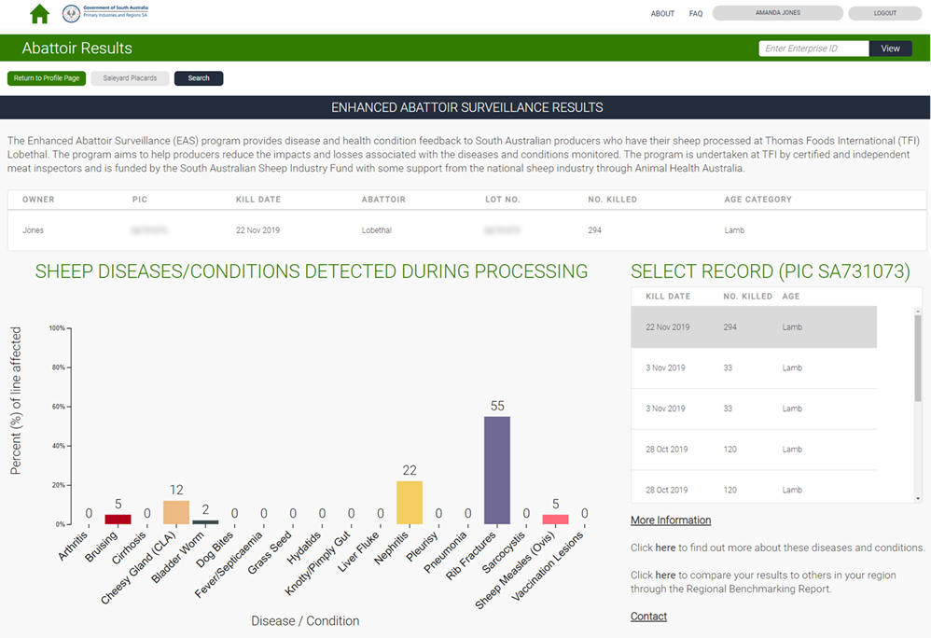

Producers registered with Livestock Data Link (LDL)
Livestock Data Link (LDL) is an online application that facilitates improved information sharing in the supply chain. LDL enables feedback to be received, analysed, and compared to other results in an efficient way. Consignment performance can also be linked to supporting materials such as fact sheets and web links to help understand what management practices could be considered to improve performance. The overall objective of LDL is to assist in optimising supply chain performance through turning complex information into simple decision making, through analysis and reporting.
LDL currently offers two modules:
- carcase compliance – users can analyse carcase performance in terms of compliance to the grid they consigned against, with performance outcomes linked to a library of solutions on how to address non-compliant issues on farm.
- animal health information – users can view any animal health conditions that were identified as part of post-mortem inspection. Please note the current functionality relates only to sheep health data collected through the National Sheep Health Monitoring Project.
To access carcase compliance and/or animal health data in Livestock Data Link (LDL), you need to consign to a processor participating in either the LDL program or the National Sheep Health Monitoring Project (NSHMP). Currently there are 26 processing facilities (involving 18 supply chains) participating in the LDL program from either a carcase compliance or animal health perspective. These companies are at various stages of implementation and involve both beef and sheep processors.
How do you register for Livestock Data Link?
LDL can be accessed by using your National Livestock Identification System (NLIS) User ID and password. If you do not already have an account with NLIS you will need to create one at https://www.nlis.mla.com.au.
Go to the LDL login page and enter your NLIS User ID and Password and click Login. Upon entering LDL for the first time, you will be required to agree to the LDL Terms of Use, after which your account will be activated and you will be able to view reports on your data within LDL.
Alternatively, you can log in to your LDL account through myMLA once your registration has been confirmed through LDL. For more information on how to register for myMLA and link accounts within this platform please go to the new online industry services section of the MLA website.

