DROUGHT AND FROST RELIEF BILL 1944
Legislative Assembly, 9 November 1944, pages 916-21
Second reading

The Hon. T. PLAYFOED (Gumeracha— Premier and Treasurer)—-The object of this Bill is to authorize the Government to give assistance to primary producers who, during this year, have suffered loss as the result of drought and frost. As hon. members will see, the Bill is sufficiently wide to cover losses either through drought or frost damage. I want to make it clear that this relief is given in accordance with arrangements which will be made between the State and the Commonwealth. As far as drought relief is concerned, substantial agreement has been reached with the Commonwealth Government in regard to payments, but no agreement has been reached in respect of frost damage. The matter has been submitted to the Commonwealth Government but I have not yet received a reply as to whether it is prepared to include payment for frost damage). I want it clearly understood—and I hope some publicity will be given to the matter —that it does not mean that frost relief will automatically be paid. Under the Bill, the distribution of relief is to be made in accordance with an agreement which must be reached between the Commonwealth and the State, because half of the money for the fund it is proposed to establish is being provided by the Commonwealth. The State is under some obligation to the Loan Council in regard to the remaining portion. I repeat that any power which the State Government may have to make payments in respect of frost damage is subject to the over-riding limitation that this frost relief is only to be available subject to the Commonwealth Government concurring and on a basis agreed upon between State and Commonwealth.

Let me now give the House some information regarding the agreement with the Commonwealth and the amendments it is proposed to expend. I received a letter from the Commonwealth Treasurer, Mr. Chifley, under date November 1 last, and if I place it on record it will enable members to properly discuss the question and give them the fullest information in regard to the position One of the paragraphs in the letter is to the effect that no announcement of the amount to be paid for drought relief should be made, but yesterday I noticed that an announcement had been made in Canberra and I feel justified, therefore, in concluding that I am now at liberty to make the matter public, as I believe that members of this House have a right to know what will happen to the money which is to be made available under the Bill The letter begins:— "In accordance with the resolution of the Premiers ’ conference on drought relief a committee composed of officers from the Commonwealth. New South Wales, Victoria and South Australia met to consider details of a drought relief plan.”

Diverting for a few moments, I strongly advocate that we should not charge the settler interest and administration, because in many instances, by the time he has tried to overcome his heavy commitments because of the drought, another drought might have descended upon him and his financial position might go from bad to worse, and the Government would have to finish up by introducing moratorium or debt adjustment legislation. If we are to give real assistance, I feel that we should try a new device, as those previously tried have not proved successful and have, led to much trouble to Government departments in trying to collect uncollectible amounts. This undoubtedly has caused considerable distress to settlers.

Mr. Macgillivray—And caused ill feeling?

The Hon. T. PLAYFOED—Yes. I-think that the House agrees that if we are to ask farmers to stand the complete loss of drought they must be paid in good times more substantially for their wheat to enable them to tide over bad times.

The Hon. E. S. Eichards—Do you not mean a more economic price?

The Hon. T. PLAYFOED—They must, get not only an economic price for that particular year but sufficient to tide them over a period of loss through weather conditions. The letter continues: —
The committee assumed for the basis of its recommendations that the fund is intended
to be applied:—(1) as a gift; (2) without any means test.
The committee has forwarded its recommendations to the Commonwealth Government, which in turn has sent them to the States. They have not yet been approved by the Commonwealth Government, but no doubt they will be substantially approved, although there may be some variation in accordance with the request made by this State. The committee’s recommendations are as follows:—
- Belief to be paid in cash and that provision be made to prevent its being claimed by creditors;
- As it appears that there may be a loss incurred in connection with the supply of seed wheat to growers it is considered that, if there is any surplus remaining after payment of drought relief, the surplus might be used to meet the loss on seed wheat.

That introduces an entirely new phase into the question, and I have made representations to the Commonwealth Treasurer and asked him to give it further consideration. If these funds are to be used to subsidize the Wheat Board’s activities, I feel that it may seriously curtail the assistance proposed under the Bill. It would amount to a double subsidy to some farmers and I believe that this House would not be prepared to recommend that as being equitable. Therefore, I have asked that that particular provision be deleted, because I do not believe it is the State Government’s function to assist to subsidize the Wheat Board’s activities, particularly activities which normally should pay their way. The letter proceeds:—
- Belief to be granted where the total yield of crops is under 6bush. an acre;
- For the purposes of assistance cereal crops should include barley, wheat, oats, wheaten and oaten hay;
- The maximum grant to be as follows :12s. 6d. per acre for wheat actually sown; 10s. per acre for barley actually sown; 7s. per acre for oats actually sown; 12s. 6d. per acre for wheaten hay actually sown; 7s. per acre for oaten hay actually sown.
A total failure would qualify for the full amount of 12s. 6d. an acre.

Mr. Thompson—What would be the minimum payment for hay?

The Hon. T. PLAYFORD—If the hay crop is capable of being cut there will be no payment, and if a wheat crop is eaten off it will qualify for only half the grant. The letter continues:—
- There be no announcement of the rates to be paid as drought relief.
The points above cover the main features of the scheme of relief. The Committee made the following recommendations in regard to matters which concerned administration:—
(i.) The scheme to be administered by the States on uniform lines in accordance with plans submitted by the States and approver! by the Commonwealth,
(ii.) Provision of safeguards to ensure that recipients continue farming will best be covered by an appropriate clause in the form of application.

Mr. Macgillivray—What would be the position where a farmer had arranged to give up his farm?

The Hon. T. PLAYFOBD—The basis of this grant is to keep the farmer in production.

Mr. O’Halloran—To qualify for the grant, must he sow a certain acreage in the following year?

The Hon. T. PLAYFOBD—No stipulated acreage has been fixed, but what we want is an assurance that he will remain in the industry and continue farming. It is not the duty of the State to subsidize someone who intends to sell out. Mr. Chifley’s letter continues:—
(iii.) Loans, or provision of commodities, from drought relief funds will not be required.
(iv.) A maximum limit to the amount of' assistance to be granted any individual is not required.
(v.) The closing date for applications for drought relief to be January 31, 1945, and payments to be made as soon as possible after the new year.
(vi.) Damage by fire should not be included for relief purposes.
(vii.) States should exchange drafts of applications forms, so as to obtain reasonable uniformity.
(viii.) Where more than one farmer has an interest in a crop the assistance to be shared according to the existing arrangements to share the crop; subject to each claimant undertake to continue farming.
(ix.) Where a farmer has an interest in more than one property the aggregate yield for all properties.to be taken and relief paid accordingly.

Mr. Thompson—If a farmer has a good crop on one property and a poor one on another, but the average is over 6bush., he gets nothing ?

The Hon. T. PLAYFOBD—If a farmer on one property has nothing and on another gets 20bush, to- the acre, he should be able to carry on, and under those circumstances there is no justification for the grant to be made. He would be in a totally different position from a farmer who had a total failure on a single property.

The letter continues:—■
(x.) Farmers not in financial difficulties should not be discriminated against.
(xi.) Banks, companies, State institutions, etc., should not receive relief payments.
(xii.) Farmers who prepared for sowing and were unable to sow, should be entitled to receive up to 50 per cent of the failure rate, subject to submission of proof to the satisfaction of the State administration.
(xiii.) The area planted or intended for planting, should be 10 acres or more in order to qualify for relief
(xiv.) Provision is not required to cover crops compulsorily cut for hay.
It appears that the relief on the scale recommended can "be granted, and that the total will fair within the limit of £3,000,000. It is clear, however, that until the season is ended it is impossible for any State to give accurate estimates of the area affected, the degree of relief needed, or the total amount required. Similarly at present it cannot be stated whether the tentative allocation of funds made at the Premiers’ Conference should stand, or whether it will be necessary later to reconsider it.
At the Premiers’ Conference it was agreed that a total of £3,000,000 should be made available, half of which is to be provided by the States and half by the Commonwealth.
The allocation for South Australia was £900,000, of which the State will have to find £450,000. Mr. Ohifley’s letter concludes:—
I have not yet had an opportunity of conferring with my colleagues on the recommendations of the Committee, but should' be glad if you could give them consideration and advise whether you approve of them.
My reply to that was:—
With reference to your letter of the 1st instant (J.325/9/3), in regard to drought relief, I desire to inform you that since the Premiers’ Conference met at Canberra a very disastrous frost has caused heavy losses to many of the vine and fruit growers in this State. My Government feels that it would create a very invidious distinction if financial assistance were given to cereal growers whilst refusing it to another section of primary producers who have experienced a disastrous season as the result of the frost. For that reason and also taking into account that the maintenance of production in this particular industry is important, I would toe glad if you would take into consideration the question of allowing relief to be extended to frost damage as well as to cover drought conditions. This would involve a slight alteration of the terms set out in your communication . Those terms are generally acceptable to my Government, with the exception of (iv.) (b) on page 1 of your Wheat growers—
Total failure and below 1 bush, per acre . .
lbush. and below 2bush. per acre
Sbush. and below 3bush. per acre
3busli. and below 4bush. per acre
4bush. and below 5bush. per acre
5bush. and below 6bush. per acre
Barley growers—
Total failure and below lbush. per acre . .
lbush. and below 2bush. per acre
2bush. and below 3bush. per acre
3bush. and below 4bush. per acre
4bush. and below 5bush. per acre
6bush. and below 6bush. per acre
letter, which deals with losses incurred in connection with the supply of seed wheat to growers. These growers will be getting normal relief, and my Government feels that it is unable to agree to provide a small section affected with assistance disproportionate to other growers. For this reason we would desire that paragraph (iv.) (b) should be deleted from, the conditions. The other amendments I mentioned would be the inclusion of the words “and frost” at the end of (iii.), and also at the end of clause (iv.) (d). No other matter appears to call for comment at this state. Legislation has been prepared and will be introduced to make the necessary appropriation of money in South Australia, and I have made the Bill sufficiently wide to enable frost damage cases to be considered if your Government will concur.
To that I have not yet had a reply.

Mr. Macgillivray—What was the date of that letter ?

The Hon. T. PLAYFORD—That was written yesterday, but I had previously communicated with the Prime Minister by telegram, possibly seven, or eight days ago, requesting consideration regarding frost relief, and this statement is in addition to a previous submission I had made before I received the communication from the Prime Minister. To give members some idea of the amount which would be required for drought relief, I have here a statement setting out what is believed by the Agricultural Department to be a conservative estimate. Since this statement was prepared, distinctly helpful rains have fallen and the season in the main has improved to the extent that it is now believed that nearly every district will be able to take care of its own seed wheat requirements. From information to hand there will, even in the drier districts, be sufficient seed wheat to meet requirements. The position has improved to some extent since the estimate was made by our agricultural officers. The figures show the probable requirements to cover the scheme I outlined this afternoon. Departmental officers have set out in the following table the compensation they estimate will be required for 1944-45:—
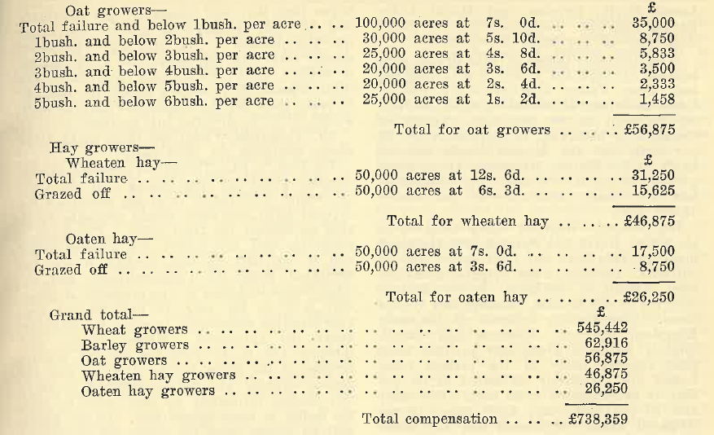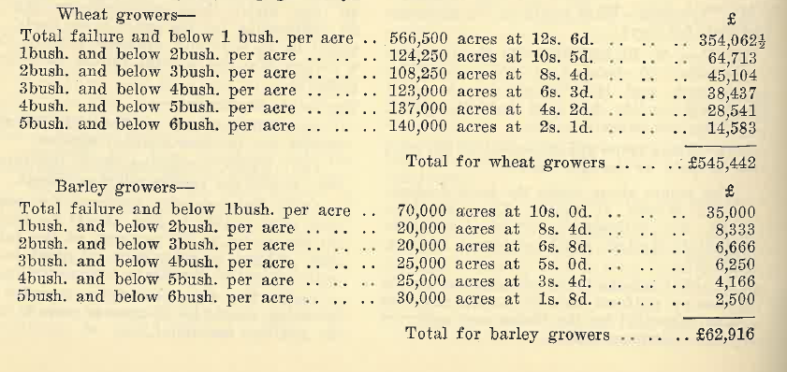

That is a conservative estimate. After having paid all the amounts proposed for assistance under drought relief from the £900,000 which has been provisionally allotted to us by the Commonwealth, more than £100,000 will be available, subject to the Commonwealth’s concurrence, for payment to growers whose crops have been affected by frost.

Mr. Teusner—Will the cost of administration be paid out of the £900,000?

The Hon. T. PLAYFORD—It is proposed that the administration in all States shall be uniform. Probably South Australia will undertake the administrative work without cost to the scheme.

The Hon. R. S. Richards—It would still be a good bargain to the State.

The Hon. T. PLAYFORD—Yes, and I hope our officers will be able to do the work, with perhaps a little assistance. I should like, if possible, to avoid drawing on the fund for administration expenses. In regard to frost damage, the following report has been made to the Minister of Agriculture:—

Frosts experienced in September and particularly those of October 7 and 18 caused widespread and erratic damage to many kinds of deciduous fruit trees and vines. Earlier frosts in June, July, and August occasioned damage to citrus fruits and in some areas—notably the Inman Valley— destroyed all foliage as well as fruit. Citrus trees which were totally defoliated and which have suffered extensive bark injury will take two or three years for return to normal production. Estimation of damage is most difficult owing to the erratic incidence of the frosts. Recognized frost pockets in some parts sustained little damage, whereas areas generally considered "safe" were cut badly. The position regarding major kinds of fruit is as follows:—

Apples.—Losses of individual growers ranged from nil to 50 per cent with some higher. The most serious damage occurred in the Northern Mount Lofty Ranges, Barossa, and Clare districts. Estimated loss for South Australia—10 per cent—70,000bush.

Pears.—Losses similar to those sustained by apples. Estimated loss for South Australia—7 per cent—15,000bush.

Apricots.—Most extensive damage occurred in the Lower North and Barossa areas, where there has been practically a total loss on unheated areas. In the Clare area the loss is practically total, and in the Barossa region 75 per cent to 80 per cent of the district crop has been destroyed. At Coonawarra in the South-East the apricot crop (about 10,000bush.) has been completely destroyed for the second year in succession. Erratic, but in some cases, serious losses were experienced throughout the Murray irrigation areas. There has been little damage on the Adelaide Plains or in the Southern district. Estimated loss for South Australia—40 per cent to 50 per cent—140,000.bush.

Peaches and Nectarines.—A cold, frosty, winter favoured bud development and, on the basis of blossom show, a peach and nectarine crop above average was in prospect. In some areas heavy thinning would have been necessary if all had gone well. Most serious losses occurred in the Barossa Valley and South-East. Freestone varieties suffered more than clingstones, and the former suffered about 50 per cent loss through the Barossa district. The entire crop was destroyed in the South-East. Moderate losses occurred in. low-lying areas through the Mount Lofty Ranges. Estimated loss for South Australia—15 per cent—25,000bush.

Plums and Prunes.—A light to average crop according to district was in prospect. The frosts caused heaviest losses in the Lower North, Barossa, and Mount Lofty Ranges districts. Estimated loss for South Australia—15 per cent—20,000bush.

Wine Grapes.—Losses of wine grapes were heaviest through the Lower North, Barossa, and Eden Valley districts where district losses have been estimated variously at from 30 per cent to 60 per cent. Losses at Coonawarra amounted to approximately 25 per cent, and the Muscat Gordo suffered badly in the Murray Irrigation Areas, many growers losing their entire crop. Estimated loss for South Australia—17 per cent— 12 000 tons.

Dry Grapes.—Heaviest losses occurred in the Lower North and Barossa districts where many growers have lost their entire crop of currants. Damage in the irrigated areas has been difficult to estimate. Severe damage occurred in the Monash, Glossop, and Winkie areas. Less damage occurred at Renmark, Kingston, Moorook, Waikerie, and Cadell. Slightly damaged areas may produce more than appears likely at the present time. Losses are tentatively estimated at 60 per cent, in non-irrigated areas (say, 1,000 tons) and 10 per cent (say, 2,000 tons) in the irrigated areas. Estimated loss for South Australia—say, 15 per cent—3,000 tons dried.

Citrus.—Losses of citrus occasioned by the heavy frosts early, in the year were very variable according to district, topography, and variety. Lemons suffered badly almost everywhere, and in low-lying areas much of the orange and mandarin crop dried out and became useless. In the frostiest locations trees were severely damaged and in the Inman Valley all trees were completely defoliated and quite large limbs killed. Most trees in the Inman Valley will not return to normal cropping for two to three years. An estimate of total State losses is very difficult- as much frost-damaged fruit was salvaged by the juice factories. It is considered that total losses would amount to 5 per cent of the estimated crop of all kinds of citrus— 867,000bush. Estimated loss for South Australia-—5 per cent—45,000bush.

Monetary Losses.—Based upon an approximate value of naked fruit (exclusive of dry- in or packing- costs) the State losses are estimated as follows:—
£
Apples 18,000
Pears 6,000
Apricots 49,000
Peaches 9,000
Plums, prunes 5,000
Wine grapes .. 96,000
Drying grapes 90,000
Citrus 27,000
£300,000

Mr. Strickland’s recommendation gives an outline of what he considers is the-best method of approaching a most difficult question and what relief should be granted for frost damage. As the Commonwealth Government has not approved of payment for any frost damage it would be inappropriate to raise growers’ hopes that they will ultimately get assistance and for that reason I do not propose to go into the question of the form that frost relief should take. In any ease, the whole matter is subject to Commonwealth approval. The State cannot, on principle, accept the liability to make good all the losses that may be occasioned either by drought, fire,, or frost.

Mr. Thompson—Could the State make other money available for frost relief?

The Hon. T. PLAYFORD—I expected an hon. member would ask why, seeing that the Commonwealth Government is giving assistance for drought relief, the State should not make available an amount for frost relief. The State is providing half the money for drought relief and it can only do that because it has the assurance from. the Commonwealth and the other States that they would be prepared, if necessary later in the year, to increase our loan appropriation sufficiently to cover the £450,000 under the agreement. Money in the first instance has to be paid out of the general revenue of the State, but as we know that our general revenue will not be sufficient to carry this charge, ultimately we shall have to raise the money in some special way. To the extent that we cannot cover the money out of general revenue, it is proposed that the Commonwealth Government, through the Loan Council, will make available the necessary additional money to finance this proposal. New clauses prepared provide that the Treasurer may float a loan to cover the money. Actually, I have the assurance of the Loan Council that it is prepared to make the money available. It will be made available as a deficit on ordinary revenue. On present figures we shall have a deficit this year, and I do not think it would be proper for the State to attempt to finance relief measures out of deficit. Not only would we have to pay possibly 3 1/4 per cent for the money, but I remind the House that deficit finance comes under a definite clause of the Financial Agreement, which provides that in addition we have to pay a very heavy sinking fund rate of not less than 4 per cent. Therefore, the interest paid would be not less, than 7 1/4 per cent, and no State could long continue to finance its activities on such a deficit basis.

I am hopeful that the Commonwealth Government will allow frost relief to be included in the. scheme. On the provisional amount granted to South Australia there is room to include relief for frost damage without asking for any additional money above that already proposed. Perhaps the Government may accept the extension. It is an extension, not only in money, but in principle. I hope that the extension will be granted.
I will now explain the clauses of the Bill. Clause 2 provides that the Treasurer may make a grant of money to any primary producer who has suffered loss as the result of drought or frost in the present year. The grant must be made in accordance with arrangements made between the State and the Commonwealth and a person will not be eligible for a grant unless he falls within a class of primary producers approved by or on behalf of the Commonwealth as being eligible for grants. Clause 3 merely sets out the financial machinery for making grants. They will, in the first instance, be met out of any cash balances available at the Treasury and debited to a suspense account. The suspense account will be ultimately recouped by the moneys paid by the Commonwealth and by State, moneys being either revenue or loan, according to what is available for the purpose. At this stage it is not possible to say whether there will be sufficient revenue, to make these grants out of revenue and it is therefore necessary to provide power for the Government to borrow. By clause 4 it is provided that the Treasurer may raise a sum not exceeding £450,000 for the purpose of making the grants under the Bill. Clause 5 is the usual appropriation clause. Clause 6 exempts documents executed in connection with applications for relief from stamp duty, while clause 7 contains the usual regulation-making power for the Government.

In conclusion, I should stress the fact that the Commonwealth, as a condition of making money available for drought relief, has insisted that it shall have the right to approve of the terms and conditions on which the money is to be distributed. The State will therefore be bound by these conditions and will not have a free hand to vary them without the concurrence of the Commonwealth . I move the second reading.

The Hon. R, S. RICHARDS secured the adjournment of the debate.

