Marine Scalefish Fishery Reform – Stage 1 information
June 2020

Contents
Aim 3
Marine Scalefish Fishery management zones 3
Cape Jervis/Backstairs Passage boundary 3
South of Kangaroo Island boundary 3
Marine Scalefish Fishery zones of management map 4
Recommended biological catches 5
Indicative TACC 5
Quota management for priority species 6
Proposed priority species for ITQ by zone 6
Feedback 7
Next steps 7
Contact 7

Aim
This document provides the following information about the marine scalefish fishery reform:
- boundaries of proposed management zones
- indicative Total Allowable Commercial Catch (TACC) for priority fish stocks
- indicative priority species to be managed under Individual Transferrable Quota (ITQ).

Marine Scalefish Fishery management zones
In its final report presented in October 2019, the Commercial Marine Scalefish Fishery Reform Advisory Committee (CMSFRAC) advised that there was support for dividing the fishery into four management zones; West Coast, Spencer Gulf, Gulf St Vincent/Kangaroo Island and the South East. However, further refinement was recommended for the Gulf St Vincent/Kangaroo Island zone and South East zone boundary.
A project team including fisheries managers, fisheries scientists, ecosystem modellers and fisheries officers have undertaken a further review to refine the boundaries. In refining these zone boundaries consideration was given to:
- advice from the CMSFRAC and industry feedback to the Industry Consultation paper (September 2019) relating to zoning scenarios
- existing marine fishing area (MFA) blocks used by fishers since 1983 to report catch and effort
- biological stock structure for snapper, and the recently developed snapper management boundary for South East waters
- habitats and bioregions identified through ecosystem modelling, which will be used to underpin future management strategy development, including:
- the outer depth limit of zones
- other SA fisheries and Commonwealth-managed fisheries
- natural breaks in habitat and connectivity

Cape Jervis/Backstairs Passage boundary
The proposed division of MSF block 44, into 44A and 44B, has been determined as the boundary as it aligns with a natural ecosystem break and with historical fishing effort in the fishery.

South of Kangaroo Island boundary
Feedback to the Industry Consultation paper favoured including the region south of Kangaroo Island in the GSV/KI zone. However, fishing effort in the MSF has been historically low in the region.
Current understanding of the biological stock structure for snapper indicates that the fish south of Kangaroo Island are likely part of the Western Victorian stock. Combined with natural ecosystem breaks including depth, habitat and connectivity it was determined that it is sounder for MFA blocks 48 and 49 to be included as part of the South East zone.
Most of MFA block 47 is deeper off shelf water, so was included in the Spencer Gulf management zone.
Do you have any comments on the proposed management zones? Complete the online feedback form.

Marine Scalefish Fishery proposed zones of management map
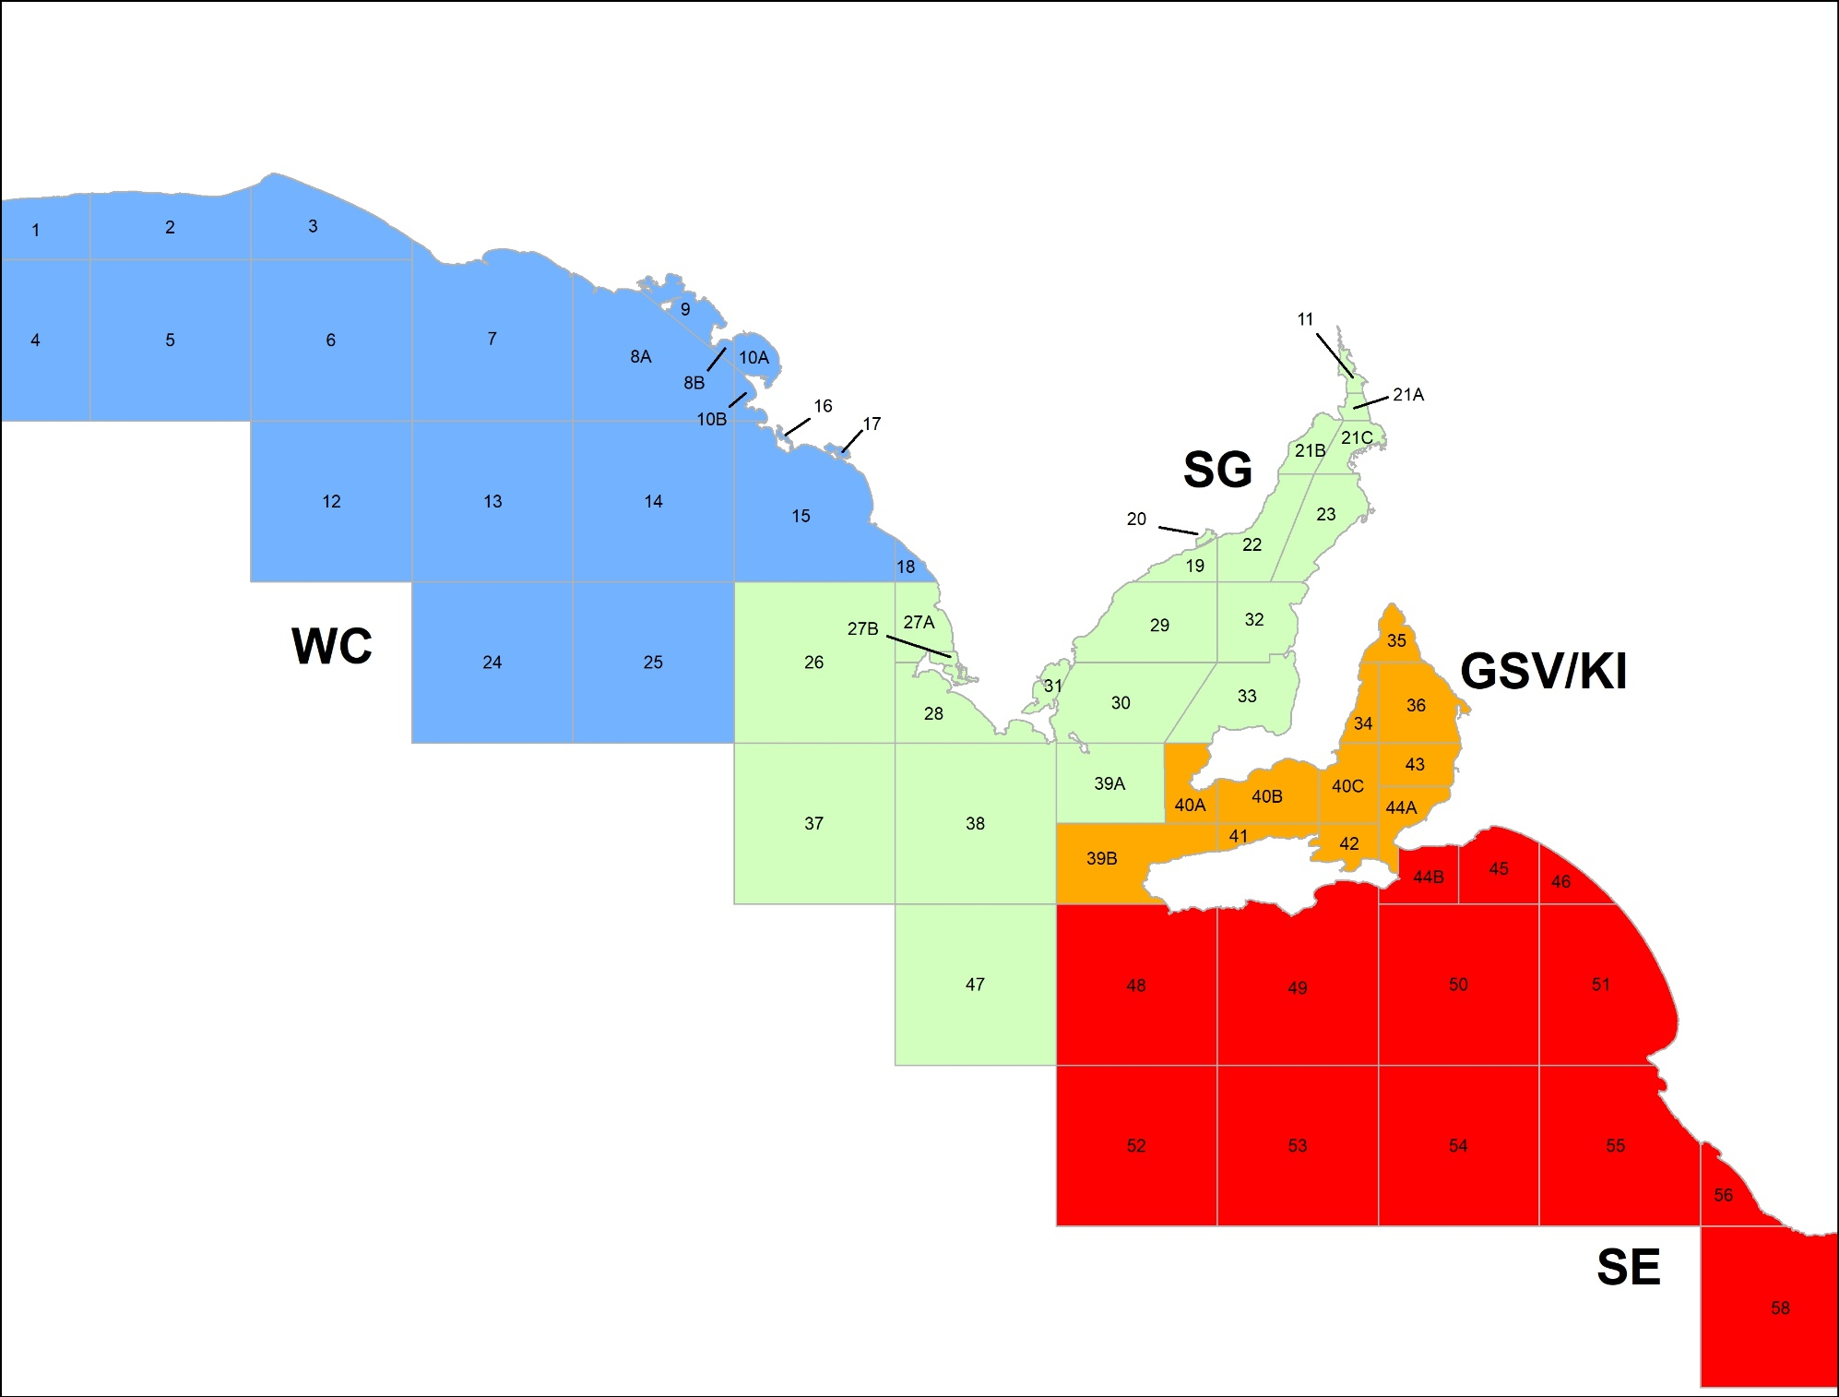

Recommended biological catches
The CMSFRAC recommended SARDI develop Recommended Biological Catch (RBC) limits for priority species in each region.
The RBC limits are based on the maximum level of catch to be harvested for each stock to maximise production while avoiding overfishing.
The indicative catches have been informed by latest stock assessments along with the best available data from recreational fishing surveys. A 1% allocation has been provided to the Aboriginal Traditional sector as per the current allocation in the MSF management plan.
The RBC for each species is dependent on current levels of biomass and will be adjusted over time depending on the outcomes of future stock assessments.

Indicative TACC
Indicative RBCs and TACCs have been determined for King George whiting, southern garfish and southern calamari within each of the four management zones.
Note, snapper information is yet to be determined as the supporting stock assessment is still being finalised.

 | King George Whiting (T) |  | Snapper (T) |  |  | Southern Garfish (T) |  |  |  | Southern Calamari (T)
 | RBC  TACC  3YR AVG* |  | RBC  TACC  3YR  AVG* |  |  | RBC  TACC  3YR  AVG* |  |  |  | RBC  TACC  3YR  AVG*
West Coast | 672 473 93 |  |  | - - 20 |  |  | 14 10 2 |  |  |  | 25 9 9
Spencer Gulf | 394 175 103 |  |  | - - 52 |  |  | 79 62 104 |  |  |  | 431 266 196
Gulf St Vincent/ Kangaroo Island | 188 76 43 |  |  | - - 200 |  |  | 61 50 77 |  |  |  | 230 162 164
South East | 10 0 0 |  |  | - - 19 |  |  | 7 1 1 |  |  |  | 3 1 1
*Three year catch average, 2017-2019.
Do you have any comments on the proposed TACCs for priority species across each region? Complete the online feedback form.

Quota management for priority species
The four priority species in the marine scalefish fishery are: snapper, King George whiting, southern calamari and southern garfish.
The concept of a tiered management approach was supported through the consultation process and the CMSFRAC recommended further refinement of a tiered management framework to be adopted for all zones of the fishery.
- Tier 1 - highly regulated ITQ system managed within a TACC
- Tier 2 - management arrangements designed to constrain the total catch within a RBC limit
- Tier 3 - monitored against prescribed performance indicators
A team of experts including fisheries scientists, an economist, social scientist and fisheries managers assessed the four priority species against the key criteria of their stock status; their importance to the recreational, indigenous and commercial fishing sectors; target levels; and their vulnerability to overfishing.

Proposed priority species for ITQ by zone

 | King George Whiting | Snapper | Southern Garfish | Southern Calamari
West Coast | ITQ | ITQ
Spencer Gulf | ITQ | ITQ | ITQ | ITQ
Gulf St Vincent/ Kangaroo Island | ITQ | ITQ | ITQ | ITQ
South East |  | ITQ
In Stage 2 information, a proposed tiered management framework tool will be released for consideration by licence holders. The tiered management framework tool will be used by the Management Advisory Council to assist in their recommendations of categorisation (tier allocation) of all MSF species by zone.
Do you have any comments on the proposed management framework for priority species? Complete the online feedback form.

Feedback
Licence holders are invited to provide feedback on this information. Feedback will be considered as part of future refinements to the reform process.
Please complete the online feedback form via www.pir.sa.gov.au/fishingreform

Next steps
In mid July 2020, Stage 2 information will be released for licence holders to consider and provide feedback. This information will include:
- the proposed method of allocating catch quota units to licence holders
- the compliance program to inform the integrity of the quota management system
- how other fisheries with access to marine scalefish will be integrated into the reform process
- research program to inform the new management framework
- potential amendments to regulations, licence conditions and management arrangements
- the tiered management framework tool.

Offers for the voluntary licence surrender program must be submitted by 13 November 2020.

Contact
If you have any questions on the reform process, please contact:

Email: MSF.Reform@sa.gov.au

Jon Presser
Manager Fisheries Reform
Phone: (08) 8429 0588

Alice Fistr
Senior Adviser Fisheries Reform
Phone: (08) 8429 3565

For more information visit www.pir.sa.gov.au/fishingreform

