ENHANCED ABATTOIR SURVEILLANCE PROGRAM

Vaccination lesions
Vaccination lesions are reactions, such as an abscess or scar tissue at vaccination sites. The incidence of vaccination lesions increases with poor technique and hygiene. Sheep vaccinated with the Gudair ® OJD vaccine often develop a large vaccination reaction at the injection site. This is “normal” for Gudair ® but not for the other vaccines commonly administered to sheep. If a severe reaction and infection occurs, the injection site can burst and discharge pus.
Condition summary
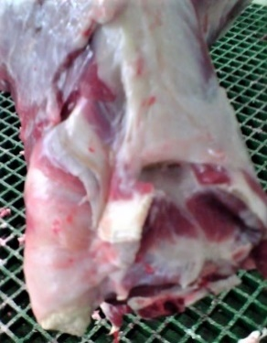
Vaccination lesions are the body’s reaction to an administered vaccine, at the site of injection. They are areas of thickened tissue which may contain pus or scar tissue. Lesions may be several centimeters in diameter. Reactions may be considered normal for Gudair ®.
Vaccine reactions may affect the ability of sheep to eat or walk if incorrect vaccination sites are used and an abscess or infection develops. An abscess initially may be a soft swelling which progresses to a hard reddened area with wool loss and discharging pus. Rarely flystrike and septicemia may develop if severe.
Vaccine lesions are trimmed from the carcass. This has the least impact on the value of the meat cut if vaccination is high up on the neck, behind the ear. Reactions associated with the spine or leg muscle results in more significant trimming and loss of carcass/dressed weight.
Prevention centres around correct vaccine technique, hygiene, and administration at the right location to avoid excessive trim of valuable cuts.

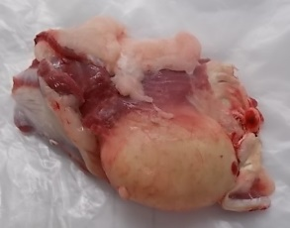

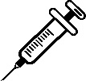
Large pus filled vaccination lesion at the top of the neck in a carcase (circled, top), and vaccination lesion removed in trim (bottom)

How do sheep get vaccination lesions?
Vaccination lesions other than those from Gudair ® are as a result of bacteria being injected under the skin, from dirty needles or vaccination guns, or vaccinating in wet or dusty conditions. Vaccines are designed to be given into the space under the skin, not into the skin, muscle or spine. Incorrect vaccination technique may cause bleeding or trauma in the underlying tissues which may contribute to vaccination lesions.

How do I prevent vaccination lesions?

Vaccination technique
- Ensure correct vaccination technique is demonstrated to new workers.
- For both lambs and adults, use short needles (18 gauge, 0.25 inch or 6mm in length) – longer needles break more readily and make it easier to accidently inject into muscle.
- Inject under the skin. Injection should be easy, if there is resistance this may indicate the needle tip is not just beneath the skin but in the muscle or in the skin.
- Inject at a 45⁰ angle to the skin routinely or if long wool at a 90⁰ angle.
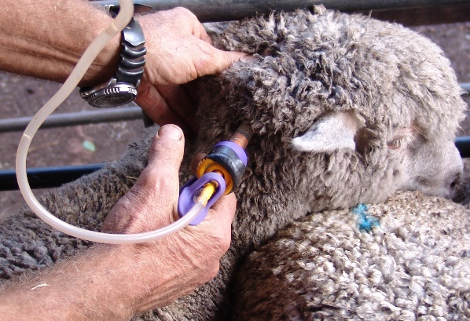
- Vaccination sites
- Ideally, vaccinations should only be given high up on the side of the neck behind the ear. If a reaction was to occur it will be trimmed from a low value cut. Do not give in the cheek as reactions can interfere with grazing, or in the leg or back as these are high value areas of the carcase.
Image courtesy of Sheep Connect SA
- Vaccination hygiene
- Avoid vaccinating wet animals or vaccinating in dusty, wet or muddy conditions.
- Use clean, sharp needles. Replace frequently (every 50-100 sheep) and needles that are blunt, bent or dropped should be replaced immediately.
- When finished vaccinating, ensure equipment is cleaned and disinfected. Re-usable injection guns can be sterilised by washing thoroughly and suspending them in boiling water for 10 minutes. Allow the gun to dry out before use.
- Avoid the use of strong disinfectants which may inactivate the vaccine.

General vaccination guidelines:
In order to avoid wasting time and money and to prevent costly disease it is essential that the following is considered when vaccinating your flock:
- Type of vaccine – ensure the correct vaccination is being used for your enterprise.
- Do you need a 3-in 1 or a 6-in 1?
- Do you need to vaccinate for arthritis, scabby mouth or OJD?
- Number of vaccines – ensure product instructions are followed clearly regarding the number of vaccinations required for the initial vaccination course and for yearly boosters.
  - Does the vaccination course require 2 initial doses 4-6 weeks apart followed by a yearly booster?
  - Is the vaccine required once only?
- Timing of vaccinations – adhere to the appropriate timing of vaccinations.
  - If the second vaccination of a primary course is to be given 4-6 weeks after the first, ensure this occurs. Giving a second vaccination and at the correct time is essential.
  - Timing of annual boosters is also important for some diseases, for example ewes previously vaccinated with Eryvac ® needs their annual Eryvac ® booster 4 weeks before lambing.
- Be aware of what else has been included in the vaccination, some vaccines contain selenium
- You may inadvertently cause toxicity if you are not in a selenium deficient area and a sheep dose is used in lambs or you have also used a drench containing selenium.
- Ensure appropriate vaccination and equipment is obtained before yarding stock
- Check vaccine to be used is in date, has been stored correctly and hasn’t become contaminated.
- Check condition of the vaccine gun, including adequate cleaning, disinfection and dryness.

