  - Recreational mesh net fishing in Lake George
Don’t forget to register to operate a recreational mesh net.
Lake George, near Beachport on the Limestone Coast, is the only area in the State where open access to the use of recreational mesh nets is permitted.

How to register
- Annual registration for the use of a recreational mesh net is open to anyone over 15 years old.
- Mesh net registrations are accepted year-round and expire on 30 June each year. A fee applies.
- One recreational mesh net is permitted per registration, for the sole use by the registered owner.
- All registered nets will receive a PIRSA tag which must be attached to the yellow buoy.
- Registration holders are permitted to net in the central and northern lagoons of Lake George. The southern lagoon is closed to netting.
- If your tag is lost or stolen, you must immediately remove your net from the water and report it to Fishwatch on 1800 065 522. A fee applies for a replacement tag.
- Register at pir.sa.gov.au/lakegeorge

Mesh net rules
Mesh nets must meet the following specifications:
- Maximum length: 75 m
- Minimum mesh size: 70 mm
- Maximum height of net (drop): 2.5 m
- Net must float on the surface and be no more than 2.5 m below the surface of the water.
Mesh nets used in Lake George must be attended by the registered owner between one and a half hours after sunrise and one and a half hours before sunset on the same day. The net is not required to be attended outside of these times.
Attendance of net means the registered owner must be no more than 50 m from the landward boundary of the Lake. The use of mesh nets is not permitted in marine coastal waters of South Australia. All mesh nets must be marked with a yellow buoy at one end, and two black buoys on the other end. Buoys must be a minimum volume of 4 litres.

Closures and fishing limits
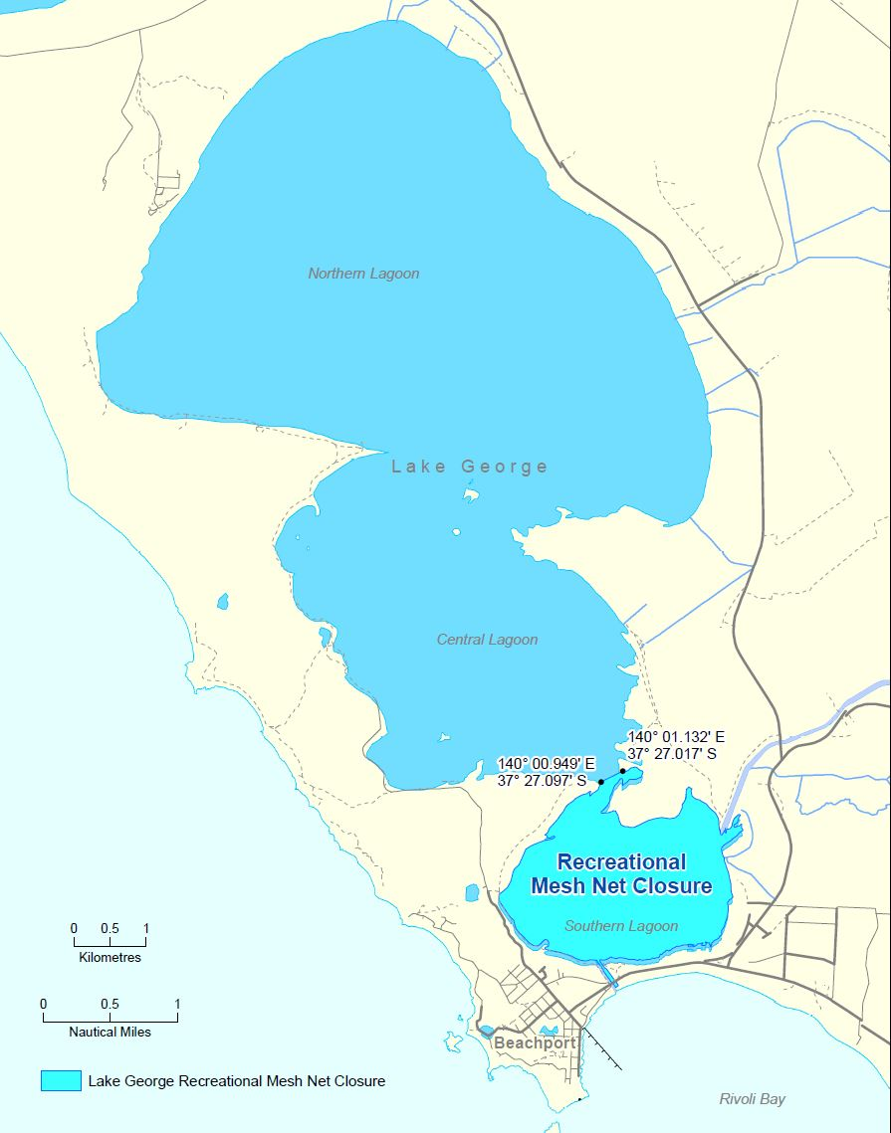
The following netting closures apply to the Lake George region:
- the southern lagoon
- the drainage channel connecting Lake George to Rivoli Bay
- any other waters that feed into Lake George.
Using rods, handlines and a hand net is permitted in closure areas.

Other Permitted Devices
Each person can use:
- up to two rods
- two handlines
- or one of each.
Each line can have:
- up to three hooks attached
- or up to five hooks joined eye to shank or threaded together (considered as one hook).
In addition to a rod and handline,
a person can only use at any one time no more than:
- one mesh net registered in your name
- one hand net.
All existing regulations for size, bag and boat limits apply to recreational fishing in Lake George.
Mullet are the key species found in the Lake and must be the minimum legal length of 21 cm measured from tip of snout to tip of tail. A personal daily bag limit of 60 mullet applies to the person who took the fish, that is, the registered operator of the net. A daily boat limit of 180 mullet applies where three or more people on that boat are actively fishing. Bag and boat limits apply for a 24-hour period from midnight to midnight.

More information
For further information, visit pir.sa.gov.au/lakegeorge or download the free SA Fishing app at pir.sa.gov.au/recfishingapp

