ENHANCED ABATTOIR SURVEILLANCE PROGRAM

Grass seeds
Grass seeds reported at the processor refer to seeds found in the carcass. Seeds can penetrate through the wool and skins into the underlying muscle within days of infestation. Spear grass, brome grass, barley grass, geranium, silver grass and Chilean needle grass are the most important species responsible for seedy carcasses in South Australia. In most regions, the greatest risk period for picking up seeds is October to January. Seed contamination causes significant financial losses for the whole sheep industry.

Condition summary
Grass seed contamination of carcases is the result of penetration of dried seed heads of various grass species through wool and skin into the underlying muscle. This causes significant discomfort in affected animals. Grass seeds can remain in the carcase for up to two years.
On farm, reduced feed intake, decreased growth rates and weight loss are seen which can cause significant production losses. Wool production and quality is also decreased. Death may occur due to bacterial infections, tetanus and flystrike.
Trimming can be significant, and is of most significance in high value meat cuts. Carcass downgrading, carcass condemnation (if there is fever or sepsis), potential loss of export markets, and reduced wool and skin quality and value may also occur.
Prevention depends on region, flock structure and production system and includes pasture and soil improvement, grazing management, stock management and target market and turn-off time.
Document Title Here
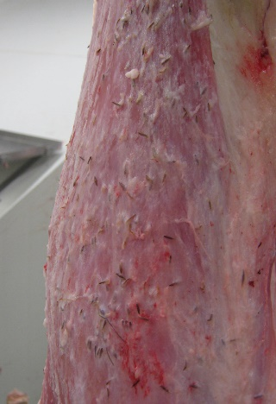

Seedy carcass

What impact does this have?
The financial cost of grass seeds to the sheep industry, producers, processors and the entire supply chain has been estimated to be up to $50 million per year, and is one of the three most significant conditions monitored by the Enhanced Abattoir Surveillance program. It can cost the processor up to $30 per head for heavily seed infested lambs.

What might be seen on farm?
Signs will depend on the severity of the grass seed problem however as few as 25 seeds per animal can result in a 50% reduction in post-weaning daily live weight gain. Signs of grass seed include:
- young sheep and lambs may be reluctant to move
- eye, ear, face and mouth injuries may result in blindness, lameness or loss of appetite
- flystrike, tetanus and death
- rough, discoloured or cotted wool from biting or rubbing.

How do I prevent grass seeds?
Producers should consider as many of the appropriate following options on-farm to help reduce the incidence of seedy carcasses. Options will vary dramatically, based on region, flock structure and production system, and includes:
- Pasture and soil improvement
- Strategic grazing
- Other management options such as use of feedlots, chemical control, early shearing and/or finishing.
Comprehensive information can be found in the following excellent resources:
- Winning Against Seeds Tips and Tools (4 pages), available on the MLA website, at mla.com.au, via News & Events → Publications → Search Publications and enter keywords and free download
- Grass seeds tutorial Winning Against Seeds YouTube clip at youtube.com/watch?v=F8H5F9lvkXc
Some handy tips include:
- Ensure a strong perennial pasture base where possible.
- Consider lucerne use, particularly in cropping rotations.
- Improve soil fertility to allow pasture species to out-compete weeds.
- Graze heavily and/or slash (or burn) during emergence of seed head development but before seed set, paying attention to shelter belts, laneways, sheep tracks and dam areas.
- Control chemicals at lethal or sub-lethal rates – spray grazing, winter cleaning of annual pastures and spray topping.
- Stagger crop sowings to ensure enough seed-free paddocks for lamb and weaner production.
- Select breeds in seed prevalent areas without wool or dense hair such as Dorpers, White Dorpers, East Friesians and Damaras. Merinos and merino crosses are more prone to seed damage.
- Wean early on to prepared pastures or into a feedlot.
- Shear lambs before seed set to reduce grass seed pick up and skin penetration.
- Update production management to finish lambs sooner, or sell them to finishers.
- Make hay/silage to create grass seed-free paddocks and conserve fodder to be used for finishing.
- Work with your local agronomist to tailor a program that best suits your property.
IMPORTANT POINTS: Although grass seeds threaten livestock for only a few months of the year, controlling them requires an ongoing, long term strategy over the whole year. Grass seed contamination can cause major problems for processors and can place key meat markets at risk. Producers also bear the cost of carcases being trimmed and downgraded which can be up to 50% of their retail value. Many processors encourage a trial lamb kill to act as a useful tool to assess the extent of the problem and to further inform management decisions on farm.

