March 2018
Contact: Margaret Sexton (08) 8429 0913

Poultry Diseases - Marek’s Disease and Leucosis

MAREK’S DISEASE
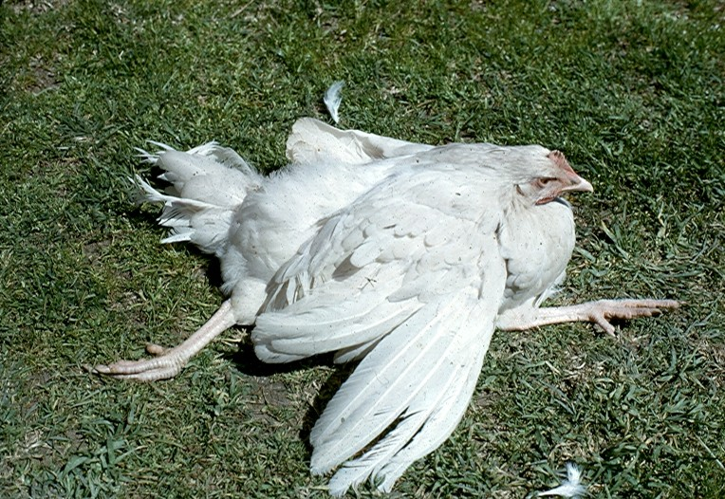
Marek’s Disease is a highly contagious viral disease causing the production of tumours within the bird’s body. The virus has unusual features in its transmission and disease mechanisms leading to much confusion among poultry owners as to what can or should be done to control it in a flock.

The Causative Agent
Marek's disease is caused by a Herpes virus that within the body is strongly cell associated. It is shed in the feather and dander and being protected by this material, the virus can remain infective for many months.
Species Affected
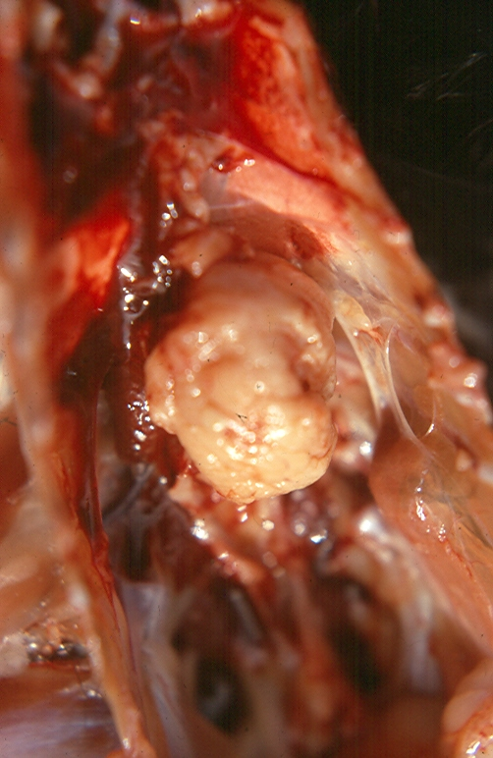
It predominantly causes disease in domestic fowl but turkeys, pheasants ducks and quail have been experimentally infected, although no disease was produced.
Chickens are usually infected in the first few days of life, particularly if hatched under a hen, placed near adult birds or put into a contaminated environment.
There are a number of syndromes now recognised and the incubation period and disease symptoms depend on the virulence of the virus strain and the resistance of the bird. It can be as short as 3-4 weeks after hatching in intensively reared meat chickens where there may be tumours in the skin and internal organs. In layers it is usually about 12-16 weeks and in the early stage, birds appear bright and alert but may have one or both legs paralysed.
This is followed a few weeks later by internal tumours (often of the ovary) seen as wasting and delayed onset of lay. There are rarer forms involving tumours in the eye or skin and also a condition termed ‘transient paralysis’ where birds in a flock may become paralysed for a few days, recover and then a few weeks later develop the full clinical disease.

Transmission
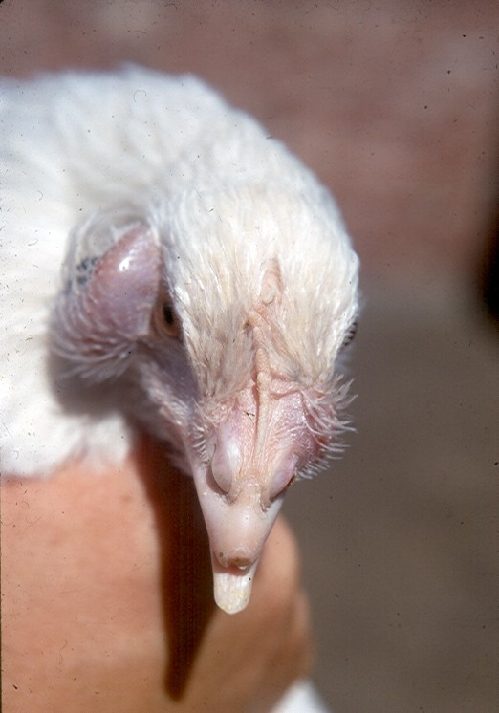
The Marek’s virus within the body becomes associated with the blood white cells and turns them cancerous. These then infiltrate body organs but nerves appear to be the most common target and leads to the paralysis seen.
The virus does not become infectious until it infects the skin cells that are shed as dander and feathers. It is the inhalation of this by the young bird that causes the infection.
Insects living in the litter may also carryover the virus between flocks.
It is considered that most chooks are infected. This means that new strains of the virus could be introduced to a property by bringing on new birds. As the virus is in the dander and feathers, this can be easily carried on equipment, people and vehicles, as well as blown on the wind.
It is not transmitted inside the egg.

Infectious Period
Once infected a bird is infectious for life. Not all birds die from the disease, so apparently healthy adult birds will be shedding and contaminating the environment with their feathers and dander.

Diagnosis
The clinical observation of leg weakness or paralysis associated with nerve or organ tumours is fairly diagnostic. Microscope examination of tumour tissues may confirm the likelihood but leucosis can give a similar microscopic lesion.

Differential Diagnosis
Fowl tick paralysis, Leucosis, Riboflavin deficiency and Reticuloendotheliosis virus
Treatment
There is no treatment for affected birds.

Prevention
The commercial industry vaccinates chicks at the hatchery, in some cases in the egg before hatch. They use a cell associated attenuated Marek’s virus vaccine or HVT vaccine (Herpes Virus of Turkey).
Smaller breeding operations are limited to the freeze dried HVT as the Marek’s virus vaccine needs liquid nitrogen for storage.
It must be given before the chickens become infected, so really only works when machine hatching in an environment removed from possible dander contamination of older birds.
Vaccine does not prevent infection but rather prevents clinical disease in most birds.
Vaccine failure is often due to the birds being infected before vaccination or improper handling of the live virus vaccine. It needs to be kept on ice while being used, mixed with the diluent correctly, all used within 2 hours of reconstitution and not allowing contamination with disinfectants that will kill the vaccine virus.

LEUCOSIS
Leucosis is a complex of diseases affecting the chook, caused by various strains of a retro virus that has the capacity to induce cancer in lymphoid cells. It is egg transmitted but can also spread between post hatch fowls.
Rarely as acute as Marek’s disease, it affects birds well into their first year of age and beyond, although there are some forms that may show as early as three to four months of age.
There is no treatment or vaccine for leucosis but commercial breeders have run selective breeding and testing regimes to eliminate it as it has been demonstrated to reduce the egg output of hens. In backyard flocks, this is rarely a problem and most owners are probably unaware of the disease in their flock.
Author: Dr Kim Critchley, Poultry Health, PIRSA

FOR FURTHER INFORMATION:
Contact your local veterinary practitioner.
IF YOU HAVE SIGNS OF UNUSUAL OR SERIOUS ANIMAL DISEASE*, phone Biosecurity SA Animal Health at Glenside on 82077900, contact your local PIRSA Animal Health officer, call your local veterinary practitioner
OR RING THE DISEASE WATCH HOTLINE: 1800 675 888.
*Signs such as mass mortality events, sudden onset of multiple ill birds, rapid spread of a problem or a noticeably unusual illness in birds.

