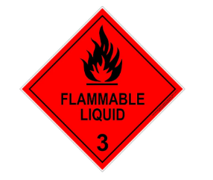
CAUTION: contains ethanol and dead bees for Varroa testing
For road freight only
To: GRIBBLES VETERINARY PATHOLOGY
33 FLEMINGTON STREET,
GLENSIDE, 5065
Beekeeper Name: ___________________Brand: _________Phone: ________________
Number of hives owned: ☐ 1-19 ☐ 20 or more
ATTENTION: Australian Clinical Labs staff refer to Varroa mite – alcohol wash sampling – Information for Australian Clinical Labs. If there are any delivery queries, contact PIRSA Apiary Unit 0408 812 698 or 0439 864 382

CAUTION: contains ethanol and dead bees for Varroa testing
For road freight only
To: GRIBBLES VETERINARY PATHOLOGY
33 FLEMINGTON STREET,
GLENSIDE, 5065
Beekeeper Name: ___________________Brand: _________Phone: ________________
Number of hives owned: ☐ 1-19 ☐ 20 or more
ATTENTION: Australian Clinical Labs staff refer to Varroa mite – alcohol wash sampling – Information for Australian Clinical Labs. If there are any delivery queries, contact PIRSA Apiary Unit 0408 812 698 or 0439 864 382

