Yorke Peninsula and Mid North
Yorke Peninsula/Mid North Region
Includes all PIC numbers beginning with SA/SB35 and SA/SB51 to SA/SB56

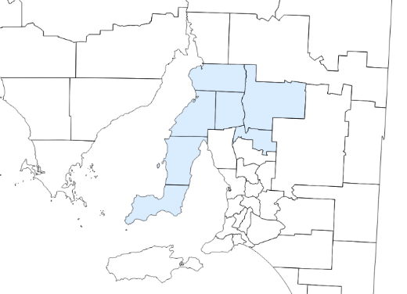
2020 Benchmarking report

Enhanced abattoir surveillance
The Enhanced Abattoir Surveillance program provides feedback to South Australian producers on conditions and diseases detected in sheep at Thomas Foods International abattoirs. The program helps producers to improve sheep health and welfare, maximise farm productivity and increase profits.
This benchmarking document enables producers to measure their animal health performance against others within their region.

Who and what does this data represent?
53% of all commercial* Yorke Peninsula and Mid North sheep producers (*commercial producers were defined as those who transferred >100 sheep on the NLIS database in 2020) | 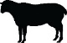  ~192,000 sheep
Direct consignments
(not sheep sold through sale yards)

How do I use this information?
Results show the number of producers in the region affected for each condition (low, medium, high, very high) and the average percent of sheep affected by each condition within affected consignments. An indication of potential lost value due to the conditions both on-farm and at the abattoir is also provided.
By checking your abattoir condition feedback sent to you for each consignment during the 2020 year, you can compare if the condition is rarely or commonly seen in your region, and at what levels the condition is seen in consigned affected stock in your region.
It is recommended results are also interpreted in conjunction with the detailed fact sheets provided (also available on the PIRSA website) and advice from your veterinarian, livestock consultant or PIRSA Animal Health Advisor.

What’s happening in your region?
Conditions with HIGH farm &/or abattoir impacts | Lamb | Mutton
Grass seeds:  - Number producers affected**  - Proportion animals affected in affected lines  - Lost value to affected producers (on farm, trim, condemns) | - Low**  - 35%  - High | - Low  - 2%* state average  - High
Arthritis:  - Number producers affected  - Proportion animals affected in affected lines  - Lost value to affected producers (on farm, trim, condemns) | - Low  - 6%  - High | - Medium  - 6%  - High
Sheep measles:  - Number producers affected  - Proportion animals affected in affected lines  - Lost value to affected producers (condemns) | - Low  - 9%  - High | - High  - 7%  - High
Pleurisy:  - Number producers affected  - Proportion animals affected in affected lines  - Lost value to affected producers (on farm, trim, condemns) | - Low  - 11%  - High | - High  - 10%  - High
Cheesy gland:  - Number producers affected  - Proportion animals affected in affected lines  - Lost value to affected producers (on farm, trim, condemns) | Mutton predominant condition | - Medium  - 12%  - Medium
Conditions with lower farm &/or abattoir impacts | Lamb | Mutton
Vaccine lesions: (depends on lesion location on carcase)  - Number producers affected**  - Proportion animals affected in affected lines  - Lost value to affected producers (on farm, trim, condemns) | - Low**  - 42%  - Medium | - Low  - 40%* state average  - Medium
Pneumonia:  - Number producers affected  - Proportion animals affected in affected lines  - Lost value to affected producers (on farm, trim, condemns) | - Low  - 12%  - Medium | - Low  - 13%* state average  - Medium
Rib fractures:  - Number producers affected  - Proportion animals affected in affected lines  - Lost value to affected producers (on farm, trim) | - Low  - 9%* state average  - Medium | Lamb predominant condition
Nephritis:  - Number producers affected  - Proportion animals affected in affected lines  - Lost value to affected producers (possible on farm; offal condemn) | - Low  - 17%  - Low | Lamb predominant condition
Bladder worm:  - Number producers affected  - Proportion animals affected in affected lines  - Lost value to affected producers (offal condemn only) | - Low  - 20%  - Nil | - Very High  - 28%  - Nil
*State average represents data from across the whole state as insufficient regional data available to calculate accurately
**Number of producers who consigned affected stock: | LOST VALUE INCLUDES:  On Farm: deaths, poor growth, treatment costs  Producer: carcase trim, carcase condemns,  penalties  Abattoir: downgraded carcases, offal condemns
Low 1% to 24%
Medium 25% to 50%
High 51% to 75%
Very high >75%

