HACCP PLAN
Ellgar, Elyse (PIRSA)
In-Pack Surface Pasteurisation of RTE Meat
Business Name
PIRSA Accreditation Number: XX/XXXX

This is a based HACCP template, developed by the Department of Primary Industries and Regions South Australia (PIRSA) for In-pack surface pasteurisation of Vacuum packed RTE meats.
An Accredited Producer may identify additional steps or hazards upon undertaking their own hazard analysis and risk assessment of each hazard. If this occurs, the Accredited Meat Producer must discuss this with the PIRSA Food Standards team to ensure that this is reflected in this document and appropriately addressed.
It is the responsibility of the accredited operator to implement and maintain the HACCP plan as part of the approved Food Safety Arrangement.

Table of Contents
1 HACCP PROCESS 3
1.1 PRODUCT SPECIFICATION 4
1.2 FLOW CHART 5
1.3 CCP DECISION TREE 6
1.4 HAZARD ANALYSIS TABLE 7
1.5 HAZARD AUDIT TABLE 9
1.6 CCP WORK INSTRUCTIONS 11
1.7 CCP MONITORING FORMS 15
1.8 PROCESS VALIDATION 17

HACCP PROCESS

OUTCOME
To process food safely, producing safe food which complies with relevant legislation, regulations and standards.

HACCP
Process

This HACCP plan forms part of the Approved Food Safety Arrangement for the Accredited Meat Producer.
The HACCP team (as identified it the Food Safety Arrangement) is responsible for maintaining this HACCP manual through analysing and improving procedures along with implementing effective controls to manage food safety risks. Each process undertaken by the accredited meat producer needs to be covered by a HACCP plan. This HACCP plan covers:
In-Pack Surface Pasteurised Vacuum Packed RTE Meats

The Accredited Meat Producer acknowledges the following have been taken into consideration in the development of this HACCP plan;
- Primary Produce (Food Safety Schemes) Act 2004
- Primary Produce (Food Safety Schemes) (Meat) Regulations 2017
- AS 4696:2023: Australian Standard for Hygienic Production and Transportation of Meat for Human Consumption
- Meat and Livestock Australia - Guidelines for the Safe Manufacture of Smallgoods – 2nd edition 2015
- Process times and temperatures to deliver a 6D reduction of Listeria monocytogenes (NSW Food Authority 2019).

Application for any alternative methods to those identified in the Australian Standard AS4696 must be approved by the Accrediting body.
Note: To produce and sell In-Pack Surface Pasteurised Vacuum Packed RTE Meats for human consumption the producer must hold accreditation and approval for these processes. Additional conditions may be required by PIRSA Food Standards Program as part of the approval of this process.

PRODUCT SPECIFICATION
As per the Food Safety Arrangement, Product Specifications detail the product characteristics as listed below and are considered when reviewing the HACCP plan.
General Category Product Specification (Example)
Product Category | Vacuum packed ready-to-eat (RTE) meats, whole or individually packed portions.
Form | Cooked ready to eat meat.
Method of Preservation | Refrigeration, less than 5°C.  Vacuum Packaging  Preservative addition (Nitrite) – optional
Packaging | Primary | Sealed plastic shrink bag
 | Secondary | Cardboard carton
Storage Conditions | Refrigerated: Store under active refrigeration less than 5°C.
Distribution Method | Direct to customer, over the counter sales.  Wholesale, transported in accredited vehicle
Shelf Life | To be determined by Producer:  Chilled, sealed shelf life: x days from production.  Chilled shelf life once opened: x days once opened.
Labelling | As per AS4696:2023 and Section 4.1 of FSA; Labels to include:  - Product name  - Accredited business  - Business address and contact details  - Directions for use and storage conditions  - Packaging Date  - Use By Date (may include batch identification)  - Advisory statement/warning (e.g., allergens)  - Ingredient information (as per recipe)  - Nutrition information  - Country of Origin
Intended Use | Sensitive Customer | Not suitable for vulnerable populations or those with allergies to listed ingredients.
 | Customer Preparation | Ready-To-Eat (RTE), no preparation required prior to consumption.
Microbiological Limits | As per FSANZ | Listeria Not detected in 25g.

FLOW CHART
Objective | A step-by-step diagram of the flow of the operation/process with all inputs and outputs identified. Key steps in the process that are critical to food safety are referred to as Critical Control Points, CCP. These are highlighted on the Flow Chart.

CCP DECISION TREE

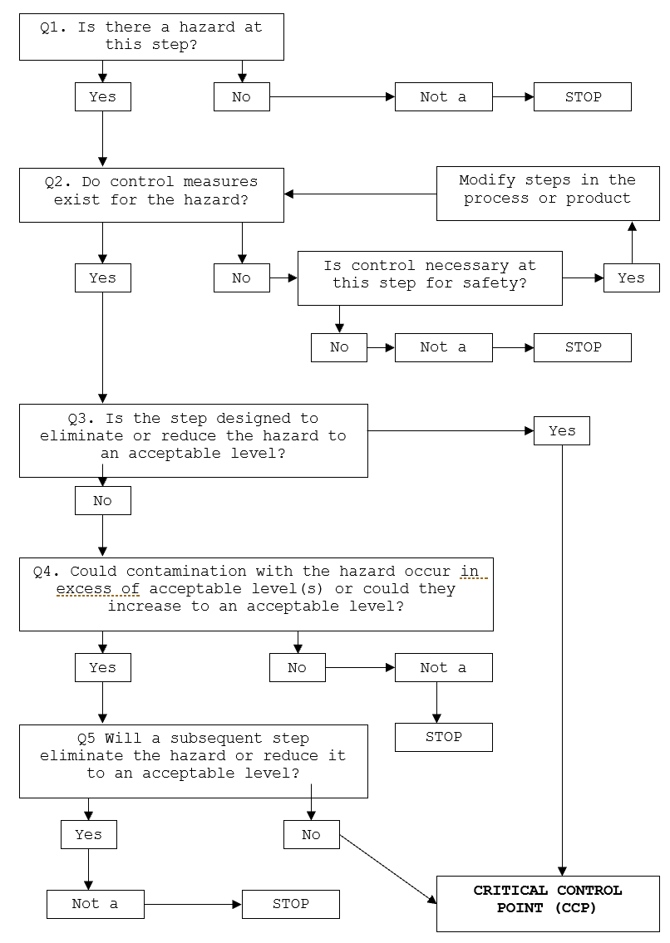

HAZARD ANALYSIS TABLE
Hazard Types: B – Biological; C – Chemical; P – Physical;
Objective | A documented review of each step identified in the flow chart and with the importance of each step in the safety of the finished product rated to identify Critical Control Points (CCP).

Process Step | Hazard | Cause | Q1 | Q2 | Q3 | Q4 | Q5 | Hazard control measure | CCP | CP | GMP | Support Program
- Finished Product from Cooked Smallgoods Process | Selection of Finished Product compliant with Cooked Smallgoods Process
- Offset (optional) | C, B – Offset not applied as per manufacturers specifications to control microbiological growth. | Improper application of offset. | Y | Y | N | Y | Y | Food grade offset applied at concentration specified by manufacturer’s specifications. | CP
- Packing | B - Growth of microbiological pathogens above unsafe levels. | Inadequate seal or vacuum of bag | Y | Y | N | Y | Y | Packaging purchased from an approved supplier; food grade packaging used only.  Inspect each bag for seal integrity after application of vacuum. | CP
- Pasteurisation | B – Growth of pathogenic bacteria. | Inadequate application of thermal treatment to surface for sufficient time to achieve 6D log reduction for Listeria monocytogenes. | Y | Y | Y | Y | N | Heat treatment applied to surface for validated time and temperature to achieve 6D log reduction for Listeria monocytogenes at surface (e.g. product submerged in 90°C for 3 minutes to achieve equivalent surface temperature of 76°C for 1 minute) | CCP
Process Step | Hazard | Cause | Q1 | Q2 | Q3 | Q4 | Q5 | Hazard control measure | CCP | CP | GMP | Support Program
- Labelling | B – Growth of microorganisms. | Bacterial growth if temperature and time allow | Y | Y | N | Y | Y | Process in facility set at ≤10 ̊ C to prevent growth of bacteria.  Or temperature at point of microbiological concern is maintained ≤5°C.
 | C – All ingredients or warning statements not listed on packaging. | Inadequate traceability and labelling of finished product. | Y | Y | Y | Y | N | Validate Use By Date applied to product.  Mandatory information included on labels. | CCP
- Cold Storage | B – Growth of microbiological pathogens above unsafe levels. | Product not stored under appropriate temperature control. | Y | Y | Y | Y | N | Product stored <5°C under active refrigeration without delay. | CCP
 | C – cross contamination | Operator error with cleaning chemicals | Y | Y | N | Y | Y | Suitable chemical storage and control and appropriate training for staff handling chemicals
 | P – contamination | Foreign objects | Y | Y | N | Y | Y | Chiller construction
- Despatch & Distribution | B – Growth of microbiological pathogens above unsafe levels. | Product not stored under appropriate temperature control. | Y | Y | Y | Y | N | Product maintained <5°C under active refrigeration. | CCP

HAZARD AUDIT TABLE
Objective | Documented controls to be implemented and measured and recorded to demonstrate compliance to process to make safe food.

Step | Hazard | Critical Limit | Monitoring | Corrective Action | Records
5. Pasteurisation | B – Growth of microbiological pathogens above unsafe levels. | Surface of vacuum-packed product achieves minimum time and temperature of 76°C for 1 minute or equivalent time and temperature to achieve 6D log reduction for Listeria monocytogenes. | What: Time and Temperature of process application | If sufficient time and temperature is not achieved, extend processing time and validate surface temperature of product achieves 76°C for 1 minute. | In-Pack Surface Pasteurisation (IPSP) record
 |  |  | How: Thermometer / gauge
 |  |  | When: Every batch
 |  |  | Who: Operator
6.  Labelling | C – All ingredients or warning statements not listed on packaging | Validated Use-By Date applied.  Adequate traceability and labelling of finished products. | What: Label applied to product | Isolate and hold product with incorrect labels.  Where labelling details are incorrect or inaccurate, the labels shall be removed.  Discard incorrect labels, apply correct details to product.  All previous products from the batch shall be re-inspected for compliance and corrective action taken if found to be incorrect/inaccurate.  All non-complying and used packaging shall be disposed of and not reused.  Release product for despatch once correct labels have been applied and verified. | In-Pack Surface Pasteurisation (IPSP) record
 |  |  | How: Visually
 |  |  | When: Every batch
 |  |  | Who: Operator
Step | Hazard | Critical Limit | Monitoring | Corrective Action | Records
7.  Cold Storage | B – Growth of microbiological pathogens above unsafe levels. | Active refrigeration in place to maintain temperature of meat at less than or equal to 5°C. | What: Chiller temperature | Assess temperature of meat. If >5°C, move product to alternate storage if available.  Adjust room temperature setting to achieve <5°C product temperature.  Repair chiller.  Discard if this cannot be achieved. | Daily Storage Temperature record  Calibration record
 |  |  | How: Chiller gauge
 |  |  | When: Daily
 |  |  | Who: Operator
8.  Despatch & Distribution | B – Growth of microbiological pathogens above unsafe levels. | Active refrigeration in place to maintain temperature of meat at less than or equal to 5°C. | What: Product temperature | Product is not loaded out until product temperature is ≤5°C. | Load out record/invoice  Calibration record
 |  |  | How: Thermometer
 |  |  | When: At point of despatch/delivery
 |  |  | Who: Operator

CCP WORK INSTRUCTIONS
Objective | At steps that are critical for the safety of the finished product, checks on the process are completed to confirm the process has met the critical limits and the results recorded. If the check finds the product has not met the critical limit of the process, actions need to be taken to make the product safe. These steps need to be documented in a work instruction.

WORK INSTRUCTION | In-pack Surface Pasteurisation
Objective | The surface of vacuum packed cooked RTE meat is pasteurised to control the risk of Listeria monocytogenes.  During packaging the wholesomeness of meat and meat produces is not jeopardised and all packaging comply with the requirements of the Food Standards Code.
Procedure | Overview of process:  - Cooked product has been stored in chiller.  - Product is portioned if applicable.  - Product is packed into vacuum bag with option of offset application.  - Offsets can be applied to reduce the ability of bacteria to grow on the surface of food.  - Product is vacuum-packed (recommend packing within 24 hours from cooking/cooling).  - In-pack Surface Pasteurisation (IPSP) - Surface of vacuum-packed product has sufficient treatment applied to achieve minimum time and temperature of 76°C for 1 minute or equivalent time and temperature to achieve 6D log reduction for Listeria monocytogenes (Table 1).  - Appropriate labelling is applied, including product Use-By Date, to allow for effective traceability of product.  - Product is returned to chiller after processing.  - Record batch details on In-pack surface pasteurisation monitoring form.  In-pack surface pasteurisation process:  - Submersion in water  - Water is heated to appropriate temperature (>90°C).  - Vacuum-packaged product is fully submerged in water for a validated time at set temperature to achieve 6D log reduction for Listeria monocytogenes.  - Steam Oven  - Validated steam cycle is applied to achieve sufficient time and temperature on surface of vacuum-packaged product to achieve 6D log reduction for Listeria monocytogenes.  Table 1: Process times and temperatures to deliver a 6D reduction of Listeria monocytogenes (NSW Food Authority 2019)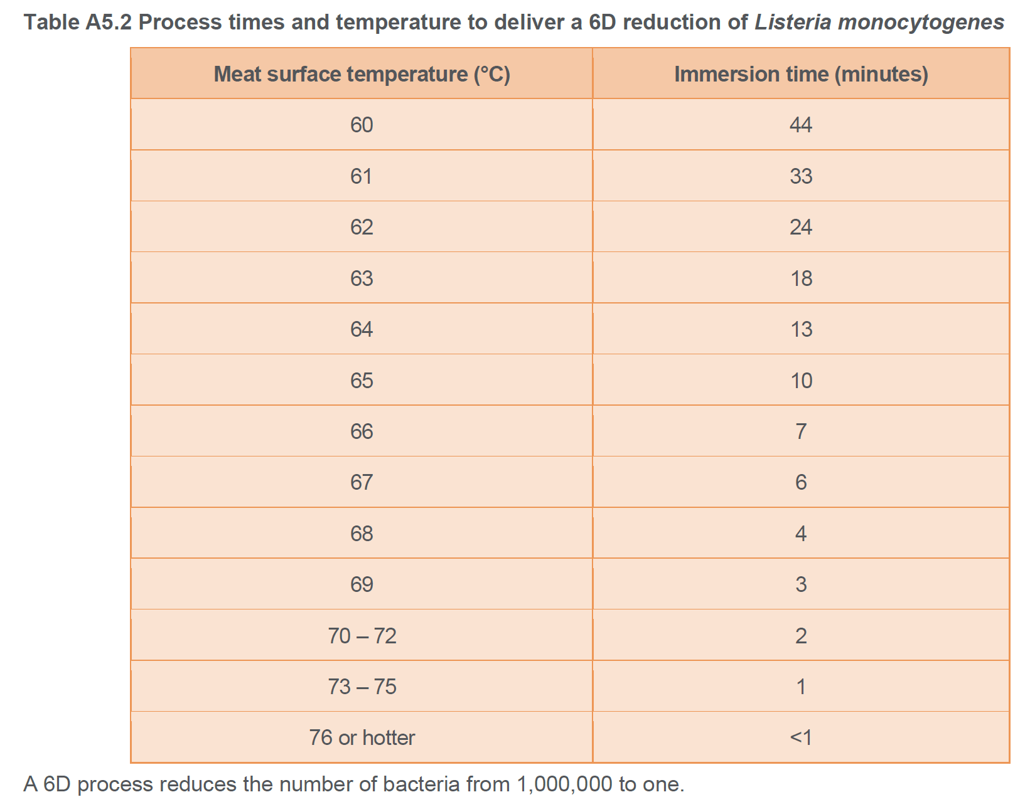  Meat products are packaged in accordance with the time and temperature controls as outlined in AS4696:2023, Section 12 Thawing, tempering, boning and other processing of raw meat.  Where meat and meat product packaging is not undertaken in a temperature controlled environment maintained <10°, the times and temperature of packaging of meat and meat products is monitored on raw meat production form with product returned to Chiller upon completion of packaging to maintain surface temperature ≤5°C, unless additional processing is undertaken without delay.  Meats are to be packaged with approved material, suitable for food contact. All packaging shall be new and not used or contaminated.
Frequency | Each batch
Records | In-pack surface pasteurisation record
Corrective Action | If surface temperature is not reached, extend processing time and validate surface temperature of product achieves 76°C.  Packaged meat is returned to chiller and surface temperature monitored to confirm temperature achieves ≤5°C.
Responsibility | The operator is responsible for the in-pack pasteurisation of meats.

WORK INSTRUCTION | Labelling
Objective | During labelling the wholesomeness of meat and meat produces is not jeopardised and all labelling comply with the requirements of the Food Standards Code.
Procedure | All food must be accurately labelled for items not sold through assisted display.  An accurate description of the meat product including its ingredients shall be displayed in a prominent position.  A label shall include mandatory information where applicable as per FSANZ Food Standards Code.
Frequency | Every Batch.
Records | In-pack surface pasteurisation record.
Corrective Action | Isolate product with incorrect labels.  Discard incorrect labels, apply correct details to product.
Responsibility | The operator is responsible for monitoring and documenting the label application for each batch.

WORK INSTRUCTION | Cold Storage, Despatch & Distribution
Objective | Product is maintained ≤5°C.
Procedure | - Storage condition is inspected prior to use.  - Cleaning is performed as required.  - Maintenance is conducted as required.  - Temperatures are recorded daily for each piece of temperature controlling equipment.  - Calibration of thermometers and gauges is conducted every 3 months.
Frequency | Daily
Records | Daily Storage Temperature monitoring form.
Corrective Action | Assess temperature of meat. If >5°C, move product to alternate cold storage if available.  Adjust room temperature setting to achieve <5°C product temperature.  Repair chiller.  If product is unable to be relocated to alternative cold storage and product temperature increases to above 5°C, time out of temperature control is monitored.  - If product is out of temperature control for <4 hours, it can be sold immediately.  - If product out of temperature control for >4 hours, it must be disposed of.
Responsibility | The operator is responsible for maintaining cold storage.

CCP MONITORING FORMS

In-Pack Surface Pasteurisation Record combines CCP monitoring for the following steps:
- Preservative addition (Curing solution)
- Cooking
- Cooling
- IPSP temperature and time
- Labelling

DATE PRODUCED / BATCH # | / / | / / | / / | / / | / / | / /
PRODUCT(S) MADE

QUANTITY PRODUCED (Units | kg)
MEAT TEMPERATURE (From Chiller) °C | °C | °C | °C | °C | °C | °C
CURING SOUTION MIXTURE / INGREDIENTS
(to specification) /
COOK DATE
COOKING: CORE  Temperature ( ≥ 65°C)  Cooking Time ( ≥10 mins) | °C  MINS | °C  MINS | °C  MINS | °C  MINS | °C  MINS | °C  MINS
COOLING: CORE  Uncured- from 52°C to 12°C (≤6 hrs)  Cured- from 52°C to 12°C (≤7.5 hrs)  Total ≤5°C within 24 hours | HRS  HRS | HRS  HRS | HRS  HRS | HRS  HRS | HRS  HRS | HRS  HRS
DATA LOGGER VERIFICATION /
DATE PACKED | / / | / / | / / | / / | / / | / /
Quantity Packed (Units | kg)
OFFSET applied /
(Optional – as per specification)
IPSP Date applied | / / | / / | / / | / / | / / | / /
IPSP Temperature and Time | °C  MINS | °C  MINS | °C  MINS | °C  MINS | °C  MINS | °C  MINS
Labelling applied /
PRODUCT USE BY DATE | / / | / / | / / | / / | / / | / /
REturned to chiller after packing
TEST & HOLD /
SIGNATURE
CORRECTIVE ACTION

PROCESS VALIDATION AND VERIFICATION
Objective | Confirm the process followed will control the hazards identified, making the product safe for consumption.

VERIFICATION & VALIDATION | In-Pack Surface Pasteurisation (RTE meat)
Validation | Provide evidence of the following requirements and surface treatment parameters to demonstrate implementation and compliance to the IPSP process.
Theoretical validation – MLA Guidelines for the safe manufacturer of smallgoods (section 6.19) and Process times and temperatures to deliver a 6D reduction of Listeria monocytogenes (NSW Food Authority 2019).
The In-Pack Surface Pasteurisation (IPSP) process requires validation. The validation process needs to cover:
- Datalogging of process used for surface treatment, e.g. temperature settings and time of treatment applied (e.g. via Steam Oven or Water submersion)
- Surface temperature of product after treatment (temperature sensitive labels)
- Product analysis (test for Standard Plate Count (SPC) and Listeria)
This validation is required to be completed on 5 BATCHES (5 x 25g/batch, test per 125g) of RTE Vacuum packed products. Testing to be completed at a NATA Accredited laboratory across applicable product range (e.g., whole muscle/bone in whole muscle, emulsified, portioned products), as per Table 2. As per standard testing procedures, each batch of product tested to be placed on HOLD and released upon receipt of compliant test results.
Table 2: Initial validation testing.
Testing frequency | Duration | Tests | Limits
First 5 batches | Initial validation | - Standard Plate Count (SPC)  - Listeria monocytogenes  - Datalogging  - Temperature sensitive labels | - <100 org/g  - Not Detected/125g  - Logging of heat application  - Colour change on label

Upon completion of initial process validation and approval to proceed with IPSP process from PIRSA, testing to continue in accordance with Table 3.
Table 3: Table of testing requirements and frequencies.
Testing frequency | Duration | Tests  (Limits as per Table 2)
Ongoing,  Quarterly testing | Quarterly testing – 1 batch every 3 months  Rotate through product range to cover different product types throughout the year | Standard Plate Count (SPC)  Listeria monocytogenes/25g
Annual validation | Annually – 1/year | Standard Plate Count (SPC)  Listeria monocytogenes /125g  Datalogging  Temperature sensitive labels

Shelf-life Validation

Validation of IPSP product shelf-life to be completed,
- end of shelf-life target SPC <10 000 000cfu/g.

As per table 2.3 Interpreting results for standard plate counts in RTE foods, Category 2b.
Compendium March 2022 (foodstandards.gov.au)
Verification |  | Refer to work instruction for monitoring records and frequency to confirm validated process has been followed to achieve hazard control.

Testing Schedule

Initial Validation

Sample | Test For | Frequency | Date Completed
1 | - Standard Plate Count (SPC)  - Listeria monocytogenes (per 125g)  - Datalogging (IPSP process)  - Temperature sensitive labels | Every Batch
2
3
4
5

Ongoing Testing

Sample | Test For | Frequency | Date Completed
Products – whole muscle (including bone in)/portioned
Q1 | - Standard Plate Count (SPC)  - Listeria monocytogenes/25g | 3 monthly
Q2 |  | 3 monthly
Q3 |  | 3 monthly
Q4 |  | 3 monthly
Products – emulsified/portioned
Q1 | - Standard Plate Count (SPC)  - Listeria monocytogenes/25g | 3 monthly
Q2 |  | 3 monthly
Q3 |  | 3 monthly
Q4 |  | 3 monthly

Annual Validation

Sample | Test For | Frequency | Date Completed
Products – whole muscle (including bone in)/portioned
1 batch | - Standard Plate Count (SPC)  - Listeria monocytogenes (per 125g)  - Datalogging (IPSP process)  - Temperature sensitive labels | Annually
Products – emulsified/portioned
1 batch | - Standard Plate Count (SPC)  - Listeria monocytogenes (per 125g)  - Datalogging (IPSP process)  - Temperature sensitive labels | Annually

