A quick reference guide for accessing eCatch services using myPIRSA

Create a myPIRSA account
In your internet browser search for myPIRSA Services. Click on the link at the top of the page to go to the myPIRSA web page <http://pir.sa.gov.au/top_menu/services/mypirsa>.
- From the myPIRSA web page, click the Register link to be redirected to the ‘Register for myPIRSA’ form. Complete all fields and submit form by clicking ‘Register’.
Note that Postal Address displays a list of possible matching street addresses as you enter it. Click on the correct address out of the list. If a match is not found eg. in the case of a PO Box, ‘My address is not listed – Allow me to supply my own.’ will be displayed. Click on it to enter your address into the component address fields.
- Upon successfully submitting the form, an email will be sent to your specified email address with a link to verify your email. Please be aware that the email may go to your ‘Spam’ folder.
- Click on the Verify Email link to verify your email and then click on the Login button to go to the myPIRSA Login page.
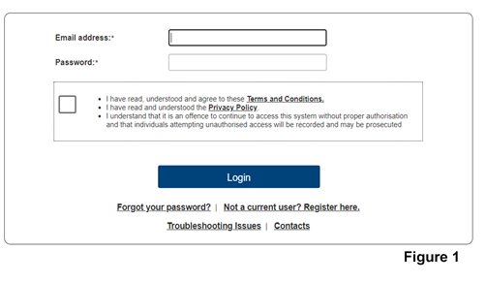
- On the myPIRSA Login page (see Figure 1), enter your email address and password, read and tick the box to accept the Terms and Conditions and then click Login.

- Once you have successfully logged into myPIRSA you will be directed to the myPIRSA landing page.
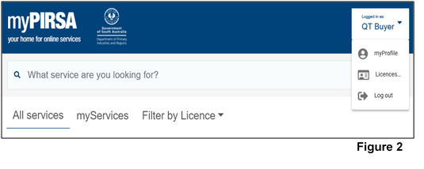
You will see a drop down box alongside your name at the top of the screen (see Figure 2 below).

Clicking on the ‘myProfile’ allows you to:
- Update your personal details (e.g. address, phone number etc.)
- Change your password.
Clicking on ‘Licences and Registrations’ allows you to view licences you own or are registered on when you have an approved eCatch service, including any recreational device you hold a current registration for.

How to apply for eCatch
One the myPIRSA homepage, follow the below steps:
- Select ‘Fishing’ then locate ‘Use eCatch (Digital Reporting) Service’ and select.
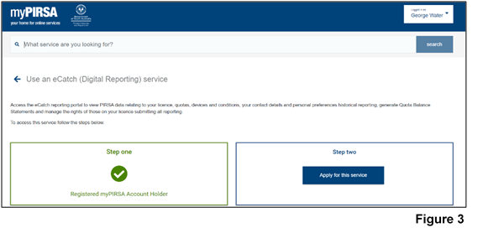
- Click ‘Apply for this service’ (see Figure 3)
- The ‘Apply for a Service’ screen will now open. Figure 4 shows a Service Request for ‘Use an eCatch (Digital Reporting) service’. For approval click on the Submit button.
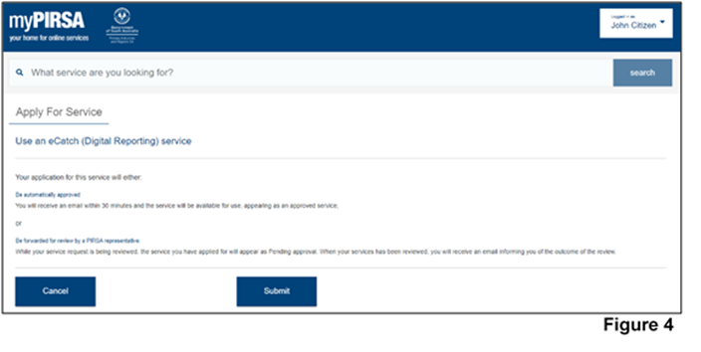
- Your application for a service will be sent to PIRSA Fisheries & Aquaculture Licensing in Adelaide for approval. Once the service is approved, you will be notified via email and can access the service via the link in the email
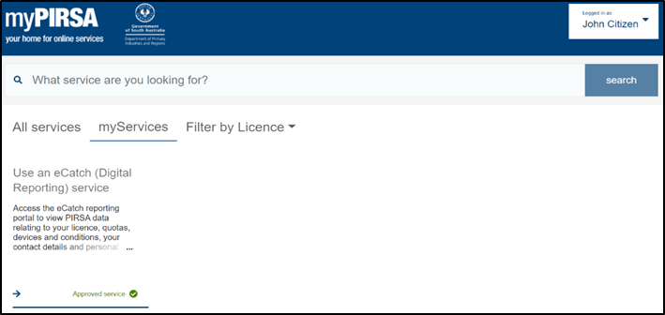
- Once approved, the approved service will be listed in the ‘myServices’ tab at the top (see Figure 5).
Figure 5
Note: Any service application that has been denied will no longer be displayed in the ‘MyServices’ tab and an email will be sent to your specified myPIRSA email address stating the reasons why the service was denied.
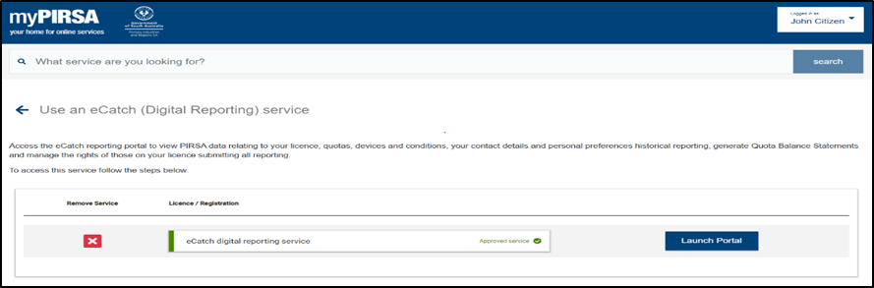
- Once you have a service approved, you can access at any time by logging into myPIRSA, select the ‘myServices’ tab, then click ‘Use an eCatch (Digital Reporting) service’. Select ‘Launch Portal’ to be directed to eCatch (See Figure 6).
Figure 6

