ENHANCED ABATTOIR SURVEILLANCE PROGRAM

Liver fluke
Liver fluke are parasites found in the liver and bile ducts of sheep and other animals. They are widespread across south-eastern Australia, especially in high rainfall and irrigated areas. Liver fluke are rare in South Australia, however where they occur, they can be a major economic burden.

Condition summary
Liver fluke (Fasciola hepatica) are large leaf-shaped parasites found in the liver. The fluke require fresh water snails and wet conditions to complete the life cycle in sheep, other ruminants and horses.
A liver fluke burden can result in deterioration in wool quality, reduced meat production, reduced lambing percentages and ill-thrift in young stock. Stock may die from heavy burdens.
Affected livers are condemned. Occasionally a carcase may be condemned if found to be emaciated or oedematous (containing excessive fluid as a result of the disease).
Strategic drenching treatments, good biosecurity, snail habitat control and grazing management will control fluke infection.
Document Title Here
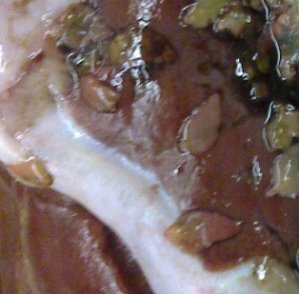

Liver fluke present near bile ducts in the liver (circled)

What might be seen on farm?
Clinical signs of liver fluke vary depending on the size of the infection and how quickly it is acquired. Acute signs include ill thrift, anaemia, sudden weakness and death due to rapid blood loss, jaundice, abdominal pain and reluctance to move.
More chronic signs include anaemia, loss of appetite, and ‘bottle jaw’ (submandibular oedema).Chronic disease is the most common form and is due to the accumulation of adult fluke within bile ducts and signs develop slowly.
Black disease can also occur usually due to young fluke migrating through the liver. This is an acute and fatal liver disease and is preventable by vaccination with 5-in-1 (clostridial vaccine).

How do sheep get liver fluke?
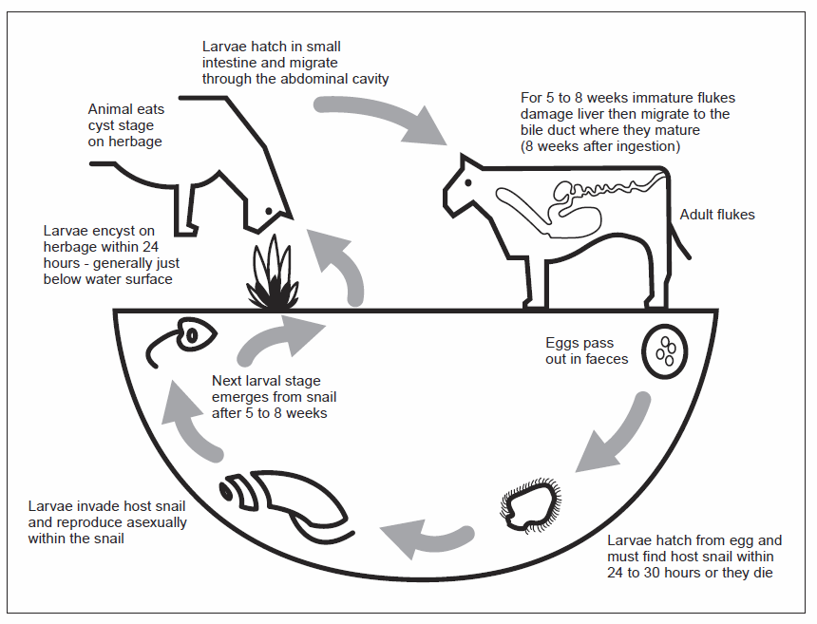
Adult fluke live in the liver of the infected animal, and eggs are passed in faeces. In warm, moist conditions, the eggs hatch into larvae which infect specific species of intermediate host freshwater snails. The larvae develop in the snail, then leave the snail and form cysts on pasture. Sheep ingest cysts which hatch, then immature fluke burrow through the gut wall of the sheep and travel through liver until they reach the bile ducts. Fluke mature in the bile ducts feeding on blood. They can live for several years and produce over 20,000 eggs per day.
© State of Western Australia (Department of Primary Industries and Regional Development, WA)

How do I prevent liver fluke?
- Strategic fluke drench treatments containing triclabendazole can help reduce liver fluke populations. Resistance has been documented and drench groups should be rotated.
- One to three drench treatments may be needed per year, depending on the severity of the problem. The late autumn drench is the most important.
- Avoid introducing sheep onto your property infected with fluke. Quarantine and drench all sheep that come from a liver fluke area.
- Fence off swampy areas to stop sheep access, and improve drainage where possible.
- Provide clean trough water as an alternative to drinking from swamps and drains.
- If infested paddocks must be used, graze clean sheep over infected areas and move to a snail-free paddock after eight to 10 weeks and drench. This prevents fluke eggs from reaching the snails and continuing their life cycle.
- Monitor for the presence of fluke by using fluke faecal egg counts (or blood tests for early infections), abattoir surveillance reports and post-mortem findings. Ensure stock are fully vaccinated, including correct timing of boosters against Black Disease using commercial 5-in1 and 6-in-1 vaccines.
IMPORTANT POINTS: Liver fluke infect stock in moist environments which can support specific species of freshwater snails. Most losses associated with infection occur on farm. Control is by both strategic drenching with an effective flukicide containing triclabendazole, and grazing management.

