Asian black-spined toad
November 2018
Pest Alert Hotline 1800-084-881

asian black-spined toads pose an extreme threat to south australia

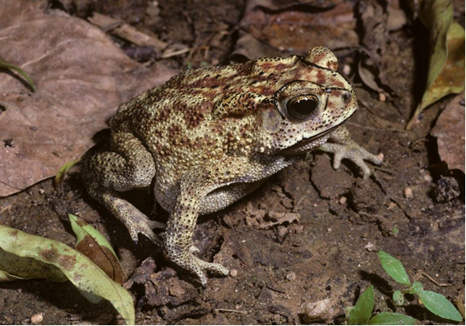
what is it?
The Asian black-spined toad Duttaphrynus melanostictus is not native to Australia. It has been described as one of Australia’s “most unwanted” species, and has the potential to be more damaging than the cane toad.

what does it look like?
Asian black-spined toads are a stocky toad with a small head and short hind limbs. It has black-tipped, hooked toes on its front limbs. The toads are generally yellow-brown, with dark or reddish-brown streaks and spots. Their back is covered with pimple-like warts that are often surrounded by a darker pigment and are capped with distinctive spines. The toads have a prominent black ridge over each eye, which meet at the nose. They have a visible ear drum and a parotoid gland containing poison behind each eye.
There are some native frog species in South Australia that look similar to the Asian black-spined toad. These include the eastern banjo frog and the meowing frog. The introduced cane toad looks like an Asian black-spined toad, and should also be reported.

why is it a problem?
The Asian black-spined toad could compete with native frogs and toads for suitable habitat and food. It may also carry and spread parasites and diseases. Because the toad is carnivorous, it would feed on native wildlife. The poison gland behind its eye makes it toxic to native animals and domestic pets.
There are no known populations in Australia. The Asian black-spined toad favours warmer climates, but there are concerns that it is also able to survive and breed in the cooler southern states, including South Australia.

how does it spread?
The Asian black-spined toad is not known to be in Australia, but an increasing number of them are being intercepted at Australian airports and sea ports, where they arrive on airplanes and ships from Asia. It is important that travellers check their luggage before arriving into Australia.

what can you do?
We rely on vigilant members of the public to detect these toads in the wild. Be on the alert for the Asian black-spined toad, using this Fact Sheet as a guide. By immediately reporting any Asian black-spined toads seen in the wild, action can be taken to ensure that the toads do not establish wild populations. If you see an animal that may be an Asian black-spined toad, please report it to the Pest Alert Hotline on 1800-084-881, to your local Natural Resources Management Board or to NRM Biosecurity on 08-8303-9620.

